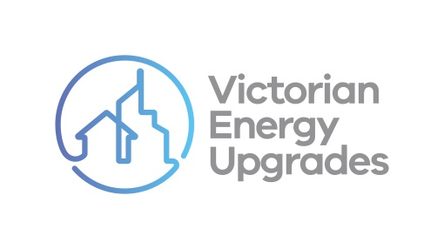

VEU program compliance checklist

Virtual lead generation and marketing

Instructions for use

The compliance checklist on the following page is part of a series for accredited persons and scheme participants to use as they engage in a variety of common activities under the Victorian [Energy Upgrades (VEU) program. It outlines some of the main obligations created by the VEU code of conduct (‘the code’).](https://www.legislation.vic.gov.au/as-made/statutory-rules/victorian-energy-efficiency-target-amendment-code-conduct-regulations-2022)

It has been supplied as a template to assist businesses engaging in lead generation and marketing for the VEU program. It can be used to help them identify some necessary steps and behaviours they must or must not do. It can also be used as one form of documentary evidence about different business’ compliance with the code. The content of this document is intended to be included in other branded products. It is not designed to inform consumers about the VEU program.

If being used in other branded products, users:

|  |  |  |
| --- | --- | --- |
| Can… | Can’t… | |
| * Change the font, structure and format of the document | ✗ | Include the commission’s branding or the Essential Services Commission logo |
| * Include their own brand colours, logos and styles | ✗ | Change any of the content of the document |
| * Add relevant obligations under the code of conduct to your checklist | ✗ | Present only some of the content (i.e. it must be made available in full) |
| * Add evidence the consumer agrees activities have   taken place (e.g. their signature) | | |

*It is the responsibility of accredited persons and scheme participants to comply with the Code of Conduct at Schedule 6 to the Victorian Energy Efficiency Target Regulations 2018. This checklist is a template prepared by the Essential Services Commission for general guidance only, it does not constitute legal or other professional advice and should not be relied on as a statement of the law.*

|  |
| --- |
| **Victorian Energy Upgrades program Compliance checklist**  **LEAD GENERATION AND MARKETING** |
| *<insert company logo>*  *As part of generating a lead for or marketing the VEU program on*  *………..……………, I…*  (date) | | |
| did not use high-pressure tactics  *e.g. bullying, pressuring or manipulating people; acting in an aggressive manner; asking irrelevant or unreasonable questions; etc.* | | Y / N |
| did not call a number on the Do Not Call Register | | Y / N |
| gave the consumer the required information about the VEU program *This includes making sure the consumer knew I did not work for the Victorian Government and would not supply products on behalf of the Victorian Government.* | | Y / N |
| gave the consumer the required information about the upgrade  *This includes the name of the accredited person creating certificate(s) for the upgrade.* | | Y / N |
| gave the consumer all other information they needed to make an informed decision  *This includes making sure they knew any estimated prices were not final quotes.* | | Y / N |
| *While generating a lead for or marketing the VEU program on ,*  *I stopped engaging with the consumer when… (date)* | | |
| I was requested to do so |  | Y / N / NA |
| Consumer:  …………………………………………….  *(name or phone number)*  VEU Activity:  ……………………………………………. | Name:  …………………………………………….  Signed:  ……………………………………………  *(lead generator/marketer)*  Name of accredited person:  …………………………..………………  *(AP who will create VEECs for the activity)* | |
|  |  | |