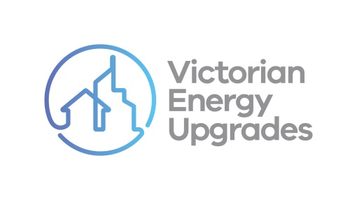

VEU program compliance checklist

Undertaking upgrades

Instructions for use

The compliance checklist on the following page is part of a series for accredited persons and scheme participants to use as they engage in a variety of common activities under the Victorian [Energy Upgrades (VEU) program. It outlines some of the main obligations created by the VEU code of conduct (‘the code’).](https://www.legislation.vic.gov.au/as-made/statutory-rules/victorian-energy-efficiency-target-amendment-code-conduct-regulations-2022)

It has been supplied as a template to assist businesses undertaking upgrades as part of the VEU program. It can be used to help them identify some necessary steps and behaviours they must or must not do. It can also be used as one form of documentary evidence about different business’ compliance with the code. The content of this document is intended to be included in other branded products. It is not designed to inform consumers about the VEU program.

If being used in other branded products, users:

|  |  |  |
| --- | --- | --- |
| Can… | Can’t… | |
| * Change the font, structure and format of the document | ✗ | Include the commission’s branding or the Essential Services Commission logo |
| * Include their own brand colours, logos and styles | ✗ | Change any of the content of the document |
| * Add relevant obligations under the code of conduct to your checklist | ✗ | Present only some of the content (i.e. it must be made available in full) |
| * Add evidence the consumer agrees activities have taken place (e.g. their signature) | | |

*It is the responsibility of accredited persons and scheme participants to comply with the Code of Conduct at Schedule 6 to the Victorian Energy Efficiency Target Regulations 2018. This checklist is a template prepared by the Essential Services Commission for general guidance only, it does not constitute legal or other professional advice and should not be relied on as a statement of the law.*

|  |  |  |
| --- | --- | --- |
| **Victorian Energy Upgrades program Compliance checklist UNDERTAKING UPGRADES** | *<insert company logo>* |  |
| *As part of the upgrade(s) I was involved in delivering to a consumer under the VEU program on , I…*  *(date)* | | |
| gave notice to residents that their essential service(s) or access to their premises may be impacted  *This notice included all pieces of information I am required to give to residents under the VEU code of conduct.* | | Y / N / NA |
| took all reasonable steps to make sure the upgrade was undertaken on the agreed date(s) and time(s)  *This includes advising the consumer as soon as practicable if the upgrade was not going to happen at those times.* | | Y / N |
| undertook the upgrade in accordance with the VEU program rules  *This includes the VEET Regulations 2018 and Secretary’s Specifications.* | | Y / N |
| gave the consumer the following information:   * the name, telephone number and email address of the accredited person I am working with * the name, telephone number and email address of any other people working with me * the dispute resolution information related to the upgrade * a copy of any instructions and warranties for any products or services supplied or installed as part of the upgrade | | Y / N / NA Y / N  Y / N  Y / N / NA |
| left immediately when I established that no one 18 years of age or over was present | | Y / N / NA |
| Name:  ..….…………………………………………  Address:  ………………………………………………  *(consumer)* | Name:  .……………………………………………  Signed:  ……………………………………………  *(lead generator/marketer)* | |
| VEU Activity:  ………………………….…….……………. | Name of accredited person:  ……………………………………………  *(AP who will create VEECs* for the activity) | |