Price Submission
price review
2023-28

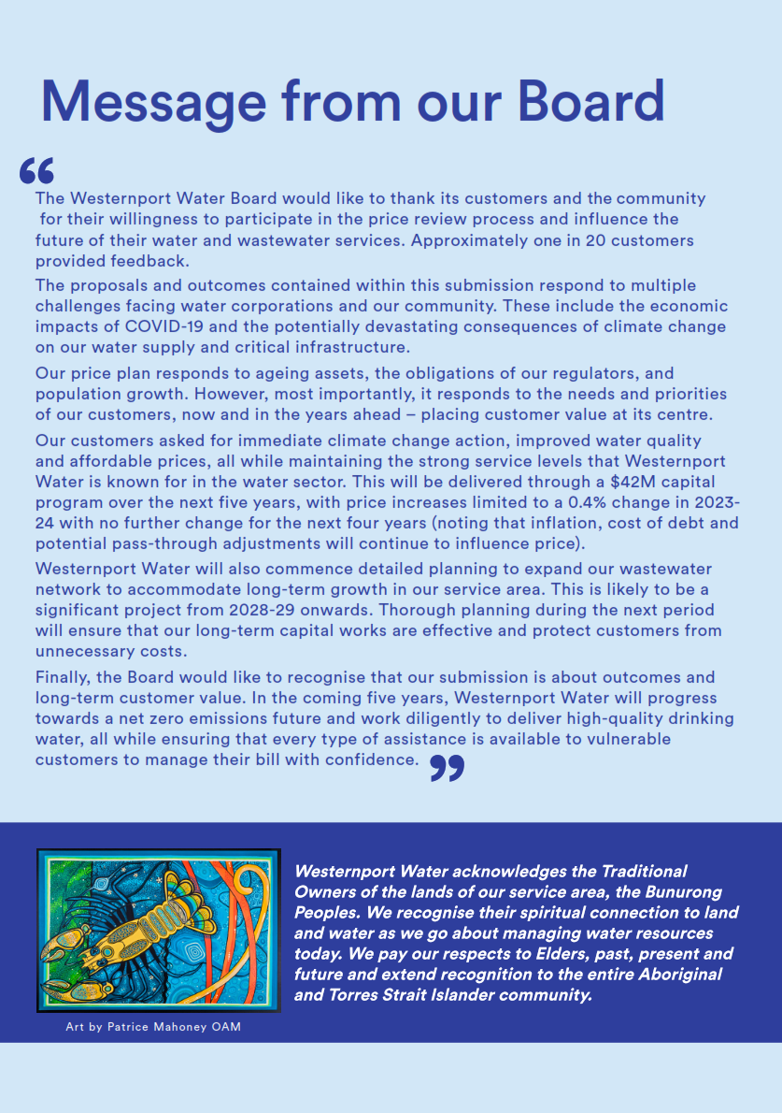
Table of contents

1 Board Attestation 6
2 Quality Assurance 7
3 About Us 8
4 Performance (2018-23) 12
5 Customer Engagement 25
6 Outcomes Framework 36
7 Capital Expenditure 51
8 Operational Expenditure 74
9 Demand 88
10 New Customer Contributions 99
11 Revenue Requirement 106
12 Managing Risk 114
13 Price Control 122
14 Prices and Customer Impacts 123
15 PREMO Self-Assessment 131

Customer Engagement Findings Appendix One
Deliberative Forums Pre-Reading Materials Appendix Two
Annual Watermark Brochures 2018-22 Appendix Three
Customer Fact Sheets Appendix Four
Deliberative Forum Summary Report Appendix Five
Independent Quality Assurance Approach (URA) Appendix Six

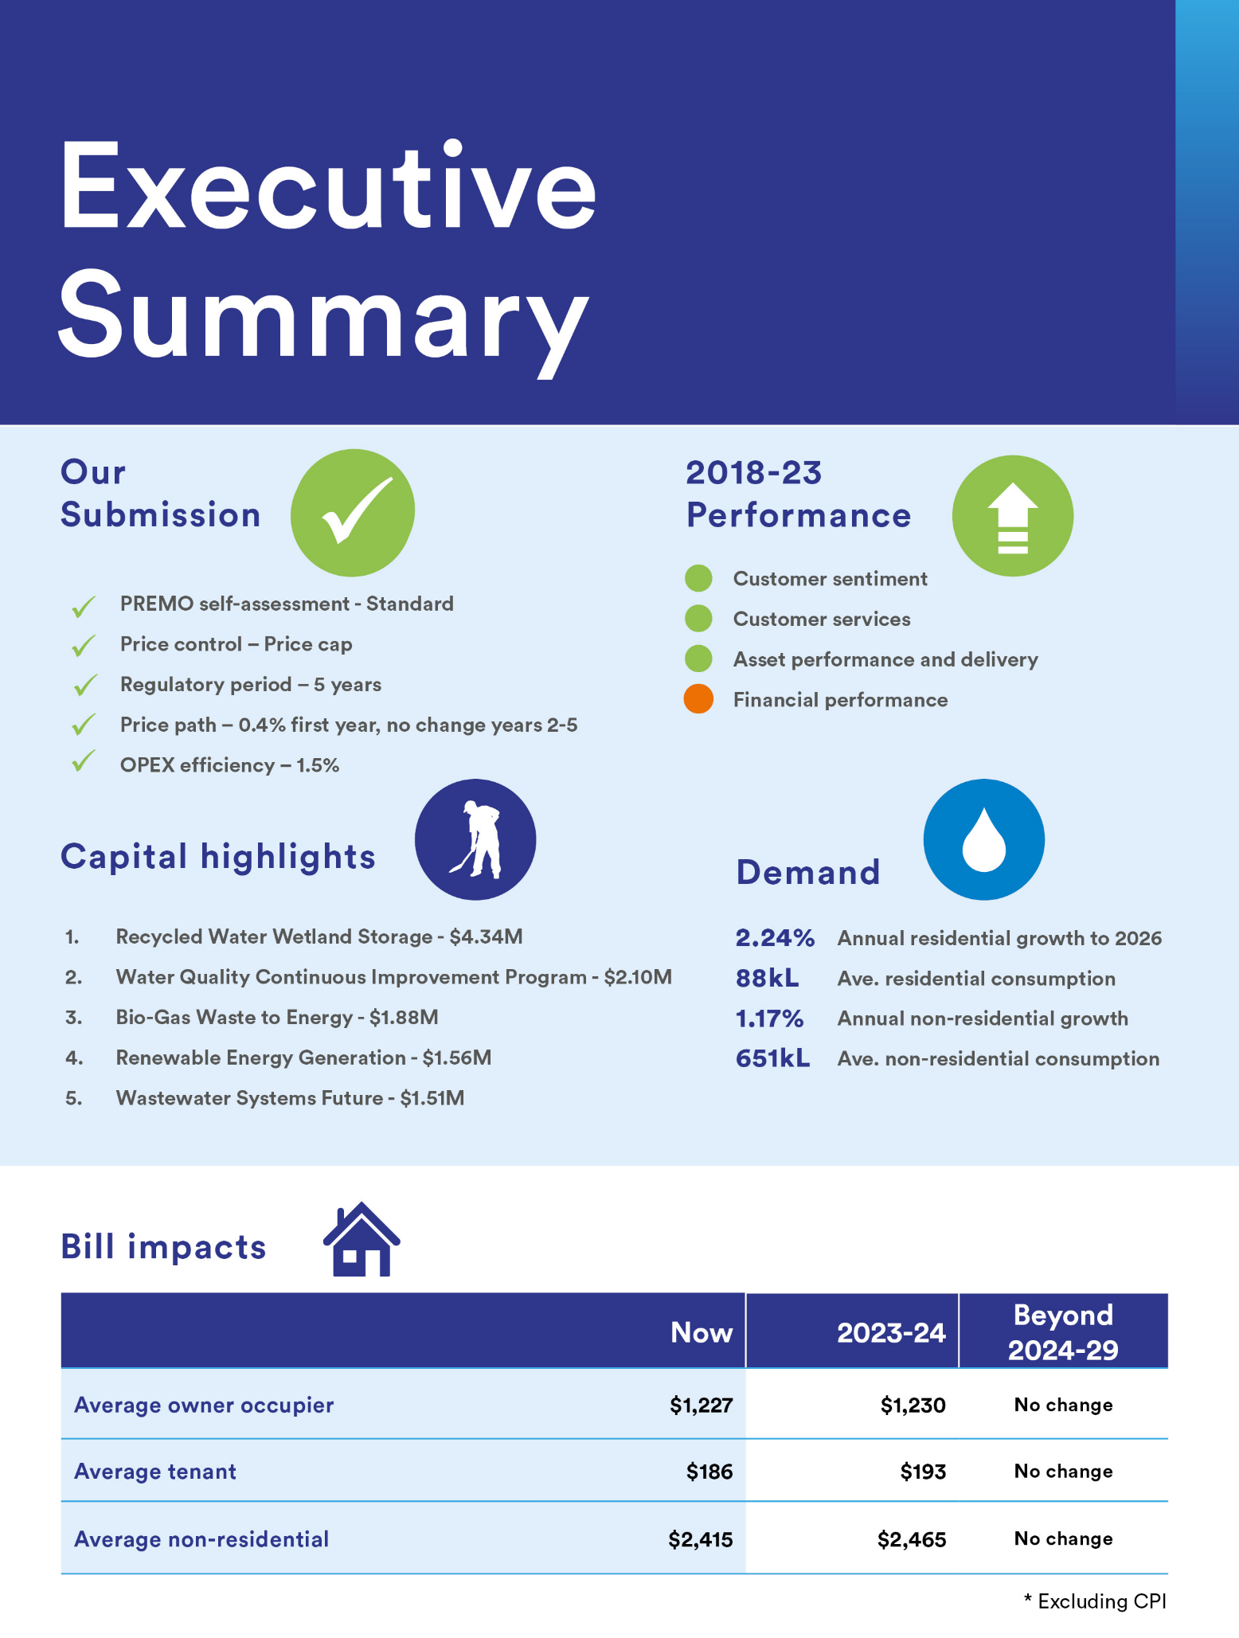
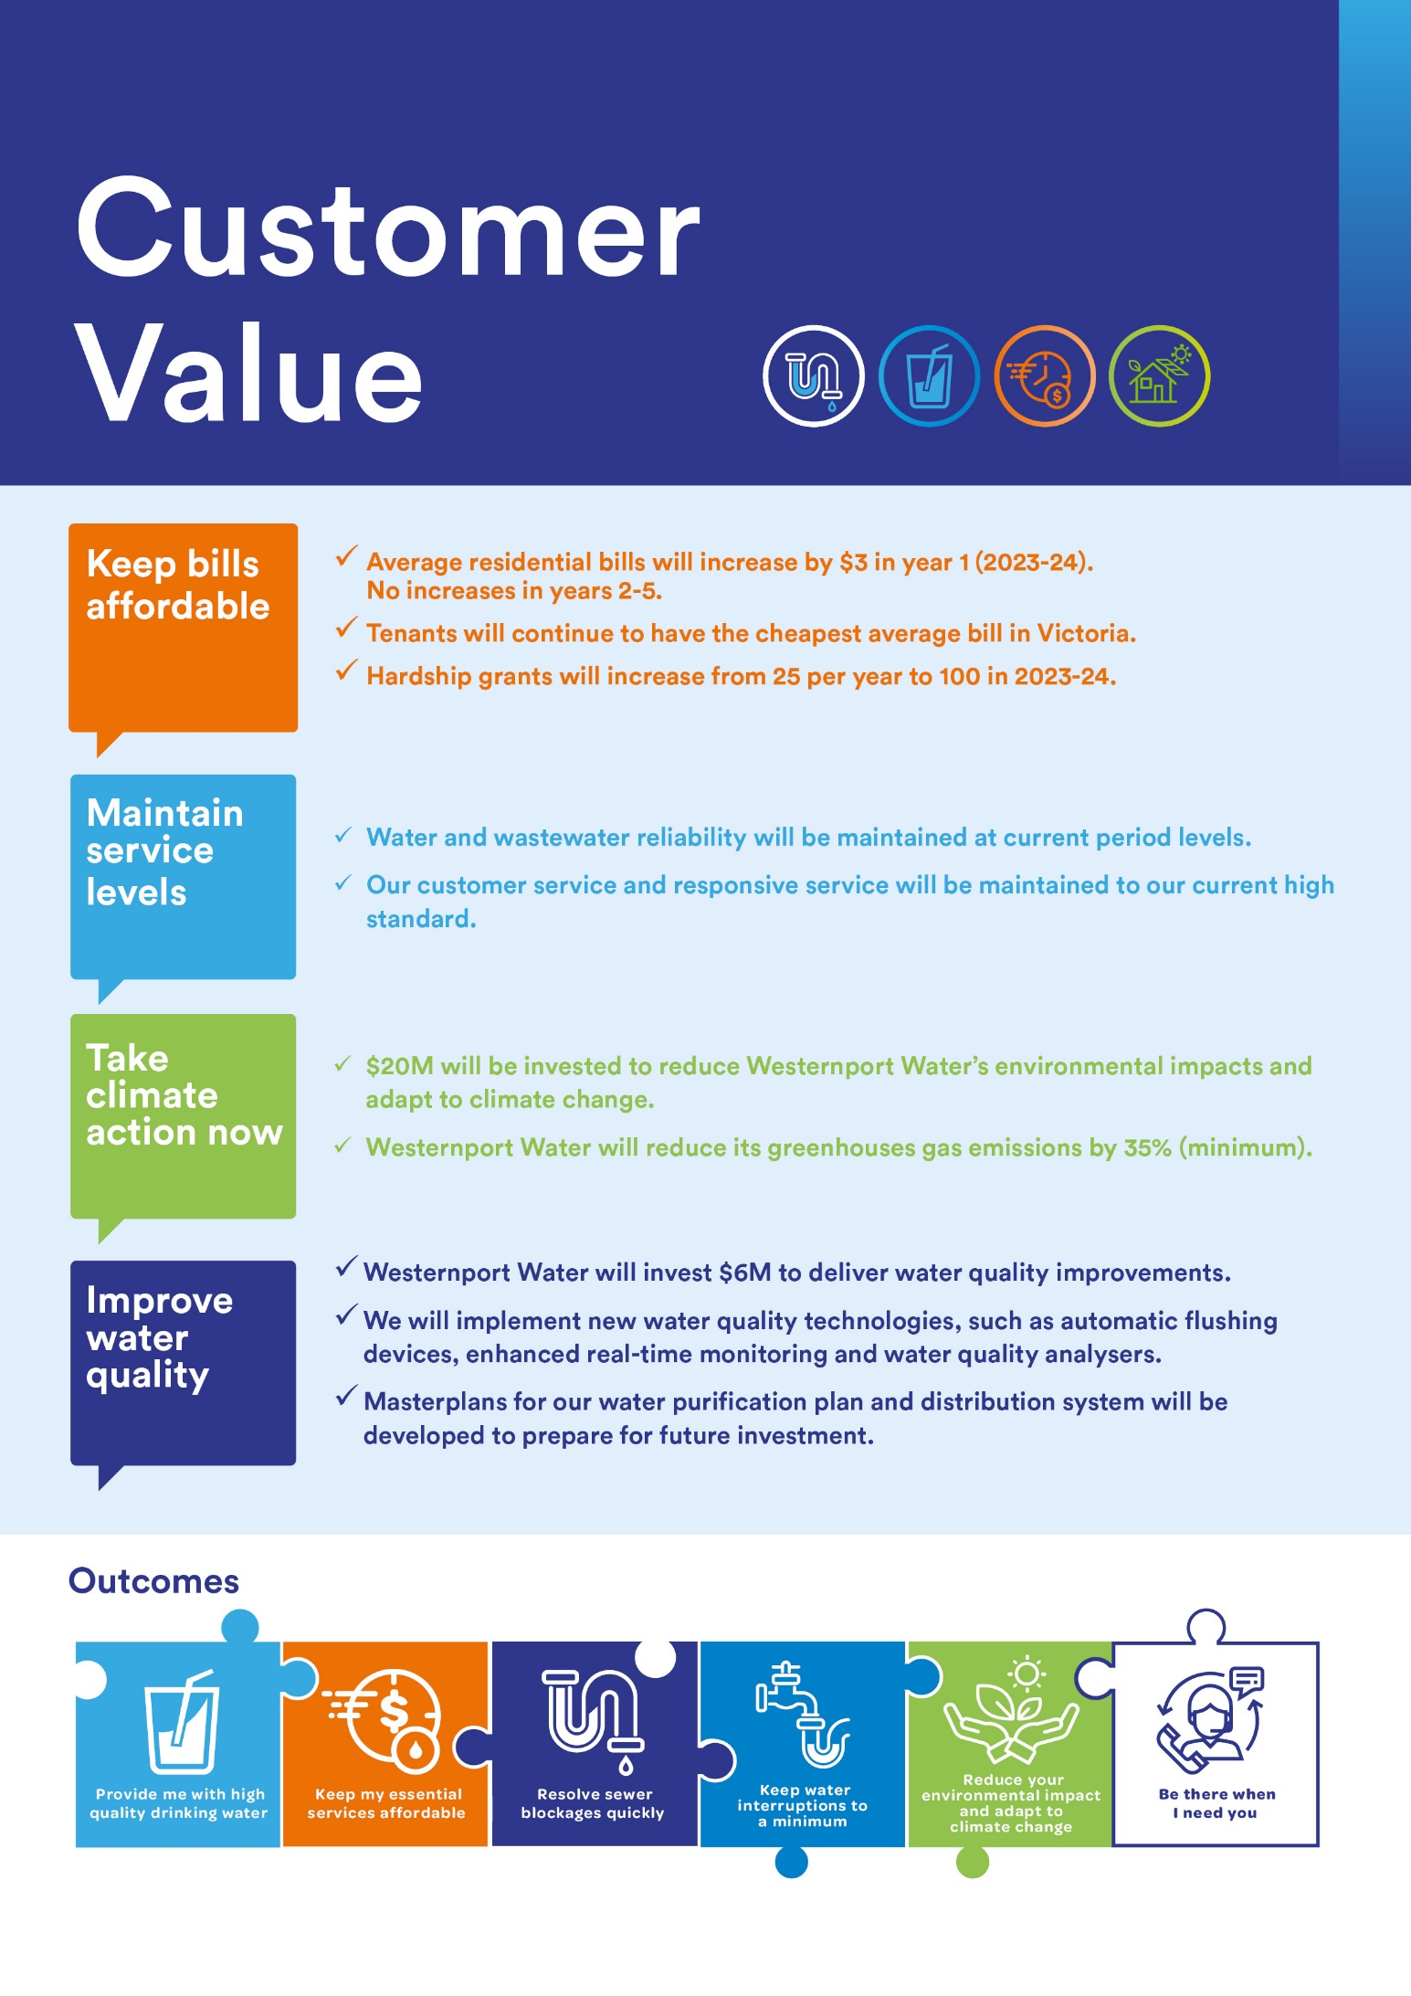

1 Board Attestation

The Directors of Westernport Water having made such reasonable inquiries of management as we considered necessary (or having satisfied ourselves that we have no query), attest that, to the best of our knowledge, for the purpose of proposing prices for the Essential Services Commission’s 2023 water price review:

- information and documentation provided in the price submission and relied upon to support Westernport Water’s price submission is reasonably based, complete and accurate in all material respects

- financial and demand forecasts are the business’s best estimates, and supporting information is available to justify the assumptions and methodologies used; and

- the price submission satisfies the requirements of the 2023 water price review guidance paper issued by the Essential Services Commission in all material respects.

(Signed)

Rueben Berg
Chair
30 September 2022

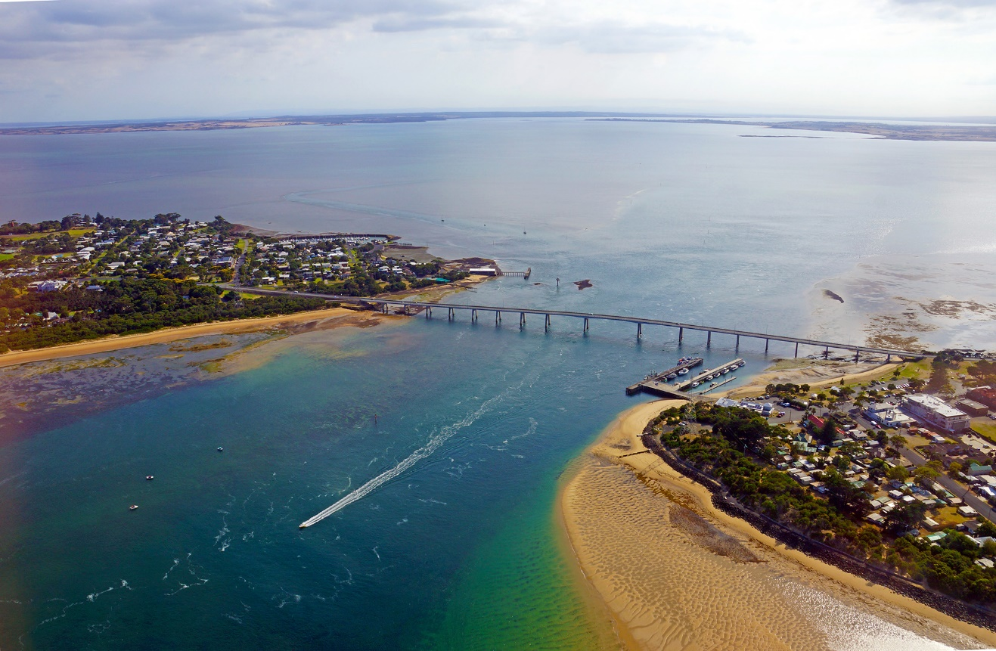

2 Quality Assurance

Westernport Water has relied on independently audited data, engaged appropriately skilled and independent experts to provide inputs to the submission, and undertaken multiple third-party quality and assurance checks of the final submission and associated model, including:

Conversation Co.
Co-Designed and facilitated Westernport Water’s first series of online deliberative engagement forums.

GHD Advisory
Developed quality demand forecasts for the Urban Water Strategy 2022.

Insync
Delivered Westernport Water’s annual customer satisfaction surveys throughout the current regulatory period.

Landells Consulting
Developed ICT-related business cases to support the 2023 Price Submission.

Mott MacDonald
Reviewed Westernport Water’s top ten business cases against the Essential Services Commission’s guidance criteria.

Ranbury Management Group
Developed risk-based cost estimates for top ten projects in partnership with project specialists.

Utilities Regulation Advisory
Developed revised New Customer Contributions model and delivered three compliance and two information-based reviews (refer Appendix 6) of the submission and associated price model.

3 About Us

Westernport Water provides water, wastewater and recycled water services to approximately 21,000 customers across an area covering 300 square kilometres encompassing Phillip Island and townships from The Gurdies to Archies Creek.

Water is accessed from a number of different sources. The primary water supply is from the Tennent Creek catchment via the Candowie Reservoir, with additional entitlements from the Bass River, Corinella Aquifer and a connection to the Melbourne Water Supply System.

Drinking water is produced at Ian Bartlett Water Purification Plant at Candowie Reservoir and then pumped to waterline communities and the San Remo Basin for distribution to customers within Westernport Water’s service area.

Westernport Water operates two wastewater treatment plants and supplies wastewater services to 90 per cent of properties that receive drinking water. Effluent collected from the townships of Kilcunda and Dalyston is treated under an agreement with South Gippsland Water at its Wonthaggi Treatment Plant.

Westernport Water also produces Class-A recycled water for residential, recreational, agricultural and commercial purposes in specific areas of Phillip Island. We also provide commercial trade waste services, operate a liquid waste disposal facility, undertake catchment programs to improve raw water quality and deliver water efficiency education programs and initiatives.

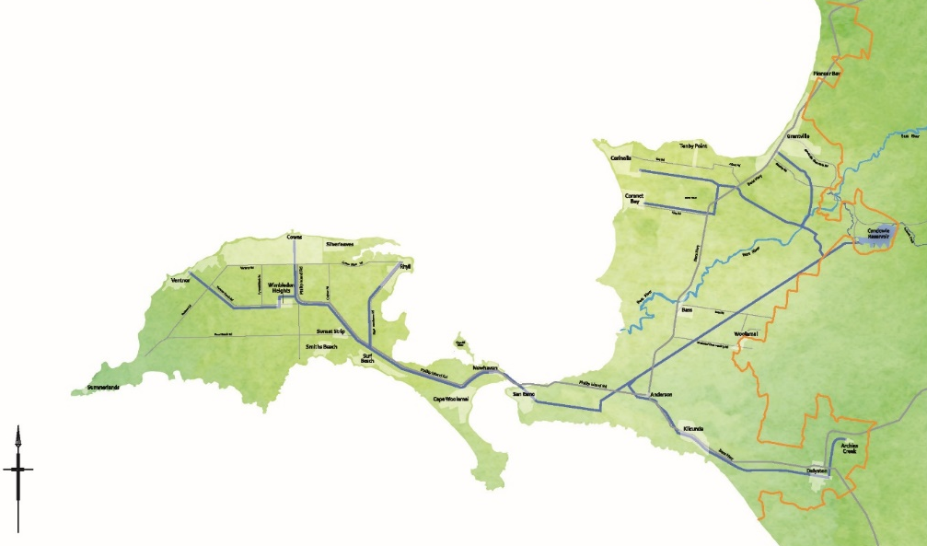
Figure 1: Westernport Water’s Service Area

Strategic Focus Areas
Westernport Water's strategic context is set by an independent Board and informed by the Victorian Government's key policy document for our sector, Water for Victoria, and the Minister for Water's Letter of Expectations. We are a state-owned company, a community-based organisation and an essential service provider working within a highly regulated industry, overseen by a range of regulators including the Essential Services Commission, the Department of Health and the Environment Protection Authority.

Westernport Water’s strategic focus areas bring together the interests of government, regulators, stakeholders and customers to provide direction to our people:

We meet the expectations of our customers
- Provide reliable services that meet our customers’ needs
- Empower customers with accessible services and information to manage their water use
- Provide and promote flexible payment options for customers experiencing hardship
- Continually seek opportunities to deliver increased value for our customers.

Our people are safe and well, every day
- Provide a safe and healthy work environment
- Empower each other to respond to future challenges.

We are a great place to work
- Be an employer of choice
- Reflect the diverse community we serve through inclusion, participation and engagement
- Provide an environment where our people are able to thrive.

Our assets enable the sustainable delivery of products and services
- Foster an engaged culture of asset management
- Enable reliable service delivery in an increasingly variable climate
- Provide safe, sustainable and reliable water and wastewater services.

We are a valued member of the community we serve
- Support a more liveable and resilient community through affordable and efficient services
- Communicate and engage effectively and openly with all areas of our community
- Build strong community partnerships focused on shared liveability benefits
- Contribute to community wellbeing through opportunities that support social and recreational benefits.

We value and protect our natural environment
- Minimise environmental impacts
- Mitigate and adapt to climate change
- Protect and enhance our environment
- Empower the community to use water in a sustainable manner.

Our business is financially sustainable through sound governance and prudent investment
- Plan for our future through strategic business planning
- Be financially sustainable
- Regularly find ways to reduce costs and become more efficient
- Recognise and manage risk, while meeting our regulatory requirements.

What Makes Us Different
Westernport Water is different to other Victorian water corporations in several ways. While our customer-base is the smallest in the sector, our network is sized to accommodate the peak holiday season, contributing to higher maintenance and renewal costs than similar-sized regional service areas.

The Phillip Island / San Remo area has one of the highest ratios of visitors to residents of any destination in Australia. At peak times during December and January, there are 120 visitors to every resident (Bass Coast Shire Council, Visitor Economy Strategy 2035).

The Bass Coast area is also the most popular ‘weekender’ destination in Victoria with approximately 37.5% of residential households unoccupied compared to the Victorian average of 11.2% (2021 Census Data, Australian Bureau of Statistics). Furthermore, households are more likely to be single person households (or couple families without children). The average household size is 2.19 compared to the Victorian average of 2.52. People aged over 60 make up 22.4% of the population compared to the Victorian average of 20%.
As a result of the above, households in our service area use the least amount of water in Victoria – approximately half of the state-wide average (92 kilolitres in 2020-21, compared to 182 kilolitres). As a consequence, Westernport Water is more reliant on fixed water and wastewater access charges to meet its revenue requirement than other water corporations.
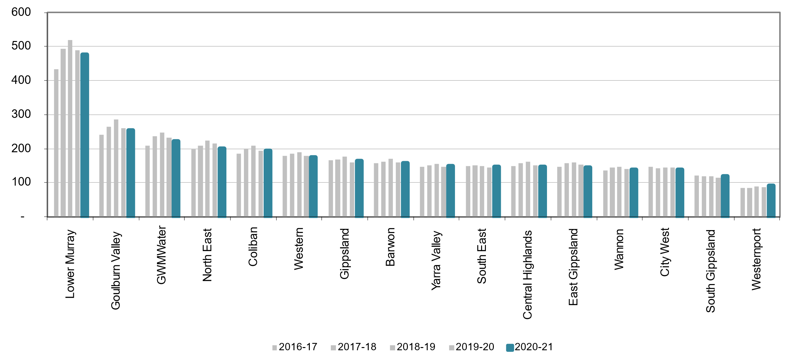
Graph 1: Average water consumption per household (ESC, Water Performance Report 2020-21)

Our Network
Table 1: Network characteristics for Westernport Water as at 30 June 2022
 | Sewer | Water | Recycled Water
Mains (km) | 393 | 445 | 45
Number of connections | 16,060  (Residential) | 17,033  (Residential) | 996  (Residential)
 | 654  (Non-Residential) | 1,116  (Non-Residential) | 11  (Non-Residential)

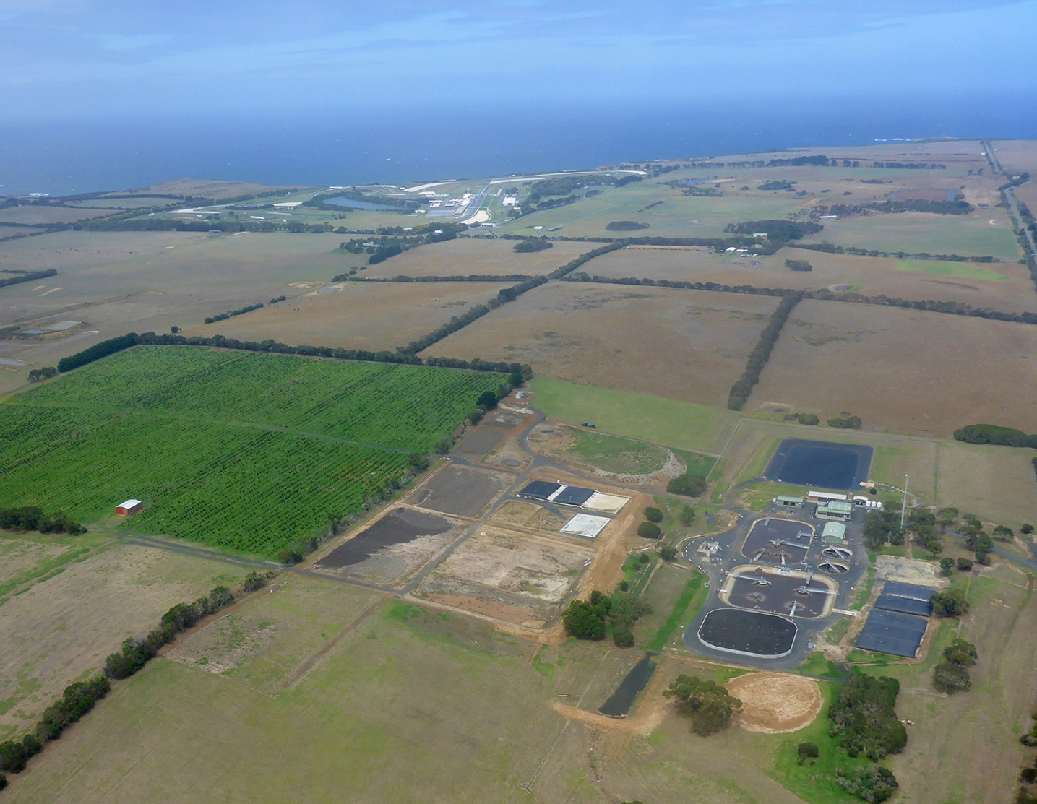
Photo 1: Aerial photograph of the Cowes Wastewater Treatment Plant

4 Performance (2018-23)
Key Points
- Westernport Water consistently rated in the top third of the sector for each of the Essential Services Commission’s customer satisfaction metrics.
- Performance has exceeded many operational service standards, meaning customers have received greater value for the prices paid.
- Westernport Water met or exceeded 18 of its 21 performance standards. Customers will be compensated for any missed commitments under a performance-based rebate scheme for failed targets.
- Customers have been kept informed of our performance every year through the Annual Watermark.
- Eight years of customer insights and benchmarking data has driven improved performance and informed strategic plans.

Background
Westernport Water committed to delivering enhanced customer value in the current regulatory period. This was supported by increased service levels, new infrastructure to enhance water security and accommodate growth, and flat prices (2.1% increase in the first year, excluding inflation and incorporating the end of a four-year government rebate program). The price submission was self-assessed by Westernport Water as ‘Standard’ under the PREMO framework and this was accepted by the Essential Services Commission (the Commission). Westernport Water was also one of four water corporations to receive an early decision from the Commission due to the accuracy, quality, and completeness of its submission.

Customer Value
Our customers expect that water and wastewater services are delivered in an accessible, reliable, efficient, and safe manner. However, they also desire strong performance in the areas that matter at an affordable price. This is not unique to Westernport Water. In considering our performance we must ask ourselves: did our customers get what they paid for? Did we depart from our plans and was it in the best interests of our customers? And ultimately, are our customers satisfied with our performance against the original offer? We will explore these questions through the lenses of customer satisfaction, customer commitments, operational service standards, capital program outcomes and financial performance.
Customer Satisfaction
The Commission surveys approximately 6,000 customers every 12 months across the 16 urban regional water corporations on four key areas: value for money, reputation in the community, level of trust and overall satisfaction. The quarterly survey results provide a customer sentiment comparison between water corporations, providing insight into whether customers believe that they are receiving customer value.
Throughout the current regulatory period, Westernport Water has regularly ranked in the top half of the Victorian water sector for customer satisfaction. On average, Westernport Water has been ranked 6th for value for money (as high as 2nd in 2019), reputation in the community (as high as 2nd in 2019), level of trust (as high as 1st in 2020) and overall satisfaction (as high as 3rd in 2019).
The Commission’s results reported a decline in customer sentiment in 2021. This was likely influenced by a water quality event during December 2020. Challenges to water quality are generally related to naturally occurring algal blooms, mainly blue-green algae that can lead to distinctive taste and odour issues. Algal blooms are an ever-present risk and remain a constant challenge because of the shallow nature of Westernport Water’s reservoir. During December 2020, a bloom occurred earlier than is traditionally seen. This resulted in taste and odour impacts to our waterline communities. Following an independent review, Westernport Water has implemented procedural changes to the treatment process. The review has also informed our Water Quality Continuous Improvement Program in the next price period.

Graph 2: Westernport Water Ranking for ‘How customers rate their water business’ (www.esc.gov.au)
Since 2014, Westernport Water and six other Victorian water corporations have come together to survey 2400 customers annually, gaining insight into the customer experience to identify whether we are meeting customer expectations for water and sewerage services.
This annual survey provides a rich source of trend information to benchmark against other water corporations and compare with the Commission’s methodology. Westernport Water interviews 400 customers by phone for approximately 10 minutes each. Results for comparable questions – overall customer satisfaction and value for money – support the strong performance results (pictured above) and are used to help shape our plans and outcomes.
Graphs 3&4: Westernport Water annual customer satisfaction results (2014-2021)
Customer Commitments
Westernport Water developed a unique set of 14 customer commitments with its customers for the current regulatory period. Progress against these customer commitments is reported to customers via the Annual Watermark, which is published online and distributed to every customer as a bill insert. The customer commitments are also supported by a performance-based rebate scheme (payable in 2023-24) to ensure that customers are compensated if they do not receive the levels of performance that they pay for.
Table 2: Performance against Outcome 1: Reliable Water and Wastewater Services
Outcome 1:  Reliable Water and Wastewater Services | PS18 Target  (Annual Average) | PS18 Actual  (4 Year Annual Average)
Number of water supply interruptions  – unplanned and planned (per 100km) | 46.0 | 22.7
Average total customer minutes off water supply – unplanned and planned | 103.0 | 115.9
Number of sewer main blockages  (per 100km) | 4.1 | 5.8

Westernport Water improved the reliability of water services during this price period. Water supply interruptions stood at 40.1 per 100km of water main in 2017-18. Each year since, there have been fewer water interruptions for customers. In 2019-20, water supply interruptions reached a low of 16.4 (59% fewer interruptions within two years) and averaged 22.7 over four years (43% fewer over four years).
Furthermore, although the target was not met, Westernport Water significantly reduced the average total customer minutes off water supply. In 2017-18, average customer minutes off supply was 126.5. In 2019-20, it reached a low of 83.9 (37% fewer minutes) and an average of 115.9 over four years (8% fewer minutes)
Westernport Water improved the reliability of wastewater services during this price period. Sewer main blockages per 100km stood at 6.0 in 2017-18 and have improved since, reaching a low of 3.6 in 2019-20 (40% fewer within two years) and averaging 5.8 for the four-year annual average (3% fewer over four years).
Overall improvements to water reliability have been achieved by providing a temporary supply through COVID-19 years to minimise disruption and the delivery of the $2.42M Phillip Island Water Supply Security Project, which provides back-up during interruptions between the San Remo Basin and Cowes. Wastewater reliability has improved following the Sewer Junction Rebuild Program and targeted CCTV inspections. Despite improvements, performance targets for sewer main blockages and average total customer minutes off water supply were missed. The former was due to seasonal conditions from the La Nina weather pattern, which contributed to more severe storm and flood events. The latter resulted from increased air scouring in response to water quality complaints in late December 2020. As per our customer charter, Westernport Water informs customers of all planned works, including approximate time and duration, at least two business days in advance.
Water and Wastewater Reliability Performance
Graphs 5&6: Westernport Water performance as per ESC Water Performance Report Data Summary 2020-21
Table 3: Performance against Outcome 2: Better Tasting Water
Outcome 2:  Better Tasting Water | PS18 Target  (Annual Average) | PS18 Actual  (4 Year Annual Average)
Customers satisfied with drinking water  (% of annual survey respondents that are satisfied) | 70% | 68%
Number of Safe Drinking Water Act non-compliances (water sampling and audit) | 0 | 0
Number of water quality complaints  (Number per 100 customers) | 0.22 | 0.37

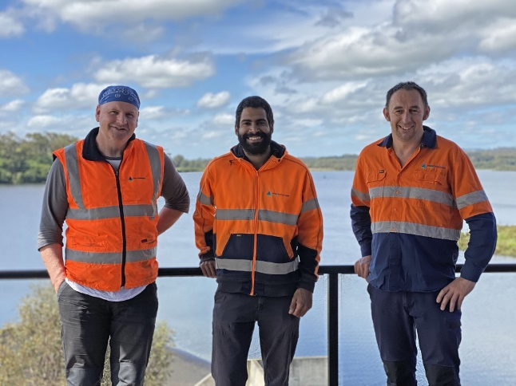
Westernport Water delivered the Water Quality Improvement Program during the price period that built upon prior improvements to our water treatment assets, including the installation of UV disinfection, implementation of a continuous vertical raw water profiler, filter to waste and upgrade of the carbon dosing facility.
This period’s program included a focus on improving the water network with the construction of a backup treated drinking water storage at Wimbledon Heights, renewal of large sections of water mains, and maintaining the network with annual cleaning programs. These investments led to improvements that were recognised when the Water Industry Operators Association of Australia awarded Westernport Water as having the best tasting tap water in Victoria in 2021.
Unfortunately, Westernport Water was unable to meet the targets that were set for drinking water satisfaction and water quality complaints. For both measures, Westernport Water was able to meet the annual targets on occasion but has not been able to achieve consistent results. Both measures are thought to have been influenced in-part by COVID-19 restrictions with a changing customer demographic and an unanticipated spike in demand when travel restrictions were lifted contributing to water colour complaints. Once again, Westernport Water reported no Safe Drinking Water Act non-compliances during this period.

Graphs 7&8: Westernport Water performance as per annual customer satisfaction survey (left) and ESC Water Performance Report Data Summary 2020-21 (right).
Table 4: Performance against Outcome 3: Affordable and Responsive Services
Outcome 3:  Affordable and Responsive Services | PS18 Target  (Annual Average) | PS18 Actual  (4 Year Annual Average)
Average time to attend water bursts and leaks (Priority One) | 30.0 | 0.8
Average time to attend water bursts and leaks (Priority Two) | 35.0 | 42.5
Average time to attend water bursts and leaks (Priority Three) | 300.0 | 71.9
Telephone calls answered within 30 seconds (%) | 97 | 97
Number of hardship grants approved | 25 | 158.5
Westernport Water has delivered increased customer value around affordable and responsive services. Average turnaround times have remained consistent, reporting low numbers of Priority 1 bursts and leaks and significantly exceeding performance expectations for Priority 3 bursts and leaks. Westernport Water continues to provide accessible call centre operations with 97% of calls answered within 30 seconds. This service was maintained despite the challenge of transitioning all centre operations to a virtual call centre due to COVID-19 restrictions preventing agents from working in the office. Customers have supported the change with increasing ‘ease of effort’ results (refer below).
The economic impacts of COVID-19 placed additional pressures on our customers. Based on results provided by the Essential Services Commission, Westernport Water regularly reported one of the highest rates of customer hardship in the Victoria water sector. Consequently, Westernport Water redirected debt recovery funds to support hardship customers, exceeding the hardship grant target and increasing grants by over 300% from 2017-18 to 2021-22.

Graphs 9&10: Westernport Water performance as per ESC Water Performance Report Data Summary 2020-21 (left) and annual customer satisfaction survey (right).
Table 5: Performance against Outcome 4: A More Sustainable Community
Outcome 4:  A More Sustainable Community | Target  (End-of-Period) | Actual  (2021-22)
Effluent Reuse | 25% | 18%  (On Track)
Net Greenhouse Gas Emissions | 5,974 | 5,973  (Achieved)
 | Target  (Annual Average) | Actual  (4 Year Annual Average)
Number of community education engagements | 22 | 22

Two significant projects (Sustainable Water Reuse & Land Management and Emissions Reduction Pledge Implementation) have been delivered this price period in support of a more sustainable community, and more specifically, increased effluent reuse and reduced net greenhouse gas emissions. Both projects are expected to build capacity, whether through irrigation or renewable energy to meet our end of period targets.
To date, seasonal conditions have proved challenging to make headway against targets. La Nina weather patterns have contributed to localised storm and flooding events that have reduced our window for irrigation and increased inflows into our wastewater treatment plant, which leads to increased pumping/energy demands.
During 2021-22, the Class-A recycled water plant was offline due to the membrane condition, which required replacement. Greenhouse Gas Emissions fell by 731 tonnes CO2-e due to our new 99kW solar array operating to design at Cowes Wastewater Treatment Plant and the voluntary surrender of 211 MWh equal to 211 tonnes CO2-e from the Zero Emissions Water (ZEW) – Power Purchase Agreement.
The number of community education engagements target has also been met, despite COVID-19 restrictions causing cancellations to many planned events over a two-year period. Where possible, these events have been transitioned online – as was witnessed with the sector’s National Water Week Online Learning Festival, which was supported by Westernport Water.

Graph 11: Westernport Water performance as per annual customer satisfaction survey.
Annual Outcomes Report
Westernport Water is committed to delivering the outcomes and performance that customers sought as part of the 2018 Price Review engagement process. As part of this commitment, transparent and accessible progress reporting is in place to ensure that customers can remain confident that their expectations are driving the priorities of our business.
Our Annual Watermark is distributed to every Westernport Water customer each year. It is also published online and is accessible via our website. The report details our performance against each measure, our achievements, our focus areas, and major projects delivered.
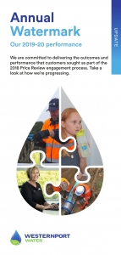 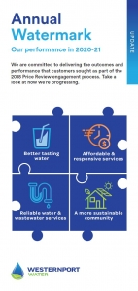 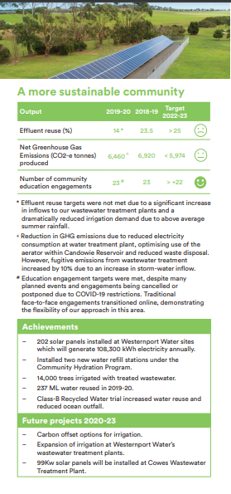 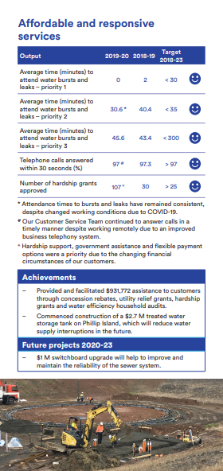
Photos 2: Examples of Westernport Water’s ‘Annual Watermark’ customer brochure.

Performance Rebate Scheme
Westernport Water recognises that any failure to meet our output targets during this regulatory period represents a reduction in the value that customers paid for (acknowledging, that additional value may have been delivered in other areas).
In consultation with our customers during the 2018 Price Review, Westernport Water established its own performance rebate scheme to incentivise performance and recognise the impacts of potential reductions in service on customers. The performance rebate is payable in 2023-24 in the event that one or more of our performance targets are missed. The scaled performance rebate ranges from $5 (one missed target) to $20 (four or more missed targets) for each customer.
As part of the 2023 Price Review, customers have sought a different performance management model (p.33). In recognition of this, Westernport Water will seek an independent party to facilitate a decision with the community in 2023 regarding whether the customer rebate should proceed as currently designed or whether an equivalent amount should be reinvested in a targeted, customer supported proposal to improve performance in the area that did not meet customer expectations. These funds will remain a ‘penalty payment’ and have not been budgeted for.
Operational Performance Standards
Operational service standards provide a comparison across corporations to highlight strong performance. They are also important to compare service levels from one regulatory period to the next to ascertain whether customers are receiving more value for the prices they pay.
Westernport Water’s targets for this regulatory period reflected strong ambition compared to the targets that were set in the last regulatory period (Water Plan 3). On balance, Westernport Water is delivering more customer value than it committed to for the prices that customers are paying.
Table 6: Performance against 2018 Price Submission Performance Standards
Performance Standard - Water | Target | Period-Ave.*
Unplanned water supply interruptions – per 100km | 46 | 17
Average time taken to attend bursts and leaks- P1 – Mins | 30 | 1
Average time taken to attend bursts and leaks- P2 – Mins | 35 | 43
Average time taken to attend bursts and leaks- P3 – Mins | 300 | 72
Unplanned water supply interruptions restored within 5 hours - % | 99 | 99
Planned water supply interruptions restored within 5 hours - % | 99 | 97
Average unplanned customer minutes off water supply | 31 | 10
Average planned customer minutes off water supply | 72 | 27
Average unplanned frequency of water supply interruptions | 0.5 | 0.12
Average planned frequency of water supply interruptions | 0.5 | 0.13
Average duration of unplanned water supply interruptions | 96 | 84
Average duration of planned water supply interruptions | 157 | 145
Number of customers experiencing more than 5 unplanned water supply interruptions in the year | 0 | 0
Unaccounted for water - % | 10 | 6

Performance Standard - Sewerage | Target | Period-Ave.
Sewerage blockages – per 100km | 4.1 | 5.8
Average time to attend sewer spills and blockages | 60 | 26
Average time to rectify a sewer blockage | 200 | 101
Spills contained within 5 hours | 100 | 100
Customers receiving more than 3 blockages in the year | 0 | 0
Performance Standard - Customer | Target | Period-Ave.
Complaints to EWOV – per 1000 customers | 1.1 | 0.8
Telephone calls answered within 30 seconds | 97 | 97
*Does not include 2022-23 performance
Overall performance against service standards has been strong throughout the current period, delivering customers greater value for the prices paid when compared to the targets that Westernport Water committed to.
Pass Through Adjustments
In recognition of the unique economic circumstances that stemmed from the pandemic, Westernport Water chose not to pass through any of the approved price adjustments for changes to the forecast use of the Melbourne Water Supply System. As set out in the 2018 Price Submission, this adjustment sought to share the risk 50-50 with customers. This resulted in increased customer value.

Capital Program Delivery
Top 10 Projects
Westernport Water has largely delivered the major projects and associated benefits that it proposed in its 2018 Price Submission. Each successful project has positioned Westernport Water to deliver the service levels and outcomes that customers desire, whether reduced greenhouse gas emissions and water interruptions, increased capacity to service growth, or increased effluent reuse, while ensuring no step change in prices.
The most challenging of the major projects was the Business Transformation Program, which comprised four parts: transitioning the organisation to a new managed services provider and implementing new payroll, finance and HR information management systems. Three of the four elements were successfully delivered. However, following multiple independent reviews, the decision was made to suspend and subsequently cease the finance system implementation. This decision was made based on whether the replacement system would provide ongoing value to the organisation. Ongoing configuration challenges led to reduced functionality meaning that it was no longer a fit-for-purpose solution for Westernport Water. Reduced functionality meant that the product was no longer able to deliver the benefits and productivity gains to the business that were first anticipated. An independent assessment identified that the investment would no longer deliver a viable return. Ultimately, other available solutions offer better value for Westernport Water. This decision resulted in a one-off accounting adjustment which impacted operational spend in the 2021-22 year and has been removed from the base year adjustment as detailed on page 75-76.

Table 7: PS18 Major Project Performance
Major Projects (as reported 30 Jun 2022)* | Status | On-Time | Benefits  Realised
Business Transformation Project | Completed |  | Delivered in part
Building Asset Management Plan – Stage 3 | Completed
Phillip Island Water Supply Security Project | Completed
Cowes Wastewater Treatment Plant Upgrade – Stage 2 | Completed
Zone Metering and Pressure Management | Completed |  | Pilot completed  (informs PS28)
Emissions Reduction Pledge Implementation | Completed
Sustainable Water Reuse & Land Management | Completed
San Remo Basin Renewal Project | On Schedule
San Remo Basin to Cowes 648 Pipeline Valve Replacement Program | On Schedule
San Remo to Newhaven Bridge Pipeline and Fittings Renewal Project | On Schedule
*Financial performance for major projects is detailed on page 53.
Additional Projects and Benefits
PS50 estimates were used for the PS18 top 10 projects which resulted in very low contingencies for uncertainties. The program delivered efficiencies and reprioritisation within the PS18 program that allowed Westernport Water to deliver the full program without passing additional capital expenses to customers.
Although one land purchase to service future growth was scheduled for the PS18 period and one for the PS23 period, due to the opportunistic timing of the adjoining land being offered for sale and the increase in developer revenue related to above-plan growth, Westernport Water was able to bring forward land purchases under the Sustainable Water Reuse & Land Management Project from the PS23 forecast into PS18. This included the purchase of 32.6 ha of land at Lot 1, Pyramid Rock Road, Cowes which adjoins the southern boundary of the Cowes Wastewater Treatment Plant. As this investment was made pre COVID-19, the value is already estimated to be 50% more than the purchase price. This purchase will allow us to increase irrigation to meet our EPA licence requirements and reuse targets and has already resulted in a positive impact to the balance sheet which will provide ongoing benefits for future customers and pricing.
Power outages can cause serious problems in the wastewater distribution network, resulting in sewer spills and environmental damage. In response, Westernport Water installed permanent generators at three critical locations for the network and upgraded three portable generator units to minimise the potential impacts of power outages to customers and the environment. Permanent generators have been installed at San Remo, Grantville and Newhaven to ensure that critical pump stations continue to transport sewage to our wastewater treatment plants at Coronet Bay and Wimbledon Heights. The generators operate as a safety net for when we have unplanned power outages.
Financial Performance 2018-23
The PS18 capital program for Westernport Water includes 41 projects and programs. Financially, Westernport Water has performed well and is forecast to complete its full program by the end of the period. The decision to not price for uncertainty led to a $2.7M increase in renewal projects primarily related to the additional land purchase and the implementation of the Business Transformation Project, which experienced a change in scope, delivering a new HRIS and Managed Services Payroll System. The revised scope delivered significant operational efficiencies including a reduction in FTE in the payroll department during year three of the current regulatory period. A further FTE reduction in the People, Culture and Safety Team is planned for FY2026 due the ongoing efficiencies that this project will continue to provide.

Operational Expenditure 2018-23
Initiatives were investigated and continuously implemented throughout the current regulatory period to reduce operational expenditure which exceeded plan largely attributed to above planned growth. This overspend was also due to Westernport Water’s approach to accept more risk and to avoid passing on the cost of uncertainty to customers. A review of the impacts to the operational base year and forecast expenditure is detailed in Section 8 – Operational Expenditure on page 74.
Initiatives included the use of internal labour and increase FTE to address growth and unforeseen compliance and regulatory obligations rather than rely on outsourcing additional contractors and specialised consultants. Where possible, all contracts were purchased through the Victorian Government Purchasing Board framework and State Procurement offerings. This included electricity which was also cost contained through the introduction of solar projects and through the voluntary investment in the industry led Zero Emissions Water initiatives. Investments in new information technology systems through the Business Transformation Project resulted in a reduction in FTE. Westernport Water continues to seek opportunities to partner on initiatives with VicWater and our Gippsland Regional Water Alliance Partners to seek better procurement offerings.
Graph 12: Westernport Water’s actual/forecast operating expenditure ($real2023). Expenditure in 2021-22 includes $2.1M of expenditure related to the Business Transformation Project was has been removed from the base year.
Westernport Water’s operational expenditure is above forecast due to the nature of growth, demand, increased compliance expectations, staffing costs, contractors, information technology and COVID-19 safety requirements. An increase in operational spend of $2.1M in 2020-21 relates to a one off accounting adjustment related to the Business Transformation Project which is detailed in adjustments to base year operational expenditure on page 75-76. Further detail on current operational expenditure is provided below:
Growth. Residential connections as at 30 June 2022 is 2.5% above PS18 forecast connections (16,614 forecast, compared to 17,033 actual). However, non-residential connections are 7% below PS18 forecast connections (1,202 forecast, 1,116 actual). This is likely a result of COVID-19 travel restrictions, which led to Melburnians moving into regional areas, while demand for tourism and hospitality slowed. Increased property activity contributed to a higher volume of customer transactions, that required the engagement of fixed term staff to customer service. Increased residential connections also required the need for an additional full-time meter reader.
Demand. Average residential consumption for 2021-22 was 89kL, which was 10% greater than the PS18 forecast consumption of 80kL. This was driven by non-permanent residents transitioning to permanent residents resulting in increased occupancy rates and consumption. Westernport Water relies on high fixed rates and low variable water rates, so when a material shift in consumption occurs without growth there is not a significant change in revenue. However, treatment and chemical costs rise because of increased water production.
Compliance. The expectations of regulators and government continue to grow. VicWater engaged Inxure Strategy Group to assess compliance obligations on Victorian water corporations over the last five years, including the costs. The investigation found that compliance costs for the 11 participating water corporations (including Westernport Water) almost doubled over that last 5 years. This resulted from approximately 30 new or amended obligations that had been introduced. As the smallest water corporation in Victoria, increased compliance often leads to increased contractor and consultancy costs to reform existing practices. Furthermore, the importance of cybersecurity in the utility sector has also contributed to increased information technology related operational costs to ensure that controls and mitigations are tested and effective and up to date.
Staffing costs. When the last price submission was developed, Westernport Water was undergoing an organisational realignment leading to changes in roles and increased recruitment activity. As a result, there was a degree of uncertainty regarding salaries and it was assumed that new employees would enter at the midpoint of the salary band. Due to the increase in skills required, primarily resulting from unplanned compliance obligations introduced throughout the regulatory period, Westernport Water was successful in recruiting highly capable and experienced staff leading to negotiated salaries at the higher end of the salary band. Total staff numbers have increased by 2.4 from PS1 due to an increase in staffing demands relating to growth and compliance activities. In addition, a lower than planned vacancy rate was experienced throughout the regulatory period which also contributed to above budget employee costs.
COVID-19. The need for Westernport Water to consistently adapt to the dynamic nature of COVID-19 to ensure the safety of staff and the maintenance of customer service levels has been an ongoing challenge throughout the current regulatory period. This has placed additional pressure on operational expenditure. There are many examples of changes to work practices that have increased costs:
- Westernport Water has had to maintain a virtual call centre to service customer phone calls while agents continue to work from home.
- Cleaning regimes for all Westernport Water worksites increased to ensure that hygienic environments were maintained, including management of personal protective equipment such as masks and hand sanitiser.
- An increased fleet of vehicles was temporarily maintained to allow staff to limit time with others within confined spaces.
- Staff were financially supported to establish an ergonomic work from home office that met workplace, health and safety requirements.
- Additional workforce management measures and COVID-19 absences reduced capacity, leading to a number of fixed-term engagements.
- Video conferencing facilities were optimised to support hybrid work arrangement while density limits were maintained at worksites.
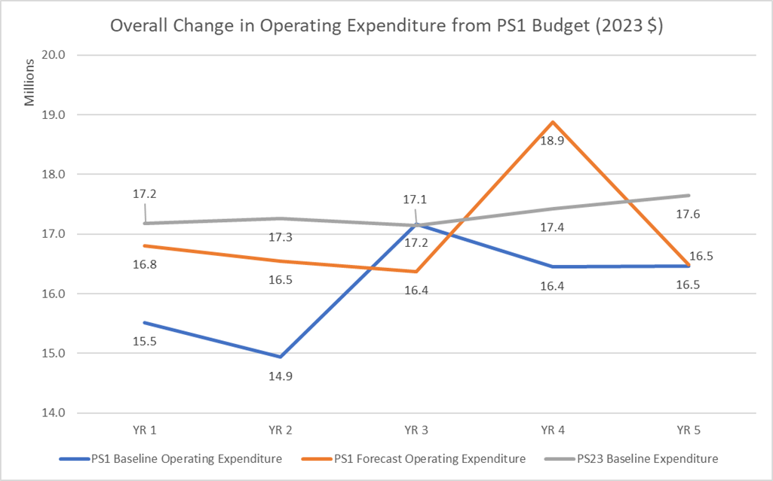Graph 13: Westernport Water’s actual/forecast operating expenditure versus 2018-23 baselines. Expenditure in 2021-22 includes $2.1M of expenditure related to the Business Transformation Project, which has been removed from the base year.

5 Customer Engagement
Key Points
- More than 1 in 20 customers participated in the customer engagement process for the 2023 Price Review.
- ‘Getting to Fair’ interviews focused on vulnerable customers and online deliberative forums that refined customer-led options were just two examples of new customer engagement approaches for this price review process.
- The focus of deliberative forums was tailored to respond to the priority areas that emerged from customer engagement. Feedback from the events demonstrated that customers appreciated the depth of discussion.
- Over 2,000 customers have been surveyed over the current pricing period to measure and track our performance and levels of customer satisfaction.
- Customer engagement directly informed the development of a new set of customer outcomes, shaped the prioritisation of capital projects and informed our proposed new pricing structure.

Introduction
Westernport Water is the smallest water corporation in Victoria with a customer-base of approximately 22,000 customers. We are passionate about ensuring that our priorities and performance reflect the needs and expectations of our community. We are fortunate to have been undertaking annual customer satisfaction surveys for over 18 years and continue to refine our engagement approach to ensure that it is appropriate for the challenges facing our business and our community.
In comparison to the 2018 Price Review engagement process, Westernport Water introduced a series of new innovations, in part addressing the challenges of COVID-19 restrictions and its implications for face-to-face engagement. These changes included:
- a series of ‘Getting to Fair’ interviews to understand the needs of customers experiencing vulnerability
- engagement with the Bunurong Land Council Aboriginal Corporation and our Reconciliation Action Plan Working Group
- community support donations to incentivise customer participation in online surveys
- externally facilitated online focus groups and deliberative forums to explore complex priority areas identified in the early stages of customer consultation.
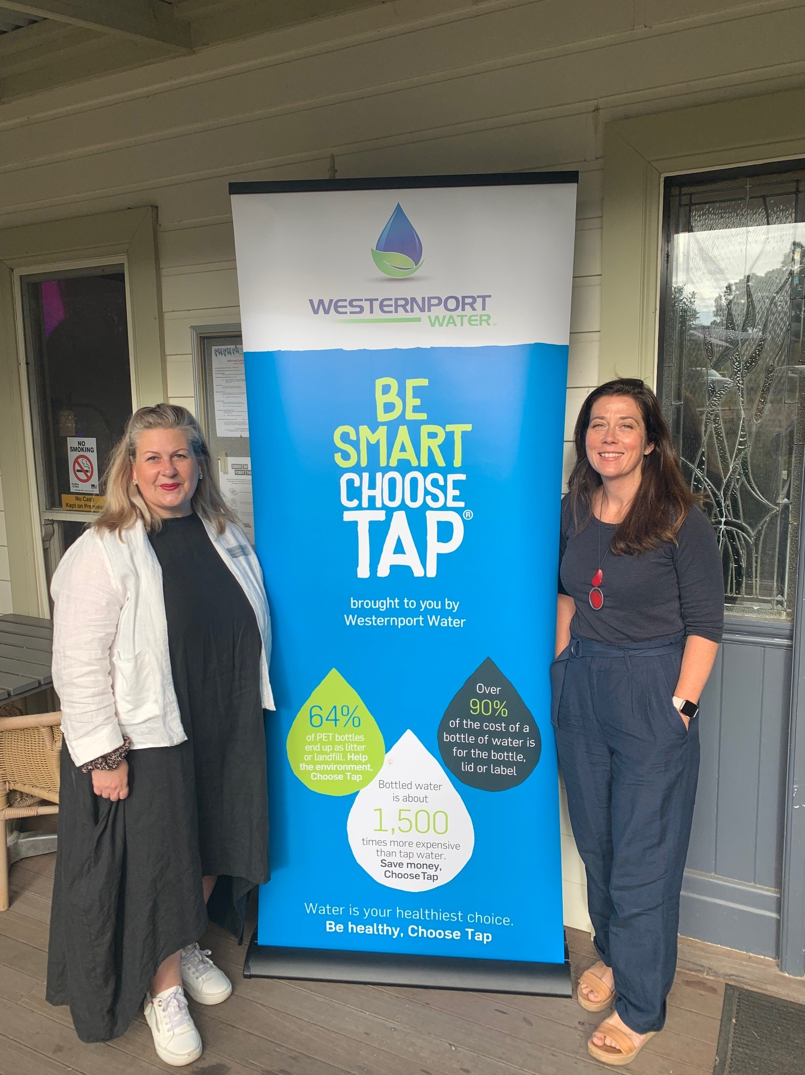 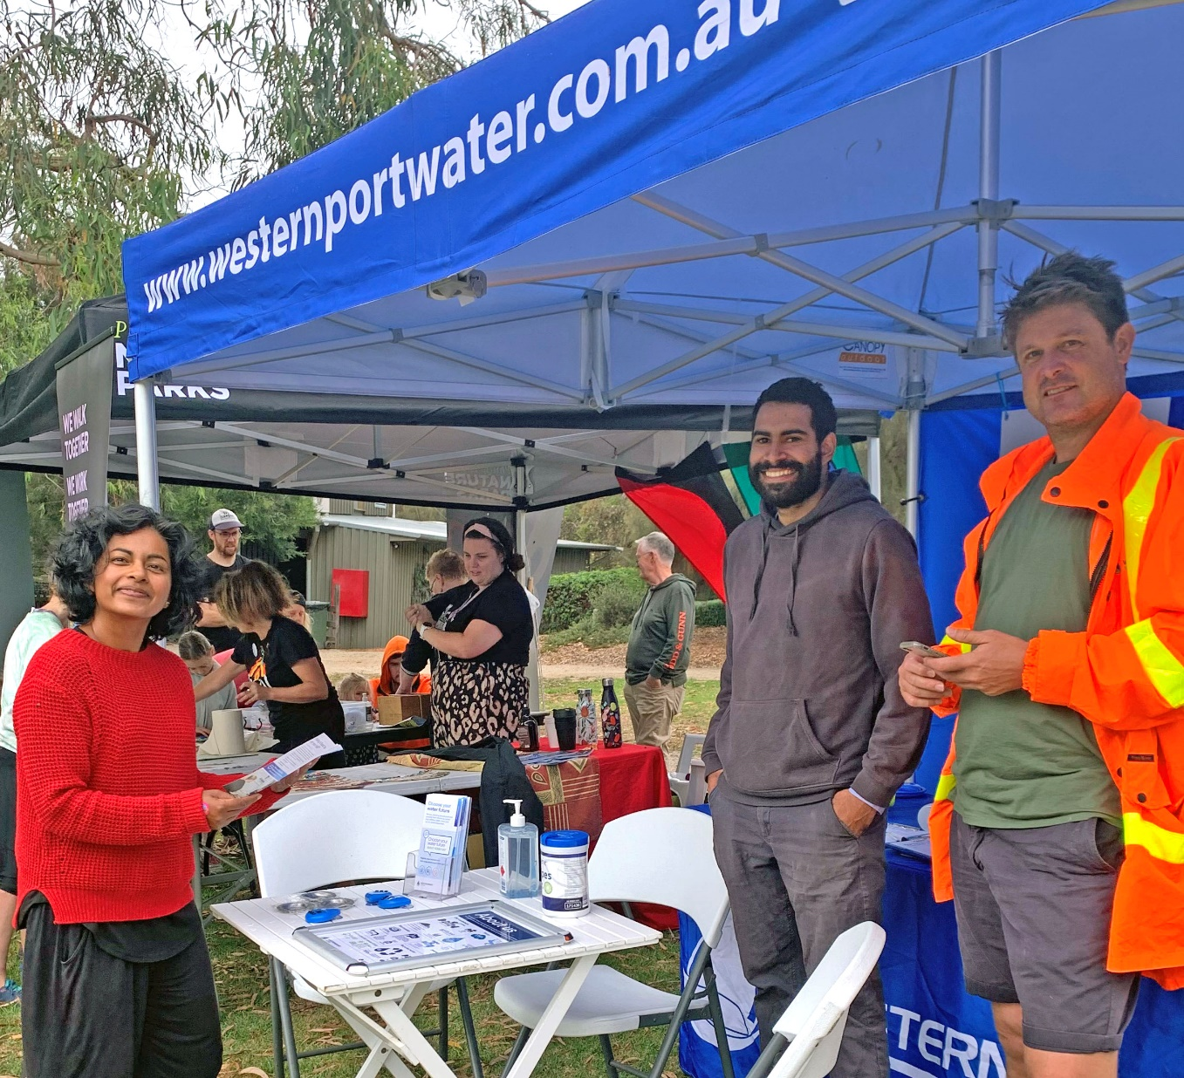
Photos 3&4: Westernport Water staff undertaking engagement with key stakeholders and customers

Our Approach
Westernport Water set out to undertake an accessible, inclusive, and fair engagement process that identified customer priorities and responded by developing options to address them.
The exploration stage was deliberately broad and included online, face-to face, and phone-based engagement. Over 22,000 bill inserts were distributed to promote the ‘Choose Your Water Future Surveys’ and approximately 9,000 people were reached via social media (over 50 Facebook comments also offered insights). In addition, 23 stakeholder invitations were distributed to encourage people to participate. To incentivise participation, each survey respondent was able to contribute $2 to their preferred charity and nominate a local community group to enter a $500 prize draw.
Surveys were supplemented by a series of ‘Getting to Fair’ interviews that were scheduled to support the objectives of the Commission’s strategy focused on access, inclusion and empowerment. The interviews considered the needs of vulnerable customers in our area through the lens of local service providers or elected representatives.
The test stage included a series of externally facilitated focus groups and deliberative forums that centred around the issues that mattered most to customers – climate change, water quality and the balance of fixed and variable charges. Each forum participant underwent a screening process to ensure that the overall balance of attendees was reflective of our community. Our approach to recruitment and results are detailed in the summary report (Appendix Five). Participants were also provided with pre-reading to ensure that they were empowered to contribute and provide feedback on the options that were presented (Appendix Two) . All customers that participated received a bill credit in acknowledgement of their contribution over three hours.

Figure 2: The key stages of Westernport Water’s engagement approach
Table 8: An Overview of Westernport Water’s Customer Engagement Program
Exploration Stage (Since September 2021) | Participants
Annual Customer Satisfaction Telephone Survey | 400
Exploration Stage – Choose Your Water Future Surveys (Since October 2021)
Choose Your Water Future Survey – Urban Water Strategy | 314
Choose Your Water Future Survey – Priorities & Perceptions | 320
Choose Your Water Future Survey – Performance and Expectations | 153
Newhaven Farmer’s Market | Survey promotion
Bass Coast Landcare Sustainability Festival | Survey promotion
Exploration Stage – Getting to Fair Interviews (Since February 2022)
Cr Bruce Kent & Cr Rochelle Halstead (Bass Coast Shire Council) | NA
South Coast Inclusion Network | NA
Corinella & District Community Centre | NA
St John’s Uniting Church, Cowes | NA
Anglicare Financial Counsellor | NA
Phillip Island Community & Adult Learning Centre | NA
Test Stage (Since March 2022)
Online Focus Group – Outcomes Framework | 13
Corinella Probus Club Meeting | 35
Phillip Island Community Orchard Open Day | NA
Regenerating Australia Community Screening | NA
Phillip Island Business Network | 21
Phillip Island Baptist Church Men’s Group | 25
Validate Stage (From April 2022)
Climate Change Deliberative Forum | 29
Water Quality & Taste Deliberative Forum | 27
Access & Usage Charges Deliberative Forum | 26
Online Developer NCC Consultation | NA
Total Participants Across 21 Events/Surveys/Forums | 1,363  (reflects 6% of customers)

Customer Feedback
Annual Customer Satisfaction Survey
The first phase of our 2023 Price Review engagement process was the annual customer satisfaction survey, which examined the perceptions, values, preferences and behaviour of our customers. Westernport Water has been undertaking annual customer satisfaction surveys since 2003. The phone survey was completed by 400 customers (approximately 2% of overall customers). The research identified the following key findings and trends since 2017:
- Customers are increasingly satisfied that they receive value for money for the services that are provided (63% in 2017 to 68% in 2021 – the highest on record).
- Customers are more likely to trust Westernport Water (NPS -8 in 2017 to NPS -1 in 2021 – the equal highest on record).
- Customers continue to find Westernport Water easy to deal with (92% in 2017 to 93% in 2021).
- Customers continue to report a very high level of satisfaction with response times to bursts and leaks (only 2% in 2017 and 2021 reported dissatisfaction).
- Customers remain generally satisfied that Westernport Water is a valued member of the community (64% in 2017 to 63% in 2021). A large proportion continue to state that they don’t know (32% in 2021).
- Customers remain generally satisfied with Westernport Water as a service provider (4.1 in 2017 to 4.0 in 2021).
- Customers remain satisfied with the balance between service quality and affordability (85% in 2017 to 83% in 2021).
- More customers expect ‘affordability’ (28% in 2017 to 31% in 2021) and less expect ‘efficiency’ (11% in 2018 to 7% 2021) in their base expectations for Westernport Water.
- Customers are less satisfied with the quality of their drinking water (73% in 2017 to 66% in 2021).
- Customers are less satisfied with the reliability of wastewater services following a decrease in the last 12 months (96% in 2017 to 90% in 2021).
- Customers are less confident that Westernport Water is planning for the future (46% in 2017 to 38% in 2021).
Influenced Result: These results influenced early internal capital project bids by setting the customer appetite for improved services. They also provided a good basis for informing Westernport Water’s performance self-assessment for the current period.

Choose Your Water Future Surveys
The second phase of our engagement process comprised three surveys focused on water security, customer priorities and expectations. This was a key input into the development of the outcomes framework for the 2023 Price Review and included a focus on potential performance indicators and a review of the existing Guaranteed Service Level Scheme. Key findings are summarised below:
- Customers value drinking water that tastes and looks the same every time (62%) and protecting the natural environment (80%) over affordability.
- Customers value affordability over minimising interruptions/restrictions (63%) and greening community spaces during drought (66%).
- Outside of essential services, customers place most importance on using water to support healthy waterways, environment, agriculture, and food production.
- Customers believe that water sources should be determined based on which one has the least impact on climate change.
- The top five measures rated by customers as most meaningful for managing performance were:
  - Customer satisfaction with drinking water
  - Average response time to bursts and leaks
  - Net greenhouse gas emissions
  - Quantity of wastewater reused
  - Total number of water quality complaints.

- Customers reported high levels of satisfaction across all guaranteed service levels within the scheme (79% - 89%).
- Customers ranked the following water corporation responsibilities in the top five for importance (in order of importance):
  - Respond quickly to contain sewer spills
  - Repair leaks and bursts quickly
  - Deliver safe and reliable wastewater services
  - Focus on making water bills affordable for everyone
  - Provide friendly and efficient customer service.

- Customers ranked the following priorities in the top five, specifically for Westernport Water (in order of priority):
  - Deliver water that tastes and looks the same every time
  - Adapt to climate change and plan for future climate challenges
  - Focus on making water bills affordable for everyone
  - Deliver reliable wastewater services
  - Protect and enhance the natural environment.
Influenced Result: Findings from the price review surveys formed the basis of the draft outcomes framework, including output targets. They also identified where customers were seeking improvement, which in turn prioritised our capital expenditure. Findings also identified the themes of the deliberative forums.

Getting to Fair Interviews
The third phase of our engagement process was designed to ensure that vulnerable customers were appropriately represented in our feedback. This was not in place of representation at deliberative forums and/or survey participation. Rather, it built upon these phases to engage with local service providers and elective representatives to better understand the challenges of vulnerable community members and how we may assist further as an essential service provider. Our key findings from these interviews were as follows:
- Limited mental health services in our region leave many people without support. Many of these people are also under rental or mortgage stress and may default on bills.
- Levels of debt have increased over COVID-19 and this is having an impact on people with COVID-19 specific support coming to an end.
- Housing affordability and increasing rental prices is a major issue for many people.
- Water bill prices are relatively cheap from a tenant’s perspective and flexible payment plans are effective for customers experiencing financial hardship.
- Feedback from service providers is that customers under financial stress may not open their bills because they feel overwhelmed, others have poor digital literacy or simply do not have access to reliable internet to access information.
- Westernport Water’s hardship services are only helpful if people know they exist; more community education is needed to raise awareness of support services.
- Visibility at events in the community will help overcome some of the barriers that exist to access information and services.
Influenced Result (p.45): Westernport Water has worked hard to maintain flat prices for the next period, while increasing its commitment for hardship grants from 25 per annum to 100 in 2023-24. We have rebalanced fixed and variable pricing to give customers greater control over their bill and introduced an output target to focus on the facilitation of utility relief grants. All hardship program education and promotion has been included in operating expenditure forecasts.

Aboriginal and Torres Strait Islander Engagement
Westernport Water engaged with its Reconciliation Action Plan Working Group (RAPWG) throughout the engagement process for the 2023 Price Review. Members of the RAPWG also provided input into the ‘Choose Your Water Future’ surveys. Westernport Water also engaged with the Bunurong Land Council Aboriginal Corporation as the Traditional Owners for our service area to ensure that partnership opportunities and engagement expectations from 2023-28 were identified and well understood.
Following discussions, Westernport Water will seek to: develop a Memorandum of Understanding with the Bunurong Land Council in the next regulatory period; explore opportunities to support further research into cultural water values within our service area; and establish regular briefings around long term plans for capital works to ensure the Bunurong Land Council can resource for cultural heritage and engagement work ahead of time.
Influenced Result: Westernport Water has included funding to deliver its third Reconciliation Action Plan. Funding for other commitments have not been included at this stage due to uncertainty with scope and timing.

Deliberative Forums and Focus Groups
Westernport Water originally planned to explore options around priority themes and validate findings with customers in person, however COVID-19 risks forced a change in our approach. A skilled customer engagement specialist was recruited to facilitate each online three-hour forum. Management and subject matter experts attended to support the conversation and answer questions.
The forums focused on three main areas: building customers' understanding of their role, the work of Westernport Water and creating trust in each other; listening to subject matter experts and discussing key focus areas; and providing customers with information on the “next steps” of the process, and the opportunity to give feedback on the session and ask additional questions.
Information was provided prior to the forums, to build an understanding of the broader engagement and the options available. Participation in the process was supported through training on online tools (people that required additional support using online meeting tools like Zoom were offered support); reminder SMS messages were sent prior to each meeting; and closed captioning for hearing impaired participants.
Customers were selected to reflect the demographic makeup of the Westernport Water service area, using a stratified sampling approach. To ensure the process was fair and unbiased, recruitment and selection was managed by our independent provider. Demographic identifiers included gender, age, cultural background, township, concession, and living arrangements. Participants were sourced from registrations to align with proportional customer data as much as possible – 89 attendees were recorded across the three forums, selected from 178 customer registrations. The forums were promoted online, in local papers and via bill inserts.
Three priority themes were selected for the three forums: climate change, water quality and taste, and access and usage charges/bill impacts. These three themes were identified as the three highest priorities for Westernport Water as part of the ‘Choose Your Water Future Surveys’.
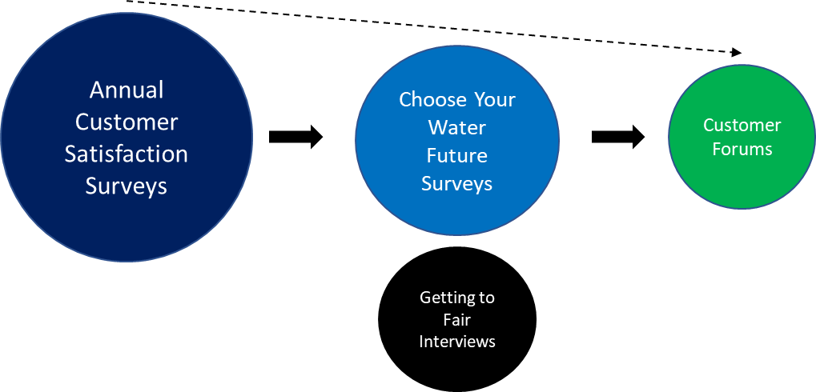

Figure 3: How priority engagement themes for customers emerged.

Key findings by priority theme and/or questions were as follows:
Q. What is the right timeframe for Net Zero and what mix of initiatives should Westernport Water implement in the next five years?
- Customers supported efforts to accelerate Westernport Water’s program of investments to achieve Net Zero by 2030.
“If we hold off doing this now then we may be dealing with tougher challenges in the future, not having the funds to do this”
- Customers noted that timeliness is critical regarding climate change and that now is a good time to invest with low interest rates. However, any efforts to reduce greenhouse gas emissions need to be supported by a strong evidence-base.
- Customers were cautious about over-committing to projects, noting the need to be mindful of capacity to deliver and the ongoing maintenance costs of projects.
Influenced Result (p.39-40): Three of the top 10 major projects (totalling $4.73M) will support the acceleration of efforts to reduce environmental impact and adapt to climate changes. Our greenhouse gas reduction target will also look to improve upon our Statement of Obligations target.

Q. How can Westernport Water drive increased value from its wastewater?
- Customers supported a balanced approach towards using wastewater that would deliver benefits to the environment and support a growing economy.
“Learning from your mistakes is very important (lower than anticipated re-use levels). I do like the wetlands idea – the bigger the better!”

- Customers noted that restorative wetlands would increase opportunities for tourism, recreation and biodiversity. However, any investment in recycled water is unlikely to be profitable and relies on cross-subsidisation – funds should be used carefully - more capital investment will increase cost for customers.
- Any investment for an environmental solution to reduce ocean discharge and improve wastewater quality should start small and be supported by research and benchmarking as it grows.
Influenced Result (p.39-40): Two of the top 10 major projects (totalling $5.47M) will utilise recycled water for environmental benefit. The balance between reuse outcomes and reducing nutrient discharge to the ocean is now reflected in our output targets in the outcomes framework.

Q. What initiatives should Westernport Water plan for now to deliver improved and consistent tasting water tomorrow?
- Customers were concerned by the potential for increased costs associated with some options. There was a clear preference for incremental improvements to smooth price impacts.
“I’m far more interested in an incremental process, rather than “let’s try new tech”, WPW should always be aware of new technology and it should be phased in as required.”

- Customers supported investigating new and emerging treatment options that could reduce chemical dosing, noting that Westernport Water needs to be confident that treatment reflects best practice.
Influenced Result (p.63): As a direct result of customer feedback, an independent review of emerging treatment technologies will be undertaken for long-term consideration at our purification plant (as part of the $2.1M Water Quality Continuous Improvement Program).

Q. What should Westernport Water explore for community education and access to drinking water?
- Customer views were mixed. Some customers supported additional drinking water fountains, particularly for children’s sporting facilities, while others expressed reticence to use fountains due to COVID-19. Overall, there was consensus that the current program be maintained.
“With the current issues we face with climate change… and drinking water avoidance – no brainer. Look at option 2 (an increase in community education)”
- Customers supported additional funds for community drinking water education and the maintenance of the existing program of water refill stations (rather than expansion) with a focus on sporting precincts for children.
Influenced Result (p.37-38): As a direct result of customer feedback, Westernport Water will install 7 community refill stations with a focus on community sport precincts. Westernport Water will also work with hospitality and accommodation providers to improve drinking water literacy for visitors and tourists who may be using bottled water.

Q. What is your view on the current customer performance-rebates for failed targets?
- Customers agreed that while the principle was correct, they did not believe that the current approach to managing underperformance was effective for two reasons: rebates came at the expense of operational funds that would be spent elsewhere; and the size of the rebate is not material to most customers.
“It seems counter intuitive making WPW find the penalty from their operations budget, thereby reducing opportunity to meet other KPIs.”

- A customer panel was the preferred means to assess performance or redirect funds to relevant projects, identified for consideration by Westernport Water.
Influenced Result (p.47-48): A new performance management framework will be introduced. A customer panel will be formed each year to provide commentary on Westernport Water’s performance to accompany the Annual Watermark. Further, if an outcome is missed in consecutive years, Westernport Water must present a corrective action plan to customers and provide $25,000 to a related community-led initiative following an Expression of Interest process.

Q. How does reducing the fixed (access) charge affect different types of residential and commercial customers?
“My water usage is so low; I would like to see reduced fixed charges to reduce my bill.”

- Some customers felt current charges discriminate against good water savers and Westernport Water should promote more of a user pays system.
- Others felt the current balance should remain, otherwise changes will discriminate against low income and vulnerable customers.
- Some believed that an increase in variable charges would not make any difference to water use. Most believed that there were better ways to encourage water efficiency in the community.
“As a renter, I don’t mind paying more if it means my pensioner mother saves money.”

- Majority of customers supported no more than a 2% reduction in the fixed rate, offset by an increase in the variable usage charge.
Influenced Result (p.45): Westernport Water will reduce the fixed access water charge by 2% in the first year of the next regulatory period. This represents a rebalance and will be offset by an increase in the variable water charge to provide customers with more control over their bill.

Q. Do you support the application of the special meter reading charge for outgoing tenants (paid by the landlord) in the future?
- Two thirds of customers were supportive of introducing a charge for outgoing tenants to be paid by the landlord, noting that it wasn’t fair on others that Westernport Water was absorbing the special meter read costs.
Influenced Result: Westernport Water will commence application of the special meter reading charge to outgoing tenants (to be paid by the landlord) in the next regulatory period to cover costs incurred.

Engagement Evaluation
Customers were asked to provide feedback following each deliberative forum to enable us to refine and improve our engagement approach in the future. Feedback was voluntary and 39 customers responded, noting the following:
- What worked well? Facilitators and speakers (21), information provided (17), opportunity to speak/be heard (16).
- What can improve? Ensure pre-reading material is read (5), prefer in-person (7), shorten sessions (5)
- Why would you recommend? Chance to learn (22), chance to contribute (14).
“It was fantastic working with Westernport Water; their management team and subject matter experts showed commitment to the process, not only by attending the forums but by thoroughly answering all customers’ questions.

Westernport Water provided a great level of detail in their pre-reading materials, which other organisations may fear their community would be uninterested or incapable of understanding complex issues. It was refreshing to see an organisation trust the intelligence and capability of their customers, with detailed pre-reading, presentations and Q&As producing rich, informed discussions.”
– Conversation Co.
“Found you very open to the real concerns of your customers. I am happy I decided to invest in the area knowing you are doing your best to get us the best water. It was an excellent forum! Well done!”
“Listened, organised, showed commitment to the process with the large contingent of staff, great presentation, clear communication.”
“Great opportunity to understand and be part of the strategy to shape the future.”

Customer Expectations
Westernport Water is confident that it has been able to balance and accommodate customer priorities effectively. In accordance with customer feedback, Westernport Water has worked hard to sustain existing performance levels and maintain flat prices for customers, while investing in climate change adaption and mitigation action and water quality improvements.
There were not majority-held views from our customer-base that we were unable to deliver on, however there were occasions where we had to explain constraints and limitations (in terms of customer influence) in some areas:
- Westernport Water was reluctant to complicate our tariff structure with tiered variable water prices based on consumption. Firstly, we believe that simple, accessible tariff structures empower customers to better understand their bill. Secondly, we had reservations that our current billing technology could support the changes.

- Some customers believed that Westernport Water could find cost efficiencies by eliminating business priorities that were perceived to be unrelated to the delivery of water and wastewater services. We explained that water corporations have an obligation in Victoria to follow written directions issued by the Minister for Water under the Water Act 1989, which are broader than water and wastewater service delivery.

- Westernport Water continues to maintain a very strong water quality record in reference to the Australian Drinking Water Guidelines. We were also recognised in 2021 as having the best tasting tap water in Victoria by the Water Industry Operators of Australia. However, customers continue to seek improvements to the taste of tap water. We will focus on incremental improvement measures, however the nature of our open-catchment will remain a factor in the taste of our water, compared to that available in metropolitan Melbourne.

Conclusion
Once again, Westernport Water is incredibly proud of our customers and their willingness to engage with us in record numbers across all mediums (online, by phone and face-to-face) to shape the future of their water and wastewater services. We believe that the introduction of our ‘Getting to Fair’ interviews ensured that the needs of vulnerable customers were brought to the forefront of each deliberation. In addition, the use of deliberative forums allowed Westernport Water to understand our customers and their diverse views better, rather than rushing to solutions and recommendations.
On balance, we believe that our customers sought the following:
- Affordable products and services for everyone
- Maintenance of existing service levels
- Further improvement in drinking water quality
- Accelerated investment to respond to climate change.
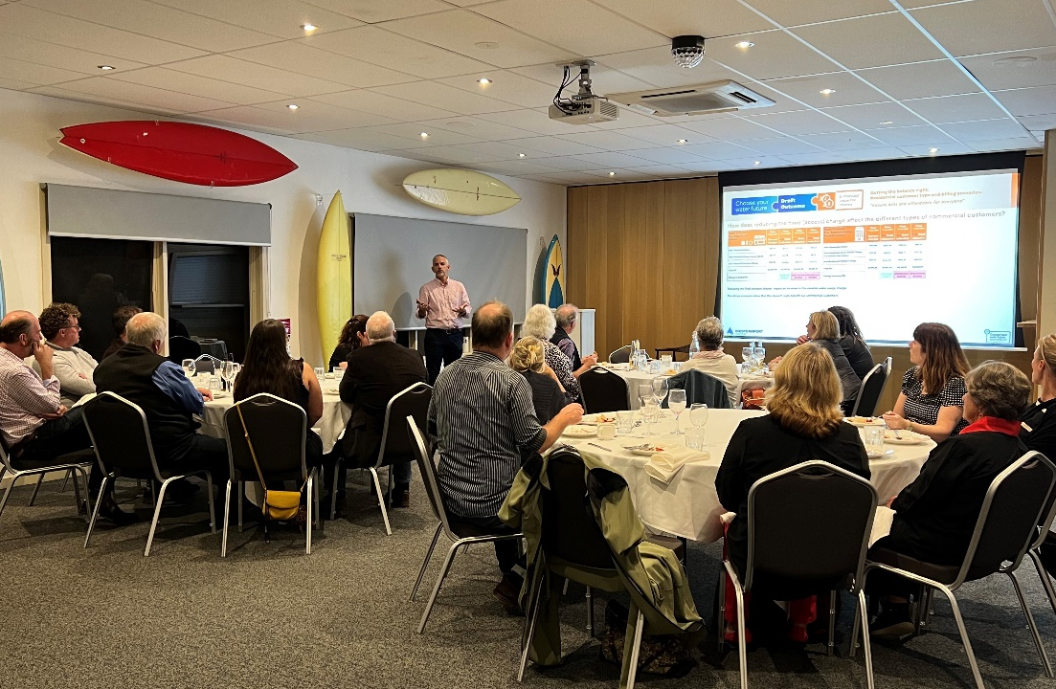

Photo 5: Westernport Water’s General Manager Corporate & Customer discussing tariff options with Phillip Island and San Remo’s business network

6 Outcomes Framework
Key Points
- Westernport Water has revised its outcomes framework to provide greater clarity for customers and to remove ambiguity.
- Westernport Water is focused on maintaining existing performance levels and delivering improvements in key investment areas, such as emissions reduction and drinking water satisfaction.
- Customers will have the final say regarding annual performance assessment in the next regulatory period. Repeated failure to meet a target will require the release of a corrective action plan and a $25,000 payment to a related community-led initiative.
- The new customer outcomes signal to our workforce what’s important to customers and guides their daily work.

Introduction
The outcomes framework for the 2023 Price Review reflects the priorities and expectations of our customers, providing a clear link between our customer engagement findings and our projects, service levels and activities.
The framework is our set of commitments to our customers and will be reported on annually via the Annual Watermark. While it provides clarity for customers in the way it identifies the areas that matter and contribute to customer value, it also signals to our workforce how their daily work contributes to customer priorities.
Following previous feedback from the Commission and findings from customer focus groups, we have sought to take a different approach to our outcomes for this price period:
“I’m not quite sure what is meant by environmentally sustainable operations. I know environmentally responsible operations are really important to me, and particularly just given the whole island is an eco- tourist area as well. We do value sustainability but I don’t quite know what environmentally sustainable means.”
- The language now reflects the customer voice, excluding ‘corporate’ or ambiguous terminology.
- Outcomes are no longer bundled together, linking different concepts or products/services.
- Projects have been included at the ‘output/deliverable’ level, providing customers with greater clarity around the contribution that projects make toward services levels and outcomes.
- Output targets are annual, moving away from the 5-year averages used previously – making our performance progress easier to understand and manage.

Outcome #1 - “Provide me with high-quality drinking water”
Why is this important? | - Customers rated ‘customer satisfaction with drinking water’ as their most meaningful performance measure for Westernport Water (71%).  - Customers rated the ‘delivery of water that tastes and looks the same every time’ as their highest priority (67%).  - Customer focus groups supported an emphasis on the quality of water, as opposed to just taste.  - Deliberative forums identified a desire for Westernport Water to make incremental improvements to water quality, while taking the time to understand best practice treatment approaches and new technologies. This is reflected in the satisfaction targets, that start at the average of the current regulatory period and improve over time.
Measures, Targets and Key Projects
KPI 1 - Increased Customer Satisfaction with Drinking Water (Per Annum)

18-19  Actual | 19-20  Actual | 20-21  Actual | 21-22  Actual | 22-23  Target | 23-24  Target | 24-25  Target | 25-26  Target | 26-27  Target | 27-28  Target
64% | 68% | 72% | 66% | >70% | >67% | >68% | >69% | >70% | >70%

Target Rationale Explained: The 5-year average target (>70%) for the current regulatory period will not be achieved. Westernport Water’s highest customer satisfaction rating was 73% in 2017. Since COVID-19, our demographic has changed due to Melburnians moving to regional Victoria, which has influenced our results in the short term due to taste comparison (due to the nature of our catchment, our drinking water tastes different to Melbourne’s). Westernport Water remains committed to improving customer satisfaction above current levels and will therefore target incremental improvements year on year up to 70%.

KPI 2 - Reduced Number of Water Quality Complaints (Per 100 Customers) (Per Annum)

18-19  Actual | 19-20  Actual | 20-21  Actual | 21-22  Actual | 22-23  Target | 23-24  Target | 24-25  Target | 25-26  Target | 26-27  Target | 27-28  Target
0.22 | 0.08 | 0.95 | 0.25 | <0.22 | <0.22 | <0.22 | <0.22 | <0.22 | <0.22

Target Rationale Explained: The 5-year average target (<0.22) for the current regulatory period will not be achieved. Westernport Water remains committed to meeting the target in the next period. Based on ESC’s 2020-21 Water Performance Report, the target is reflective of the sixth best water corporation in Victoria (out of 16) for water quality complaints.

KPI 3 Completion of the Water Quality Continuous Improvement Program

23-24 Target | 24-25 Target | 25-26 Target | 26-27 Target | 27-28 Target
On-track | On-track | On-track | Complete

KPI 4 Delivery of Community Drinking Water Education Program

23-24 Target | 24-25 Target | 25-26 Target | 26-27 Target | 27-28 Target
On-track | On-track | On-track | On-track | Complete

Key Contributing Activities and Processes
- Extensive quality monitoring and sampling process across the water distribution network
- Revegetation activities to improve catchment health and in turn, raw water quality prior to treatment
- Water purification processes, including dissolved air flotation, ultraviolet disinfection, and chlorination (multibarrier approach)
- External auditing of our drinking water quality system, led by the Department of Health
- Responsive water quality complaint handling procedures, supported by a Guaranteed Service Level.

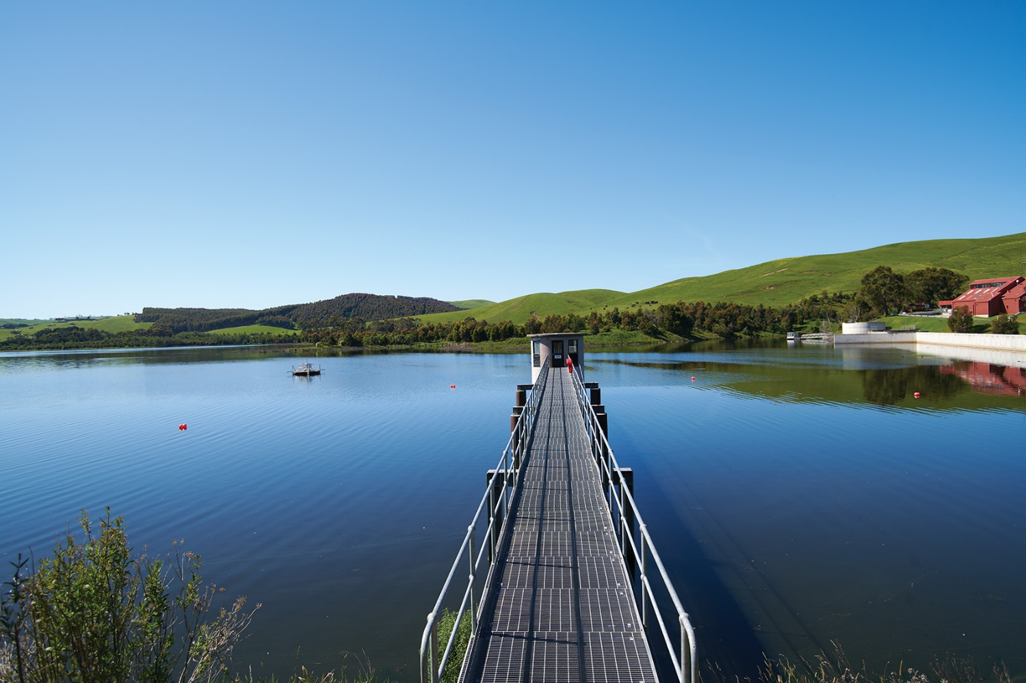
Photo 6: The view from the Candowie Reservoir offtake tower

Outcome #2 – “Reduce your environmental impact and adapt to climate change”
Why is this important? | - Customers rated ‘adapt to climate change and plan for future climate challenges’ (41%), ‘protect and enhance the natural environment’ (23%), ‘use more recycled water to save on drinking water’ (21%) and ‘reduce greenhouse gas emissions from our operations’ (21%) as some of their highest priorities for Westernport Water.  - Greenhouse gas emissions was rated as the third most meaningful performance measure.  - Focus groups noted that customers wanted to avoid using corporate language, such as sustainable or sustainability.  - Deliberative forums supported Westernport Water to accelerate efforts to address climate change in a cost-effective manner.
Measures, Targets and Key Projects
KPI 1 - Reduction in Nutrients Discharged to the Ocean
(Tonnes of Nitrogen) (Per Annum) (Per 1000 Sewer Connections)*

18-19  Actual | 19-20  Actual | 20-21  Actual | 21-22  Actual | 22-23  Target | 23-24  Target | 24-25  Target | 25-26  Target | 26-27  Target | 27-28  Target
1.7 | 1.6 | 1.0 | 0.9 | NA | <1.2 | <1.2 | <1.2 | <1.2 | <1.2
*Not applicable for 90th percentile year of average rainfall.

Target Rationale Explained: This is a new target reflecting customer interest in ocean discharge. The target will reflect a decrease on the average performance in the current regulatory period. Due to the impacts of inflow and infiltration during heavy rainfall events, the target will not be applicable for a 90th percentile year of average rainfall.

KPI 2 – Reduction in Greenhouse Gas Emissions (CO2-e Tonnes) (Per Annum)

18-19  Actual | 19-20  Actual | 20-21  Actual | 21-22  Actual | 22-23  Target | 23-24  Target | 24-25  Target | 25-26  Target | 26-27  Target | 27-28  Target
6,920 | 6,460 | 6,704 | 5,973 | <5,974 | On-Track | <5,598 | On-Track | On-Track | <4,199

Target Rationale Explained: Westernport Water is committed to an ambitious reduction in greenhouse gas emissions. Targets reflect those outlined in the Statement of Obligations (Emission Reduction). After 2024-25, Westernport Water will reduce emissions to 606 by 2029-30. This pathway is represented by a 25% reduction from 2024-5 to 2027-28.

KPI 3 – Increased Volume of Effluent Reused (ML) (Per Annum)*

18-19  Actual | 19-20  Actual | 20-21  Actual | 21-22  Actual | 22-23  Target | 23-24  Target | 24-25  Target | 25-26  Target | 26-27  Target | 27-28  Target
339 | 237 | 125 | 303 | NA | >267 | >267 | >267 | >267 | >267
*Not applicable for 90th percentile year of average rainfall.

Target Rationale Explained: The target will reflect average performance in the current regulatory period, plus 5%. Westernport Water is also moving from an end-of-5-year target to an annual target to improve consistency. Due to the impacts of higher-than-average rainfall, which reduces potential for irrigation and demand for recycled water, the target will not be applicable for a 90th percentile year of average rainfall.

KPI 4 - Delivery of Recycled Water Wetland Storage

23-24 Target | 24-25 Target | 25-26 Target | 26-27 Target | 27-28 Target
On-track | On-track | On-track | On-track | Complete

KPI 5 - Delivery of Bio-Gas Waste to Energy

23-24 Target | 24-25 Target | 25-26 Target | 26-27 Target | 27-28 Target
On-track | On-track | Complete

Key Activities and Processes
- Management of environmental risk in accordance with our Environmental Management System
- Optimisation of assets and operations to reduce emissions and energy consumption
- Increased water security through the promotion of integrated water management initiatives and recycled water programs
- Continued expansion of on-site irrigation to increase wastewater reuse benefits
- Procurement and sourcing of renewable energy
- Investigation of nature-based solutions for wastewater treatment
- Adherence to EPA licensing requirements and the General Environmental Duty
- Maintenance of permanent generators at sewer pump stations to avoid spills
- Telemetry and SCADA monitoring and alarms to effectively, proactively manage the network.

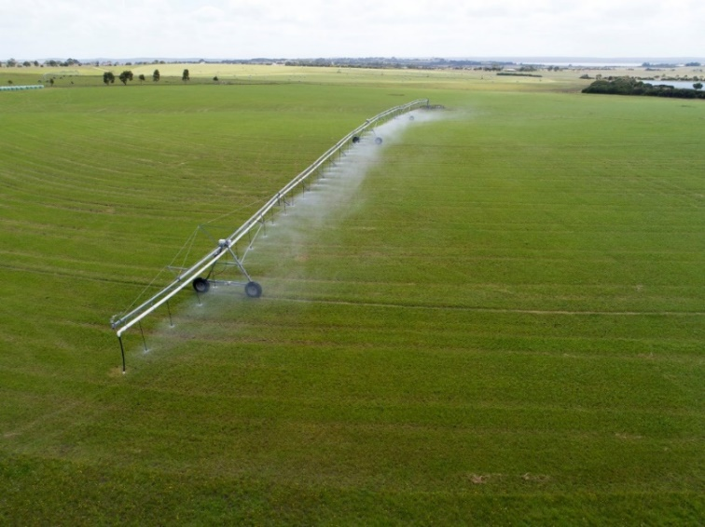
Photo 7: On-site irrigation at King Road Wastewater Treatment Plant
Outcome #3 - “Resolve sewer blockages quickly”
Why is this important? | - Customers rated ‘Responds quickly to contain sewer spills’ (91/100) as the most important responsibility for their local water corporation.  - ‘Delivers safe and reliable wastewater services’ (87/100) was rated third most important and 28% identified it as a top priority for Westernport Water.  - In 2021, customer dissatisfaction with wastewater services increased from 4% to 11% (the highest since annual surveys commenced in 2014), which identified it as an emerging issue for consideration in the Outcomes Framework.
Measures, Targets and Key Projects
KPI 1 – Maintain Average Sewer Blockage Response Time (Per Annum)

18-19  Actual | 19-20  Actual | 20-21  Actual | 21-22  Actual | 22-23  Target | 23-24  Target | 24-25  Target | 25-26  Target | 26-27  Target | 27-28  Target
35.7 | 9.3 | 27.8 | 30.5 | 60 | <35 | <35 | <35 | <35 | <35

Target Rationale Explained: The target reflects our priority response time, noting the size of our service area and depot location. In the current regulatory period, the service standard that Westernport Water committed to was 60 minutes – our new standard reflects a 42% decrease.

KPI 2 Maintain Average Sewer Blockage Rectification Time (Per Annum)

18-19  Actual | 19-20  Actual | 20-21  Actual | 21-22  Actual | 22-23  Target | 23-24  Target | 24-25  Target | 25-26  Target | 26-27  Target | 27-28  Target
111.6 | 28.7 | 138.4 | 125.8 | 200 | <150 | <150 | <150 | <150 | <150

Target Rationale Explained: The target reflects our average performance in the current regulatory period. In the current regulatory period, the service standard that Westernport Water committed to was 200 minutes – our new standard reflects a 25% decrease.

Key Activities and Processes
- Management of trade waste framework
- Facilitation of greasy waste pump outs to avoid sewer blockages
- Multiple Guaranteed Service Levels to incentivise timely response to sewer blockages
- Preventative maintenance program, including CCTV inspections of high-risk areas on sewer network
- Regular condition assessments of manholes and sewer network
- Air scouring of rising sewer mains twice a year
- Management of modern and reliable plant and vehicle fleet.

Outcome #4 - “Keep water interruptions to a minimum”
Why is this important? | - Customers rated ‘Repairs leaks and bursts quickly’ (88/100) as the second most important responsibility for their local water corporation. ‘Keeps water interruptions to a minimum’ was not far behind (82/100).  - Furthermore, 21% listed limiting water interruptions as a top priority for Westernport Water.  - In terms of performance measures, 22% of customers rated ‘minutes off supply per customer’ in their top 5 most meaningful measures for the organisation – 18% rated water supply interruptions per customer in their top 5 meaningful measures.
Measures, Targets and Key Projects
KPI 1 – Maintain Average Duration of Unplanned Water Supply Interruptions (Minutes)

18-19  Actual | 19-20  Actual | 20-21  Actual | 21-22  Actual | 22-23  Target | 23-24  Target | 24-25  Target | 25-26  Target | 26-27  Target | 27-28  Target
85.9 | 72.5 | 71.8 | 83.9 | NA | <85 | <85 | <85 | <85 | <85

Target Rationale Explained: The target reflects our average performance in the current regulatory period. Westernport Water is focusing on unplanned customer minutes off supply, noting that planned network maintenance for improved water quality outcomes is a focus for customers. In the current regulatory period, the service standard that Westernport Water committed to was 96 minutes – our new standard reflects an 11% decrease. Based on ESC’s 2020-21 Water Performance Report, the target is reflective of the seventh best water corporation in Victoria (out of 16) for water quality complaints.

KPI 2 – Reduced Number of Water Supply Interruptions Per Customer (Per Annum)

18-19  Actual | 19-20  Actual | 20-21  Actual | 21-22  Actual | 22-23  Target | 23-24  Target | 24-25  Target | 25-26  Target | 26-27  Target | 27-28  Target
0.27 | 0.13 | 0.24 | 0.62 | NA | <0.4 | <0.4 | <0.4 | <0.4 | <0.4

Target Rationale Explained: The target reflects our average performance over the last 5-years (0.66 in 2017-18).

KPI 3 - Delivery of Water Main Renewal Program

23-24 Target | 24-25 Target | 25-26 Target | 26-27 Target | 27-28 Target
On-track | On-track | On-track | On-track | Complete

Key Activities and Processes
- Use of hydro-excavator, which allows staff to work on assets live without interruption
- Use of Wimbledon Heights tank and new valves to minimise areas of outage
- Provision of 24/7 operations and customer contact centre
- Regular renewal programs and asset condition assessment.

Outcome #5 - “Be there when I need you”
Why is this important? | - Customers rated ‘average response time to bursts and leaks’ as the second most meaningful performance indicator for Westernport Water (42%).  - Total customer complaints were included as a meaningful measure for 20% of customers.  - ‘Provides friendly and efficiency customer service’ was rated 84/100 for importance by customers.  - Customers believed that customer service response times were very good and would be willing to divert resources elsewhere. Only 7% of customers believed average time to answer was a meaningful measure of performance. This has therefore been removed as a KPI and replaced with the Commission’s customer experience quality assurance measure.
Measures, Targets and Key Projects
KPI 1 Reduced Total Number of Customer Complaints (Per 100 Customers) (Per Annum)

18-19  Actual | 19-20  Actual | 20-21  Actual | 21-22  Actual | 22-23  Target | 23-24  Target | 24-25  Target | 25-26  Target | 26-27  Target | 27-28  Target
0.40 | 0.21 | 1.18 | 0.45 | NA | <0.6 | <0.6 | <0.6 | <0.6 | <0.6

Target Rationale Explained: Based on the ESC’s 2020-21 Water Performance Report, the target is reflective of the seventh best water corporation in Victoria (out of 16) for total customer complaints. The target also represents half of the number of complaints that were received in 2020-21.

KPI 2 Maintain Response Times to Water Busts and Leaks (Priority 1 & 2 - Minutes)

18-19  Actual | 19-20  Actual | 20-21  Actual | 21-22  Actual | 22-23  Target | 23-24  Target | 24-25  Target | 25-26  Target | 26-27  Target | 27-28  Target
2.0  40.4 | 0  30.7 | 0  34.8 | 1  64.1 | <30  <35 | <30  <35 | <30  <35 | <30  <35 | <30  <35 | <30  <35

Target Rationale Explained: Westernport Water has committed to maintaining the existing targets for response times to bursts and leaks. Based on the ESC’s 2020-21 Water Performance Report, the target (P2) is reflective of the eighth best water corporation in Victoria (out of 16). P1s are difficult to set annual targets for because they occur so infrequently.

KPI 3 Maintain Customer Satisfaction with ‘Ease of Effort’ (Per Annum)

18-19  Actual | 19-20  Actual | 20-21  Actual | 20-21  Actual | 22-23  Target | 23-24  Target | 24-25  Target | 25-26  Target | 26-27  Target | 27-28  Target
86% | 89% | 91% | 93% | NA | >89% | >89% | >89% | >89% | >89%

Target Rationale Explained: Every year, Westernport Water asks 400 customers whether they have been in contact with the business in the last 12 months, and if so, whether we were easy to deal with. Our PS23 target reflects the midpoint of performance in the last period.

Key Activities and Processes
- SCADA real-time monitoring and alarm system
- Provision of 24/7 operations and customer contact centre
- Call quality coaching framework
- Complaint handling policy
- Customer charter

Photo 8: Westernport Water staff member operating a forklift at Newhaven Depot

Outcome #6 - “Keep my essential services affordable”
Why is this important? | - Customers rated ‘making water bills affordable for everyone’ 85/100 for importance and 34% included it as a top priority for Westernport Water.  - Throughout deliberative forums, most customers supported a 2% rebalance of fixed charges to promote water efficient behaviours and provide customers with more control over their bill.  - Hardship grants and utility relief grants are two key means through which we can support customers that are finding it difficult to keep up with their water and wastewater bill.
Measures, Targets and Key Projects
KPI 1 Delivery of Westernport Water Grants to Customers in Hardship (Per Annum)

18-19  Actual | 19-20  Actual | 20-21  Actual | 21-22  Actual | 22-23  Target | 23-24  Target | 24-25  Target | 25-26  Target | 26-27  Target | 27-28  Target
30 | 107 | 259 | 238 | >25 | >100 | >75 | >50 | >50 | >50

Target Rationale Explained: Westernport Water recognises that it’s important to support our customers coming out of the economic impacts of COVID-19 and the potential for higher interest rates in the future. We have quadrupled the number of grants in the first year to reflect this need.

KPI 2 Rebalance of Fixed Access Charges
Fixed access charges will be reduced by 2% and offset by an increase
in variable water charges in 2023-24.

Target Rationale Explained: In consultation with our customers, we have rebalanced our fixed and variable charges to empower customers to control their bill by using less water.

KPI 3 Increased Number of Utility Relief Grant Applications Facilitated (Per Annum)

18-19  Actual | 19-20  Actual | 20-21  Actual | 21-22  Actual | 22-23  Target | 23-24  Target | 24-25  Target | 25-26  Target | 26-27  Target | 27-28  Target
42 | 53 | 58 | 78 | NA | >53 | >53 | >53 | >53 | >53

Target Rationale Explained: Westernport Water recognises that the facilitation of utility relief grant applications is an effective way to provide greater financial support for our hardship customers. Our target reflects our performance in 2019-20, noting that demand for applications may have temporarily increased following the impacts of COVID-19.

Key Activities and Processes
- Hardship policy and program, including flexible payment options and dedicated Hardship Officer
- Family violence policy
- Provision of 24/7 operations and customer contact centre
- Call quality coaching framework and customer service induction and training program
- Complaint handling policy and customer charter

Customer Commitment Change Summary
For clarity, the following table identifies changes to outputs from a performance perspective and a target perspective. Please note that while some targets are new as a customer commitment, they previously existed in the current period as a customer service standard.
Table 9: Overview of Changes to Customer Commitments
Output Measure | Performance | Target
Customer satisfaction with drinking water | Improve | Maintain
Water quality complaints | Improve | Maintain
Nutrients discharged to the ocean | Improve | New
Greenhouse gas emissions | Improve | Improve
Volume of effluent reused | Improve | New
Sewer blockage response | Maintain | New/Improve
Sewer blockage rectification | Maintain | New
Duration of unplanned water interruptions | Maintain | New/Improve
Water supply interruptions per customer | Maintain | New
Customer complaints | Maintain | New
Response to bursts and leaks | Maintain | Maintain
Customer satisfaction with ease of effort | Maintain | New
Hardship grants | Maintain | Improve
Utility relief grants facilitated | Maintain | New

Cost of Delivering Outcomes
Westernport Water is not proposing any increase to prices or customer bills to deliver the commitments and performance targets associated with each outcome. This will be achieved by ensuring a 1.5 per cent efficiency is delivered which will assist to absorb the 2.02 expected growth and growth-related costs over the period as detailed on page 78. In accordance with customer feedback, Westernport Water has sought to maintain performance at existing service levels as a minimum. In specific areas such as greenhouse gas emissions, we are seeking material improvements in line with investments and customer appetite for change.
As per customer feedback, we are also seeking to borrow funds to pay for capital projects associated with our Net Zero Roadmap to accelerate our emissions reduction path, while maintaining a largely flat price path.
Where service levels have been improved, this is the direct result of investment in this regulatory period, efficiencies from renewals, or re-prioritisation of funds. For example:
- Nutrients discharged to the ocean is expected to remain flat despite growth due to investment in on-site irrigation and recycled water wetland storages.
- Greenhouse gas emissions will fall due to further investments in renewable energy, which will in turn reduce energy costs in the later years of the submission.
- An increase in hardship grants will be funded via a reprioritisation of debt recovery funds.
- Service level commitments in greenhouse gas emissions, water quality, and customer responsiveness have been maintained or improved despite growth. This focus was maintained following an organisational realignment in 2022 that redirected funds from a vacant General Manager position to network maintenance capability, and SMEs in climate-change and water quality.
- Where there are additional costs to maintain service levels due to growth, this will be funded by customer growth.
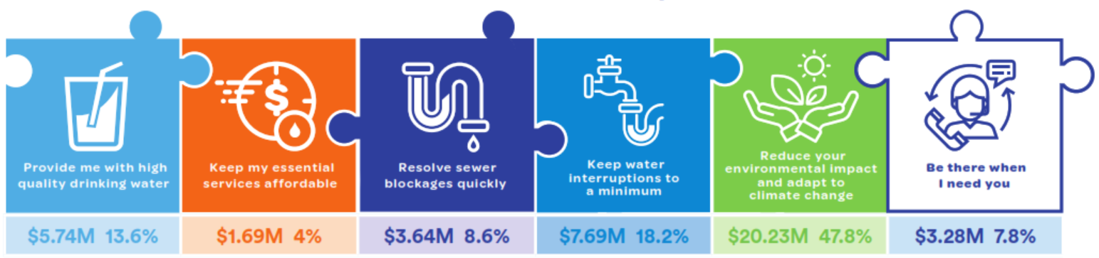

Figure 4: An overview of capital expenditure by outcome

Reporting Approach
Westernport Water has reviewed its current approach to annual reporting in consultation with our customers. Currently, Westernport Water reports on progress against its outcomes framework in the ‘Annual Watermark’, which is published on our website and distributed to customers with their bill (physically or electronically depending on their preference). In select years, we have also timed its release with customer engagement sessions to validate our own progress assessment, listen to feedback and answer any questions that customers may have.
Following feedback from our customers, we will continue to release the Annual Watermark as we have done in the past. However, each year, a customer panel will be formed to provide commentary on our performance following a briefing from management and subject matter experts. This commentary will be independently facilitated and included in the Annual Watermark.

Managing Underperformance
Westernport Water currently maintains a performance-rebate scheme, which will credit customers $5 for every failed target up to a cap of $20. The rebate is payable in 2023-24 and is based on our end-of-period performance.
Customer feedback was sought on the current scheme and customers agreed that while they appreciated the principle, the customer rebate amount was deemed immaterial, and ultimately funds would have to be redirected away from other areas to pay for it. As per the above, customers wanted to be involved in the annual performance evaluation to ensure transparency and a continuous customer voice throughout the price period.
Current period: Westernport Water acknowledges customer feedback on the existing performance rebate scheme. In 2023-24, we will ask customers whether they would prefer to receive the performance rebate
($5-$20) on their bill, or an alternative proposal that would see additional funds invested to improve performance in the output areas that underperformed. This customer consultation process will be independently managed and Westernport Water will implement the majority position.
Next period: From 2023 to 2028, a customer panel will be formed every year to evaluate performance and report back to customers via the Annual Watermark. In addition, if an overall outcome is missed over consecutive years, Westernport Water will need to develop and present a corrective action plan to customers. The action plan must include: the problem, root cause analysis, required actions, timeframes and success criteria (typically, this will reflect the original output targets). A financial penalty will also be imposed of $25,000, which will be directed to a related, community-led initiative following an Expression of Interest.
Furthermore, at the midpoint of the next regulatory period, the customer panel may recommend a change to the outputs and/or output targets for consideration. If this occurs, all customers will be provided with an opportunity to approve or decline the proposed change.

Service Standards for Reliability and Faults
As per Clause 9.2 in the Customer Service Code for Urban Water Businesses, service standards are minimum service levels that our customers can expect to receive. Where applicable, Westernport Water has aligned our service standards to our output targets, as both reflect the minimum level of service that customers pay for.
Adjustments to service standards reflect customer feedback (p.28) that the balance between service quality and affordability was satisfactory. Consequently, some service standards were increased to be more reflective of current performance levels.

Table 10: Overview of Westernport Water’s Service Standards from 2023-24
Service Standard | 18-23Target | 23-28  Target
Water
Minimum water pressure or flow rate a customer should receive (kPa or L/min) | 300 kPa | 300 kPa
Maximum number of unplanned water supply interruptions a customer should experience in any 12-month period | 5 | 4
Average time taken to attend bursts and leaks (priority 1) (minutes) | 30 | 30*
Average time taken to attend bursts and leaks (priority 2) (minutes) | 35 | 35*
Average time taken to attend bursts and leaks (priority 3) (minutes) | 300 | 300
Average duration of unplanned water supply interruptions (minutes) | 96 | 85*
Average duration of planned water supply interruptions (minutes) | 157 | 157
Sewerage
Maximum number of sewer blockages a customer should experience in any 12 month period | 3 | 3
Average time to attend sewer spills and blockages (minutes) | 60 | 35*
Average time to rectify a sewer blockage (minutes) | 200 | 150*
Maximum time taken to contain a sewer spill (minutes) | 300 | 300

*Indicates a service standard that is also an output target within Westernport Water’s 2023-28 Outcomes Framework.

Guaranteed Service Level Scheme
As per Westernport Water’s 2018-23 Price Submission, our Guaranteed Service Level Scheme reflects our performance commitment to individual customers by setting an agreed payment or rebate on bills if a minimum standard is missed. The intent is to compensate customers for poor performance, while incentivising consistent levels of performance in the areas that matter.
Customers reported high levels of satisfaction across all current guaranteed service levels within the scheme (79% - 89%) and there were no common themes or suggestions from customers to include for the future. Consequently, our Guaranteed Service Level Scheme remains unchanged from 2022-23:

Table 11: Overview of Westernport Water’s Guaranteed Service Level Scheme
Outcome | Guaranteed Service Level | Payment
“Keep water interruptions to a minimum” | We will limit unplanned interruptions to no more than 4 in any 12-month period. | $75
“Provide me with high-quality drinking water” | All water quality complaints will receive a response within three business days after notification (noting resolution may take longer). | $100
“Be there when I need you” | We will not restrict the water supply of a residential customer, or take legal action, prior to taking reasonable endeavours to contact the customer and provide information about help that is available if the customer is experiencing difficulties paying (Reimbursement of annual water access fee; or $350 for tenants). | Reimbursement of Annual Water Access Fee or $350 for tenants.
“Resolve sewer blockages quickly” | We will contain sewage spills within a house resulting from the failure of our pipes within one hour of notification (Reimbursement of annual wastewater access fee – or $550 for tenants; in addition to clean‐up costs). | Reimbursement of Annual Wastewater Access Fee or $550 for tenants in addition to clean-up costs.
“Resolve sewer blockages quickly” | We will contain sewage spills onto property within five hours of notification ($350). | $350

Table 12: Total Expenditure By Outcome
Total Expenditure – By Outcome  ($m, real2023) | 2023-24 | 2024-25 | 2025-26 | 2026-27 | 2027-28 | Total
Capital Expenditure | $1.39 | $1.07 | $1.09 | $1.33 | $0.86 | $5.74
Additional Operating Expenditure | $0.36 | $0.37 | $0.52 | $0.61 | $0.62 | $2.48
Outcome Expenditure - Provide me with high quality drinking water | $1.75 | $1.44 | $1.61 | $1.94 | $1.48 | $8.22
Capital Expenditure | $4.62 | $4.51 | $4.54 | $4.70 | $1.86 | $20.23
Additional Operating Expenditure | $0.06 | $0.17 | $0.07 | $0.11 | $0.04 | $0.45
Outcome Expenditure - Reduce your environmental impact and adapt to climate change | $4.68 | $4.68 | $4.61 | $4.81 | $1.90 | $20.68
Capital Expenditure | $0.59 | $0.62 | $0.57 | $1.16 | $0.71 | $3.65
Additional Operating Expenditure | - | - | - | - | - | -
Outcome Expenditure - Resolve sewer blockages quickly | $0.59 | $0.62 | $0.57 | $1.16 | $0.71 | $3.65
Capital Expenditure | $3.24 | $0.89 | $0.84 | $1.93 | $0.78 | $7.68
Additional Operating Expenditure | - | - | - | - | - | -
Outcome Expenditure - Keep water interruptions to a minimum | $3.24 | $0.89 | $0.84 | $1.93 | $0.78 | $7.68
Capital Expenditure | $0.87 | $0.48 | $1.15 | $0.36 | $0.42 | $3.28
Additional Operating Expenditure | $0.01 | $0.01 | $0.01 | $0.02 | $0.02 | $0.05
Outcome Expenditure - Be there when I need you | $0.88 | $0.49 | $1.16 | $0.38 | $0.44 | $3.35
Capital Expenditure | $0.26 | $0.50 | $0.65 | $0.15 | $0.14 | $1.70
Additional Operating Expenditure | $0.01 | $0.01 | -$0.12 | $0.07 | $0.07 | $0.04
Outcome Expenditure - Keep my essential services affordable | $0.26 | $0.50 | $0.53 | $0.21 | $0.21 | $1.70
Total Controllable Operating Expenditure (Less Additional) | $16.79 | $16.84 | $16.83 | $16.79 | $16.75 | $83.99
Total Non-Controllable Operating Expenditure | $1.59 | $1.58 | $1.56 | $1.53 | $1.51 | $7.77
Total Expenditure | $29.78 | $27.03 | $27.71 | $28.75 | $23.78 | $137.04

7 Capital Expenditure
Key Points
- Westernport Water’s capital program was designed to balance customer advocacy for water quality improvement, climate change action, and sustained performance with affordability.
- Renewal activity remains the key driver for the capital program.
- Growth and planning for more extreme weather events are driving key projects to increase capacity at wastewater treatment plants and minimise potential environmental impacts.
- Total capital investment of $42.28M which is a 21% increase in investment on PS1 (2018-23).

Capital expenditure is a key element of the annual revenue requirement that informs our submission. Westernport Water’s 2023‐28 capital expenditure program has been designed to ensure that our infrastructure investment:
- Enables customer expectations for performance to be met
- Reflects the priorities that have been expressed by our customers throughout engagement
- Ensures our regulatory obligations can be delivered
- Maintains asset reliability and does not contribute to a significant increase in renewals in the next regulatory price period
- Includes a balanced risk-based approach to cost estimates, avoiding conservative contingencies
- Accommodates forecasts for long term growth.

Capital Expenditure 2018-23
From 2018 to 2023, Westernport Water’s determination provided for a capital works program of $29.66 million ($real2023) in comparison to $24.43 million ($real2018) in the previous period (Water Plan 3), reflecting an increase of increase of 21%. Westernport Water is on track to deliver all top 10 projects in our current regulatory period (p.20) and is forecast to spend $33.8 million ($real2023).
Over two-thirds of the program supported the delivery of reliable water and wastewater services and approximately 55% was committed to renewals. The investment has proved successful in delivering more reliable water and wastewater services as per customer expectations, along with increased renewable energy capacity (decreasing greenhouse gas emissions) and increased irrigation capacity (increasing recycled water consumption). Key critical infrastructure projects were also delivered with the construction of the Cowes WWTP Stage 2 Upgrade, Phillip Island Water Supply Security Project and the San Remo Basin Cover and Liner Renewal.
Following the ESC PREMO guidance, our capex program was managed in an agile, prudent, and efficient way to ensure that it delivers better value for money for customers. Savings were used to fund additional projects that were future-focused and aligned to the needs of our customers. These included the installation of generators at critical sewer pump stations, which improves the resilience of our wastewater network during extreme weather events and outages (PS18 Outcome – Reliable Water and Wastewater Services). It also included the purchase of additional land adjoining our Cowes Wastewater Treatment Plant, which will enable us to increase irrigation and reuse wastewater, that would otherwise be discharged to the ocean (PS18 Outcome – A More Sustainable Community).

Table 13: PS18 Actual Expenditure by Cost Driver
Cost Driver ($m, real2023) | 2018-19 | 2019-20 | 2020-21 | 2021-22 | 2022-23
Compliance | $1.100 | $1.344 | $1.600 | $0.277 | $0.187
Growth | $0.793 | $1.088 | $2.106 | $3.653 | $0.073
Improved Services | $0.454 | $0.434 | $0.754 | $0.470 | $0.210
Renewals | $2.803 | $3.296 | $4.407 | $4.554 | $4.211
Total | $5.151 | $6.162 | $8.867 | $8.953 | $4.681

Table 14: PS18 Actual Expenditure by Asset Category
Product – Asset Category  ($m, real2023) | 2018-19 | 2019-20 | 2020-21 | 2021-22 | 2022-23
Water
Headworks | $0.002 | $0.053 | $0.160 | $2.272 | $0.212
Pipelines/network | $0.589 | $1.441 | $2.011 | $0.625 | $1.483
Treatment | $0.721 | $0.693 | $0.947 | $0.342 | $0.327
Corporate | $1.105 | $0.974 | $1.440 | $0.370 | $1.014
Total Water | $2.416 | $3.161 | $4.558 | $3.609 | $3.036
Sewerage
Headworks | $0.026 | - | - | - | -
Pipelines/network | $0.396 | $0.361 | $0.329 | $0.317 | $0.320
Treatment | $0.654 | $0.760 | $2.257 | $4.656 | $0.314
Corporate | $1.636 | $1.850 | $1.683 | $0.362 | $0.990
Total Sewerage | $2.712 | $2.971 | $4.270 | $5.335 | $1.624
Recycled Water
Headworks | - | - | - | - | -
Pipelines/network | - | - | - | - | -
Treatment | - | $0.001 | - | $0.001 | $0.001
Corporate | $0.022 | $0.029 | $0.039 | $0.008 | $0.020
Total Recycled Water | $0.022 | $0.030 | $0.039 | $0.009 | $0.021
Total | $5.151 | $6.162 | $8.867 | $8.953 | $4.681

Table 15: PS18 Major Project Performance
Top 10 PS18 Major Projects ($real2023) |  | $Determination | $Actual | Expected  Completion | Actual  Completion
Cowes Wastewater Treatment Plant Upgrade – Stage 2 |  | $3,778,670 | $5,363,286 | $5,363,286 | $5,363,286
San Remo Basin Renewal Project |  | $2,267,202 | $2,442,234 | $2,732,234
Phillip Island Water Supply Security Project |  | $3,133,941 | $2,417,288 | $2,417,288 | $2,417,288
Business Transformation Project |  | $1,894,044 | $1,867,713 | $1,867,713 | $1,867,713
San Remo to Newhaven Bridge Pipeline and Fittings Renewal Project |  | $1,028,202 | $211,042 | $941,042
Sustainable Water Reuse & Land Management |  | $911,590 | $927,941 | $927,941 | $927,941
San Remo Basin to Cowes 648 Pipeline Valve Replacement Program | $672,760 |  | $429,989 | $644,989
Building Asset Management Plan – Stage 3 | $579,078 |  | $635,543 | $635,543 | $635,543
Emissions Reduction Pledge Implementation | $460,841 |  | $476,452 | $476,452 | $476,452
Zone Metering and Pressure Management | $1,024,838 |  | $145,057 | $145,057 | $145,057
Cowes Wastewater Treatment Plant Upgrade – Stage 2
The PS1 budget for this project was $3.37M using a Monte Carlo P50 estimate developed based on the preliminary concept. The additional improvements including a new Return Activated Sludge (RAS) pump station and other minor upgrades contributed to the increase in the project cost. However, the improvements were an efficient investment at the time of works to provide additional capacity to service growth. The public tender price of the lowest tenderer was $4.75M and with internal project management costs and detailed designs costs, the actuals was $5.4M.
Zone Metering and Pressure Management
This project aims to reduce the water pressure in reticulation mains to extend asset life. The project includes the construction of seven pressure reduction stations in Westernport Water’s distribution network. The concept design was completed for all seven zones. The pressure reduction facility at Cape Woolamai has been successfully commissioned as a Pilot Project. An assessment has been undertaken and it was determined that deferring the remaining six (6) stations will not directly impact our service level or our customer outcome. The deferral will allow Westernport Water to understand the project outcomes better before investing for the remaining six stations. The project budget savings have been reallocated to Cowes WWTP Stage 2 upgrade budget shortfall.
Outcomes of Pilots and Trials
Westernport Water has not delivered any trials or pilots in the current regulatory period that will inform proposed future projects and/or expenditure in the next regulatory period (Learning from investment in Zonal Metering will be considered in PS28).

Building our Capital Program (2023-28)
Westernport Water has an obligation to our community to ensure we manage our assets effectively and efficiently to support the successful delivery of our outcomes.
Westernport Water has developed and is utilising a capital works planning and prioritisation process based on guidelines completed by Water Services Association of Australia (WSAA). The prioritisation process is aligned to our Project Management Framework, and has been designed and applied to:

- Ensure that project submissions are justified as both prudent and efficient and are prepared in a manner that is both consistent and comparable
- Ensure projects are prioritised on considerations of both their contribution to customer outcomes and risk if deferred
- Define a robust and deliverable capital program.
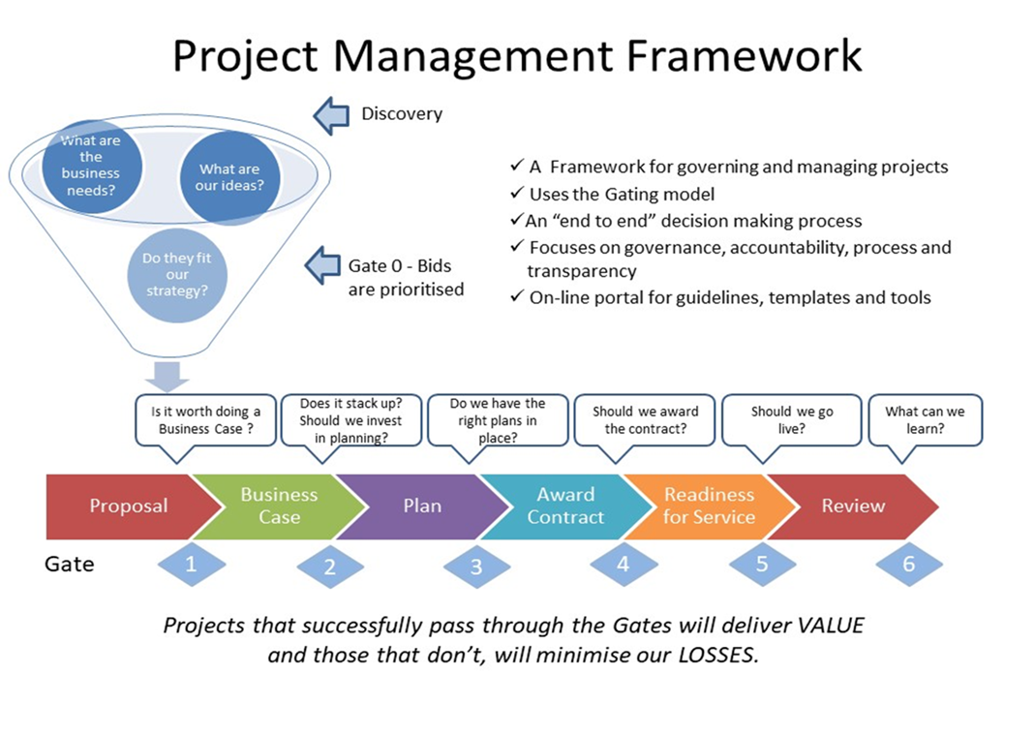
Figure 5: Westernport Water Project Management Framework
All planned capital projects for the next regulatory period started as a project bid (Gate Zero) in response to asset performance, customer feedback or government priorities.

For ‘Gate Zero’ project bids, all staff were engaged as part of the prioritisation process and were able to submit a bid for consideration. Project bids incorporated preliminary project and budget information, risk assessments, existing customer service levels and outcomes, and strategic alignment with policy and regulatory objectives.

Some projects are required to address compliance requirements, such as workplace health and safety, drinking water and climate action projects. These will all be delivered this period.

Other projects were chosen based on the value that they provide to our customers. This net benefits approach considered the contribution of the project to achieving outcomes and the approximate financial benefits / costs to customers if the project was implemented. The latter considers the total costs of the project over the regulatory period and the risk reduction if the project was implemented. The value of the reduced risk is estimated using the Corporate Risk Framework ratings expressed as equivalent dollar values (p.117-120).

The preliminary screening assessment considered projects that provided high business objective scores and high financial benefits as opposed to those projects delivering lower objective scores and apparent short term financial costs to the business.

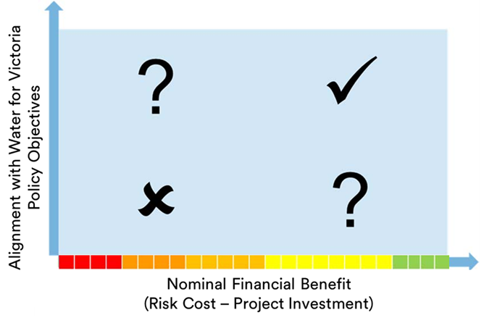
Further Executive level assessments were conducted to consider the outputs of the net benefit approach, against customer expectations and future regulatory and operational requirements. Successful projects were nominated for ‘Gate One’ inclusion.

Detailed project scopes have been prepared for all successful project bids for the 5-year regulatory period. This has been further refined by customer consultation, which in turn has influenced projected capital and operational expenditure.

Preliminary business cases (Gate 2) have been developed for the top 10 projects and additional assessments have been conducted to support the project scopes and provide a greater confidence regarding cost.

Following customer consultations, these preliminary business cases were refined, and other projects reassessed to give an investment program that addresses customer priorities and aspirations.

Each preliminary business case will be subject to Board approval prior to proceeding to procurement planning (Gate 3) and tender analysis & assessments (Gate 4).

Cost Estimation Methodology
Westernport Water has an internally approved standard cost estimating procedure and template for base cost estimates, comprising the costs of all goods and services provided by consultants, contractors, internal staff and materials, plus the cost of all fees, licences, permits and land acquisition required to undertake a project. The accuracy of these cost estimates depends on the detail available at each phase of a project.

Each base cost estimate includes an allowance that reflects the accuracy of rates, quantities and amounts for the delivery of each element of the scope of a project. The application of this accuracy allowance reflects the inherent risk contained in the definition of the scope and cost of each element at the time of preparation.

The assumptions based on the cost estimates are specific to each project and detailed in the Westernport Water project documentation. The base estimate (including sunk costs) is the sum of our direct costs and constructions costs and are prepared based on our best assessment of the quantities and costs of similar projects delivered previously, provided by expert consultants or the market rates. The accuracy of the project estimate is dependent on how progressed the project is in the design process.

The base cost estimate is the sum of all costs that will be incurred by Westernport Water in the delivery of a project and includes external costs (consultants, contractors, equipment) and internal costs (staff costs, day labour costs, fees, permit costs, land acquisition, and equipment).

In addition, the business cases and base cost estimates for all major projects have been independently reviewed, including the completion of probability modelling of contingencies using @RISK software to assess the P50/P90 outcome costs.

Risk workshops to assess the robustness of current cost estimates and the identification of specific project risks were also undertaken. Risk registers were created, and project contingent risks were quantified with a probability of occurrence and amount of severity on a three-point scale.

This approach to cost estimation, following a rigorous project prioritisation process that aligns investment to customer value and priorities, has allowed us to design a prudent and efficient capital program with optimised contingences.

Capacity to Deliver
As at 30 June 2022, Westernport Water had completed seven of the top 10 projects for the current regulatory period and a further three projects were on schedule to be completed by the end of FY2022/23. Overall, $29.1M of the $33.8M PS1 capex budget has been spent with $4.7M remaining to be spent in Year 5 ($real2023).

Westernport Water has a good track record of delivering capital works programs with a well-established project management structure and internal project management resources to deliver projects and renewal programs. In addition, Westernport Water has access to a consultant panel for the concept designs, detailed designs and tender preparation (if required) to deliver the capital program in the next period.

Managing Risk in Procurement and Delivery
Westernport Water undertakes a range of activities to effectively manage project risks, including:
- Detailed planning and accurate cost estimation– Westernport Water has completed an independent review of all business cases for major projects included in this Price Submission.
- Early investigation and planning has allowed us to confidently define project scopes and objectives. In doing so, Westernport Water will avoid scope creep or re‐work during the project delivery phase.
- Westernport Water used a probabilistic cost estimating process for our top 10 projects and a deterministic cost estimating process for minor projects and programs. Project risks were identified as part of project cost estimation. P50 estimates have been developed using a Monte Carlo analysis, with contingencies linked to each risk item.
- Westernport Water uses a “Project Management Framework” based on the Project Management Excellence methodology. This methodology uses a “gateway” review process for projects and programs at key decision points. The framework provides consistency and governance in managing our capital works projects and program.
- Westernport Water uses Victorian Public Construction Contracts as per the Ministerial Directions and Instructions for the public construction procurement (Direction and Instruction 7.1 – Department of Treasury and Finance Victoria.
- Westernport Water’s standard contract management is based on an appropriate Australian Standard. As an example, Westernport Water regularly uses General Conditions of Contract, such as AS4300 for Design and Construct contracts, AS4000 for Construction contracts and AS4122 for the Engagement of Consultants.
- We operate in a regional context and have a small capital works program. Our access to large construction contractors is limited. Similarly, our opportunity to maximise benefits created by “economies of scale” is also limited. Consequently, Westernport Water uses different procurement types for projects depending on complexity, value, and size. Some examples may include, bundling “like” projects into programs, utilising preferred suppliers and contractors, and maximising opportunities with VicWater and our Gippsland Regional Water Alliance Partners. We are a small and nimble corporation which can individually tailor procurement approaches to each project. This approach allows us to maximise efficiencies and identify innovations.
- As mentioned above, Australian Standards are consistently used for contract management. General Conditions of Contract, such as AS4000, provide for the principal to apply Liquidated Damages and Contractor Delay Payments. This standard contract provision is utilised by Westernport Water where appropriate.
Proposed Capital Expenditure (2023-28)
The proposed $42.28M ($real2023) capital expenditure for the next regulatory period is outlined in full in the table below. In comparison to the actual PS18 capital expenditure ($33.8M $real2023), this represents a 21% increase in expenditure. As the table below demonstrate, the focus of the program has moved primarily into growth and renewal activity. The complete program is listed below and includes all capital expenditure, including smaller discreet projects and programs. No grants or contributions are expected at this time and therefore have not been included.
Table 16: 2023-28 Capital Program
Project ($real2023) | 2023-24 | 2024-25 | 2025-26 | 2026-27 | 2027-28 | Total
Bio-gas waste to energy | $376,045 | - | $1,504,179 | - | - | $1,880,224
Renewable energy generation | - | - | $1,223,602 | $336,104 | - | $1,559,706
Treatment plant energy efficiency | $344,148 | $940,199 | - | - | - | $1,284,347
Sustainable reuse and afforestation | $466,054 | $532,633 | - | - | $133,158 | $1,131,846
Minor compliance projects | $75,000 | $45,000 | $100,000 | $40,000 | $103,000 | $363,000
OH&S compliance program | $50,000 | $50,000 | $50,000 | $50,000 | $50,000 | $250,000
Compliance Total | $1,311,247 | $1,567,833 | $2,877,781 | $426,104 | $286,158 | $6,469,123
Water quality improvement program - stage 2 | $133,263 | - | $383,132 | $1,588,232 | - | $2,104,627
Recycled water wetland storage | $228,472 | - | $456,945 | $3,531,639 | $118,790 | $4,335,846
Wastewater systems future | $390,884 | $377,855 | - | $744,542 | - | $1,513,281
Cowes Wastewater Treatment Plant - master plan upgrades - stage 3 | $100,899 | $1,144,196 | - | - | $100,899 | $1,345,994
King Road Wastewater Treatment Plant effluent pump station upgrade | $993,828 | - | - | - | - | $993,828
Recycled water improvement program | - | - | $540,540 | - | $250,000 | $790,540
King Road Master Plan Stage 2 | $180,569 | $85,985 | - | - | $220,696 | $487,250
Growth Total | $2,027,916 | $1,608,036 | $1,380,616 | $5,864,412 | $690,385 | $11,571,366
Information and communications technology roadmap | $914,050 | $611,650 | $640,850 | $127,250 | - | $2,293,800
Building asset management plan | $71,903 | $665,718 | $167,359 | - | - | $904,980
Plant improvement program | $30,000 | - | $557,500 | $105,000 | $25,000 | $717,500
Odour & corrosion mitigation program | - | - | $30,000 | $20,000 | $450,000 | $500,000
Water distribution and storage improvement | $280,000 | $22,500 | $372,500 | $570,000 | - | $1,245,000
Sewage pump station improvement program | $10,000 | $140,000 | $30,000 | $30,000 | $60,000 | $270,000
Improvement Total | $1,305,953 | $1,439,868 | $1,798,209 | $852,250 | $535,000 | $5,931,280

Project - ($real2023) | 2023-24 | 2024-25 | 2025-26 | 2026-27 | 2027-28 | Total
Sewage pump station civil, mechanical and electrical | $507,480 | $485,738 | $289,260 | $477,092 | $603,560 | $2,363,129
Fleet and plant - renewal program | $474,400 | $393,900 | $333,250 | $283,500 | $446,250 | $1,931,300
Cowes Wastewater Treatment Plant civil, mechanical and electrical | $326,037 | $177,859 | $655,937 | $179,458 | $301,758 | $1,641,049
Asset management information system upgrade | $177,430 | $1,123,265 | - | - | - | $1,300,695
Sewer mains and junction renewals | $180,000 | $180,000 | $180,000 | $330,000 | $337,000 | $1,207,000
Water mains renewals | $375,000 | - | $460,000 | $390,000 | $375,000 | $1,600,000
Candowie & Ian Bartlet Water Purification Plant civil, mechanical and electrical | $179,025 | $174,290 | $175,343 | $186,944 | $521,475 | $1,237,077
San Remo to Newhaven bridge pipeline and fittings renewal project - stage 2 | $3,144,720 | - | - | - | - | $3,144,720
Information and communications - hardware and minor software renewals program | $130,000 | $130,000 | $280,000 | $220,000 | $130,000 | $890,000
Water distribution civil, mechanical and electrical | $187,329 | $411,025 | $49,375 | $58,635 | $58,092 | $764,455
Water meter and connections renewal program | $150,000 | $142,000 | $188,000 | $142,000 | $138,000 | $760,000
Corporate improvement and renewals | $119,403 | $103,221 | $88,690 | $130,183 | $243,321 | $684,818
King road wastewater treatment plant civil, mechanical and electrical | $338,993 | $88,509 | $39,235 | $43,101 | $51,173 | $561,011
Minor storages civil, mechanical and electrical | $32,720 | $37,660 | $43,876 | $51,141 | $59,564 | $224,960
Renewals Total | $6,322,536 | $3,447,467 | $2,782,965 | $2,492,054 | $3,265,192 | $18,310,215
Grand Total | $10,967,652 | $8,063,204 | $8,839,571 | $9,634,821 | $4,776,735 | $42,281,983

Table 17: 10-Year Forecast Capital Expenditure by Driver
Cost Driver ($m, real2023) | 2023-24 | 2024-25 | 2025-26 | 2026-27 | 2027-28 | Total
Compliance | $1.31 | $1.57 | $2.88 | $0.43 | $0.29 | $6.47
Growth | $2.03 | $1.61 | $1.38 | $5.86 | $0.69 | $11.57
Improved Services | $1.31 | $1.44 | $1.80 | $0.85 | $0.54 | $5.93
Renewals | $6.32 | $3.45 | $2.78 | $2.49 | $3.26 | $18.31
Total | $10.97 | $8.06 | $8.84 | $9.63 | $4.78 | $42.28
Cost Driver ($m, real2023) | 2028-29 | 2029-30 | 2030-31 | 2031-32 | 2032-33 | Total
Compliance | $0.34 | $1.76 | $0.18 | $0.18 | $0.18 | $2.64
Growth | $14.68 | $6.27 | $2.23 | $2.24 | $2.25 | $27.67
Improved Services | $0.59 | $0.25 | $0.28 | $0.28 | $0.28 | $1.68
Renewals | $4.03 | $3.93 | $3.49 | $3.41 | $3.61 | $18.48
Total | $19.64 | $12.21 | $6.18 | $6.11 | $6.32 | $50.47

Graph 14: PS23 Forecast Capital Expenditure by Driver

Graph 15: PS23 Forecast Capital Expenditure by Driver
The 2023-28 Capital Program is again driven largely by renewals (43%). However, in comparison to the previous regulatory period, the proportion of funds allocated to growth and improvement projects have increased. This is in line with customer priorities for water quality improvements and environmentally responsible operations. It is also reflected in two of Westernport Water’s 10 major projects – Recycled Water Wetland Storage ($4.34M) and the Water Quality Continuous Improvement Program ($2.1M).
Once again, Westernport Water has sought to keep capital expenditure as low as possible, while ensuring that our asset performance and customer service levels are not compromised. As demonstrated in our outcomes framework, there is a strong link between the delivery of the capital program and the service levels that we seek to achieve. The alignment between project, outcome and service level allows customers to understand the value they receive for the prices paid (p.46).
Westernport Water is forecasting an increase in renewal activity due to ageing assets and growth-related investment in PS28. Based on wastewater projections, Westernport Water will need to augment its wastewater network to accommodate growth in our service area. Resourcing has been provided in PS23 to undertake detailed planning to ensure that the preferred option delivers value for customers.
Table 18: PS23 Forecast Capital Expenditure by Outcome
Cost – By Outcome ($m, real2023) | 2023-24 | 2024-25 | 2025-26 | 2026-27 | 2027-28 | Total
Provide me with high quality drinking water | $1.39 | $1.07 | $1.09 | $1.33 | $0.86 | $5.74
Reduce your environmental impact and adapt to climate change | $4.62 | $4.51 | $4.54 | $4.70 | $1.86 | $20.23
Resolve sewer blockages quickly | $0.59 | $0.62 | $0.57 | $1.16 | $0.71 | $3.64
Keep water interruptions to a minimum | $3.24 | $0.89 | $0.84 | $1.93 | $0.78 | $7.69
Be there when I need you | $0.87 | $0.48 | $1.15 | $0.36 | $0.42 | $3.28
Keep my essential services affordable | $0.26 | $0.50 | $0.65 | $0.15 | $0.14 | $1.69
Total | $10.97 | $8.06 | $8.84 | $9.63 | $4.78 | $42.28

Table 19: PS23 Forecast Capital Expenditure by Product
Driver – Service ($m,real2023) | 2023-24 | 2024-25 | 2025-26 | 2026-27 | 2027-28 | Total
Growth
Recycled Water | $0.23 | - | $1.00 | $3.53 | $0.37 | $5.13
Water | $0.13 | - | $0.38 | $1.59 | - | $2.10
Sewerage | $1.67 | $1.61 | - | $0.74 | $0.32 | $4.34
Total Growth | $2.03 | $1.61 | $1.38 | $5.86 | $0.69 | $11.57
Renewals
Recycled Water | $0.02 | $0.04 | $0.01 | $0.01 | $0.02 | $0.10
Water | $3.45 | $2.11 | $1.55 | $1.62 | $2.16 | $10.89
Sewerage | $2.86 | $1.30 | $1.22 | $0.86 | $1.09 | $7.33
Total Renewals | $6.32 | $3.45 | $2.78 | $2.49 | $3.27 | $18.31
Improvements/Compliance
Recycled Water | $0.49 | $0.56 | $1.25 | $0.34 | $0.14 | $2.78
Water | $0.84 | $0.69 | $1.12 | $0.73 | $0.09 | $3.47
Sewerage | $1.29 | $1.75 | $2.31 | $0.21 | $0.60 | $6.16
Total Improvements/Compliance | $2.62 | $3.01 | $4.68 | $1.28 | $0.82 | $12.41
Total | $10.97 | $8.06 | $8.84 | $9.63 | $4.78 | $42.28

Table 20: PS28 Forecast Capital Expenditure by Product
Driver – Service  ($m,real2023) | 2028-29 | 2029-30 | 2030-31 | 2031-32 | 2032-33 | Total
Growth
Recycled Water | $11.59 | $2.21 | $0.16 | $0.16 | $0.16 | $14.28
Water | $1.00 | $2.00 | - | - | - | $3.00
Sewerage | $2.09 | $2.06 | $2.07 | $2.08 | $2.09 | $10.39
Total Growth | $14.68 | $6.27 | $2.23 | $2.24 | $2.25 | $27.67
Renewals
Recycled Water | $0.08 | $0.08 | $0.07 | $0.06 | $0.06 | $0.35
Water | $2.19 | $2.21 | $1.96 | $1.98 | $2.16 | $10.50
Sewerage | $1.76 | $1.65 | $1.46 | $1.37 | $1.39 | $7.63
Total Renewals | $4.03 | $3.93 | $3.49 | $3.41 | $3.61 | $18.47
Improvements/Compliance
Recycled Water | $0.11 | $0.04 | $0.01 | $0.01 | $0.01 | $0.18
Water | $0.24 | $0.96 | $0.19 | $0.19 | $0.19 | $1.77
Sewerage | $0.58 | $1.01 | $0.26 | $0.26 | $0.26 | $2.37
Total Improvements/Compliance | $0.93 | $2.01 | $0.46 | $0.46 | $0.46 | $4.32
Total | $19.64 | $12.21 | $6.18 | $6.11 | $6.32 | $50.46

A Prudent and Efficient Capital Program
Historically, Westernport Water’s capital expenditure has been efficient in comparison to other regional water corporations in Victoria. Proposed capital expenditure totals were sourced for each regional water corporation from the Commission’s customer fact sheets for the 2018 Price Review. The number of water connections and length of water main for each corporation was used to understand efficiency and provide the basis for comparison. As the graphs below demonstrate, Westernport Water’s capital expenditure was the lowest by water connection and second lowest by kilometre of water main. Westernport Water is confident that the proposed program for the next period will once again compare favourably across the sector as most water corporations are anticipating increased capital works programs in PS23.

Graph 16&17: PS18 Capital Program Expenditure Comparison – By Water Connection (left) By Length of Main (right).
As previously mentioned, the focus of the PS23 capital program is to:

- Increase network capacity to service forecast demand and growth (in accordance with VIF forecasts and Urban Water Strategy scenario-based forecasts)
- Sustain existing performance levels via targeted renewal activity
- Deliver improved outcomes via investments in renewable energy and water quality
- Exclude expenditure relating to uncertainty and optimise contingencies through robust Monte Carlo analysis.

Westernport Water considered substitution possibilities between forecast operating and forecast capital expenditure. Our renewal program prioritises electrical and mechanical assets in our treatment plants and sewer pumps stations as these are critical for compliance purposes and to sustain the performance levels that our customers expect. While operational expenditure could be increased to accommodate a reduction in linear asset renewals, the number of bursts and leaks would likely increase and place pressure on our output targets. Consequently, our approach has remained consistent with the current period and has been heavily influenced by customer feedback.

Top 10 Projects ($m, real2023)
The following top 10 projects are all supported by preliminary business cases that have been independently reviewed against the Commission’s guidance paper requirements. These business cases are available for review upon request. Furthermore, each project’s risk-based cost estimates were independently developed following base cost estimates and risk analysis workshops that were conducted with project leaders. This summary report is also available upon request.
Recycled Water Wetland Storage - $4.34M
Outcome | Reduce your environmental impact and adapt to climate change | 2023-24 | 2024-25 | 2025-26 | 2026-27 | 2027-28
Service | Recycled Water | 0.23 | - | 0.46 | 3.53 | 0.12
Driver | Growth
Category | Treatment
Design and construction of a wetland system that provides an additional 60ML of recycled water storage at King Road Wastewater Treatment Plant (KRWWTP) to ensure Westernport Water can manage increasing inflows whilst meeting EPA discharge licence requirements, improve wastewater quality, enhance biodiversity, and allow for potential recreational access in the future. Failure to invest in storage expansion at KRWWTP will result in the inability to manage increasing sewer inflows as a result of growth within the region.
Water Quality Continuous Improvement Program - $2.10M
Outcome | Provide me with high quality drinking water | 2023-24 | 2024-25 | 2025-26 | 2026-27 | 2027-28
Service | Water | 0.13 | - | 0.38 | 1.59 | -
Driver | Growth
Category | Treatment
This program comprises a series of projects to plan for and deliver improvements to water quality, including the installation of a manganese analyser at our purification plant, cleaning of trunk mains, installation of automatic flushing devices, new water main to maintain service levels and the replacement of a pressure management station with SCADA monitoring facilities. Following customer feedback (p.31), Westernport Water will also undertake an independent investigation of emerging treatment technologies for long-term consideration at our purification plant and install an additional seven community water refill stations.
Bio-Gas Waste to Energy - $1.88M
Outcome | Reduce your environmental impact and adapt to climate change | 2023-24 | 2024-25 | 2025-26 | 2026-27 | 2027-28
Service | Sewerage | 0.38 | - | 1.50 | - | -
Driver | Compliance
Category | Treatment
Design and construction of Stage 1 of the Bio-Gas Waste to Energy project, a cover and flare on the existing bio-digester at the Cowes Wastewater Treatment Plant to capture methane and nitrous oxide gas present in wastewater streams to reduce the impact of greenhouses gases on the environment. Direct emissions of methane and nitrous oxide from this site contribute some 75% of our direct scope 1 emissions. This project is critical to meeting the 2030, 90% emission reduction target in addition to customer and community expectations. If investment in this project does not proceed Westernport Water is obligated to annually purchase significant amounts of Australian Carbon Credit Units (ACCUs) to meet emissions targets.
Renewable Energy Generation - $1.56M
Outcome | Reduce your environmental impact and adapt to climate change | 2023-24 | 2024-25 | 2025-26 | 2026-27 | 2027-28
Service | Sewerage | - | - | 1.22 | 0.34 | -
Driver | Compliance
Category | Treatment
Installation of a solar system at Ian Bartlett Water Purification Plant for 99kW and increase in renewable energy at our Newhaven office site and Cowes Wastewater Treatment Plant by 50kW and 280kW respectively. Failure to invest in renewable energy sources will impact Westernport Water opex requirements due to the compliance requirement of sourcing 100% of energy from renewable sources. As a result, Westernport Water will be obligated to purchase of significant amounts of Large Generation Certificates (LGCs).
Wastewater Systems Future - $1.51M
Outcome | Reduce your environmental impact and adapt to climate change | 2023-24 | 2024-25 | 2025-26 | 2026-27 | 2027-28
Service | Sewerage | 0.39 | 0.38 | - | 0.74 | -
Driver | Growth
Category | Pipelines/Networks
Proposed upgrades to the wastewater network to support growth, including the design and construction of two 85kW sewage pumps at Cape Woolamai and two 55kW sewage pumps at Hastings Street. The macerator at Church Street sewer pump station in Cowes will also be relocated and replaced. With pumps reaching their capacity and aging/failing infrastructure, this project will ensure reliability in customers sewer services and that Westernport Water is meeting General Environmental Duty (GED) requirements.
Cowes Wastewater Treatment Plant Upgrade – Stage 3 - $1.35M
Outcome | Reduce your environmental impact and adapt to climate change | 2023-24 | 2024-25 | 2025-26 | 2026-27 | 2027-28
Service | Sewerage | 0.10 | 1.14 | - | - | 0.10
Driver | Growth
Category | Treatment
The third stage of the Cowes Wastewater Treatment Plant Upgrade involves an upgrade of the effluent transfer pumping system to increase capacity in response to growth, replacement of a step screen and the refurbishment of two clarifiers due to poor condition. The project’s delivery is critical to meeting our obligations under our EPA licence, and ensuring customers in San Remo and Phillip Island continue to have wastewater services.
Asset Management Information System Upgrade - $1.30M
Outcome | Keep my essential services affordable | 2023-24 | 2024-25 | 2025-26 | 2026-27 | 2027-28
Service | Water | 0.18 | 1.12 | - | - | -
Driver | Renewal
Category | Corporate
The current Asset Management Information System (AMIS) has been in existence at Westernport Water for 12 years and is approaching end-of-life. An upgrade will increase our asset management capability and remove error prone and time-consuming manual processes, delivering automated processes. Failure to invest in an upgrade of the current AMIS system will further magnify growing legacy issues and impact the organisations planning capabilities.
Treatment Plant Energy Efficiency Project - $1.28M
Outcome | Reduce your environmental impact and adapt to climate change | 2023-24 | 2024-25 | 2025-26 | 2026-27 | 2027-28
Service | Sewerage | 0.34 | 0.94 | - | - | -
Driver | Compliance
Category | Treatment
Energy saving efficiency measures at Ian Bartlett Water Purification Plant and Cowes Wastewater Treatment Plant, including pump optimisation, aeration optimisation compressed air optimisation and bubble aeration. These measures are projected to decrease the total greenhouse gas emissions by 12% and increase electricity savings. This will reduce the amount of LGCs Westernport Water will be required to purchase from 2025.
Sustainable Reuse and Afforestation - $1.13M
Outcome | Reduce your environmental impact and adapt to climate change | 2023-24 | 2024-25 | 2025-26 | 2026-27 | 2027-28
Service | Recycled Water | 0.47 | 0.53 | - | - | 0.13
Driver | Compliance
Category | Treatment
This project will expand on-site recycled water reuse at Cowes and King Road Wastewater Treatment Plants by investigating options for increased irrigation and afforestation for carbon offsets. The project will also explore the Class-B market for agricultural and industrial use. Without further expansion of recycled water reuse Westernport Water will be non-compliant at CWWTP due to failure to reduce ocean discharge, and inability to manage wet weather events at KRWWTP.
King Road Wastewater Treatment Plant Pump Station Upgrade - $0.99M
Outcome | Reduce your environmental impact and adapt to climate change | 2023-24 | 2024-25 | 2025-26 | 2026-27 | 2027-28
Service | Sewerage | 0.99 | - | - | - | -
Driver | Growth
Category | Treatment
The effluent pump station at King Road Wastewater Treatment Plant requires augmentation to meet increase in demand for irrigation due to current and proposed growth within the area, to optimise system efficiencies, and to reduce operator intervention. With forecasted inflow increases, the current effluent pump station is incapable of managing increases in treated effluent and ensuring Westernport Water can meet reuse targets.

Top 10 Programs ($m, real2023)
Westernport Water’s top 10 programs is predominantly comprised of renewal programs, and with $18.31M of the $42.28M capex program invested in renewals, Westernport Water plans to deliver efficiencies by moving further towards proactive asset management. This includes building upon asset risk and criticality assessments developed in PS18, to further conduct exercises such condition assessments and performance monitoring, which is more cost-effective and sustainable.
San Remo to Newhaven Bridge Pipeline and Fittings Renewal Project - $3.14M
Outcome | Keep water interruptions to a minimum | 2023-24 | 2024-25 | 2025-26 | 2026-27 | 2027-28
Service | Water/Sewerage | 3.14 | - | - | - | -
Driver | Renewal
Category | Pipelines/Networks
Price submission 2018-23 expenditure was $1.03M ($real2023). This is a continuation of the PS18 pipeline bracket renewal program due to further condition assessments highlighting the need to refurbish the main cross island transfer pipeline. Investment is critical to ensuring water security for customers residing on Phillip Island.
Sewage Pump Station Civil, Mechanical and Electrical - $2.36M
Outcome | Reduce your environmental impact and adapt to climate change | 2023-24 | 2024-25 | 2025-26 | 2026-27 | 2027-28
Service | Sewerage | 0.51 | 0.49 | 0.29 | 0.48 | 0.60
Driver | Renewal
Category | Treatment
Price submission 2018-23 expenditure was $1.39M ($real2023). Increase in forecast expenditure is due to many of Westernport Water’s sewage pump station facilities being constructed during the 1990s. Within these facilities there are many assets that will reach or exceed their expected lives (assets with 20–25-year expected lives) during the PS23 period. Without any intervention the condition of these aging assets will rapidly deteriorate leading to performance failure and higher operating and maintenance cost.
Information Communication Technology Road Map - $2.29M
Outcome | Provide me with high quality drinking water | 2023-24 | 2024-25 | 2025-26 | 2026-27 | 2027-28
Service | Water/Sewerage/Recycled | 0.91 | 0.61 | 0.64 | 0.13 | 0.00
Driver | Improvement
Category | Corporate
Price submission 2018-23 expenditure was $1.23M ($real2023). The significant increase in forecast expenditure is due to outdated legacy systems and compliance requirements. This program includes the implementation of a security operations centre and upgrade / renewal of corporate systems in addition to data improvement, integration, and management, crucial system upgrades to maintain / improve business efficiency and ensuring the organisation is compliant with government requirements.

Fleet and Plant Renewal Program - $1.93M
Outcome | Be there when I need you | 2023-24 | 2024-25 | 2025-26 | 2026-27 | 2027-28
Service | Water/Sewerage/Recycled | 0.47 | 0.39 | 0.33 | 0.28 | 0.45
Driver | Renewal
Category | Corporate
Price submission 2018-23 expenditure was $1.69M ($real2023). Increase in forecast expenditure is for the replacement of 35 fleet vehicles, in addition to replacement of the King Road Wastewater Treatment Plant’s tractor and Newhaven Depot forklift. Inability to replace key fleet and plant will increase safety risks and put service levels at risk.
Cowes Wastewater Treatment Plant Civil, Mechanical and Electrical $1.64M
Outcome | Reduce your environmental impact and adapt to climate change | 2023-24 | 2024-25 | 2025-26 | 2026-27 | 2027-28
Service | Sewerage | 0.33 | 0.18 | 0.66 | 0.18 | 0.30
Driver | Renewal
Category | Treatment
Price submission 2018-23 expenditure was $0.67M ($real2023). Increase in forecast expenditure is due to Cowes Wastewater Treatment Plant’s aging asset profile (45 years old by the end of PS23) with many short life assets reaching their useful lives coupled with a decline in performance and reliability. Additionally, for PS23, this program includes minor works such as variable speed drive and generator relocation and replacements, and replacement of Class A ultra-filtration membranes. Overall, this program ensures the operability of CWWTP, ensuring San Remo and Phillip Island customers have a reliable sewer service.
Water Main Renewals- $1.6M
Outcome | Provide me with high quality drinking water | 2023-24 | 2024-25 | 2025-26 | 2026-27 | 2027-28
Service | Water | 0.38 | - | 0.46 | 0.39 | 0.38
Driver | Renewal
Category | Pipelines/Network
Price submission 2018-23 expenditure was $1.45M ($real2023). The proposed decrease in expenditure is due to a shift in asset renewal profile due to valuers adjusting useful lives of water mains from 70 to 80 years. Problematic AC mains with installation and unstable pipe support issues were also addressed in PS18. Moving forward, Westernport Water plans to continue to track maintenance data to identify upcoming issues due to other failure modes, to ensuring the reliability of customers water services.
Water Distribution and Storage Improvement - $1.25M
Outcome | Provide me with high quality drinking water | 2023-24 | 2024-25 | 2025-26 | 2026-27 | 2027-28
Service | Water | 0.28 | 0.02 | 0.37 | 0.57 | -
Driver | Improvement
Category | Pipelines/Network
A program of works to improve distribution system and storage infrastructure. Includes caustic dosing to improve pH adjustments within the networks, and a continuation of Stanley Road Tank civil works. This program aligns with customer expectations around great tasting drinking water and reliable water services.
Candowie and Ian Bartlet Water Purification Plant Civil, Mechanical and Electrical - $1.24M
Outcome | Provide me with high quality drinking water | 2023-24 | 2024-25 | 2025-26 | 2026-27 | 2027-28
Service | Water | 0.18 | 0.17 | 0.18 | 0.19 | 0.52
Driver | Renewal
Category | Treatment
Price submission 2018-23 expenditure was $0.94M ($real2023). Increase in forecast expenditure is due to age. A whole suite of assets including civil and mechanical (short life), electrical, and pumps have reached their expected lives. This program also includes funds for improvement to the Candowie destratification unit which will improve water quality in line with customer feedback. As a result, the $1.24M investment ensures the security of the Westernport Water potable water supply.
Sewer Mains and Junction Renewals - $1.21M
Outcome | Reduce your environmental impact and adapt to climate change | 2023-24 | 2024-25 | 2025-26 | 2026-27 | 2027-28
Service | Sewerage | 0.18 | 0.18 | 0.18 | 0.33 | 0.34
Driver | Renewal
Category | Pipelines/Networks
Price submission 2018-23 expenditure was $1.68M ($real2023). Decrease in forecast expenditure is due to the identification and rectification of poor condition sewers following CCTV inspection. Additionally, junction renewals have been based on failure history. Given critical sewers in poor condition have been addressed, Westernport Water is seeking to transition into maintenance monitoring by conducting CCTV inspection programs and tracking sewer main failures, hence the significant decrease in capital budget. This program is crucial to ensuring Westernport Water meets EPA GED requirements and customer expectations to reduce sewer blockages.
Building Asset Management Plan – $0.90M
Outcome | Be there when I need you | 2023-24 | 2024-25 | 2025-26 | 2026-27 | 2027-28
Service | Water/Sewerage/Recycled | 0.07 | 0.67 | 0.17
Driver | Improvement
Category | Corporate
Price submission 2018-23 expenditure was $0.64M ($real2023) and focused on improvements at Newhaven Head Office and Depot. The PS23 expenditure is for upgrades to the three treatments plants to deliver building improvements and renew staff amenities. In addition, CWWTP works include addition building improvements due to thermal issues that have developed in ICT control rooms.

Other Capital Expenditure ($m, real2023)
As per the 2023 Price Review Guidance Paper, all other capital expenditure not associated with the aforementioned major projects and programs have been grouped into the initiatives listed below:
Table 21: PS23 Other Capital Expenditure
 | 2023-24 | 2024-25 | 2025-26 | 2026-27 | 2027-28 | Total
Minor compliance projects | $0.08 | $0.05 | $0.10 | $0.04 | $0.10 | $0.36
OH&S compliance program | $0.05 | $0.05 | $0.05 | $0.05 | $0.05 | $0.25
Recycled water improvement program | - | - | $0.54 | - | $0.25 | $0.79
King Road Master Plan Stage 2 | $0.18 | $0.09 | - | - | $0.22 | $0.49
Plant improvement program | $0.03 | - | $0.56 | $0.11 | $0.03 | $0.72
Odour & corrosion mitigation program | - | - | $0.02 | $0.02 | $0.45 | $0.50
Sewage pump station improvement program | $0.01 | $0.14 | $0.03 | $0.03 | $0.06 | $0.27
Information and communications - hardware and minor software renewals program | $0.13 | $0.13 | $0.28 | $0.22 | $0.13 | $0.89
Water distribution civil, mechanical and electrical | $0.19 | $0.41 | $0.05 | $0.06 | $0.06 | $0.76
Water meter and connections renewal program | $0.15 | $0.14 | $0.19 | $0.14 | $0.14 | $0.76
Corporate improvement and renewals | $0.12 | $0.10 | $0.09 | $0.13 | $0.24 | $0.68
King road wastewater treatment plant civil, mechanical and electrical | $0.34 | $0.09 | $0.04 | $0.04 | $0.05 | $0.56
Minor storages civil, mechanical and electrical | $0.03 | $0.04 | $0.04 | $0.05 | $0.06 | $0.22
Other Capital Expenditure | $1.30 | $1.23 | $2.00 | $0.89 | $1.84 | $7.26
Major Projects | $3.21 | $4.12 | $3.57 | $6.20 | $0.35 | $17.45
Major Programs | $6.45 | $2.71 | $3.27 | $2.54 | $2.59 | $17.57
Total Capital Expenditure | $10.98 | $8.06 | $8.84 | $9.63 | $4.78 | $42.28

Alignment with Corporate Risk Framework
All PS23 projects and programs were assessed for alignment against the organisation’s corporate risk framework. Results of the following assessment is shown in the table below.
Table 22: Capital Program Corporate Risk Alignment
Program Name | Health & Wellbeing | Service Delivery | Financial | Environmental | Reputation | Water Quality
Top 10 Projects
Recycled Water Wetland Storage |  | Minor | Minor | Major | Major
Water Quality Continuous Improvement program | Minor | Moderate | Minor |  | Major | Major
Bio-Gas Waste to Energy | Minor | Moderate | Moderate | Major | Moderate | Minor
Renewable Energy Generation | Minor | Moderate | Moderate | Major | Moderate | Minor
Wastewater Systems Future - PS23 | Minor | Insignificant | Minor | Major | Moderate
Cowes WWTP Upgrade - Stage 3 | Minor | Major | Moderate | Moderate | Moderate
AMIS Upgrade Project or Replacement | Minor | Moderate | Moderate | Moderate | Moderate | Moderate
Treatment Plant Energy Efficiency | Minor | Moderate | Moderate | Moderate | Moderate | Minor
Sustainable Reuse and Afforestation |  | Minor | Minor | Moderate | Moderate
KRWWTP Effluent Pump station upgrade | Minor | Insignificant | Minor | Moderate | Minor | Moderate
Top 10 Programs
San Remo to Newhaven bridge pipeline and fittings renewal project - stage 2 | Minor | Major | Moderate | Major | Moderate | Minor
Sewage pump station civil, mechanical, and electrical | Minor | Moderate | Minor | Moderate | Moderate | Moderate
Information and communications technology road map | Minor | Moderate | Moderate | Minor | Moderate
Fleet and plant - renewal program | Moderate | Moderate | Moderate | Moderate | Minor | Moderate
Cowes Wastewater Treatment Plant civil, mechanical, and electrical | Minor | Moderate | Minor | Moderate | Minor | Minor
Water mains renewals |  | Moderate | Minor |  | Minor | Moderate
Water distribution and storage improvement | Minor | Moderate | Minor |  | Minor | Moderate
Candowie & Ian Bartlet Water Purification Plant civil, mechanical, and electrical | Minor | Moderate | Moderate | Moderate | Minor | Moderate
Sewer mains and junction renewals | Minor | Insignificant | Minor | Moderate | Moderate
Building asset management plan | Moderate | Moderate | Moderate | Moderate | Moderate | Minor

Driving Efficiencies through Renewals
A key aspect of Westernport Water’s Strategic Asset Management Plan is to move toward a more proactive approach to the management of assets that would identify assets and actions that would cost-effectively avoid asset / service delivery failures and provide overall savings in operation and maintenance costs.

During the next period, Westernport Water will continue to invest in asset condition assessments, risk assessments and service performance requirements of our critical infrastructure. The 2023-28 regulatory period will see us increase our focus on the renewal of the critical infrastructure in response to the outcomes of the condition assessments of existing ageing assets. Further, these asset condition assessments will inform the renewal forecasting in PS28 beyond, allowing us to target our capital expenditure.

Eliminating Speculative Expenditure
Westernport Water is committed to ensuring that all major capital projects are supported by sound, independently reviewed business cases that have been adequately scoped, prioritised, risk assessed and costed.
Speculative projects and expenditure have not been included in this submission and there are many examples through the prioritisation process where it has been removed. Examples include:
- Data integration, data analytics, data quality. Westernport Water’s project bid process identified the need to invest in data integration and analytics to improve performance and drive evidence-based decision making. However, at this time, Westernport Water did not have sufficient insights to support a detailed scope for funding. Consequently, funds have only been included to develop a strategy to identify and prioritise investment.
- San Remo Wastewater Futures. Westernport Water has identified the need to augment our wastewater network to accommodate growth in future years. Further funding has been provided in PS23 to critically analyse assumptions and our strategic options to ensure that any investment is targeted and timed to provide the best value for existing and future customers. An additional FTE has been included for this purpose.
- Customer feedback regarding size and scale of recycled water projects. Westernport Water was exploring a nature-based wetland solution at Cowes Wastewater Treatment Plant to reduce ocean discharge. However, following feedback from customers, Westernport Water will focus on delivering the King Road Wastewater Treatment Plant’s recycled water storage in PS23, building an evidence-base to support future investment options at Cowes.
Planning costs have been included where appropriate to inform projects in the next regulatory period beyond 2028. The long-term cost implications for customers have been carefully considered when designing the capital expenditure program.
As Graph 14 shows, annual capital expenditure is forecast to increase in the long term. Borrowings may be used to smooth out price impacts from 2028-33 relating to our need to augment Westernport Water’s wastewater network to accommodate future growth and an increase in renewal activity. Rather than bringing forward capital spend, Westernport Water will focus on ensuring that upgrades are timed to align with growth forecasts and that asset renewals are optimised and performance-based to ensure asset life can be extended without any material decrease to service levels.

Inputs to Capital Expenditure
Customer Feedback
Key themes identified through our customer engagement informed the overall nature of the capital program in terms of its focus, scope, impact and overall spend. Westernport Water is satisfied that most customers were satisfied with the services they received and believed they are receiving more value for money than they ever have. However, customers wanted more evidence that we were planning for the future (with a particular focus on growth and climate change) and are seeking increased investment in water quality.
Furthermore, project-specific feedback via deliberative forums raised overlapping themes including: starting small and building a strong evidence base for innovative solutions; keeping customers engaged and involved in projects where possible; and accelerating action on climate change (including borrowing funds for the future).
Regulatory Compliance and Statement of Obligation Requirements
The regulatory framework for the Victorian water sector is far-reaching. Legislative responsibilities govern how we manage our corporate, economic, environmental and social functions. They also detail our water quality, workplace health and safety, water resource management and cyber security accountabilities. These are all areas that have informed our capital program from 2023-28. While $6.47M will be spent on projects driven by our compliance obligations, many other projects respond to compliance considerations. For example, most growth-related projects are required to meet future compliance-obligations that will not be met unless increased capacity is built into our network.
Westernport Water’s forecast expenditure includes all known regulatory compliance and Statement of Obligation Requirement changes.
Our regulators include:
- The Department of Health, which oversees the Safe Drinking Water Act 2003, and ensures accountability to risk management requirements, water quality standards and associated reporting requirements.
- The Environmental Protection Authority, which oversees the Environment Protection Act 2017, and ensures accountability for the management of environmental impacts of water and wastewater services through monitoring, reporting and risk management requirements.
- The Essential Services Commission, which was established as the independent economic regulator for the performance and service standards of Victorian water corporations.
Government Priorities
In accordance with guidance from the Minister for Water (which includes the General Statement of Obligations, the Emissions Reduction Statement of Obligations and the annual Letter of Expectations), Westernport Water’s capital expenditure program has considered the following key policy areas:
- Climate change ‐ Provide services that minimise environmental impacts, mitigate climate change and put in place adaptation strategies.
- Customer and community outcomes ‐ All aspects of service delivery will be customer and community centred.
- Water for Aboriginal cultural, spiritual, and economic values ‐ Recognise and support Aboriginal cultural values and economic inclusion in the water sector.
- Resilient and liveable cities and towns ‐ Contribute to healthy communities by supporting safe, affordable, high-quality services and resilient environments.
- Recognising recreational values ‐ Support the wellbeing of rural and regional communities by considering the recreational values in water management.
- Leadership and Culture ‐ Water corporations reflect the needs of our diverse communities.
- Financial Sustainability ‐ Delivering safe and cost‐effective water and wastewater services in a financially sustainable way.

Growth Predictions
The capital expenditure program has also considered growth predictions for residential and non‐residential customers for water, recycled water, and sewerage. These growth forecasts are explained in further detail from page 82. Growth and demand forecasts have considered historical trends, Victoria in Future Forecasts 2021, and our Urban Water Strategy 2022.
Associated Capital Forecasts
The proposed capital program does not include the items listed below.
Table 23: Customer Contributions
The following is based on the number of new connections multiplied by the NCC rate.

Customer Contributions ($m, real2023) | 2023-24 | 2024-25 | 2025-26 | 2026-27 | 2027-28
Water | $0.44 | $0.45 | $0.46 | $0.42 | $0.42
Sewerage | $0.52 | $0.54 | $0.55 | $0.49 | $0.50
Total Customer Contributions | $0.97 | $0.99 | $1.01 | $0.91 | $0.92
 | 2028-29 | 2029-30 | 2030-31 | 2031-32 | 2032-33
Water | $0.39 | $0.40 | $0.41 | $0.42 | $0.42
Sewerage | $0.47 | $0.48 | $0.48 | $0.49 | $0.50
Total Customer Contributions | $0.86 | $0.88 | $0.89 | $0.91 | $0.93

Table 24: Gifted Assets
The current period average is $3.02M per year. Westernport Water has reduced this to $2M in the next period as we are anticipating growth to slow based on data supplied through Victoria in Futures (VIF). Our current period average was influenced by large construction projects, such as major road works.
Gifted Assets ($m, real2023) | 2023-24 | 2024-25 | 2025-26 | 2026-27 | 2027-28
Total | $2.00 | $2.00 | $2.00 | $2.00 | $2.00
 | 2028-29 | 2029-30 | 2030-31 | 2031-32 | 2032-33
Total | $1.50 | $1.50 | $1.50 | $1.50 | $1.50
Table 25: Asset Disposals
Westernport Water’s assumptions for asset disposals remain consistent with the current regulatory period.

Asset Disposals ($m, real2023) | 2023-24 | 2024-25 | 2025-26 | 2026-27 | 2027-28
Total | $0.05 | $0.05 | $0.05 | $0.05 | $0.05
 | 2028-29 | 2029-30 | 2030-31 | 2031-32 | 2032-33
Total | $0.05 | $0.05 | $0.05 | $0.05 | $0.05

8 Operational Expenditure
Key Points
- Westernport Water has a clear focus on cost containment to maintain affordability for customers.
- Westernport Water will accelerate action on climate change which will reduce pressure on future electricity prices in the long term.
- Operational expenditure is forecast to grow by up to 2% due to growth, however this will be offset by a proposed 1.5% operating efficiency.

Westernport Water is facing uncertain economic conditions, low to moderate growth and a changing demographic heading into the next regulatory period. Commercial development activity is slow coming out of COVID-19. Westernport Water will respond to these challenges with a focus on cost containment to maintain a profitable position. In accordance with customer feedback, Westernport Water will accelerate action on climate change which will reduce pressure on electricity prices in the long term however, in the short term will require an increase in borrowings to fund capital expenditure.
Westernport Water has sought to deliver an operating efficiency of 1.5 per cent. Following an organisational realignment in the 2022-23 financial year, Westernport Water has funded an additional meter reader, climate change specialist and increased capacity in Network Operations & Maintenance. These new roles were required to manage growth, maintain service levels and respond to increased government expectations on climate change. To ensure efficiency changes were funded in part by removing a general manager position. The realignment provided Westernport Water with confidence that it will be able to absorb growth-related costs to fund an operating efficiency.
Westernport Water’s forecast expenditure includes all known regulatory compliance changes and does not price for uncertainty.
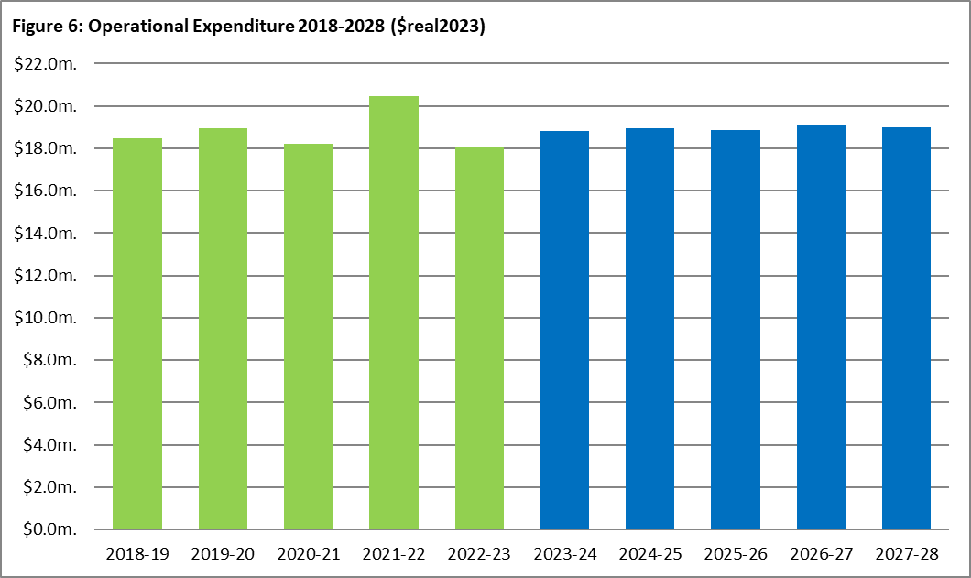
Graph 18: Actual and forecast operational expenditure. Refer to Graph 12 on Page 22 for proportional split between Non-Controllable and Controllable. Expenditure in 2021-22 includes $2.1M of expenditure related to the Business Transformation Project, which has been removed from the base year.

Base Year (2021-22) Operational Expenditure Assumptions
Westernport Water’s base year operational expenditure is modelled on 2021‐22 actual expenditure which reconciles to the audited financial statements and audited regulatory account data. Although additional uncontrollable expenditure was previously experienced, no pass through of costs is proposed from the current period into the next regulatory period. Operational trends and historical performance outlined in the Performance section on pages 22-24 was taken into account in the baseline assumptions.
The baseline has been constructed using a Base Step Trend (BST) forecast approach. The core components of this BST are:
- Base year, including the 2.7% efficiency of the base year and forecast for 2022-23, and non-recurrent and recurrent adjustments)
- Base year extrapolation (application of efficiency and growth factors as detailed below, including treatment of the factors for the intermediate year 2022-23).
- Base year adjustments quantified as set out in the ESC financial template in Table 26 detailed below.
- Base year adjustments have been removed to ensure improved customer value.
Table 26: Base Step Change Forecast
Base Step Change Forecast  ($m, real2023) | 2021-22 | 2022-23 | 2023-24 | 2024-25 | 2025-26 | 2026-27 | 2027-28
Base Year | $18.88 | - | - | - | - | - | -
Base Year Adjustments | -$2.49 | - | - | - | - | - | -
Adjusted Base Year | $16.38 | $16.38 | $16.28 | $16.37 | $16.46 | $16.54 | $16.60
Growth | $0.44 | $0.34 | $0.34 | $0.34 | $0.34 | $0.31 | $0.31
Less Efficiency | -$0.44 | -$0.44 | -$0.25 | -$0.24 | -$0.26 | -$0.25 | -$0.26
Net Baseline Movement | - | -$0.10 | $0.09 | $0.09 | $0.08 | $0.06 | $0.05
Adjusted Baseline | $16.38 | $16.28 | $16.37 | $16.46 | $16.54 | $16.60 | $16.65
Forecast Variations to Baseline | - | - | $0.85 | $0.93 | $0.76 | $1.00 | $0.85
Total Controllable Opex | $16.38 | $16.28 | $17.22 | $17.39 | $17.31 | $17.60 | $17.50

Base Year non-recurrent and recurrent expenditure adjustments
Expenditure relating to the development of the price submission, business cases including the Urban Water Strategy 2022, customer engagement and strategic planning have been identified as non‐recurring items in the base year and have subsequently been removed.
Non-recurring expenditure also includes operational expenditure relating to the decision for Westernport Water to decommission its LPG gas network during the current period which was offset by the reduction of non-regulated revenue that the gas business previously provided. An accounting adjustment of $2.1M relating to the partially completed Business Transformation Project finance system implementation has also been removed from the base year assumptions.

Table 27: Base Year (2021-22) Adjustments
Item | ($m,real2023)
Business case preparation | $0.16
PS23 financial modelling (consultants) | $0.08
Urban Water Strategy 2022 development | $0.04
Employee costs – additional communications resource | $0.06
Gas materials and supplies | $0.01
Business Transformation Project account adjustment | $2.10
Total Baseline Adjustment | $2.49

Growth related expenditure
Westernport Water’s growth factor of 2% in the first three years and 1.8% in the last two years reflects an individual assessment of various categories of expenditure that history has shown are strongly tied to increased connections. These include materials and supplies, preventative and reactive maintenance, billing, postage, and fuel consumption.
The growth factor includes adjustments which have been made to electricity and chemicals reflecting the impacts of the additional demand resulting from growth over the period. Bulk water charges for purchasing water have also been included into the baseline which was excluded in the previous regulatory period however, have been required to meet demand during the current period, a trend which is expected to continue.
Forecast Variations to Baseline adjustments
There are three non-growth-related forecast variations to the adjusted baseline included in the regulatory period. These relate to employee costs, electricity costs and operational expenditure directly related to the delivery of capital projects.
Table 28: Forecast Variations to Baseline Adjustments
Item | ($m,real2023)
Employee costs | $1.38
PS23 Capital Expenditure Program – Opex Costs | $3.02
Total Baseline Adjustment | $4.40
a) Employee Costs
A 3% vacancy rate has been incorporated into the overall employee cost assumptions however an additional adjustment to the forecast baseline was required due to the above average 6% vacancy rate experienced in 2021-22. The vacant positions largely related to key personnel in the engineering and maintenance team which were subsequently filled in September 2022. A reduction in FTE of 0.4 from 2025-26 relates to operational efficiencies planned in the people and culture team through the continuation of ICT related improvements to the HR information system.

Westernport Water FTE historical trend
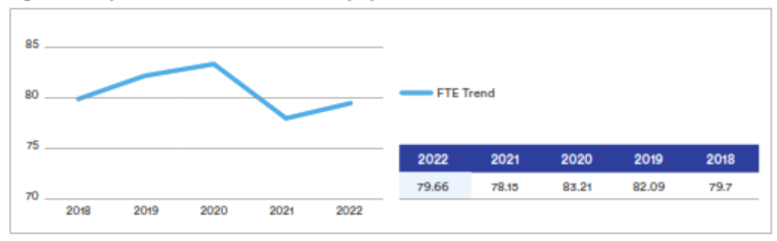
Graph 19: Actual FTE over five years
- PS23 Capex Program – Opex Costs
The capital program will deliver a number of efficiencies including a reduction in electricity costs and FTE over the period however, will also contribute to an increase in operational expenditure of approximately $604k per annum above the baseline. The incremental expenditure is largely related to the preventative maintenance, licence fees and additional initiatives as outlined in the summary tables on page 86-87 resulting from the development of new capital assets.

Operating Expenditure Efficiencies
A forecast average operating expenditure efficiency of 1.5 per cent is proposed, as Westernport Water aims to absorb the following future costs in an effort to minimise expenditure to customers and deliver improved customer value:
- Cost increases associated with forecast higher energy costs by capital investments in renewable energy and exploring opportunities to take advantage of electricity purchasing models as they enter into the market as well as creating efficiencies at our treatment plants in order to offset costs.
- Postage via Australia Post (> 90 per cent of bills are currently sent via mail each quarter). Efforts will be concentrated to continue migrating customers to eBills via the customer SMS campaign
- No labour uplift for future years, with a reduction of 0.4 FTE planned from FY2027.
- Containment of insurance costs through the benefit of the State-wide contract.
- Optimising procurement opportunities through the State-wide contract offers and VicWater and Gippsland Regional Water Alliance initiatives.
- Reducing preventative maintenance spend due to an increased investment in renewals activity
- Reduced dependency on consultants and contractors resulting from organisational realignments completed in 2022-23
- Westernport Water has examined the proportion of labour associated with capital works and will continue to capitalise labour accurately to reflect job descriptions and functions. These assumptions have been built into the capital program including the efficiencies from the delivery of projects. As a result, labour expenditure will reduce with a planned reduction in FTE of 0.4 per cent from year three.

Key programs to support our outcomes from the results of customer engagement will also be absorbed within current expenditure levels. This includes:
- Supporting our vulnerable customers by increasing hardship grants, funded via a reprioritisation of debt recovery funds.
- Implementing a coordinated communications approach to help customers better understand who we are and how what we do represents value for money.
- A dedicated focus on customer data collection, so we can increase volumes of electronic notifications to keep customers more informed about planned and emergency works and their utility bills.
- As a result of these initiatives, a forecast average operating expenditure efficiency of 1.5 per cent is proposed per annum.

Growth Rate vs Cost Efficiency
Growth projections used to forecast baseline operating expenditure are consistent with projections used in the ‘Demand – Customer Growth’ section on page 88 of this submission. The average annualised growth ranges from 2.0% to 1.8% during the next regulatory period.

Historically, above forecast growth experienced during the regulatory period resulted in an overspend of operational expenditure and while any growth above forecast will present a similar risk in this period we have only priced for certainty and have based growth on current predictions. An extensive review process of historical expenditure was undertaken which identified only the operational costs directly impacted by growth as detailed in the Growth related and forecast adjusted baseline expenditure. On this basis we have proposed that the increase in operational expenditure growth rate is below the actual growth expected for the period. This reflects the detailed assessment performed that indicates that not all operational expenditure will increase directly in-line with growth however as previously outlined in the “Performance (2018-23) – Operating Expenditure’ section of this submission, there is a definite correlation.

The current forecast customer growth related operational expenditure of between 2.0 and 1.8 per cent per annum is calculated against the increase in operational expenditure relating to customer growth to the net efficiency achieved in each year.

Full details are provided in the table below:

Table 29: Operating expenditure efficiency vs Growth
 | 2021-22 | 2022-23 | 2023-24 | 2024-25 | 2025-26 | 2026-27 | 2027-28
Growth | 2.7% | 2.0% | 2.0% | 2.0% | 2.0% | 1.8% | 1.8%
Efficiency | 2.7% | 2.7% | 1.5% | 1.5% | 1.5% | 1.5% | 1.5%
Net Efficiency (Growth less efficiency) | 0.0% | -0.7% | 0.5% | 0.5% | 0.5% | 0.3% | 0.3%
In addition, our ongoing commitment to maintaining a focus on efficiencies will extend to reviewing and improving our business processes, optimising procurement practices and continuing our focus on technology to leverage off existing and new data and digital capabilities. All operational expenditure cost increases resulting from the expected growth have been individually assessed and are calculated independently of any efficiencies identified in this submission.

Operational Expenditure Cost Allocations
Operational costs are allocated across water, wastewater and recycled water. Where the expense is not clearly defined, it is allocated by a percentage split based on the actual direct costs as per the base year. This methodology and percentage allocations are in line with historic operational cost allocations used during the current regulatory period (2018‐2023).
Table 30: Operational Expenditure by % Basis of Cost Allocation
Basis of Cost Allocation (%) | Water | Wastewater | Recycled
Operations and Maintenance | 60% | 39% | 1%
Treatment | 52% | 43% | 5%
Customer Service and Billing | 52% | 48% | <1%
Corporate and IT | 49% | 50% | <1%

Westernport does not foresee significant change to forecast levels of other revenue and non-prescribed services in the next regulatory period and as per the current period no operational cost allowance has been made due to immateriality.
Operational expenditure has been accounted for over two categories, non‐controllable and controllable expenditure.

Non‐Controllable Expenditure
Non‐controllable operational expenditure includes items identified which are beyond the authority and cost control of the organisation during the regulatory period. These include Melbourne Water Tariffs, Environmental Contribution, Defined Benefits Superannuation and mandatory licence fees relating to DoH, ESC and EPA.
Table 31: Non-Controllable Operational Expenditure by Service ($m, real2023)
Non-Controllable Opex | 2021-22 | 2022-23 | 2023-24 | 2024-25 | 2025-26 | 2026-27 | 2027-28
Bulk Charges | $0.344 | $0.344 | $0.416 | $0.432 | $0.447 | $0.447 | $0.447
Licence Fees | $0.046 | $0.045 | $0.049 | $0.049 | $0.049 | $0.049 | $0.049
Environmental Contribution | $0.552 | $0.540 | $0.524 | $0.509 | $0.494 | $0.480 | $0.466
Other Non-Controllable | $0.02 | $0.02 | $0.02 | $0.02 | $0.02 | $0.02 | $0.02
Total - Water | $0.958 | $0.944 | $1.004 | $1.004 | $1.004 | $0.990 | $0.976
Bulk Charges | - | - | - | - |  | -
Licence Fees | $0.046 | $0.045 | $0.049 | $0.049 | $0.049 | $0.049 | $0.049
Environmental Contribution | $0.552 | $0.540 | $0.524 | $0.509 | $0.494 | $0.480 | $0.466
Other Non-Controllable | $0.02 | $0.02 | $0.02 | $0.02 | $0.02 | $0.02 | $0.02
Total - Wastewater | $0.613 | $ 0.600 | $0.587 | $0.572 | $0.557 | $0.543 | $0.529
Bulk Charges | - | - | - | - | - | - | -
Licence Fees | - | - | - | - | - | - | -
Environmental Contribution | - | - | - | - | - | - | -
Other Non-Controllable | - | - | - | - | - | - | -
Total – Recycled Water | - | - | - | - | - | - | -
Total - Bulk Charges | $0.344 | $0.344 | $0.416 | $0.432 | $0.447 | $0.447 | $0.447
Total - Licence Fees | $0.092 | $0.090 | $0.097 | $0.097 | $0.097 | $0.097 | $0.097
Total - Environmental Contributions | $1.105 | $1.080 | $1.049 | $1.018 | $0.988 | $0.960 | $0.932
Total - Other Non-Controllable | $0.03 | $0.03 | $0.03 | $0.03 | $0.03 | $0.03 | $0.03
Total Non-Controllable | $1.571 | $1.543 | $1.591 | $1.576 | $1.561 | $1.533 | $1.505

Westernport Water has a number of non‐controllable operating expenditure items that are not subject to the growth adjusted efficiency calculation as detailed below:

Bulk Water
Bulk water costs from Melbourne Water are a non‐controllable expenditure item and have been separately identified. Forecast bulk water expenditure has been estimated from Melbourne Water’s Price Determination 2021. The price path from Melbourne Water 2021‐22 onwards has been estimated as zero. Forecast non‐controllable operating expenditure for bulk water is $2.19m ($real2023) over the next regulatory period. It has been estimated using our expected usage which is below our entitlement volume of 1,000ML.

Table 32: Melbourne Water Tariffs ($m,real 2023)
 | 2023-24 | 2024-25 | 2025-26 | 2026-27 | 2027-28 | Total
Headworks – Greater Yarra Thomson | $0.360 | $0.374 | $0.388 | $0.388 | $0.388 | $1.90
Transfer – Greater Yarra Thomson | $0.06 | $0.06 | $0.06 | $0.06 | $0.06 | $0.30

ESC Licence Fees
The forecast ESC Licence Fee is based on the average of 2020-21 ($34,889) and 2021-22 ($32,553). This licence fee is split across water and sewerage based on revenue. For practicality purposes recycled water is not allocated an amount of this charge due to its size.

Table 33: Non-Controllable ESC License Fees ($m,real 2023)
 | 2023-24 | 2024-25 | 2025-26 | 2026-27 | 2027-28 | Total
ESC Licence Fee | $0.03 | $0.03 | $0.03 | $0.03 | $0.03 | $0.14*
*Difference due to rounding

DoH Licence Fees
The Victorian Department of Health charges a drinking water licence fee. This fee has been conservatively estimated to be $0.004 million per annum in $real2023 based on the 2021-22 financial year actual spend.

Table 34: Non-Controllable DoH Licence Fees ($m,real 2023)
 | 2023-24 | 2024-25 | 2025-26 | 2026-27 | 2027-28 | Total
DoH Licence Fee | $0.04 | $0.04 | $0.04 | $0.04 | $0.04 | $0.18

EPA Licence Fees
Environment Protection Authority Victoria (EPA) charge water businesses for sewage discharges licences. The forecast non‐controllable EPA licence fees are based on current base year expenditure as shown below.

Table 35: Non-Controllable EPA Licence Fees ($m,real 2023)
 | 2023-24 | 2024-25 | 2025-26 | 2026-27 | 2027-28 | Total
EPA Licence Fee | $0.03 | $0.03 | $0.03 | $0.03 | $0.03 | $0.17*
*Difference due to rounding

Environmental Contribution Levy
The Environmental Contribution Levy (ECL) is a charge levied by the Victorian Government on revenue of water businesses. For urban water businesses, 5 per cent of revenue is payable. The forecast non‐ controllable ECL is shown below in $real2023. In 2021-22, Westernport Water paid $1,075,400 ($real2023) for the ECL. From 1 July 2020, the levy was re‐based at 5 per cent of 2018-19 revenue, which has been the basis for the ECL calculated and presented in the table below.

Table 36: Non-Controllable ECL Licence Fees ($m,real 2023)
 | 2023-24 | 2024-25 | 2025-26 | 2026-27 | 2027-28 | Total
ECL Licence Fee | $1.05 | $1.02 | $0.99 | $0.96 | $0.93 | $4.95

Defined Benefits Superannuation
For the pricing period commencing 1 July 2023, Westernport Water will continue to claim $30k per annum ($nominal) in accordance with the 2013 ESC Decision. Also note that Westernport Water is not forecasting any additional call on funds.

Table 37: Non-Controllable Other - Defined Benefits Superannuation ($m, real2023)
 | 2023-24 | 2024-25 | 2025-26 | 2026-27 | 2027-28 | Total
Defined Benefits Superannuation | $0.03 | $0.03 | $0.03 | $0.03 | $0.03 | $0.15

Controllable Expenditure
Westernport Water’s strong focus on cost containment will limit increases to operational expenditure throughout the regulatory period with small increases associated with the treatment of more drinking water, management of increased wastewater inflows and ongoing expenditure relating to the maintenance of an increased asset base.

Table 38: Controllable Operational Expenditure by Service ($m,real2023)
Controllable Opex | 2021-22 | 2022-23 | 2023-24 | 2024-25 | 2025-26 | 2026-27 | 2027-28
Operations and Maintenance | $3.698 | $3.698 | $3.786 | $3.798 | $3.780 | $3.823 | $3.856
Treatment | $1.868 | $1.868 | $2.046 | $2.066 | $2.036 | $2.108 | $2.162
Customer Service and Billing | $0.846 | $0.846 | $0.846 | $0.846 | $0.846 | $0.846 | $0.846
GSL Payments | - | - | - | - | - | - | -
Corporate | $4.539 | $3.344 | $3.426 | $3.526 | $3.549 | $3.580 | $3.289
Other Operating Expenditure | - | - | - | - | - | - | -
Total - Water | $10.952 | $9.756 | $10.105 | $10.236 | $10.212 | $10.358 | $10.154
Operations and Maintenance | $2.566 | $2.566 | $2.673 | $2.684 | $2.667 | $2.710 | $2.742
Treatment | $1.107 | $1.107 | $1.285 | $1.305 | $1.276 | $1.347 | $1.402
Customer Service and Billing | $0.574 | $0.574 | $0.574 | $0.574 | $0.574 | $0.574 | $0.574
GSL Payments | - | - | - | - | - | - | -
Corporate | $3.037 | $1.842 | $1.943 | $1.951 | $1.939 | $1.968 | $1.990
Other Operating Expenditure | - | - | - | - | - | - | -
Total - Wastewater | $7.284 | $6.089 | $6.475 | $6.514 | $6.455 | $6.598 | $6.707
Operations and Maintenance | $0.057 | $0.057 | $0.057 | $0.057 | $0.057 | $0.057 | $0.057
Treatment | $0.491 | $0.491 | $0.491 | $0.491 | $0.491 | $0.491 | $0.491
Customer Service and Billing | $0.014 | $0.014 | $0.014 | $0.014 | $0.014 | $0.014 | $0.014
GSL Payments | - | - | - | - | - | - | -
Corporate | $0.077 | $0.077 | $0.077 | $0.077 | $0.077 | $0.077 | $0.077
Other Operating Expenditure | - | - | - | - | - | - | -
Total – Recycled Water | $0.640 | $0.640 | $0.640 | $0.640 | $0.640 | $0.640 | $0.640
Total - Operations and Maintenance | $6.321 | $6.321 | $6.516 | $6.540 | $6.504 | $6.590 | $6.656
Total - Treatment | $3.467 | $3.467 | $3.823 | $3.862 | $3.803 | $3.946 | $4.055
Total - Customer Service and Billing | $1.434 | $1.434 | $1.434 | $1.434 | $1.434 | $1.434 | $1.434
Total - GSL Payments | - | - | - | - | - | - | -
Total - Corporate | $7.653 | $5.262 | $5.446 | $5.554 | $5.565 | $5.625 | $5.356
Total - Other Operating Expenditure | - | - | - | - | - | - | -
Total Controllable Opex | $18.876 | $16.485 | $17.220 | $17.390 | $17.307 | $17.596 | $17.501
*The implementation of a new finance system was discontinued in February 2022 after an independent review to pursue more cost-effective alternatives. This resulted in an accounting adjustment in the 2021-22 financial year to reallocate BTP project related costs incurred between 2019 and 2022 to operating expenditure which was removed from base year assumptions.

Labour
Wages and salaries include an anticipated 2 per cent forecast increase, in line with current Enterprise Agreement (EA) salary assumptions and an additional 0.5 per cent superannuation increase each year until 2025-26 (EA has 2% p.a. nominal, forecast is -0.10% real increase using the fisher equation before superannuation increase). Total staff numbers have increased by 2.4 from PS1 due to an increase in staffing demands relating to growth and compliance activities with a 0.4 reduction planned in the 2025-26 year. A 3% vacancy rate has been included in the assumptions, based on historical FTE over the past five years.

Table 39: Forecast Labour Costs and Full-Time Equivalent (FTE) Staff ($m, real2023)
FTE | 2022-23 | 2023-24 | 2024-25 | 2025-26 | 2026-27 | 2027-28
Opex FTE | 75.6 | 75.6 | 75.6 | 75.2 | 75.2 | 75.2
Capex FTE | 9 | 9 | 9 | 9 | 9 | 9
Total FTEs | 84.6 | 84.6 | 84.6 | 84.2 | 84.2 | 84.2
Average cost per FTE $’000s  (salary and on-cost) | $114.7 | $114.1 | $112.9 | $111.8 | $110.7 | $114.7
Total labour operating expenditure $000’000s | $9.18 | $9.14 | $9.09 | $8.99 | $8.90 | $8.82

Table 40: FTE Costs By Service ($m, real2023)
Cost Allocation | 2022-23 | 2023-24 | 2024-25 | 2025-26 | 2026-27 | 2027-28
Water | $5.508 | $5.484 | $5.454 | $5.394 | $5.340 | $5.292
Wastewater | $3.580 | $3.565 | $3.545 | $3.506 | $3.471 | $3.440
Recycled | $0.092 | $0.091 | $0.091 | $0.090 | $0.089 | $0.088
Total | $9.180 | $9.140 | $9.090 | $8.990 | $8.900 | $8.820

Graph 20: Actual and forecast expenditure on Westernport Water staff.

Electricity
Electricity costs are anticipated to increase in the short term in line with market trends. However, from 2024/25, energy consumption is expected to fall following optimisation projects and investment in behind the meter renewables.

Table 41: Electricity ($m,real2023)
 | 2022-23 | 2023-24 | 2024-25 | 2025-26 | 2026-27 | 2027-28
Electricity | $0.753 | $0.775 | $0.775 | $0.735 | $0.731 | $0.744

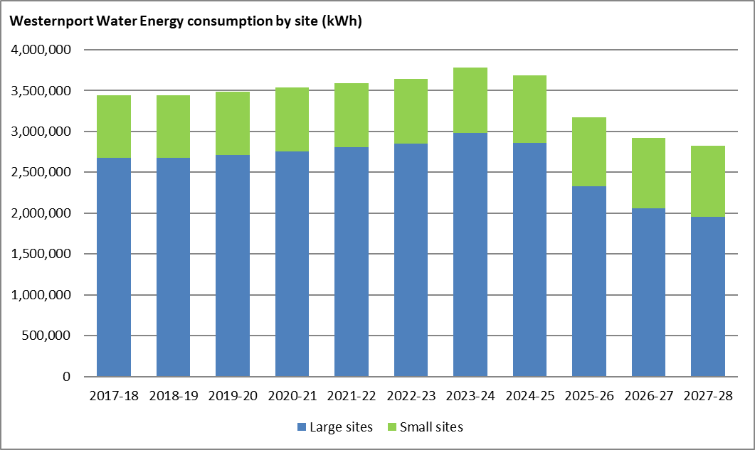
Graph 21: Actual and forecast energy consumption by site ($real2023).

Chemicals
Chemical usage is expected to remain in line with the base year and incorporates increased demand assumptions with the exception of a one-off spend increase in 2026-27 which relates to a carbon change over treatment which occurs once every five years. Significant reductions in chemical expenditure were realised in the current regulatory period following three consecutive years of good quality raw water. Procurement savings achieved through the Gippsland Regional Water Alliance are expected to continue.

Table 42: Chemicals ($m,real2023)
 | 2022-23 | 2023-24 | 2024-25 | 2025-26 | 2026-27 | 2027-28
Chemicals – Water Treatment | $0.300 | $0.326 | $0.326 | $0.326 | $0.326 | $0.326
Chemicals – Wastewater (Odour) | $0.032 | $0.038 | $0.038 | $0.038 | $0.078 | $0.038
Total | $0.332 | $0.365 | $0.365 | $0.365 | $0.405 | $0.365

Graph 22: Actual and forecast energy consumption by site ($real2023).

Information Technology
Westernport Water has reviewed system needs and infrastructure requirements to improve performance reliability and effectiveness. This optimisation process will ensure that systems are aligned and integrated where needed, eliminate the need for double handling and rework and ensure the quality and availability of our data. Westernport Water will deliver the Information and Communications Technology Roadmap, which will ensure the business requirements of employees and the evolving expectations of customers for reliable, accessible, efficient and timely information and services are met.
Increases in expenditure from 2023-24 are largely attributed to project-related operational expenses and changes in reporting requirements to ensure compliance under FRD 22H – ICT expenditure and the ongoing costs associated with cloud-based technologies, particularly SaaS. The capital investment in ICT through the Information and Communications Technology Roadmap will result in operational expenditure however will deliver significant efficiencies through the automation of the process, resulting in a reduction of FTE across future regulatory periods. Refer to pages 81-82 for more information on operational expenditure relating to capital projects.

Table 43: Information Technology ($m,real 2023)
 | 2022-23 | 2023-24 | 2024-25 | 2025-26 | 2026-27 | 2027-28
Water | $0.800 | $0.886 | $0.932 | $0.882 | $1.024 | $1.024
Wastewater | $0.800 | $0.886 | $0.932 | $0.882 | $1.024 | $1.024
Total | $1.600 | $1.772 | $1.865 | $1.763 | $2.047 | $2.047

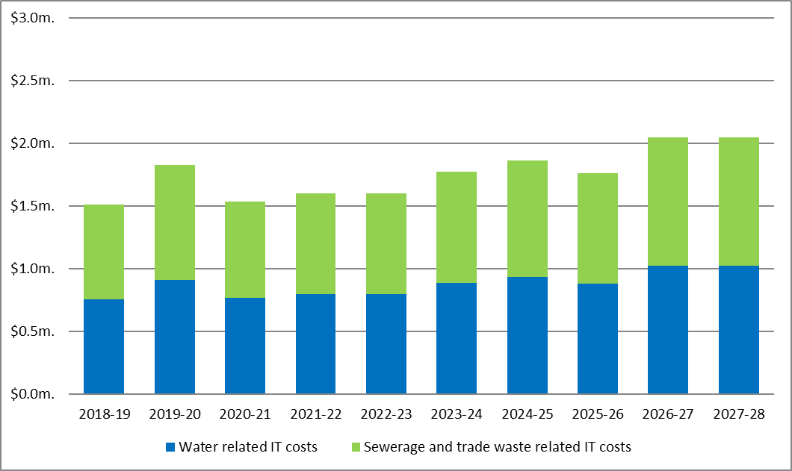
Graph 23: Actual and forecast information technology expenditure by product ($real2023).

Operating Expenditure by Outcome
Westernport Water's proposed adjustments to operational expenditure are detailed by driver and outcome below. Customer value is expressed for each adjustment via each outcome and its associated output targets from page 36-46.

Table 44: Additional Operational Expenditure by Driver
Driver – Additional Opex | 2023-24 | 2024-25 | 2025-26 | 2026-27 | 2027-28 | PS23 OPEX Totals
Compliance | $70,000 | $201,893 | $89,941 | $70,284 | $63,041 | $495,160
Growth | $60,000 | $60,000 | $100,000 | $125,000 | $85,000 | $430,000
Improvement | $238,000 | $229,550 | $348,300 | $442,300 | $457,800 | $1,715,950
Renewals | $63,000 | $63,000 | -$60,000 | $170,000 | $143,000 | $379,000
Total | $431,000 | $554,443 | $478,241 | $807,584 | $748,841 | $3,020,110

Table 45: Project-Related Additional Operational Expenditure by Outcome
Project – Additional Opex | 2023-24 | 2024-25 | 2025-26 | 2026-27 | 2027-28 | PS23 OPEX Totals
Plant Improvement Program | - | - | - | $10,000 | $15,500 | $25,500
Customer SMS Campaign | $5,000 | $5,000 | $5,000 | $5,000 | $5,000 | $25,000
Be there when I need you | $5,000 | $5,000 | $5,000 | $15,000 | $20,500 | $50,500
Asset Management Information System | - | - | -$123,000 | $57,000 | $57,000 | -$9,000
Increased Customer Hardship Support | $10,000 | $10,000 | $10,000 | $10,000 | $10,000 | $50,000
Keep my essential services affordable | $10,000 | $10,000 | -$113,000 | $67,000 | $67,000 | $41,000
Minor Compliance Projects | $20,000 | $10,000 | - | - | $14,000 | $44,000
OH&S Compliance Program | $50,000 | $50,000 | $50,000 | $50,000 | $50,000 | $250,000
Water Quality Continuous Improvement Program | $60,000 | $60,000 | $100,000 | $110,000 | $70,000 | $400,000
ICT Roadmap | $5,000 | $97,800 | $109,050 | $328,050 | $328,050 | $867,950
Water Distribution and Storage Improvement | $10,500 | $500 | $500 | $500 | $500 | $12,500
Candowie & Ian Bartlet Water Purification Plant Civil, Mechanical and Electrical | $20,000 | $20,000 | $20,000 | $20,000 | $43,000 | $123,000
Corporate Improvement and Renewals | $1,000 | $1,000 | $1,000 | $1,000 | $1,000 | $5,000
Water Literacy Education & Training | $192,000 | $132,000 | $237,000 | $102,000 | $112,000 | $775,000
Provide me with high quality drinking water | $358,500 | $371,300 | $517,550 | $611,550 | $618,550 | $2,477,450
Bio-gas Waste to Energy | - | - | - | $30,000 | $30,000 | $60,000
Renewable Energy Generation | - | - | - | -$22,204 | -$28,659 | -$50,863
Treatment Plant Energy Efficiency | - | -$22,125 | -$45,370 | -$45,370 | -$45,370 | -$158,235
Recycled Water Wetland Storage | - | - | - | $15,000 | $15,000 | $30,000
Odour & Corrosion Mitigation Program | $10,000 | $16,250 | $16,250 | $16,250 | $16,250 | $75,000
Sewage Pump Station Improvement Program | - | - | $2,500 | $2,500 | $2,500 | $7,500
Sewer Mains and Junction Renewals | - | - | - | $50,000 | - | $50,000
Inflow & Infiltration Monitoring, LGC Offsets, SPS Security | $47,500 | $174,018 | $95,311 | $67,858 | $53,071 | $437,758
Reduce your environmental impact and adapt to climate change | $57,500 | $168,143 | $68,691 | $114,034 | $42,791 | $451,160
Total | $431,000 | $554,443 | $478,241 | $807,584 | $748,841 | $3,020,110

9 Demand
Key Points
- Residential growth has been forecast to align with Victoria in Future 2021 estimates – 2.24% from 2021 to 2026, slowing to 1.97% from 2026 to 2031.
- Non-residential growth and overall consumption have been heavily influenced by COVID-19 years. Westernport Water has deemed these years to be atypical and is relying on 5-year averages in these areas to smooth out any anomalies and support forecasts.
- Westernport Water anticipates moderate growth and a changing demographic heading into the next regulatory period.
- Growth in residential recycled water customers is predicted to slow during the next regulatory period.

Customer Growth
The 2023 Water Price Review Guidance Paper states that demand forecasts should be based on the latest available ‘Victoria in Future’ (VIF) estimates provided by the Victorian Government, with variations and underlying assumptions clearly explained. VIF is the projection of population and households, based on trends and assumptions for births, life expectancy, migration, and living arrangements across all of Victoria.
Westernport Water received a draft of the VIF 2021 report from the Department of Environment, Land, Water and Planning in December 2021. As per the 2018 Price Review, VIF forecasts for Bass Coast Shire have been used. The results are divided into two statistical areas - Phillip Island and Wonthaggi. As Westernport Water’s service area only encompasses some of the Wonthaggi area, a weighted average of the two growth rates has been used.
Table 46: VIF Dwellings Forecasts for Bass Coast Shire Council
Dwellings Forecast |  | 30-Jun-16 | 30-Jun-21 | 30-Jun-26 | 30-Jun-31
Bass Coast | Permanent Dwellings | 23,956 | 28,930 | 32,589 | 36,099
 | Occupied Dwellings | 15,469 | 17,973 | 20,426 | 22,664
Phillip Island | Permanent Dwellings | 11,372 | 12,442 | 13,792 | 15,140
 | Occupied Dwellings | 4,947 | 5,780 | 6,471 | 7,105

Additional VIF population growth projections have been considered which indicates an increase in permanent occupied dwellings from 43.5% in 2016 to 46.9% by 2026. This forecast trend corresponds with recent Census 2021 data, albeit more moderate than the actual. The following table shows the 2021 VIF forecasts for dwellings and the associated growth rates for the Bass Coast Shire and for the smaller area of Phillip Island.
Table 47: VIF Growth Forecasts for Bass Coast Shire Council
Growth Forecast |  | 2016 to 2021 | 2021 to 2026 | 2026 to 2031
Bass Coast | Permanent Dwellings | 3.85% | 2.41% | 2.07%
 | Occupied Dwellings | 3.05% | 2.59% | 2.10%
Phillip Island | Permanent Dwellings | 1.81% | 2.08% | 1.88%
 | Occupied Dwellings | 3.16% | 2.28% | 1.89%

Proposed residential growth rates for the Westernport Water service area as a weighted average are detailed below.
WPW Weighted Growth Forecast – Residential | 2021 to 2026 | 2026 to 2031
Permanent Dwellings | 2.24% | 1.97%

For pricing purposes, the connections data has been forecast using the mid‐year data point. This approach assumes that new customers come on evenly through the year, rather than assuming all new customers come on at the start of the year. The mid‐year estimate for pricing is most equitable. Non‐residential forecasts have assumed a five-year historical average. However, no new large non‐residential customers are anticipated. As such, no growth has been applied to connections above 50mm. The Westernport Water Weighted Growth Forecast utilised in the Operational Expenditure assumptions on page 78 is detailed in the table below:
WPW Weighted Growth Forecast | 2024 to 2026 | 2027 to 2028
Annualised total growth | 2.02% | 1.8%

Water Connections
Residential water connections are assumed to grow at 2.24% until the end of 2025-26, and then 1.97% from 2026-27. Forecast residential water connections for pricing are shown below. No net growth is expected in unconnected vacant land. As vacant land is developed, it is accounted for in new connected customers (forecast aligns with 2018 Price Review).
Table 48: Westernport Water Residential Water Connections
Connection | 2021-22 | 2022-23 | 2023-24 | 2024-25 | 2025-26 | 2026-27 | 2027-28
Connected | 17,033 | 17,415 | 17,805 | 18,203 | 18,611 | 18,978 | 19,352
Unconnected – Vacant Land | 1,520 | 1,520 | 1,500 | 1,500 | 1,500 | 1,500 | 1,500
 |  |  | 2028-29 | 2029-30 | 2030-31 | 2031-32 | 2032-33
Connected |  |  | 19,700 | 20,055 | 20,416 | 20,783 | 21,158
Unconnected – Vacant Land |  |  | 1,500 | 1,500 | 1,500 | 1,500 | 1,500
Non‐residential (or non‐domestic) customer growth is forecast to align with average growth over the last five years, excluding water connections above 50mm (1.17%). Historically, there has been no material growth in large non‐residential water connections and no new customers are anticipated.
Table 49: Westernport Water Non-Residential Water Connections
Meter Size | 2021-22 | 2022-23 | 2023-24 | 2024-25 | 2025-26 | 2026-27 | 2027-28
20mm | 845 | 868 | 878 | 888 | 898 | 909 | 920
25mm | 185 | 191 | 193 | 195 | 197 | 199 | 201
32mm | 37 | 38 | 38 | 38 | 38 | 38 | 38
40mm | 22 | 22 | 22 | 22 | 22 | 22 | 22
50mm | 22 | 22 | 22 | 22 | 22 | 22 | 22
65mm | 0 | 0 | 0 | 0 | 0 | 0 | 0
80mm | 2 | 2 | 2 | 2 | 2 | 2 | 2
100mm | 2 | 2 | 2 | 2 | 2 | 2 | 2
150mm | 1 | 1 | 1 | 1 | 1 | 1 | 1
 |  |  | 2028-29 | 2029-30 | 2030-31 | 2031-32 | 2032-33
20mm |  |  | 933 | 944 | 955 | 966 | 977
25mm |  |  | 204 | 206 | 208 | 210 | 213
32mm |  |  | 39 | 40 | 41 | 42 | 43
40mm |  |  | 23 | 24 | 24 | 25 | 25
50mm |  |  | 23 | 24 | 24 | 24 | 24
65mm |  |  | 0 | 0 | 0 | 0 | 0
80mm |  |  | 2 | 2 | 2 | 2 | 2
100mm |  |  | 2 | 2 | 2 | 2 | 2
150mm |  |  | 1 | 1 | 1 | 1 | 1
Sewerage Connections
Growth in sewerage connections has been assumed at the same rate as water connections, in accordance with VIF 2021 for domestic (2.24% until the end of 2025-26, and then 1.97% from 2026-27) and 5-year historical growth for non-domestic (1.17%). For unconnected vacant land, forecasts are aligned to the number of water customers for unconnected vacant land.
Table 50: Westernport Water Residential Sewerage Connections
Connection | 2021-22 | 2022-23 |  | 2023-24 |  | 2024-25 |  | 2025-26 | 2026-27 | 2027-28
Residential | 16,060 | 16,420 |  | 16,788 |  | 17,144 |  | 17,528 | 17,873 | 18,225
Non-Residential | 654 | 665 |  | 673 |  | 681 |  | 689 | 697 | 705
Unconnected – Vacant Land | 2,044 | 1,509 |  | 1,500 |  | 1,500 |  | 1,500 | 1,500 | 1,500
 |  |  | 2028-29 |  | 2029-30 |  | 2030-31 |  | 2031-32 | 2032-33
Residential |  |  | 18,553 |  | 18,887 |  | 19,227 |  | 19,573 | 19,925
Non-Residential |  |  | 713 |  | 721 |  | 729 |  | 738 | 474
Unconnected – Vacant Land |  |  | 1,500 |  | 1,500 |  | 1,500 |  | 1,500 | 1,500

Cistern Forecast
Westernport Water maintains cistern charges for non‐residential customers. This charge is only applicable to those non‐residential customers that have more than two cisterns. Forecast cistern charges have been estimated using Westernport Water’s five year-average growth rate for non‐residential customers (1.17%), multiplying it by the average number of additional cisterns (more than 2) per customers (16.14 additional toilets). Cistern forecasts can be difficult due to the changing nature of non-domestic businesses and the outcomes of regular in-field audits.
Table 51: Westernport Water Non-Residential Cistern Forecast
Connection | 2021-22 | 2022-23 | 2023-24 | 2024-25 | 2025-26 | 2026-27 | 2027-28
Customers | 170 | 173 | 176 | 179 | 182 | 185 | 188
Cistern Charges | 2,743 | 2,790 | 2,838 | 2,886 | 2,935 | 2,985 | 3,036
 |  |  | 2028-29 | 2029-30 | 2030-31 | 2031-32 | 2032-33
Customers |  |  | 191 | 194 | 197 | 200 | 203
Cistern Charges |  |  | 3,063 | 3,091 | 3,119 | 3,147 | 3,175

Recycled Water Connections
Growth in residential recycled water customers is predicted to slow during the next regulatory period. Westernport Water anticipates approximately 50 new residential Class‐A recycled water customers per annum based on remaining development in Cowes (Shoalhaven Development), infill for existing developments (Island View and Keams) and new developments (Edge Water and Westernport View) in San Remo. Only one additional non-residential customer is anticipated in the next period following the awarding of a recycled water business grant in the current period.
Table 52: Westernport Water Recycled Water Connections
Connection | 2021-22 | 2022-23 | 2023-24 | 2024-25 | 2025-26 | 2026-27 | 2027-28
Residential | 996 | 1,046 | 1,096 | 1,146 | 1,196 | 1,246 | 1,296
Non-Residential | 11 | 11 | 12 | 12 | 12 | 12 | 12
 |  |  | 2028-29 | 2029-30 | 2030-31 | 2031-32 | 2032-33
Residential |  |  | 1,346 | 1,396 | 1,446 | 1,496 | 1,546
Non-Residential |  |  | 12 | 12 | 12 | 12 | 12

Demand Scenario Analysis
As part of the development of the Urban Water Strategy 2022, Westernport Water reviewed its water demand forecast to 2070. Water demand is typically difficult to forecast because it varies depending on weather conditions, changing population and water use behaviour. The Westernport region has an additional level of complexity associated with the large peaks in non-permanent population in summer and large number of tourists that visit the region. Furthermore, uncertainty has increased due to the changes brought about by COVID-19 in the way people work, and the potential for a proportion of the non-permanent residents to become permanent residents.
To reflect the uncertainty in forecast demand, Westernport Water developed a baseline demand forecast with an upper and lower bound to reflect a probable range of demand growth. These forecasts were based on historic water consumption, population growth projections for the area and recent trends in water use. Due to the high degree of uncertainty, the long-term climate change impact on demand was not quantified. Sensitivity testing showed that climate input into the demand model was insignificant when compared to the increase in demand during summer/change in property occupancy due to COVID-19, and would have less of an impact, compared to the 20% increase applied to the high demand scenario from the aforementioned factors.
Analysis of Westernport Water consumption data indicated a difference in the water consumption rates between new and old connections. On average, new residential connections use less water than existing connections. This observed difference between existing and new connections is due to new connections having improved water efficiency and typically smaller lot sizes then the existing connections. Similar differences have been observed in larger towns and metropolitan areas throughout Victoria, noting that the differences tend to be reducing as existing connections are retrofitted with more water efficient appliances and existing lots are subdivided.
Recent trends in water use help develop a picture of future water use, however large uncertainties remain. There are some areas of uncertainty that Westernport Water will not be able to accurately predict, such as the impact of climate on water consumption, or future government water conservation policy. There is however scope for Westernport Water to improve its demand forecasts through better understanding consumer behaviour, particularly differences in water consumption habits between permanent residents of the region and non-permanent. This is an increasing factor as evidenced by the number of customers that changed their primary billing address during the COVID-19 pandemic.
Upper Lower Demand Bound
A lower demand bound, shown in the graph below, was developed based on the unrestricted demand and a baseline demand forecast with an applied factor of -10% to reflect uncertainty surrounding dwelling occupancy rates and water consumption per connections as a result of COVID-19.
An upper demand bound, shown in the graph below, was developed based on unrestricted demand with an applied factor of +20% to reflect uncertainty surrounding dwelling occupancy rates and water consumption per connections as a result of COVID-19.
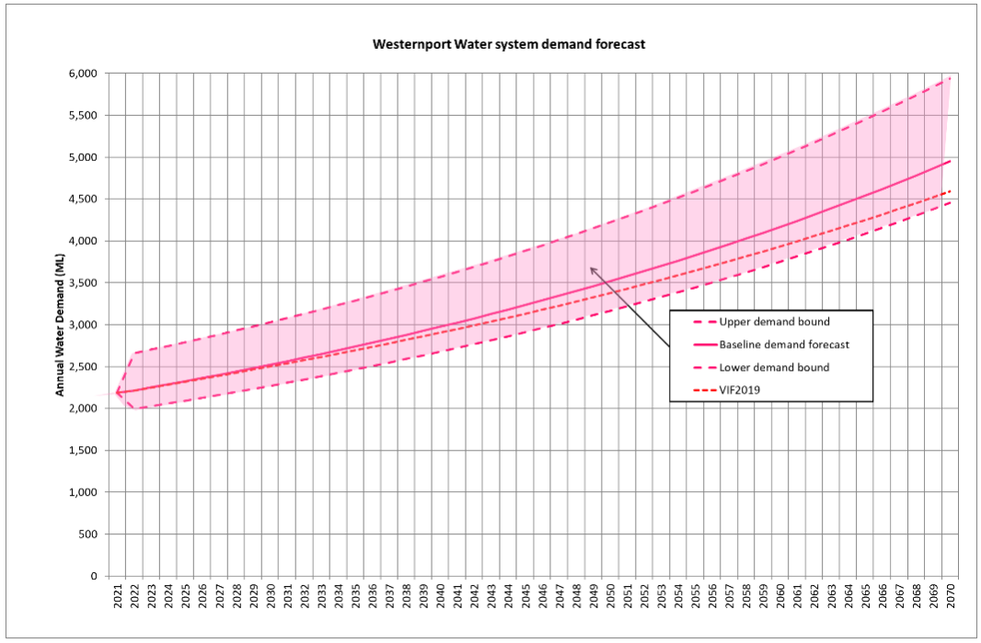Graph 24: Westernport Water 2022 Urban Water Strategy Demand Forecast
It should be noted that from a yield perspective, Westernport Water managed uncertainty relating to climate change by examining ten climate scenarios that were recommended in the 2020 Guidelines for Assessing the Impact of Climate Change on Water Supplies in Victoria by DELWP to represent a bound of possible future supply. Climate change impacts were applied to water sourced from Tennent Creek, Bass River and the Melbourne water supply system for the following upper lower yield bound:

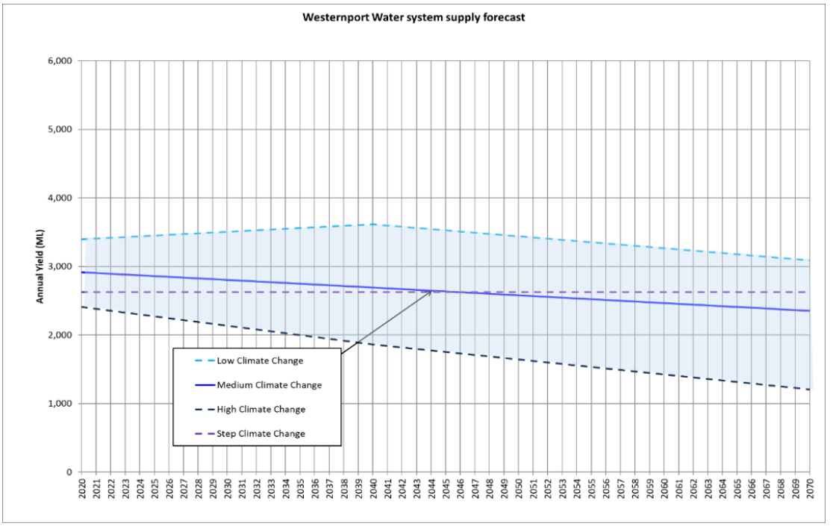
Graph 25: Westernport Water 2022 Urban Water Strategy Supply System Yield Forecast

Residential and Non-Residential Demand
Westernport Water has used historical consumption for the last five years to estimate consumption from 2023-28, which smooths out variations from COVID-19 affected years that may be atypical (Non-residential consumption for 2018-19 was removed from the average as it was heavily influenced by a suspected high-volume water leak):
- Annual residential water connection consumption is forecast at 88 kL
- Annual non-residential water connection consumption is forecast at 651 kL.
Westernport Water has forecast 6% above the 83kL per connection that was used for the Urban Water Strategy 2022. This is because of high average residential consumption in 2021-22. It also recognises the demand scenario analysis, which highlighted that uncertainty is weighted towards more consumption, rather than less due to the changing nature of our service area. We did not seek to exclude COVID-19 affected years as we believe that some customers have made permanent lifestyle changes based on customer billing data. Furthermore, we felt it provides a better price outcome for customers if we take on revenue risk in this area.
Fixed vs Variable Tariff Rebalance
Following a deliberative process, customers supported a minor adjustment to the balance of tariffs to reduce fixed costs and provide customers with greater control over their bill. The rebalance reduces fixed prices by 2% in the first year, with the revenue loss offset by an increase in variable water charges. The change was minor in nature in accordance with customer feedback (p.33). Westernport Water does not believe that the change will be a sufficient price signal to have a material effect on demand.

Price Elasticity
Westernport Water does not anticipate any elasticity in demand forecasts due to price due to the immateriality of a 0.4% price path in the first year and no proposed change for the remaining four years.

Graph 26: Actual and forecast average annual household drinking water consumption.
Graph 27: Actual and forecast average annual non-residential customer drinking water consumption.
Table 53: Actual Average Customer Drinking Water Consumption
Actual Demand | 2017-18 | 2018-19 | 2019-20 | 2020-21 | 2021-22
Residential (kL) | 84 | 89 | 87 | 92 | 89
Non-Residential (kL) | 656 | 811 | 633 | 706 | 607

Residential and non‐residential volumes have been estimated multiplying forecast growth in connections by the average consumption levels listed above. Westernport Water’s average residential consumption by household is approximately half of the state-wide average due to the large proportion of non‐permanent residential households within our service area.
Westernport Water is not proposing significant price changes and is not anticipating water restrictions in the next pricing period. Further, household bills have a high proportion of fixed charges and variable charges are a small component due to a large non‐permanent population in the region and low water consumption.
Demand forecasts are consistent with the operational and capital expenditure programs that have been proposed.

Graph 28: Forecast total annual residential customer drinking water consumption.

Graph 29: Forecast total annual non-residential customer drinking water consumption.

Table 54: PS23 Total Forecast Customer Consumption
Forecast Total  Consumption | 23-24 | 24-25 | 25-26 | 26-27 | 27-28 | 28-29 | 29-30 | 30-31 | 31-32 | 32-33
Residential (ML) | 1,566 | 1,601 | 1,637 | 1,670 | 1,702 | 1,733 | 1,764 | 1,796 | 1,828 | 1,861
Non-Residential (ML) | 754 | 762 | 769 | 778 | 786 | 799 | 809 | 819 | 829 | 838

Recycled Water Demand
Westernport Water has used historical consumption averages from the last 5 years to estimate recycled water consumption for residential and non-residential customers, smoothing out COVID-19 affected years that may be atypical. Average residential recycled water consumption has been set at 32kL. Due to the smaller number of non‐residential customers, consumption has been forecast using a five-year historic average over the period to account for wet and dry year scenarios (7,098kL). These demand forecasts are consistent with operating and maintenance expenditure forecasts at the Class A treatment plant in Cowes.
Table 55: Actual Annual Total Customer Recycled Water Consumption
Actual Recycled Water Consumption | 2017-18 | 2018-19 | 2019-20 | 2020-21 | 2021-22
Residential (ML) | 14 | 21 | 22 | 28 | 33
Non-Residential (ML) | 80 | 55 | 69 | 105 | 74

Graph 30: Forecast total annual residential recycled water consumption.

Graph 31: Forecast total annual non-residential recycled water consumption.
Table 56: PS23 Forecast Total Customer Recycled Water Consumption
Customer type | 23-24 | 24-25 | 25-26 | 26-27 | 27-28 | 28-29 | 29-30 | 30-31 | 31-32 | 32-33
Residential (ML) | 35 | 37 | 38 | 40 | 41 | 43 | 45 | 46 | 48 | 49
Non-Residential (ML) | 85 | 85 | 85 | 85 | 85 | 85 | 85 | 85 | 85 | 85

Metered Hydrant Consumption
Commercial customers can apply to access bulk amounts of drinking water at any hydrant with a corporation‐registered portable meter at the standpipe variable water rate. The charge was introduced in 2018-19. Since its introduction, metered consumption has been up and down in response to development activity and the influence of COVID-19 restrictions. In response, our forecast will assume 15,909 (kL), which is the four-year average since introduction of the new charge with no material price change in the next period.

Graph 32: Actual and forecast total annual metered hydrant drinking water consumption.
Table 57: Actual Total Metered Hydrant Consumption
Actual Consumption | 2018-19 | 2019-20 | 2020-21 | 2021-22
Metered Hydrant (kL) | 12,825 | 14,992 | 12,174 | 22,045
Table 58: Forecast Total Metered Hydrant Consumption
Forecast | 23-24 | 24-25 | 25-26 | 26-27 | 27-28 | 28-29 | 29-30 | 30-31 | 31-32 | 32-33
Metered Hydrant | 15,909 | 15,909 | 15,909 | 15,909 | 15,909 | 15,909 | 15,909 | 15,909 | 15,909 | 15,909

10 New Customer Contributions
Key Points
- Westernport Water has revised its NCC approach and methodology for the next regulatory period and undertaken consultation with the industry.
- NCCs for water will remain comparable to the current period (PS18).
- NCCs for wastewater will increase to reflect the required infrastructure growth and investment.
Introduction
The current New Customer Contributions (NCC) framework has been in place for two regulatory pricing periods. Over this time, there have been significant changes in the nature of development across the towns serviced by Westernport Water. This is most evident in the high and accelerating rates of development that have occurred during the COVID-19 pandemic, with significant migration from Metropolitan Melbourne to Regional Victoria.
The level and pattern of development could not have been anticipated when the ESC established the current framework in its 2012 guidance. To manage the ongoing growth risks related to these changes, Westernport Water has undertaken an extensive review of its NCC framework and is proposing to adopt an alternative approach that will address the risks associated with development and provide for a more intuitive and transparent approach to calculating NCCs.
This chapter sets out the rationale for changing NCCs, the process Westernport Water went through to identify the most appropriate approach to calculating NCCs, what that approach is, the impacts of the change on customers and how Westernport Water will implement the new approach.

Table 59: New Customer Contributions Comparison
New Customer Contributions | 2022-23 (Current) | 2023-24
Water | $1,133.57 | $1,133.21
Wastewater | $ 799.45 | $1,422.82
The Case for Change
There are three primary drivers for Westernport Water’s NCC reforms. The first of these is the demand risk associated with the recent development boom. The Bass Coast is one of the fastest growing areas in regional Victorian and the fastest growing part of Gippsland. Census data shows a 70.16% increase in population over the last 20 years. In the 2018 Price Submission, Westernport Water forecast 16,614 residential water connections in 2021-22 in line with Victoria in Future Forecasts. The actual number was 17,033 – 2.5% above forecast.
Westernport Water has faced unprecedented and unanticipated growth in connections over the last three years. This growth has also been distributed unevenly across the towns and systems that Westernport Water services. There is also a high level of uncertainty around the forward profile of the growth boom. To manage this demand risk, Westernport Water needs an NCC approach that is capable of signalling to developers the efficient costs associated with their location and timing decisions. Incentivising efficient location and timing of development decisions will allow Westernport Water to ensure that the prices it levies on both its existing and new customers reflect efficient infrastructure growth and investment.
The issue of cost reflectivity and NCCs providing appropriate locational signals to developers is further compounded under the current approach by the inclusion in NCC of sunk or existing assets which make it difficult for NCCs to signal to developers which systems have capacity to absorb growth.
The third driver is a lack of transparency in the rationale and calculation of current NCCs. While NCCs at a high level are a single fixed charge per lot and relatively easy for customers to understand, at a procedural and principled level the approach is not intuitive and the complexity of the current net cashflow approach leads to difficulties in explaining the rationale for NCCs to customers.
ESC Regulatory Guidance
In 2012, the ESC released a guidance paper on NCCs that set out the current principle- based regulatory framework. The framework incorporates a number of defined pricing instruments that allow for:
- the calculation of costs associated with changes in the timing of development;
- governance and negotiation arrangements; and
- a NCC estimator model.
The framework allows for both standard and negotiated NCCs. Standard NCCs are based on a net cashflow approach, where NCCs are the residual between the net present value (NPV) of the revenue stream associated with new customers and the NPV of the costs associated with connecting new customers, allowing for the recovery of the costs associated with sunk assets.
The ESC’s Pricing Principles apply to both standard and negotiated NCCs and are as follows:
- have regard to the incremental infrastructure and associated costs in one or more of the statutory cost categories attributable to a given connection;
- have regard to the incremental future revenues that will be earned from customers at that connection; and
- be greater than the avoidable cost of that connection and less than the standalone cost of that connection.
The pricing principles outlined in the ESC’s NCC guidance are informed by the ESC’s broader principles and objectives that are outlined in the Water Industry Regulatory Order 2014 (WIRO). These objectives determine the outcomes the ESC is itself obliged to pursue in its pricing decisions and the principles that must be met in order for the ESC to approve any prices including NCCs. Section 8 of the WIRO requires the ESC to have regard to and to place emphasis on:
- the promotion of efficient use of prescribed services by customers;
- the promotion of efficiency in regulated entities as well as efficiency in, and the financial viability of, the regulated water industry; and
- the provision to regulated entities of incentives to pursue efficiency Improvements.
Section 11 of the WIRO sets out the pricing principles that the ESC must base its approvals on. These include that prices should:
- enable customers or potential customers of the regulated entity to easily understand the prices charged by the regulated entity for prescribed services or the way such prices are calculated, determined or otherwise regulated;
- provide signals about the efficient costs of providing prescribed services to customers (either collectively or to an individual customer or class of customers) while avoiding price shocks where possible; and
- consider the interests of customers of the regulated entity, including low income and vulnerable customers.

NCC Reform Process
New Customer Contributions are fundamental to achieving long lasting efficient growth outcomes for our customers. Accordingly, Westernport Water has adopted a principled, evidenced, transparent and consultative reform process.
This process involved participation in the Victorian Water Industry Association (VicWater) review of the appropriateness of the current approach to NCCs. The review was undertaken on behalf of a number of regional water businesses. The overarching objective of the review was to consider approaches that not only manage the uncertainty surrounding future growth , but also to establish a pricing methodology that better meets the ESC’s principles, and is consistent with customer expectations.
The VicWater review adopted the following structure:
To meet the projects requirements, we have completed a multistage program of activities which involved consultation with each of the member participants, including:
- detailing the ESC’s regulatory framework and requirements for setting NCCs and recovering development related costs;
- documenting good practice pricing objectives and pricing principles for NCCs and developer related charges, and the assessment framework to be applied;
- assessing the ESC’s current NCC framework and approach against the criteria;
- setting out the nature and extent of growth anticipated by member participants and the impact of this growth on expenditure;
- documenting the current state of NCC charging arrangements, including governance arrangements, negotiation framework, and application of standard and negotiated NCCs;
- undertaking a desktop review of NCC and developer charges frameworks and approaches in other jurisdictions;
- specifying a comprehensive set of alternative approaches (options) for the setting of NCCs;
- qualitatively assessing the current approach and the alternative NCC tariff options against the assessment criteria, including key risks, forming a shortlist of alternative NCC options for consideration;
- quantifying the potential NCCs for water and wastewater resulting from the adoption of the shortlisted NCC options; and
- setting out a detailed specification of the final preferred NCC approach.

Average Incremental Cost Based NCCs
The proposed Average Incremental Cost (AIC) NCC is a direct cost approach based on the average incremental costs of connection. The core elements of the option are:
- Standard NCCs based on the AIC of connection associated with Westernport Water’s high growth expenditure system, with separate NCCs for water, sewerage and recycled water; and
- The continuation of the incremental finance charge to address out of sequence developments.

Estimating NCCs using Average Incremental Cost
The AIC approach estimates NCCs by separately identifying capacity related expenditure and averaging the expenditure over growth-related output.
The AIC approach can be broadly summarised under the following steps:
- Consider the resource position over 20 years. This step involves determining the availability of existing capacity for water and wastewater treatment.
- Forecast unconstrained demand (demand based on present demand policies) over the same period. Including both demand from existing customer and from new customers.
- Identify a schedule of capital projects that can be implemented to meet capacity requirements over the period — the capital program only includes expenditure relating to increased capacity and does not include expenditure relating to changes in quality of service or compliance with new obligations (unless those associated expenditures are clearly driven by growth).
- Optimise the capital program to generate the least cost solution to addressing supply/demand imbalances
- Estimate AIC as the present value of the expected costs of the optimal strategy divided by the present value of the changes in the underlying customer connections (assuming the supply demand balance is maintained).
The AIC estimation is:
$$\text{AIC} =NPV\left(\frac{\text{optimal cost servicing connection growth}}{\text{additional} connections}\right)$$
It is worth noting that the AIC estimate is the net present value of the ratio of growth-related capex to new connections, as such the discount rate used to determine the AIC must be applied consistently across both the numerator and denominator for the NPV to be mathematically correct.
Aligning the pricing period with the NCC calculation
AIC based NCCs are set based on a minimum 20 year forward estimation of cost and growth. The NCC will reflect the net present value of these forward estimations. The long-term nature of the NCC calculation raises issues regarding the alignment of the period used to generate NCCs and the five-year regulatory pricing periods proposed in the price submission.
In order to provide for continuity of NCC outcomes for developers over this period, Westernport Water is proposing to adopt 10-year price paths for our NCCs. These price paths are subject to review after the first 5-year regulatory period. The review would focus on adjusting the NCC to account for:
- changes in forecasted connections growth;
- any bring forward of planned works that had occurred during the period; and
- material changes in the capital program associated with the NCC.
This approach will allow Westernport Water to account for and recover growth related expenditure over a reasonable time frame and provide continuity in NCCs overtime. It will also avoid potentially large step increases and decreases in NCCs due to the large lumpy nature of capital expenditure that may occur over a shorter five-year price path.
Meeting Regulatory Pricing Principles
AIC delivers a number of benefits relative to the current approach. The primary benefits are:
- Sending developers efficient pricing signals and incentivising efficient locational and timing decisions. AIC is a stronger approximation of the marginal cost of connection than the current approach. It clearly aligns the charge to the incremental costs associated with the connection and excludes sunk assets from the calculation of the charge.
- Ease of understanding: AIC is a more intuitive approach than the current approach. The relative simplicity of the approach will enhance the effectiveness of the charge in incentivising efficient development decisions
- The ability to send clear signals to developers is fundamental to the management of demand risk associated with the regional growth boom. Risk is best placed with those whose actions are capable of changing risk outcomes, through their development decisions.

Table 60: AIC and the ESC’s NCC and WIRO principles
Regulatory Principles
WIRO (S.11)
Enable customers or potential customers of the regulated entity to easily understand the prices charged by the regulated entity for prescribed services or the way such prices are calculated, determined or otherwise regulated; | AIC is a much simpler and more intuitive approach to calculating NCCs than the current net cashflow approach. AIC has been developed to address feedback from developers and customers concerning difficulty in understanding the current approach.
Provide signals about the efficient costs of providing prescribed services to customers (either collectively or to an individual customer or class of customers) while avoiding price shocks where possible; and | Unlike the current approach AIC is forward looking and excludes sunk assets. As a result, AIC provides efficient signals to customers regarding their timing and locational development decisions.
Consider the interests of customers of the regulated entity, including low income and vulnerable customers. | AIC is aimed at managing demand risks such that Westernport Water’s broader customer base are not subsidising growth.
NCC
Have regard to the incremental infrastructure and associated costs in one or more of the statutory cost categories attributable to a given connection; | AIC is determined based on incremental infrastructure and associated costs.
Have regard to the incremental future revenues that will be earned from customers at that connection; and | Incremental revenues are considered through the setting of the NCC within the context of the broader price review process. Both NCCs and water and sewerage charges are set such that the revenues they generate cannot exceed the associated revenue requirement.
Be greater than the avoidable cost of that connection and less than the standalone cost of that connection. | AIC is an accepted measure of avoidable cost. AIC provides for a NCC that is within the range of avoidable and standalone costs.
In addition to the WIRO and NCC principles, Section 268 (3) of the Water Act 1989 requires businesses to seek payments that are fair and reasonable and consider the benefits associated with extending infrastructure to a property relative to the benefits to other properties. The clause states:

(3) The amount of payment required from an owner must be assessed by the Authority to be fair and reasonable, taking into account the benefit to that property relative to the benefit to other properties.

This clause is directly addressed by the proposed AIC methodology through the adoption of a definition of growth capital expenditure that references the capacity share between new and existing customers for shared assets. This definition of growth recognises that both existing and new customers may benefit from growth related capital projects.

NCC Estimating Model
Westernport Water has developed a detailed excel based model that allows for the calculation of AIC based NCCs. The model is consistent with the following treatment of AIC and its inputs.
- Growth related capital expenditure: The core underlying expenditure driving the AIC calculation is growth related capex. The data used to determine NCCs is consistent with our proposed capital program, and aligns with the ESC’s regulatory accounts definition of both regulated capital expenditure and capital expenditure growth driver. Where growth programs have been identified as servicing all customers, growth capex has been apportioned between new and existing customers based on capacity shares, ensuring that the allocation correctly reflects only new connections.
- Growth related opex: Westernport Water has only included opex directly associated with the connection of new customers that can be attributed on a system basis. Under this approach ongoing opex associated with operation of the systems in the growth area will be recovered through water and wastewater tariffs.
- Connections: NCCs are based on residential connections and assume a growth rate of 2.02% which is consistent with that assumed in the next period for pricing purposes. NCCs will be applied to non residential customers on a straight by connection basis.
- Treatment of gifted assets: Westernport Water is currently in a tax paying position under the National Tax Equivalent Regime (NTER). As the ruling from the ATO on whether gifted assets constitute taxable income or not is currently undetermined, the treatment of gifted assets remains consistent with the tax allowance proposal in the ESC financial template. Refer to Benchmark Tax Liability page 110 for further details regarding VPN.
Feedback from Stakeholder Engagement
Westernport Water consulted with the following stakeholders in relation to both the development and implementation of the revised NCCs:
- Customers: Westernport Water’s broader water and wastewater customer base were engaged through a deliberative forum. Background information was provided on how customer contributions support growth projects ensuring that existing customers are not liable for the costs of growth to the existing customer base. Refer to Appendix 2.

- Developers that are or will be facing proposed NCCs were consulted via face to face and online one on one information sessions. The list of developers consulted are:
  - Beveridge Williams & Co.
  - Brosnan Engineering
  - Reddie Surveyors
  - GPR Consulting
  - Raso Survey
  - Nobelius Consultants
  - Craig Civil
  - Peak Urban

- UDIA: as the representative body for Developers more broadly in Victoria (via VicWater engagement)
- Government: DELWP/Regional Development Victoria and DTF (via VicWater engagement).
The Engagement Outcomes
As the revised NCC charges were not dissimilar to the current charges or methodology accepted by developer consultants in the past, the new methodology was accepted by all developers who participated in the engagement process.

Implementation
Based on positive stakeholder response and the minimal increase from current charges to future charges, the proposed timing of the development process where the charge is levied is 1 July 2023. An overview of any relevant transitional arrangements has been considered and based on the feedback provided from relevant stakeholders and through consultation with the developer consultants, no transitional period is being proposed.

11 Revenue Requirement
Westernport Water’s revenue requirement reflects the costs that need to be recovered through the prices we charge to our customers.

Our revenue requirement for each product has been developed by forecasting operational expenditure, allocating capital expenditure, allocating regulatory depreciation, and splitting the regulatory asset base (RAB).

The five-year Net Present value of the revenue requirement for the upcoming regulatory period commencing 1 July 2023 is $129.25 million.

Regulatory Asset Base
The RAB from 2021-22 has been split based on the proportion of assets in each category in Westernport Water’s Asset Register. The split generated for 2021-22 was:

- Sewerage 48.69%
- Water 51.26%
- Recycled Water 0.05%
The opening RAB for the next regulatory period has been calculated by adding actual capital expenditure from each year of the current period to the opening RAB in 2018-19 and subtracting actual customer contributions, any government contributions, asset disposals and regulatory depreciation.

The current forecast capital expenditure for 2022-23 has been used to determine the 2023-24 opening asset base. Any material changes to the 2022-23 capital expenditure forecast will be provided to the ESC during the review process to ensure the expenditure included in the opening RAB is as close to actual as possible.

Table 61: RAB PS23 ($m,real2023)
Regulatory Asset Base | 2018-19 | 2019-20 | 2020-21 | 2021-22 | 2022-23
Opening Value | $132.50 | $133.92 | $136.00 | $141.00 | $144.34
Plus Gross Capex | $5.15 | $6.16 | $8.87 | $7.39 | $6.14
Less New Customer Contributions | $1.13 | $1.20 | $0.69 | $0.59 | $0.70
Less Government Contributions | - | - | - | - | -
Less Proceeds from Disposals | $0.05 | $0.05 | $0.05 | $0.05 | $0.05
Less Regulatory Depreciation on Existing Assets | $2.56 | $2.83 | $3.12 | $3.42 | $3.74
Less regulatory depreciation on New Assets | - | - | - | - | -
Closing value | $133.92 | $136.00 | $141.00 | $144.34 | $145.99
Average Asset Value | $133.21 | $134.96 | $138.50 | $142.67 | $145.16
Return on RAB | $5.41 | $5.52 | $5.62 | $5.69 | $5.75
 | 2023-24 | 2024-25 | 2025-26 | 2026-27 | 2027-28
Opening Value | $145.99 | $151.98 | $154.78 | $157.95 | $161.58
Plus Gross Capex | $10.97 | $8.06 | $8.84 | $9.63 | $4.78
Less New Customer Contributions | $0.97 | $0.99 | $1.01 | $0.91 | $0.92
Less Government Contributions | - | - | - | - | -
Less Proceeds from Disposals | $0.05 | $0.05 | $0.05 | $0.05 | $0.05
Less Regulatory Depreciation on Existing Assets | $3.87 | $3.87 | $3.87 | $3.87 | $3.87
Less regulatory depreciation on New Assets | $0.09 | $0.36 | $0.74 | $1.18 | $2.16
Closing value | $151.98 | $154.78 | $157.95 | $161.58 | $159.36
Average Asset Value | $148.98 | $153.38 | $156.36 | $159.77 | $160.47
Return on RAB | $3.81 | $3.64 | $3.57 | $3.51 | $3.45
 | 2028-29 | 2029-30 | 2030-31 | 2031-32 | 2032-33
Opening Value | $159.36 | $171.00 | $174.63 | $171.83 | $169.17
Plus Gross Capex | $19.64 | $12.21 | $6.18 | $6.11 | $6.32
Less New Customer Contributions | $0.86 | $0.88 | $0.89 | $0.91 | $0.93
Less Government Contributions | - | - | - | - | -
Less Proceeds from Disposals | $0.05 | $0.05 | $0.05 | $0.05 | $0.05
Less Regulatory Depreciation on Existing Assets | $3.87 | $3.87 | $3.87 | $3.87 | $3.87
Less regulatory depreciation on New Assets | $3.22 | $3.79 | $4.17 | $3.95 | $3.63
Closing value | $171.00 | $174.63 | $171.83 | $169.17 | $167.02
Average Asset Value | $165.18 | $172.81 | $173.23 | $170.50 | $168.09
Return on RAB | $3.48 | $3.57 | $3.66 | $3.70 | $3.67

To calculate the closing RAB for each year of the next regulatory period, forecast capital expenditure has been added to the opening RAB and any customer contributions (New Customer Contributions have been deducted off the RAB as per ESC guidance, differing from regulatory accounts submitted to the ESC where NCCs were listed as ‘operating’ rather than ‘capital, and ‘will not offset prices’), government contributions, asset disposals and regulatory depreciation has been subtracted.

Westernport Water is not expecting any Government contributions in PS23 (Refer p.101 for details in the NCC forecast). Gifted assets are not included in the gross capex presented in Table 22 (refer NCC forecast).

The average of the opening and closing RAB of each year has been used to determine the return on assets that is included in the revenue requirement below. For the regulatory period commencing 1 July 20123, regulatory depreciation on existing assets has been recalculated using updated average asset lives. This updated the rate of regulatory depreciation by increasing the total value of regulatory depreciation and placing greater depreciation on recycled water. NCCs have been split evenly between sewerage and water. Proceeds from disposals have been forecast from the DTF Budget Estimates. This is in line with our fleet replacement and Farm Management Plan.

Historical Regulatory Depreciation
The regulatory depreciation on existing assets, assets constructed prior to 1 July 2023, has been calculated using the average remaining asset life for each product. These are:

- Water: 35.93 years
- Sewerage: 39.94 years
- Recycled Water: 20.4 years
As per the opening value of the RAB, the 2022-23 capital expenditure is as per the 2018 price determination.

Forecast Regulatory Depreciation
Forecast regulatory depreciation has been calculated for each capital project and program. Depreciation is only incurred once the asset has been commissioned. This is with the exception of programs where the construction period is ongoing and depreciation is incurred in the year of expenditure. Westernport Water has adopted straight line depreciation consistent with the asset life assumptions presented in the table below. Asset lives that represent the useful economic life of an asset, i.e. a zero salvage value.

Table 62: Useful Life of Assets by Category
Asset Category | Useful Life (Years)
Corporate – General | 15
Corporate - Motor vehicles and ICT | 4
Recycled Water – Civil, Mechanical and Electrical | 15
Recycled Water – Other | 50
Recycled Water – Pipes | 70
Recycled Water – Pumps | 25
Recycled Water – Treatment | 25
Sewer - Civil and Civil, Mechanical and Electrical | 15
Sewer – Other | 50
Sewer – Pipes | 70
Sewer – Pumps | 25
Sewer - Sludge and Biosolids | 5
Sewer – Treatment | 25
Water - Civil, Mechanical and Electrical | 15
Water – Other | 50
Water – Pipes | 70
Water - Pumps and Valves | 25
Water – Storage | 100
Water – Treatment | 25

Weighted Average Cost of Capital
Westernport Water is proposing a ‘Standard’ rating in the PREMO framework. As such, the Return of Equity allowance is 4.1 per cent in real terms. The ten year rolling average nominal cost of debt is 4.56 per cent in the first year of the regulatory period, as per ESC advice.

Based on a proposed gearing ratio of 60% and 3% inflation, the Weighted Average Cost of Capital (or the Regulatory Rate of Return) is 2.29% in real terms over the five year period.

Benchmark Tax Liability
Westernport Water became a tax paying entity under the National Tax Equivalent Regime (NTER) in 2021FY. Using current estimates of revenue and expenditure, a $4.3M benchmark tax allowance has been calculated as per the table below:

Table 63: PS23 Tax Liability
 | 2023-24 | 2024-25 | 2025-26 | 2026-27 | 2027-28
Tax liability ($m, real2023) | $0.70 | $0.73 | $0.90 | $0.92 | $1.08

This is based on the following assumptions:
- Revenue consisting of the revenue allowance, customer contributions, government contributions (which are zero), and gifted assets
- Expenses consisting of operating expenditure, tax depreciation on existing assets, forecast tax depreciation on new assets and interest payments
- Interest payments have been calculated based on 60% of the average value of the RAB and using the nominal cost of debt of 4.56%
- A corporate tax rate of 25% based on current tax legislation.
- A franking credit value of 50%.
From this calculation, Westernport Water has a positive benchmark before tax income therefore a benchmark tax allowance has been included in the revenue requirement. Table 63 on page 109 contains the estimated income tax payable over the next regulatory period based on the revenue requirement calculated using the pricing model outputs.

VicWater Submission to Australian Taxation Office (ATO)
In December 2020 the Full Federal Court of Australia made a ruling in regards to the treatment of gifted assets for income taxation purposes for the Victoria Power Networks (VPN v Commissioner of Taxation 2020). The principles from the Court’s decision in the VPN case which may translate to the Victorian water sector are:
- The value to be included as assessable amount with respect to gifted assets should be the economic value to the recipient of those gifted assets and not the construction cost of the assets; and
- Where the water corporation does not derive any regulatory revenue from the gifted asset and needs to charge customer contributions for new connections, there is no direct value to the water authorities with respect to these gifted assets.

In collaboration with Vic Water, 12 water authorities have engaged Price Waterhouse Coopers (PwC) to support the sector in preparing a submission for the Australian Taxation Office (ATO) which will detail how the VPN case relates to the water sector and to formally seek the removal of gifted assets for taxation purposes.

As Westernport Water is currently in a tax paying position under the National Tax Equivalent Regime (NTER), this determination may result in a favourable financial outcome due to the historical or future amendments to tax requirements relating to gifted assets. If the ATO support the view that the application of the VPN case can be extended more broadly to the water industry, this favourable financial outcome will result in a positive financial impact to Westernport Water which will be passed through to customers in the next regulatory period.

Revenue Requirement
Graph 33 shows the annual revenue requirement for the next ten years in $real2023. As shown, there is little growth in the annual revenue requirement. The average increase in the revenue requirement from 2018-19 to 2027-28 is 1.093 per cent – which is nearly 50 per cent lower than the predicted customer growth in the next regulatory period. This reflects the proposed operational efficiency of 1.5 per cent as Westernport Water aims to absorb the future costs in an effort to minimise expenditure to customers and deliver improved customer value as detailed in Operational Expenditure Efficiencies on page 77.
Westernport Water’s baseline revenue requirement takes into account actual expenditure over the current which reconciles to the audited financial statements and audited regulatory account data. Although additional uncontrollable expenditure was previously experienced, no pass through of costs is proposed from the current period into the next regulatory period. Operational trends and historical performance outlined in the Performance section on page 22-24 was taken into account in all base year assumptions.

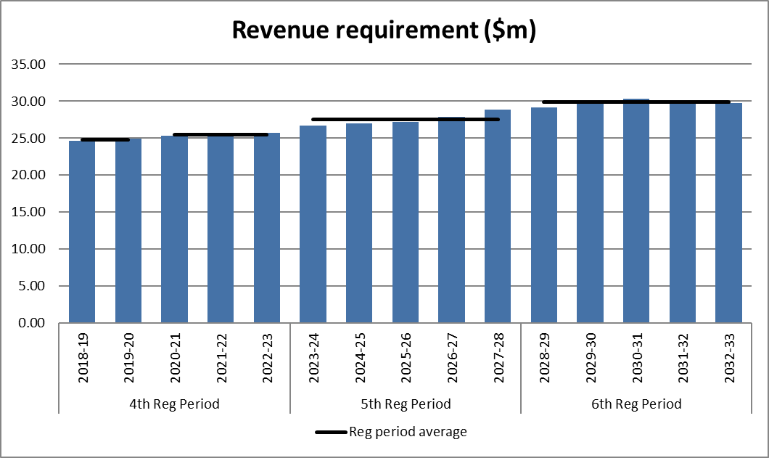
Graph 33: Annual Revenue Requirement ($real2023)

Table 64: PS23 Annual Revenue Requirement ($m,real2023)
Annual Revenue Requirement | 2023-24 | 2024-25 | 2025-26 | 2026-27 | 2027-28
Bulk Water Operating Expenditure | $0.42 | 0.43 | 0.45 | 0.45 | 0.45
Operating Expenditure | $18.39 | 18.54 | 18.42 | 18.68 | 18.56
Return on Assets - prior to 1 July 2024 | $3.67 | 3.31 | 3.08 | 2.87 | 2.71
Return on Assets - after 1 July 2024 | $0.13 | 0.31 | 0.46 | 0.60 | 0.68
Regulatory Depreciation - prior to 1 July 2024 | $3.89 | 3.89 | 3.87 | 3.89 | 3.87
Regulatory Depreciation - after 1 July 2024 | $0.07 | 0.34 | 0.74 | 1.16 | 2.15
Benchmark Tax Requirement | $0.16 | 0.17 | 0.20 | 0.24 | 0.43
Total Revenue Requirement | $26.73 | 26.99 | 27.22 | 27.89 | 28.85
Table 65: PS28 Annual Revenue Requirement ($m,real2023)
Annual Revenue Requirement | 2028-29 | 2029-30 | 2030-31 | 2031-32 | 2032-33
Bulk Water Operating Expenditure | $0.45 | $0.45 | $0.45 | $0.45 | $0.45
Operating Expenditure | $17.68 | $17.66 | $17.63 | $17.60 | $17.58
Return on Assets - prior to 1 July 2024 | $2.56 | $2.42 | $2.38 | $2.34 | $2.26
Return on Assets - after 1 July 2024 | $0.84 | $1.05 | $1.15 | $1.20 | $1.23
Regulatory Depreciation - prior to 1 July 2024 | $3.87 | $3.87 | $3.87 | $3.87 | $3.87
Regulatory Depreciation - after 1 July 2024 | $3.22 | $3.79 | $4.17 | $3.95 | $3.63
Benchmark Tax Requirement | $0.54 | $0.64 | $0.71 | $0.72 | $0.71
Total Revenue Requirement | $29.16 | $29.87 | $30.36 | $30.13 | $29.73

Gifted Assets
Forecast gifted assets are in line with historical trends. As gross capex presented earlier does not include gifted assets, these have only been used in the calculation of financial indicators, forecast NCCs and in the benchmark tax liability calculation.

Table 66: Gifted Assets ($m,real2023)
 | 2020-21 | 2021-22 | 2022-23 | 2023-24 | 2024-25 | 2025-26 | 2026-27 | 2027-28
Gifted Assets | $3.43 | $1.96 | $1.40 | $2.00 | $2.00 | $2.00 | $2.00 | $2.00

Financial Performance Indicators
Westernport Water is forecasting the following impacts to financial performance indicators based on the proposed pricing decisions. As Westernport Water maintained a AA credit rating for the past five years, an independent credit rating was not required during the Pricing Submission 1 regulatory period. The Victorian Department of Treasury and Finance’s rating analysis is available upon request.

- Funds from operations (FFO) Interest (times) (Funds from operations – income not received – total operating expenditure – income tax paid + net interest - interest payments)
FFO interest will remain stable due to a continued focus on collection activity and no planned changes to billing processes which have historically provided strong reliable cash flow. Increases to borrowings will be required to fund the capital program.

Table 67: Funds From Operations – ($m,real2023)
2018-19 | 2019-20 | 2020-21 | 2021-22 | 2022-23 | 2023-24 | 2024-25 | 2025-26 | 2026-27 | 2027-28
$6.28 | $6.34 | $5.73 | $5.22 | $6.68 | $7.49 | $7.94 | $8.76 | $9.12 | $9.81

- FFO Interest Cover (Funds from operations + net interest / net interest payments)
FFO interest cover will remain in line with the previous regulatory period due to a continued focus on collection activity and no planned changes to billing processes which have historically provided strong reliable cash flow. Increases to borrowings will be required to fund the capital program.

Table 68: FFO Interest Cover – Target > 1.5 Times, < 1.8 times used as a caution
2018-19 | 2019-20 | 2020-21 | 2021-22 | 2022-23 | 2023-24 | 2024-25 | 2025-26 | 2026-27 | 2027-28
35.50 | 64.56 | 90.51 | 28.15 | 41.23 | 57.32 | 25.74 | 26.93 | 25.77 | 22.93

- Net Debt/RAV (Gearing) Ratio (%) (Total debt, including finance leases – cash assets) / total regulatory asset values x 100)

Gearing ratio will remain low due to the low proportion of debt to equity. Although new borrowings are planned, less reliance on short term borrowing is anticipated due to strong cash flow.

Table 69: Gearing Ratio (%) – Target < 70 per cent
2018-19 | 2019-20 | 2020-21 | 2021-22 | 2022-23 | 2023-24 | 2024-25 | 2025-26 | 2026-27 | 2027-28
2.8 | 1.4 | 0.8 | 2.6 | 3.7 | 3.1 | 5.2 | 5.3 | 5.5 | 6.2

- FFO/Net debt (%) (Funds from operations) / (interest bearing liabilities – cash assets)

Current ratio is planned to remain healthy, over 10 per cent per annum throughout the period as assets will increase in line with maintenance of liability levels.

Table 70: FFO/Net debt Ratio – Target > 10 per cent
2018-19 | 2019-20 | 2020-21 | 2021-22 | 2022-23 | 2023-24 | 2024-25 | 2025-26 | 2026-27 | 2027-28
188.0 | 374.0 | 584.4 | 147.2 | 125.7 | 158.8 | 93.7 | 96.9 | 92.3 | 84.9

- Internal Financing Ratio (%) (Funds from operations – dividends) / net capital expenditure x 100)

As per current practices, borrowing will be redrawn in line with approved debt levels to ensure funding requirements are met. New financing will be drawn as required to manage cash flow during the regulatory period.

Table 71: Internal Financing Ration (%) - Target > 35 per cent
2018-19 | 2019-20 | 2020-21 | 2021-22 | 2022-23 | 2023-24 | 2024-25 | 2025-26 | 2026-27 | 2027-28
171.8 | 138.8 | 74.5 | 80.6 | 122.9 | 72.7 | 105.7 | 102.3 | 92.8 | 219.6

Other Revenue and Non-Prescribed Services
Westernport does not foresee significant change to forecast levels of other revenue and non-prescribed services in the next regulatory period.

Table 72: Other Revenue and Non-Prescribed Services Revenue ($m,real2023)
Revenue Offsetting Tariffs | 2023-24 | 2024-25 | 2025-26 | 2026-27 | 2027-28
Contract Revenue | $0.06 | $0.06 | $0.06 | $0.06 | $0.06
Other Revenue (Miscellaneous services) | $0.74 | $0.74 | $0.74 | $0.74 | $0.74
Other Revenue (Non-Prescribed Net Income) | $0.05 | $0.05 | $0.05 | $0.05 | $0.05
Total | $0.85 | $0.85 | $0.85 | $0.85 | $0.85

Contract Revenue – Westernport Water currently has one trade waste customer, which limits the opportunities to increase revenue or pricing. It is not anticipated that any additional new commercial or manufacturing activity will be introduced into the service area during the regulatory period which would increase supply or demand. Revenue for the current trade waste customer is reported in prescribed revenue reflecting service and usage charges as applicable.

Other Revenue (Miscellaneous Services) - Other revenue predominately consists of planning, information and connection-based customer requests. This revenue is used to offset the overall revenue requirements and historically has been a steady source of income.

Other Revenue (Non Prescribed Net Income) - The ESC does not regulate fees and charges levied on non-prescribed services, but provides oversight on its appropriateness. Westernport Water decommissioned its LPG gas network in the current period which although reduced non prescribed income, it also reduced operational expenditure which has been recognised in the operational base year assumptions. Revenue generated from non-prescribed services relates solely to our farm management and fleet replacement program which is achieved through the sale of cattle and our retired fleet vehicles. Non prescribed services are not included in the development of water and wastewater tariffs. The difference between revenue and expenditure has been included as an ‘other revenue’ item that offsets the water, wastewater and recycled water tariffs. From a cash flow perspective, profits from the sale of assets contributes to offset the repurchasing of assets.

12 Managing Risk
Key Points
- Westernport Water’s mature risk management approach played a significant role in the project prioritisation process for the 2023 Price Review.
- The 2023-28 capital program aligns with and addresses the corporation’s strategic risks.
- Westernport Water will accept greater risk to deliver lower prices, particularly in areas where there is uncertainty, such as growth, demand and performance management.

Risk Management Framework

Westernport Water has developed and implemented a whole of business risk management framework, that is reviewed by the Board annually, and is consistent with the AS ISO 31000:2018 Risk Management - Guidelines whilst also addressing the mandatory risk management requirements of the Victorian Government’s Risk Management Framework (VGRMF).

The VGRMF is mandated by the Standing Directions of the Minister for Finance’s (Ministerial Standing Directions) 3.7.1 – Risk Management Framework and Processes and applies to departments and public bodies covered by the Financial Management Act 1994. Westernport Water are required to attest annually within our annual report that we adhere to and can demonstrate compliance with these Standing Directions. This includes the requirement that strategic and business planning, as well as decision-making processes, have risk management embedded, that Westernport Water promotes a positive risk culture, and that adequate resources are assigned to risk management in the organisation.

Strategic risks, along with risk appetite statements, are developed and reviewed annually by the Board during our annual Strategy and Risk Workshop, the progress of the applied treatment plans against these Strategic Risks are then reported to the ARC on a quarterly basis alongside operational risk activities.

As previously outlined, Westernport Water also undertook a comprehensive whole-of-business project prioritisation process to identify proposed initiatives that were required for the next regulatory period. Our risk management frameworks was used to evaluate the likelihood and consequence risk of the highest risk that was presented from not proceeding with the project. As expected, this has ensured a strong alignment between the business’s’ capital program and strategic risks.

Consideration of Strategic Risk
Westernport Water's proposals for the next regulatory period have been informed by the following key Board assessed strategic risks:

Strategic Risk #1 | Risk Appetite | Residual Risk Rating
Unsafe work practices cause severe physical or psychological harm or death to an employee, contractor or member of the community. | Low | High

In 2021, Westernport Water participated in the Global Safety Index Safety Culture Survey and was externally benchmarked with highest performance rating of any participating water corporation. In the next regulatory period, Westernport Water will invest $250,000 over five years in an occupational health and safety compliance program to sustain this focus on safety and associated workplace improvements.

Strategic Risk #2 | Risk Appetite | Residual Risk Rating
Failed water quality management causes serious illness or death in the community | Low | High

Public health risks associated with drinking water have been effectively managed throughout the current regulatory period with no Safe Drinking Water Act non-compliance events recorded. Westernport Water will invest $2.1M in the next price period to deliver continuous improvements to water quality. In addition, customer satisfaction with drinking water and customer complaints will remain as key output measures in our Outcomes Framework.

Strategic Risk #3 | Risk Appetite | Residual Risk Rating
Ineffective asset management results in a failure to effectively manage wastewater | Low | High

Our 2023-28 capital program will effectively plan for growth and manage the performance of the wastewater network, highlighted by the following projects and programs: Recycled Water Wetland Storage (4.34M), Wastewater Future Systems ($1.51M), Cowes Wastewater Treatment Plant Upgrade – Stage 3 ($1.35M), King Road Wastewater Treatment Plant Pump Station Upgrade ($0.99M), Sewage Pump Station Civil, Mechanical and Electrical ($2.36M).

Strategic Risk #4 | Risk Appetite | Residual Risk Rating
Ineffective asset management results in a failure of water supply security | Low | Medium

Our 2023-28 capital program will effectively plan for growth and manage the performance of the water network, highlighted by the following projects and programs: Water Main Renewals Program ($1.2M), Candowie and Ian Bartlet Water Purification Plant Civil, Mechanical and Electrical ($1.14M), San Remo to Newhaven Bridge Pipeline and Fittings Renewal Project ($0.9M), Water Distribution Civil, Mechanical and Electrical ($0.76M), Water Quality Continuous Improvement Program ($2.11M), Asset Management Information System Upgrade ($1.30M).

Strategic Risk #5 | Risk Appetite | Residual Risk Rating
Poor response to an incident fails to protect personnel, information, assets, service continuity or the environment. | Low | High

Controls, early detection, and rapid response form the basis of Westernport Water’s strategic investment in the next regulatory period. This includes investment in SCADA via the Information and Communication Technology – Hardware and Minor Software Program ($0.89M) and Water Quality Continuous Improvement Program ($2.11M). Further, we will renew our fleet and plant ($1.93M) and modernise our information technology systems via the Information Communication Technology Road Map ($2.29M) and Asset Management Information System Upgrade ($1.30M).

Strategic Risk #6 | Risk Appetite | Residual Risk Rating
Lack of succession planning for key roles and critical personnel leads to poor performance. | Balanced | Medium

Westernport Water recognises that as the smallest water corporation in Victoria, we rely on a small FTE base to meet compliance requirement and sustain strong performance. In response, Westernport Water has increased FTE in water and wastewater treatment, climate change and network operations and maintenance. This increase will be maintained throughout the next regulatory period and a highly capable preferred supplier list will provide redundancy where required.

Strategic Risk #7 | Risk Appetite | Residual Risk Rating
Inadequate cyber security management results in a ransomware demand and/or data breach requiring major intervention. | Low | High

Westernport Water is modernising its technology suite in the next regulatory period providing enhanced vendor support and security controls - Information and Communication Technology – Hardware and Minor Software Program ($0.89M), Information Communication Technology Road Map ($2.29M) and Asset Management Information System Upgrade ($1.30M).

Strategic Risk #8 | Risk Appetite | Residual Risk Rating
Failure to adequately mitigate and adapt to Climate Change. | Low | Medium

In accordance with customer preference, Westernport Water will deliver a record investment to reduce greenhouse gas emissions and develop renewable energy -
Bio-Gas Waste to Energy ($1.88M), Renewable Energy Generation ($1.56M), Treatment Plant Energy Efficiency Project ($1.29M).

Strategic Risk #9 | Risk Appetite | Residual Risk Rating
Our actions negatively impact our environment and/or ecosystem. | Low | Medium

Further to our investments to mitigate and adapt to climate change, Westernport Water has committed to two significant projects that will manage increasing wastewater inflows while delivering significant biodiversity benefits - Recycled Water Wetland Storage ($4.34M) and Sustainable Reuse and Afforestation ($1.13M).

Strategic Risk #10 | Risk Appetite | Residual Risk Rating
Inability to maintain adequate financial sustainability. | Low | Medium

Westernport Water will continue to maintain low borrowings ($16.04M) at the end of the next price period and a low gearing ratio of 5.39, despite an increased capital program and a marginal increase to FTE.

Strategic Risk #11 | Risk Appetite | Residual Risk Rating
Drinking water does not meet customer expectations for taste, odour and aesthetics. | Low | Medium

Westernport Water will invest $2.1M in the next price period to deliver continuous improvements to water quality. In addition, customer satisfaction with drinking water and customer complaints will remain as key output measures in our Outcomes Framework.

Strategic Risk #12 | Risk Appetite | Residual Risk Rating
Poor performance results in a failure to meet government expectations and regulatory obligations. | Balanced | Medium

Westernport Water will invest $6.47M over five years in capital projects to meet government and regulatory obligations. This represents approximately 17% of Westernport Water’s capital program (a minor increase on the current period).

Consideration of Price-based or Service-based Risks
Westernport Water has undertaken a risk analysis of potential scenarios that have the ability to affect customer prices or services as per Appendix D of the Essential Services Commission’s 2023 Price Review Guidance Paper:
Scenario #1 – Inflow Risk | Scale of Risk | Risk Allocation | Likelihood
Inability to meet customer demand due to extended low rainfall and inflows. | <50% increase in Melbourne Water Supply System variable water costs and potential for staged water restrictions  Up to $30,000 increase per annum (0.1% price path). | WPW  (Price cap & 50% of variable water adjustment)  Customer  (Potential temporary supply change and 50% pass through of variable water adjustment) | Rare
Westernport Water maintains a very secure supply of water, including a connection and entitlement to the Melbourne Water Supply System. The Urban Water Strategy 2022 modelled a range of climate change scenarios and their affect on supply and demand. Even in the high change (sensitivity) scenario, Westernport Water will not require any change to its infrastructure to address yield in the next regulatory period.
If there is a need to access more/less Melbourne Water Supply System water than forecast, Westernport Water has included a pass through adjustment mechanism to share risk with customers.
Scenario #2 – Demand Forecast Risk | Scale of Risk | Risk Allocation | Likelihood
Actual customer demand during a regulatory period differs materially from the forecasts. | <10% change to variable water revenue expectations  Up to $160,000 increase/decrease per annum (0.6% price path). | WPW  (Price cap) | Possible
Westernport Water’s Urban Water Strategy 2021 identified a probable average household consumption level of 83kL per annum and a non-residential average consumption level of 579kL per annum for a 5-year period. Consumption trends have been volatile within our service areas as COVID-19 restrictions have significantly influenced the tourism and hospitality sector with less people travelling into and around our service area. Furthermore, occupancy rates have increased as non-permanent residents have relocated and are using holiday homes as their primary address to live and work from. This is likely to be temporary but uncertainty around COVID-19 remains. Westernport Water has used 5-year averages to account for uncertainty and set an average household consumption level of 88kL per annum and a non-residential average consumption level of 651kL. Increasing demand forecasts have assumed increased revenue and therefore reduced potential customer prices.

While the likelihood of material differences to demand is moderate due to uncertainty, the consequences are mitigated due to the proportionally low contribution of variable water revenue to overall revenue. Westernport Water also has a high reliance on fixed charges, which will remain unaffected by consumption behaviour. It should also be noted that volatility in consumption will also impact expenditure (ie. less chemicals, less pumping costs). Therefore, a fall in revenue from reduced demand should also in turn reduce expenditure offsetting the impact.

Scenario #3 – Operational Risk | Scale of Risk | Risk Allocation | Likelihood
Water business experiencing a breach of health, environmental or customer performance standards, can result from inadequate processes within water businesses, asset failures or external factors. | <Up to $1M increase over 5 years.  (0.7% price path) | WPW  (Price cap and GSL scheme)  Customer  (Inferior service from performance failure) | Rare
Westernport Water has a strong record of health, environmental and customer performance due to strong governance and effective asset management practices. An increase in our capital program and key investments in water quality improvements, growth, renewals and climate change, along with a focus on our Environmental Management System, and Water Quality Management System will ensure that significant operational risks do not materialise. We will continue to have financial penalties and clear customer reporting in place to provide customers with confidence that performance commitments will be monitored and met. In addition, our corporate insurance policies will protect us against loss to ensure customers are not impacted in the event that significant failures occur.
Scenario #4 – Construction Risk | Scale of Risk | Risk Allocation | Likelihood
Underestimating costs or experiencing project delays that affect customer prices or services. | <20% of overall capital program expenditure, including potential delays  Up to $8.5M increase in capital expenditure over 5 years.  (1.0% price path) | WPW  (Price cap)  Customer  (Delayed performance benefit and reliability risk) | Unlikely
Westernport Water recognises the importance of quality business cases regarding scope, timeframes, deliverability and cost. All mitigations regarding procurement and delivery are listed on p.54. Furthermore, all preliminary business cases for Westernport Water’s top ten projects have been independently reviewed against the Essential Services Commission’s guidance paper criteria.
Scenario #5 – Regulatory Risk | Scale of Risk | Risk Allocation | Likelihood
Changes in laws and regulations that materially affect Westernport Water’s costs or revenue potential. | <3% of overall operating expenditure  Up to $500,000 increase/decrease in operating expenditure per annum.  (1.86% price path) | WPW  (Price cap) | Possible
An independent review of compliance obligations overseen by VicWater found that cost of administering compliance obligations doubled during the current price period due to approximately 30 new of amended obligations that were introduced. Westernport Water's ability to respond to regulatory changes as the smallest corporation in Victoria is difficult and we tend to rely on external contractors or assistance from sector partnerships to respond. Westernport Water is reluctant to pass through these costs to customers, preferring to use change to realise increased customer value and build greater synergies with other water corporations through initiatives such as the Gippsland Regional Water Alliance to improve productivity.
Scenario #6 – Business Risk | Scale of Risk | Risk Allocation | Likelihood
Loss of revenue due to new technology or a change in the competitive landscape. | <1% of revenue  Up $270,000 decrease on revenue per annum. | WPW  (Price cap) | Rare
Westernport Water does not believe that there is any likelihood of a material change to revenue due to innovation or increased competition. Most customer revenue is sourced from fixed access fees. Trade waste revenue is proportionally low and unlike other regional urban water corporations, Westernport Water has limited industry within its service area and few large water consumers.

Accepting Risk to Deliver Lower Prices
Westernport Water has identified several areas in which it has chosen to accept more risk to avoid passing on the cost of uncertainty to customers.

Growth. Westernport Water’s Urban Water Strategy 2021 identified 5-year growth estimates of 2% for residential connections and 1% for non-residential connections. Westernport Water will adopt the VIF2021 forecast of 2.24% in the first 3 years (and then 1.97% from 2026-27) and a 5-year average growth rate of 1.17% for non-residential growth up to 50mm meters. This decision will assume higher revenue and reduce pressure on customer prices.

Associated strategic risk/s:
- Ineffective asset management results in a failure to effectively manage wastewater
- Ineffective asset management results in a failure of water supply security.

Scale of Risk | Customer Feedback
Westernport Water is forecasting approximately 400 new residential connections each year. A 10% variance equates to 40 connections, which translates to $42,000 per annum in fixed charges. | Customers rated ‘making water bills affordable for everyone’ 85/100 for importance and 34% included it as a top priority for Westernport Water. The assumption of higher revenue due to growth will keep prices low.

Demand. Increasing demand forecasts have assumed increased revenue and therefore reduced potential customer prices.

Associated strategic risk/s:
- Inability to maintain adequate financial sustainability.

Scale of Risk | Customer Feedback
Due to an increase in permanent residents in the area and uncertainty around the duration of the trend, Westernport Water estimates up to 10% change to variable water revenue expectations. This equates to up to $160,000 increase/decrease per annum. | Customers rated ‘making water bills affordable for everyone’ 85/100 for importance and 34% included it as a top priority for Westernport Water. The assumption of higher revenue due to lasting increased residential demand will keep prices low.

Fixed vs Variable. During customer consultation, there was widespread support for an adjustment to the tariff balance between fixed and variable water prices. In response, Westernport Water will reduce fixed prices by 2% in the first year and offset the difference in assumed revenue via an increase in variable water price. This adjustment places revenue at greater risk of uncertainty in favour of giving customers greater control over their bill. However, Westernport Water does not believe that the change in price is sufficient to have a material impact on consumer behaviour. The risk would also be offset by lower treatment costs and energy consumption.

Associated strategic risk/s:
- Inability to maintain adequate financial sustainability.

Scale of Risk | Customer Feedback
Due to an increase in permanent residents in the area and uncertainty around the duration of the trend, Westernport Water estimates up to 10% change to variable water revenue expectations. This equates to up to $160,000 increase/decrease per annum. | Customers rated ‘making water bills affordable for everyone’ 85/100 for importance and 34% included it as a top priority for Westernport Water. The assumption of higher revenue due to lasting increased residential demand will keep prices low.

Performance Management. Westernport Water will once again refine its performance management approach to ensure that appropriate mechanisms are in place to incentivise outcomes and support customer influence. Over the next 5-years, a customer panel will be appointed each year to provide commentary on our performance against the Outcomes Framework. If outcome targets are missed over consecutive years, Westernport Water will need to provide a corrective action plan to explain to customers how performance will improve to expected levels. Furthermore, a $25,000 payment will be made to a related community-led proposal following an open Expression of Interest process that aligns to one of three themes – healthy people, healthy planet and/or healthy communities.

Associated strategic risk/s:
- Poor performance results in a failure to meet government expectations and regulatory obligations.
- Inability to maintain adequate financial sustainability.

Scale of Risk | Customer Feedback
Westernport Water will place $100,000 at risk (as unbudgeted penalty payments) in total over 5 years based on its performance ($25,000 per year in the last four years of the price period). | Customers believed that the size of potential bill credits for poor performance were immaterial, preferring penalty funds to be directed to a relevant, community-led cause/proposal.

Opex Efficiency. Westernport Water will commit to an opex efficiency rate of 1.5%, which will ensure that we absorb the cost impacts of growth on our business. Details regarding our operating efficiency are detailed on p.77 of the submission.

Associated strategic risk:
- Inability to maintain adequate financial sustainability
- Ineffective asset management results in a failure to effectively manage wastewater
- Ineffective asset management results in a failure of water supply security.

Scale of Risk | Customer Feedback
Westernport Water will deliver a 1.5% efficiency rate (equivalent of $0.25m) per year. | As per above, while affordability was important to customers, customers remain satisfied with the balance between service quality and affordability (85% in 2017 to 83% in 2021).

Managing Unforeseen Events and Dealing with Uncertainty
Westernport Water is not seeking any change to the management of uncertain and unforeseen events. The approach will remain as listed under Section 4 of the Westernport Water Price Determination 2018-23.

Length of Regulatory Period
Westernport Water is proposing a 5-year regulatory period from 1 July 2023 to 30 June 2028 for the following reasons:
- There is sufficient uncertainty in growth and demand following the COVID-19 pandemic to rule out any proposal to extend the regulatory period
- Due to the changing nature of our customer base, we expect customer expectations and priorities to change in coming years and believe that five years is an appropriate time to re-assess
- The price review process is demanding on our staff and customers. We believe that our plans are forecasts are sufficiently robust to avoid the impost of a shorter regulatory period and to provide price certainty for our customers.

13 Price Control

Westernport Water considered three forms of price control for the following regulatory period:

- Revenue cap: A maximum allowable revenue is determined for each year of the regulatory period where over and under revenue amounts are to be returned to or recovered from customers in the following year, adjusted for interest (rate is the WACC)
- Price cap: A maximum price path for each tariff is determined for each year of the regulatory period where over or under recovery is not returned to or recovered from customers
- Tariff basket: A weighted average price path is determined where prices within the ‘basket’ can adjust by any amount up to a limit where over and under recovery is not returned to or recovered from customers.
Despite a minor rebalancing of fixed and variable water charges, Westernport Water continues to rely on fixed charges as the major proportion of a customer bill. Our customers are used to price certainty and minimal price fluctuations. There is no incentive to move to a revenue cap as revenue remains consistent.

Westernport Water is proposing to continue with a price cap approach.
The price control formula will remain consistent with the 2018 Price Determination.
(Westernport Water Price Determination 2018-23, Essential Services Commission, page 5). The specification of the current form of price control is available to the Commission on request.

14 Prices and Customer Impacts
Key Points
- Westernport Water consistently rated in the top third of the sector for each of the Essential Services Commission’s customer satisfaction metrics.
- Most outcome targets will be met. Customers will be compensated under a performance-based rebate scheme for failed targets.
- Performance has bettered many operational service standards, meaning customers have received greater value for the prices paid.
- Westernport Water is proposing a 0.4% price path in the first year of the regulatory period, with no further prices increases in years 2-5.
- Tenants will continue to receive the lowest average water bill in Victoria.
- Fixed water access charges will reduce by 2%, offset by an increase in the variable water charge. This change is a direct result of customer feedback.

In accordance with customer priorities, Westernport Water is proposing prices that remain affordable to customers, while providing sufficient revenue to invest in the environment, increase water quality and maintain asset performance and service levels whilst also meeting challenges associated with infrastructure renewals and replacements.

In order to achieve these objectives, Westernport Water will absorb most of the additional costs associated with increased compliance, renewable energy, ICT expenses and employee costs, however there will still be a small increase in operational expenditure required to fund future growth in our network. Additionally, we have adapted our approach to preventative vs reactive maintenance to keep our expenditure as low as possible.

Graph 34: Proposed Price Movement in 2023-24 (Based on PS1 Actual)

Westernport Water has reduced the fixed water access charge by 2% and offset this by an increase in the variable water charge, calculated from an average household bill in 2023. This change was implemented based on overwhelming feedback received during engagement where customers requested the ability to take more control over their water bills and to promote water saving measures.

Westernport Water is proposing a 0.4% price path in the first year of the regulatory period (excluding CPI). The combination of the reduced fixed water charges and the proposed 0.4 per cent price increase will deliver a 0.3 per cent increase in real terms to the average customer bill, which reflects an average increase of $3.21 in the average household bill for 2023-24.

Table 73: Proposed Price Movement (2024-28)
 | 2023-24 | 2024-25 | 2025-26 | 2026-27 | 2027-28
Revenue Requirement | $26.93M | $26.99M | $27.22M | $27.89M | $28.85M
Average Annual Bill | $1,230.26 | $1,230.26 | $1,230.26 | $1,230.26 | $1,230.26
Price Path  (Ave. Annual Bill) | 0.30% | 0.00% | 0.00% | 0.00% | 0.00%
Average Annual Change | $3.21 | - | - | - | -

Fixed Versus Variable Pricing
Westernport Water customers are currently billed for two fixed charges for water and wastewater and a variable water consumption charge. Based on 2020-21 sector-wide performance reports, average household bills for Westernport Water customers had the second highest proportion relating to a fixed water charge, and the lowest proportion relating to a variable water consumption charge, compared to other water corporations. As previously outlined, this is a consequence of our low average water consumption – less than half of the industry average due to a largely transient, non-permanent resident customer base.

There has been a marginal increase in consumption during the 2018-23 regulatory period which suggests an increase in permanent residents compared to prior years. This is supported by 2021 ABS data which indicates an increase in permanent residents to the area resulting from the influx of Victorians relocating to regional areas during the COVID-19 pandemic. To address this shift in occupancy, and the feedback from our customers wanting more control over their bill and greater encouragement of water saving, we have rebalanced our fixed water pricing by reducing it by 2% with the offset being an increase in variable water usage pricing of 3.8%. This adjustment takes into account long term and short term impacts to customers and the marginal costs, ensuring a financially sustainable and affordable outcome is delivered.

Knowing that this is a regular driver of dissatisfaction with some customers (workshopped with customers in the 2018 Price Review), Westernport Water included it as a theme in every stage of customer engagement. The results were clear. In the engagement sessions, customers on balance, preferred to make an adjustment to the current levels of split.

During the deliberative forum process, customers were presented with modelling for three price scenarios (no change, 2% reduction in fixed/offset by variable, and 5%reduction in fixed/offset by variable). Facilitated discussion was undertaken with customers regarding the strengths and weaknesses of each approach and how it would impact different people. Following the conversations, each customer was asked for their preference. A slim majority of customers preferred a modest 2% decrease in fixed, offset by an increase to variable water consumption, whilst some others preferred a larger decrease. Ultimately, Westernport Water believed there was sufficient majority support for a rebalancing of fixed and variable pricing and landed on 2%. Anything greater had the potential to negatively impact specific customers in a material way.

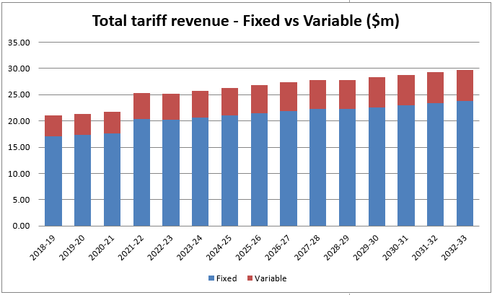
Graph 35: Fixed vs Variable Pricing

Other Price Adjustments
Westernport Water is not proposing any further adjustments to tariffs other than the rebalancing of fixed and variable water tariffs.

Our Prices
The following table outlines our proposed tariffs for the 2023-28 pricing period:

Table 74: Overview of Proposed Tariffs
Fees and Charges | 2022-23 | 2023-24 | 2024-25 | 2025-26 | 2026-27 | 2027-28
Residential Variable Charge Water | $2.1103 | $2.1926 | $2.1926 | $2.1926 | $2.1926 | $2.1926
Residential Access Charge Water | $408.16 | $401.60 | $401.60 | $401.60 | $401.60 | $401.60
Residential Access Charge Sewer | $633.18 | $635.71 | $635.71 | $635.71 | $635.71 | $635.71
Unconnected Water Access | $204.06 | $200.78 | $200.78 | $200.78 | $200.78 | $200.78
Unconnected Sewer Access | $317.14 | $318.41 | $318.41 | $318.41 | $318.41 | $318.41
Non-Residential Variable Charge Water | $2.1103 | $2.1926 | $2.19 | $2.19 | $2.19 | $2.19
Non-Residential 20mm Access Charge | $408.16 | $401.60 | $401.60 | $401.60 | $401.60 | $401.60
Non-Residential 25mm Access Charge | $734.72 | $722.91 | $722.91 | $722.91 | $722.91 | $722.91
Non-Residential 32mm Access Charge | $1,388.15 | $1,365.83 | $1,365.83 | $1,365.83 | $1,365.83 | $1,365.83
Non-Residential 40mm Access Charge | $2,531.22 | $2,490.52 | $2,490.52 | $2,490.52 | $2,490.52 | $2,490.52
Non-Residential 50mm Access Charge | $4,531.78 | $4,458.91 | $4,458.91 | $4,458.91 | $4,458.91 | $4,458.91
Non-Residential 65mm Access Charge | $9,485.58 | $9,333.05 | $9,333.05 | $9,333.05 | $9,333.05 | $9,333.05
Non-Residential 80mm Access Charge | $15,636.98 | $15,385.54 | $15,385.54 | $15,385.54 | $15,385.54 | $15,385.54
Non-Residential 100mm Access Charge | $28,130.34 | $27,678.00 | $27,678.00 | $27,678.00 | $27,678.00 | $27,678.00
Non-Residential 150mm Access Charge | $64,835.04 | $63,792.49 | $63,792.49 | $63,792.49 | $63,792.49 | $63,792.49
Non Residential Access Charge Sewer (1 Cistern) | $633.18 | $635.71 | $635.71 | $635.71 | $635.71 | $635.71
Non-Residential Sewer Access (>2 Cisterns) | $233.84 | $234.78 | $234.78 | $234.78 | $234.78 | $234.78
Residential Variable Charge Recycled Water | $1.1916 | $1.1964 | $1.1964 | $1.1964 | $1.1964 | $1.1964
Non-Residential Variable Charge Recycled Water | $0.5795 | $0.5818 | $0.5818 | $0.5818 | $0.5818 | $0.5818
Non-Residential Variable Charge >5ML Recycled Water | $0.4763 | $0.4782 | $0.4782 | $0.4782 | $0.4782 | $0.4782
Residential Access Charge Recycled Water | $29.77 | $29.89 | $29.89 | $29.89 | $29.89 | $29.89
Non-Residential Access Charge Recycled Water | $29.77 | $29.89 | $29.89 | $29.89 | $29.89 | $29.89
Standpipe Variable Charge | $3.5391 | $3.5533 | $3.5533 | $3.5533 | $3.5533 | $3.5533
Customer Bills
Average owner-occupier household bills are forecast to be $1,230 for 2023-24 based on 88kL of consumption. This is a $3 real increase on the forecast 2022-23 owner-occupier bill of $1,227 and is a result of an increase in usage per household that offsets a 2% reduction in fixed water charges.

Tenants will experience a marginal bill increase of $7 in real terms with an average tenant household bill increasing from $186 to $193 based on 88kL of consumption. This reflects the impact of the rebalancing of fixed vs variable pricing, however Westernport Water tenants will continue to receive the lowest average water bill in Victoria.

Managing Risks Associated with Bill Impacts
As per previous commentary, Westernport Water does not believe that the rebalancing of tariffs will lead to material changes in how customers consume water. Furthermore, the bill impacts for owner occupiers will be offset by the provision of the performance-based rebate in 2023-24, which will credit customer bills by between $15-$20 (depending on 2022-23 performance results).

Customer Value - Westernport Water has outlined a summary of the customer value that has been delivered to customers for the prices listed on p.46.

Table 75: Customer Bill Impacts by Customer Type
Customer Impacts  (Annual Bill, Excl CPI) | 2022-23 | 2023-24 | 2024-25 | 2025-26 | 2026-27 | 2027-28
Owner Occupier  (Inc. Water & Wastewater Access)  Low Use (30kL)  Average Use (88kL)  High Use (200k) | $1,105  $1,227  $1,463 | $1,103  (-$2)  $1,230  (+$3)  $1,476  (+$13) | $1,103  $1,230  $1,476 | $1,103  $1,230  $1,476 | $1,103  $1,230  $1,476 | $1,103  $1,230  $1,476
Tenant  Low Use (30kL)  Average Use (88kL)  High Use (200k) | $63  $186  $422 | $66  (+$3)  $193  (+$7)  $439  (+$17) | $66  $193  $439 | $66  $193  $439 | $66  $193  $439 | $66  $193  $439
Business & Property Owner  (Inc. Water & Wastewater Access)  Small (500kL)  Average Use (651kL)  Large (1200kL) | $2,096  $2,415  $3,574 | $2,134  (+$38)  $2,465  (+$50)  $3,668  (+$95) | $2,134  $2,465  $3,668 | $2,134  $2,465  $3,668 | $2,134  $2,465  $3,668 | $2,134  $2,465  $3,668

Pass Through Mechanism
Westernport Water is not proposing any changes to its pass through mechanisms from the 2018 price determination, including the management of annual cost of debt.

Westernport Water will continue to pay for our source entitlement to the Greater Yarra – Thomson pool operated by Melbourne Water. As such, we propose to include a pass-through mechanism to allow for changes in Melbourne Water’s headworks and transfer charges. This will also include an allowance for an adjustment for any allocation water we transfer from Melbourne Water’s headwork storages to our own during the next pricing period.

A pass-through mechanism ensures that we provide cost reflective pricing and as such we have included a true-up in our pass through. This safeguards our customers from any over-recovery of Melbourne Water’ charges because of water consumption being higher or lower than forecast.

This pass-through mechanism provides appropriate risk sharing between Westernport Water and its customer base. It does this by limiting the cost exposure to any usage of our entitlement in the Greater Yarra Thomson system to 50 per cent.

These changes are described in the following formulas:

Equation 1: Calculating the Pass-Through Amount
$$PT_{t}=\left(GY{TF}_{t}^{actual}-GY{TF}_{t}^{det}×\frac{CPI_{t}}{CPI_{base}}\right)+50\%×\left(GYTV_{t-1}^{actual}-GYTV_{t-1}^{det}×\frac{CPI_{t-1}}{CPI_{base}}\right)×\frac{CPI_{t}}{CPI_{t-1}}+\left(PT_{t-1}^{act}-PT_{t-1}^{}\right)×\frac{CPI_{t}}{CPI_{t-1}}$$

Equation 2: Actual Previous Period Adjustment Passed Through
$$PT_{t-1}^{act}=\sum_{i}{P_{t-1}^{i}}×Q_{t-1}^{i,act}-\sum_{i}{P_{t-1}^{i,det}}×\left(1+PPM_{t-1}^{i}\right)×\left(\frac{CPI_{t-1}}{CPI_{base}}\right)$$

Equation 1 shows how the pass-through amount will be calculated.

The first part of the equation looks at the difference between the determination and actual fixed charges from Melbourne water for Westernport Water’s Greater Yarra Thomson entitlement charge.

The second part looks at the difference in variable costs and the revenue obtained from water sales in the previous year multiplied by a proportion (represented by alpha).

The third part includes a true-up of any pass through from the previous year, adjusted for inflation.

Equation 3: Calculating the Pass-Through Amount
$$PT_{t}=\left(GY{TF}_{t}^{actual}-GY{TF}_{t}^{det}×\frac{CPI_{t}}{CPI_{base}}\right)+50\%×\left(GYTV_{t-1}^{actual}-RevWater_{t-1}\right)×\frac{CPI_{t}}{CPI_{t-1}}+\left(PT_{t-1}^{act}-PT_{t-1}^{}\right)×\frac{CPI_{t}}{CPI_{t-1}}$$
$$PT_{t}$$ | The total value of the pass through in year t
$$GY{TF}_{t}^{actual}$$ | The actual total fixed cost to Westernport Water for its entitlements in the Greater Yarra Thomson System for year t
$$GY{TF}_{t}^{det}$$ | The total fixed cost to Westernport Water for its entitlements in the Greater Yarra Thomson System for year t as determined in $real 2023
$$α$$ | The proportion of costs to be recovered from customers. This is proposed to be 50%
$$GYTV_{t-1}^{actual}$$ | The actual variable costs charged by Melbourne Water to Westernport Water for transferring its allocation of water for use in the year t-1.
$$GYTV_{t-1}^{det}$$ | The determination variable costs charged by Melbourne Water to Westernport Water for transferring its allocation of water for use in the year t-1. Westernport Water is not forecasting any water allocation to be used, and as such this is set to zero.
$$RevWater_{t-1}$$ | The total revenue received from selling allocation water during the year t-1 less any administrative costs of managing the sale.
$$CPI_{i}$$ | Consumer price index for year i for all capital cities March quarter.
$$base$$ | Base is base year of dollars 2022-23 as per the CPI for all capital cities March 2022.
$$\left(PT_{t-1}^{act}-PT_{t-1}^{}\right)$$ | This is the difference between what was passed through in the previous year and the forecast to be passed through adjusted for inflation.

This will be passed back to customers as a reduction in access and variable charges for both residential and non-residential. It is proposed that 70% will be passed through on fixed (access charges) and 30% to go on variable. This split reflects, approximately, the current and forecast average household water bill split for our customers.

Equation 4: Allocation of Pass Through to Fixed and Variable Charges
$$FPT_{t}=70\%×PT_{t} \\ VPT_{t}=30\%×PT_{t}$$

Equation 5: Potable Water Access Charge Pass Through
$${WA}_{t}^{i}=WA_{t-1}^{i}×\left(\frac{CPI_{t}}{CPI_{t-1}}\right)×\left(1+PPM_{t}^{i}\right)+ {\left(FPT_{t}×\frac{Re{vAccess}_{t-1}^{i}}{\sum{RevAccess_{t-1}^{i}}}\right)}/{Connections_{t }^{i,for}}$$
Equation 6: Potable Water Variable Charge Pass Through
$${WV}_{t}^{}=WV_{t-1}^{}×\left(\frac{CPI_{t}}{CPI_{t-1}}\right)×\left(1+PPM_{t}^{WV}\right)×\frac{VPT_{t}}{Volume_{t}^{for}}$$

$$FPT_{t}$$ | The amount of expenditure to be passed through (either positive or negative) to customers in year t on the fixed potable water access charge.
$$VPT_{t}$$ | The amount of expenditure to be passed through (either positive or negative) to customers in year t on the variable potable water charge.
$${WA}_{t}^{i}$$ | The potable water access tariff for customer category i, or tariff i, in year t in $real t
$$WA_{t-1}^{i}$$ | The potable water access tariff for customer category i, or tariff i, in year t-1 in $real t-1 (i.e. the year prior to the year in which prices are being set)
$$PPM_{t}^{i}$$ | The prescribed price movement for tariff i in year t as per the ESC determination
$$Re{vAccess}_{t-1}^{i}$$ | Revenue received in year t-1 for tariff i
$$\sum{RevAccess_{t-1}^{i}}$$ | The sum of all revenue received across access tariffs in year t-1
$$\frac{Re{vAccess}_{t-1}^{i}}{\sum{RevAccess_{t-1}^{i}}}$$ | The proportion of revenue received by tariff i in year t-1 to calculate the proportion of pass through to be received.
$$Connections_{t }^{i,for}$$ | The number of connections for tariff i as per an updated forecast
$${WV}_{t}^{}$$ | The potable water variable tariff in year t
$$PPM_{t}^{WV}$$ | The prescribed price movement for potable water tariffs in year t as per the ESC determination
$$Volume_{t}^{for}$$ | The total volume of potable water forecast for year t.

15 PREMO Self-Assessment
Westernport Water has formulated a rating for each of the PREMO elements using the guiding questions contained in the Commission’s PREMO Assessment Tool (Appendix E, 2023 Price Review Guidance Paper).

Table 76: PREMO Self-Assessment (2024-28)
PREMO Element | PREMO Rating | Justification
Performance | Standard | Westernport Water has received positive outcomes through the Commission’s perception measures and through our annual surveys for value for money and customer satisfaction.  While 3-4 output commitments will be missed or are at risk, Westernport Water will compensate customers under its performance-based rebate scheme in 2023-24. In other areas, including service standards, Westernport Water have delivered better than target results and in turn has delivered more value to customers than planned for the prices paid.
Risk | Standard | Westernport Water has adopted multiple strategies to effectively share risk with customers, such as adopting P50 estimates, delivering a 1.5% operating expenditure efficiency, targeting higher levels of performance at no further cost, implementing a performance-based penalty scheme, restructuring New Customer Contributions, and rebalancing fixed and variable tariffs.  Furthermore, strategic and scenario-based risks have been explored, quantified and addressed via planned strategies and expenditure.
Engagement | Standard | Westernport Water has expanded on its 2018 Price Review engagement process with online deliberative forums and a ‘Getting to Fair’ interview schedule to resolve issues of highest priority to customers. More than 6% of our customer-base was engaged throughout the process and has directly influenced expenditure, outcomes and service levels.
Management | Standard | Westernport Water has delivered an accurate and complete submission that has been supported by extensive third-party inputs, reviews and assurances.  Our staff and Directors have been engaged in the prioritisation process to ensure that our plans are robust, sustainable, achievable, and reflect a whole-of-business approach to delivering customer value.
Outcomes | Standard | Westernport Water is confident that customers will receive increased value in the areas that matter most – improved water quality and climate change action. Furthermore, we will maintain service levels while delivering flat prices (limited to a 0.4% price increase in the first year).  Performance management is once again a priority for Westernport Water. An annual customer panel will assess performance each year and financial penalties will be introduced for any shortfall in delivery over consecutive years. In response, a corrective action plan will be required and a $25,000 payment to a related community-led proposal will be made.
Overall | Standard | Consistent with the justification above, Westernport Water believes that it has delivered an accurate and complete submission that prioritises affordability, while addressing key customer priorities that were identified through a comprehensive customer engagement process.

Glossary
Terms | Meaning
ARC | Audit and Risk Committee
BE | Bulk Entitlement
BLCAC | Bunurong Land Council Aboriginal Corporation
CWWTP | Cowes Wastewater Treatment Plant
DoH | Department of Health
DELWP | Department of Environment, Land, Water and Planning
DTF | Department of Treasury and Finance
EPA | Environment Protection Authority
ESC | Essential Services Commission
EWOV | Energy and Water Ombudsman Victoria
GGE | Greenhouse Gas Emissions
GRWA | Gippsland Regional Water Alliance
ICT | Information Communications Technology
IBWPP | Ian Bartlett Water Purification Plant
IWM | Integrated Water Management
KRWWTP | King Road Wastewater Treatment Plant
LGCs | Large-scale Generation Certificates
LoE | Letter of Expectations
NCC | New Customer Contribution
OHSMS | Occupational Health and Safety Management System
PREMO | ESC Price Review Assessment Framework
PS18 | Price Submission 2018-23
PS23 | Price Submission 2023-28
RAP | Reconciliation Action Plan
SCADA | Supervisory Control and Data Acquisition
SoO | Statement of Obligations
URA | Utilities Regulation Advisory
UWS | Urban Water Strategy
VPSC | Victorian Public Sector Commission
WSAA | Water Services Association of Australia
WSDS | Water Supply Demand Strategy

Water Act 1989, Section 268 (3) https://www.legislation.vic.gov.au/in-force/acts/water-act-1989/137
Calculated using the same formula the ESC apply of net present value with a discount rate equivalent to the proposed WACC of 3.97% multiplied by (1+WACC)^{0.5}

