Public engagement summary — Water codes review

Project background
The commission completed a review of the Victorian water customer service codes in 2022. We developed the new Water Industry Standards based on what we head through the review. Standards for urban and for rural customers will take effect from 1 March 2023.
Beginning in 2019, the water customer service codes review was put in hold in early 2020 due to the coronavirus pandemic and recommenced in late 2021.
Stakeholder engagement to develop the draft Water Industry Standards took place between February 2022 and April 2022 and built on the engagement undertaken in 2019. Engagement activities included stakeholder forums, a community panel and targeted discussions.
In June 2022 we released draft Water Industry Standards that set out proposed amendments to the codes including an updated set of standards water businesses would need to comply with. We sought public submissions on the draft Water Industry Standards and ran a public workshop to understand stakeholder feedback.
This public engagement summary outlines what we asked, what stakeholders said, and what we have done in response to stakeholder feedback on the draft Water Industry Standards.
About the Water Industry Standards
The Water Industry Standards will apply to all urban and rural water businesses in Victoria.
Water businesses must develop a customer charter that describes how they will meet the obligations outlined in the Water Industry Standards. The standards cover key protections for consumers around billing, payment difficulty support, hardship policy, family violence protections, communication requirements prior to restriction of water supply, complaints and disputes, and quality and reliability of services.
Water Industry Standards will replace water customer codes that were first introduced in 2005 (Customer Service Code: Urban water businesses) and 2007 (Rural Water Customer Service Code). This title change is due to updates in the Essential Services Commission (Compliance and Enforcement Powers) Amendment Act 2021, the Water Industry Act 1994.

How we engaged
Number of participants
- Over 600 unique visitors accessed the Engage Victoria page between March 2022 and August 2022.
- 27 Victorian consumers from regional and metropolitan areas participated in the community panel
- Over 120 people attended the three workshop series in February and March to provide feedback on the key aspects of the codes
- 7 targeted conversations with organisations that represent small businesses and financial counsellors
- Direct conversations with rural businesses
- 45 people attended the workshop in July to provide feedback on the draft water industry standards
Number of submissions received on the draft Water Industry Standards
- 12 written submissions were received on the draft Water Industry Standards:
- Consumer Action Law Centre
- Central Highlands Water
- Coliban Water
- East Gippsland Water
- Gippsland Water
- Greater Western Water
- Lower Murray Water
- North East Water
- South East Water
- South Gippsland Water
- Wannon Water
- Yarra Valley Water

Summary of feedback – draft Water Industry Standards
We asked: We invited feedback on the draft Water Industry Standards via Engage Victoria and held a stakeholder workshop.
We asked five consultation questions and accepted general feedback on the draft codes.
You said: We received 12 submissions and 45 participants attended the workshop.
Feedback was supportive of the proposed changes, with many comments endorsing the various approaches and drafted clauses. Most provided suggestions for minor adjustments or rephrasing, often to improve clarity on the nature of the obligation.
We did: Feedback provided in submissions and the workshop informed the final Water Industry Standards. We carefully considered all submissions and feedback, adopting some suggestions where we considered there was consumer benefit. We set out our rationale on issues that attracted focused attention from stakeholders.
We asked | You said | We did
Do you have feedback on our proposed definition for a small business? | There was support for the definition of small business proposed in the draft. | We retained the proposed definition of small business.
Do you have any feedback about the costs and benefits in reducing the undercharging period in the draft water industry standards? | There was mixed feedback in response to this question.  Water businesses proposed various options, including retaining the current 12-month back billing period and reducing the period to between six to eight months (or two billing cycles). Consumer Action Law Centre considered four months limit on undercharging was appropriate. | We retained the four-month undercharging limit. We consider the benefits to customers of the shorter back billing period are sufficient to progress with the proposed four month undercharging limit.  We note the inclusion of the self-read provisions in the standards and anticipate that increased promotion of the option of providing a self-read when there is an estimated bill will limit the effect of large undercharging occurring.
Do you have any feedback on whether our proposed amendments to the reminder and final notices are appropriate? | Some disagreed with reminder notices being issues within two days of the due date.  Water businesses also raised issue with the terminology of ‘due date’ in relation to reminder and final notice. | We have amended the clause by specifying that a reminder notice must be issued no earlier than two business days after the due date if the bill is not paid by the due date.  We have addressed this by changing the terminology to ‘the date by which payment must be made’
Do you have any feedback on the proposed communication requirements checklist and whether it meets the varied communication needs of consumers? | The majority of submissions on this proposed clause were supportive of including the communication methods and the drafting of the new clause.  One submission suggested that one of the four contact attempts be a phone call or site visit. It also suggested that the term ‘digital communication’ be removed from the contact method list.  One submission supported this proposal, noting that there could be operational difficulties with the 90 days from the due date. | We amended the clause to take this feedback into account.
We also sought general feedback on the draft water industry standards. | Nine submissions raised concerns about the implementation date proposed in the draft decision – 1 January 2023. | We amended the proposed implementation date to 1 March 2023.
 | Consumer advocates sought personal contact (site visit or phone call) be mandated prior to restriction | We amended the requirements for contact prior to restriction for non-payment.
 | Stakeholders suggested that legal action be retained as a measure of last resort alongside restriction of supply due to non-payment. | We included legal action as a measure of last resort, alongside restriction due to non-payment.
 | Stakeholders identified terms that were confusing or may be difficult to implements. | We changed how we referred to payment due dates on notices issued after the initial invoice.
 | Rural water businesses noted their customer support measures extended beyond what was proposed in the new standards. | We extended rural customer support policies to non-business customers, such as hobby and lifestyle property owners.

Our engagement approach to develop the draft decision
From February to April 2022, we undertook a public engagement process to ensure that the views of interested stakeholders were considered in the proposed amendments to the customer service codes. This built on initial engagement undertaken in 2019. We used what we heard to develop the draft Water Industry Standards.
Our activities included a range of different methods, including online stakeholder forums, a community panel and targeted discussions.

Online stakeholder forums
We held three online public forums in February and March 2022. Over the course of the three forums, we covered a variety of different topics under the following themes:
- reflection of the National Principles
- communication assistance
- actions for non-payment

Community panel
We convened a community panel of 27 Victorian consumers, from a range of demographics to seek their views on issues related the customer service codes.
The topics the community panel discussed included:
- supporting customer experiencing financial stress
- communication assistance
- reminder and warning notices
- actions before restricting water supply or legal action
- E-bills
- which types of small businesses should be covered by the codes.
You can read the report summarising our customer panel process and outcomes on our website.

Targeted discussions
Small business organisations
To explore key considerations when including support for small businesses in the draft water industry standards, we spoke directly to organisations that represent or work with small businesses.
Rural water businesses
To ensure we captured rural specific issues, we consulted with representatives from each of the water businesses providing rural services in Victoria. We wanted to further understand the payment support that rural water businesses provide to their customers.

Our engagement events
We held three online public forums in February and March 2022 as part of the development of the draft decision.
We also held the Water customer service codes review forum to invite feedback on the proposed draft code on 11 July 2022.
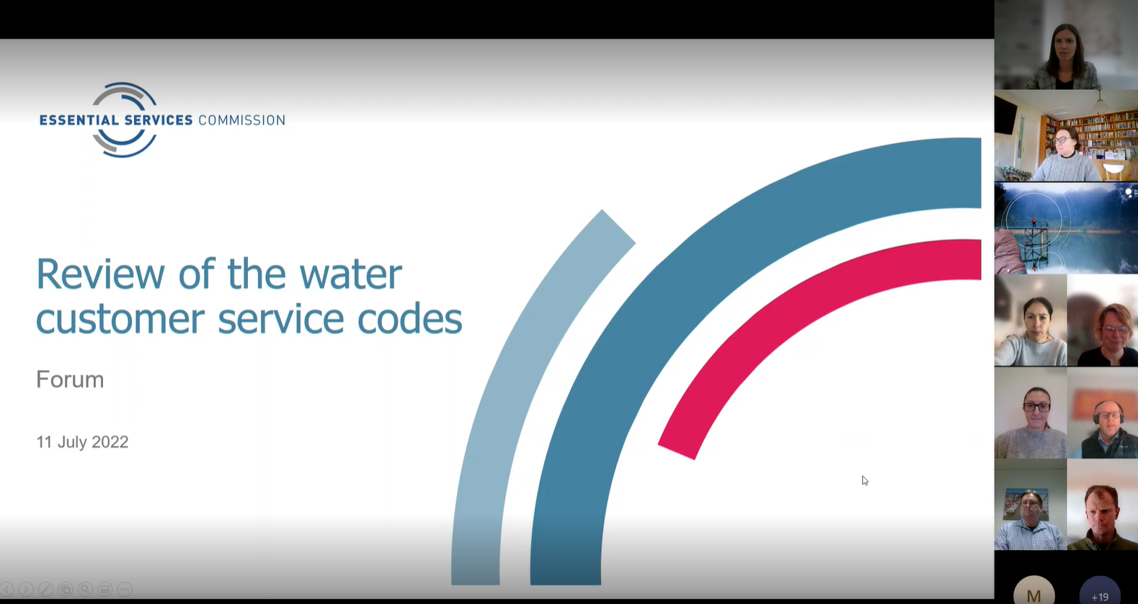
Screenshot of Engage Victoria page after consultation closed (26 July 2022)
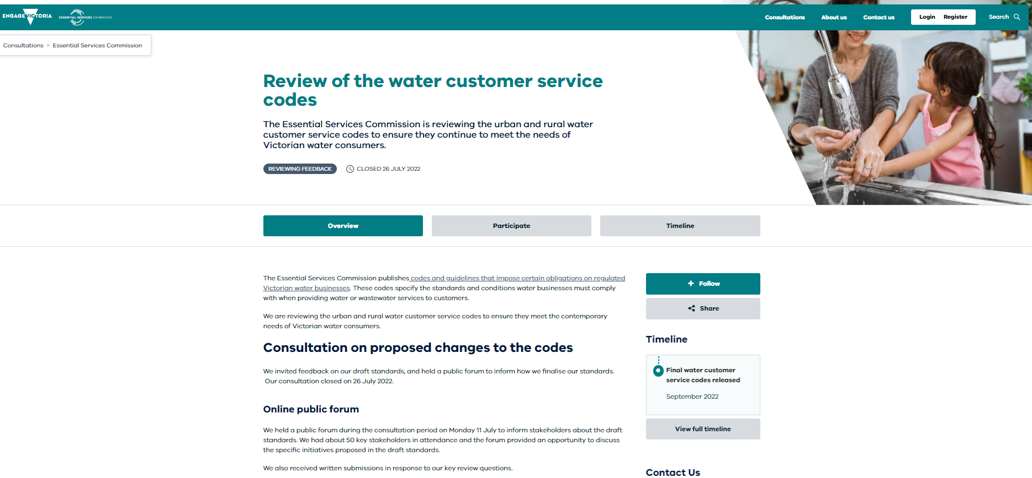

We promoted opportunities to provide feedback on the draft Water Industry Standards on social media.
