Overview
Stormwater Program Investment: Large Scale Stormwater Harvesting

Summary

The draft ESC decision removes the operational expenditure required to:
- Support the capital stormwater harvesting capital program ($4.5 million)
- Carry out further analysis and investigation work and the associated FTE ($3.5 million)
- Fund research, informing policy and monitoring programs to understand effectiveness ($3.5 million)

This outcome appears to support the Deloitte (DAE) recommendation to remove the $98 million capital expenditure related to Melbourne Water’s proposed stormwater harvesting program. The implication is that the $98 million of stormwater capital is part of the ESC decision for an average reduction of $50 million per annum to Melbourne Water’s capital program. The decision is based on the Deloitte report, which noted “we have recommended removal of a number of capital investment items associated with the waterways and drainage increased customer service levels (see section 3.4.2), approximately $98 million over RP5. We consider these capex reductions should be included as part of the broader $50m per annum reduction to the capital program.” (see discussion in Table 3.14 on pgs. 35-36 and pgs 103-104 of the Deloitte report). Deloitte raised concerns about the prudency of stormwater harvesting projects and considered insufficient justification was presented, beyond willingness to pay.

The consequence of the removal of the large scale stormwater operational expenditure means the associated capital expenditure cannot substantially progress. This operational and capital expenditure is required to meet MW’s legislative and regulatory obligations under the Water Act 1989, the Environment Protection Act 2017 / Environment Protection Act 1970, and contained within the Statement of Obligation (2015), with respect to:
- waterway management;
- environmental protection; and
- maintaining social and economic uses of valued urban waterways.

Note the three business cases relevant to this program have been updated to more clearly articulate the program drivers and reflect these specific obligations.
The works proposed are designed to prevent a decline in the health of waterways that would result from maintaining the current level of investment (i.e. business-as-usual). In addition to broader studies on the impact of stormwater on waterways (Uttigauer,2016; Walsh & Kunapo, 2009; Wenger, et al., 2009), detailed studies have been completed by Melbourne University (Chee et al,2020, Healthy Waterways Strategy 2008) which have identified that under a business-as-usual approach for Melbourne’s waterways impacted by urban growth, there will be broad and irreversible loss of waterway values such as birds, fish, frogs, macroinvertebrates, platypus, amenity, community connection and recreation if appropriate stormwater management is not undertaken. Of specific note is that no action in the Sunbury region is likely to result in extinction of platypus within the Jacksons and Emu Creeks, potentially the entire Maribyrnong River catchment. Platypus are now officially a threatened species and listed as ‘vulnerable’ in Victoria under Flora and Fauna Guarantee Act 1988 (Vic).

Evidence that supports the basis for these impacts can be found in the three business cases under this program. This includes information on the supporting research carried out by Melbourne University and the loss of values relevant to the specific waterways.

To determine the appropriate level of investment required to maintain waterway health, MW:
- identified waterways that required remediation – used waterway specific data and specialised models to identify those waterways where further investment was necessary to prevent a decline (Chee et al,2020, Healthy Waterways Strategy 2008);
- prioritised waterways that delivered the best value for money outcome – these same models were used to compare the impact on future trajectory from undertaking different waterway management actions, including relative costs, to identify ‘priority areas’ for stormwater management across Melbourne (Chee et al,2020, Healthy Waterways Strategy 2008);
- identified how much stormwater needed to be captured/harvested to avoid the degradation of waterway health – The best available science indicates that maintaining the current flow regime, and hence waterway condition, equates to around 4.4 ML/y harvested and 1.1 ML/y infiltrated respectively for every hectare of development or approximately 70-90% of the stormwater generated (Duncan et al., 2014);
- identify the waterways that require immediate action – of the identified ‘priority areas’, investment over the 2021-26 period is where there is evidence of rapid and expanding urban development (as shown in the Sunbury and Upper Merri Creek business cases), and via a prioritisation process that screened potential interventions and capital works programs;
- defined and assessed a suite of robust and comparable options – for Sunbury and Upper Merri Creek, while a range of options were considered, given the large volume of stormwater that must be harvested to prevent waterway decline direct investment in centralised infrastructure is the preferred option. For the regional business case, investment options included different asset types (ie; aquifer recharge vs collection and reuse from wetlands) and different scales (lot scale, streetscape and neighbourhood scale). The analysis undertaken was bespoke for the spatial location and intervention was fit for purpose. Analysis and investigation was performed by experienced consultants;
- completed robust cost estimates, based on modelling and engineering design completed by an appropriately experienced independent consultant, and engineering cost estimates for each of these projects (E2DesignLab, 2018; Stantec, 2021; GHD, 2021; and Alluvium 2020).

The following response seeks to:
- Directly respond to DAE’s concerns regarding the prudency and efficiency of the stormwater harvesting program;
- Demonstrate the prudency of the program; and
- Demonstrate the efficiency of the proposed works.

ESC Draft Decision

In its Draft Decision, it appeared that the ESC accepted the recommendations of Deloitte Access Economics (DAE) - the removal of all capital expenditure related to the proposed stormwater harvesting program ($98M). DAE also recommended removal of the associated operational expenditure to support the capital program ($4.5M); to carry out further analysis and investigation work and the associated FTE ($3.5M); and funding for research, informing policy and monitoring programs to understand effectiveness ($3.5M).

The justification for DAE’s findings were:
- “concerns about the prudency of stormwater harvesting projects”; and
- “the BNI cases did not sufficiently demonstrate that each of the projects would result in a net incremental benefit

We have sought to address each of these concerns.

Demonstrating the prudency of the program

The ESC, as a result of advice provided by DAE, has inappropriately removed expenditure related to the delivery of MW’s regulatory obligations. This is demonstrated by the following:

Melbourne Water’s obligations include:
  - Obligations as ‘waterway manager’ under the Water Act 1989, requiring Melbourne Water to maintain social, environmental and economic waterway values in waterways in its region, and to carry out works and activities to improve their environmental values and health, including biodiversity, ecological functions and water quality;
  - The obligation to comply with responsibilities under the General Environmental Duty (GED) within the Environment Protection Act 2017, which requires a preventative approach to avoiding harm to the environment; and
  - Delivering on opportunities for stormwater capture and fit-for-purpose reuse and take principles of integrated water management into account, as directed by our Statement of Obligation (2015). This includes in the planning for the Sunbury Growth Corridor.

Declining waterway health
A vast body of research confirms that where new urban areas are developed implementing current and/or conventional stormwater management practices will result in degradation (Uttigauer,2016; Walsh & Kunapo, 2009; Wenger, et al., 2009).
Current waterway condition and key values across Melbourne’s 25,000 kilometres of waterways were described using measured data (Chee et al,2020, Healthy Waterways Strategy 2008). A specialised model was then used to understand the resulting future trajectory of waterway condition and key values due to urbanisation and population growth, consistent with official state government projections of population and households to 2056 (DELWP, 2019). A comparison of the current condition and future trajectories under a business-as-usual approach to management (Figure 2) identified a significant decline in waterway values: broad and irreversible loss of waterway values such as birds, fish, frogs, macroinvertebrates, platypus, amenity, community connection and recreation.

Of critical importance is that no action in the Sunbury region will lead to probable extinction of platypus within the Jacksons and Emu Creeks, potentially the entire Maribyrnong River catchment. Platypus are now officially a threatened species and listed as ‘vulnerable’ in Victoria under Flora and Fauna Guarantee Act 1988 (Vic). This will result in a reduced level of service for customers.

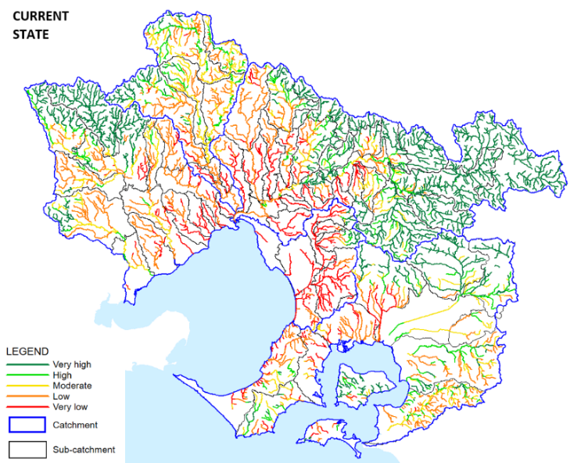  (a) | 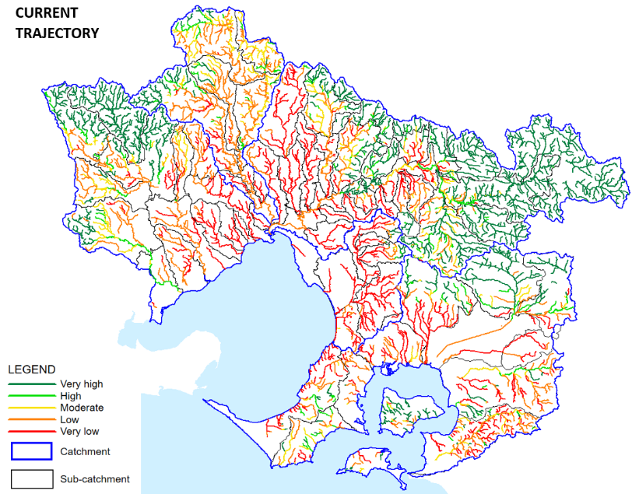  (b)
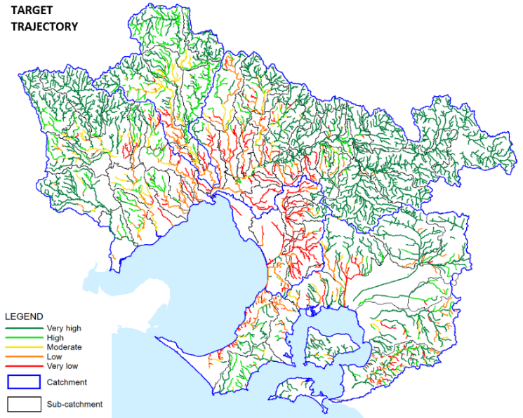
(c)
Figure 2: A comparison of the (a) current state, (b) current trajectory under BAU and (c) target trajectory of waterway health (Melbourne Water, 2018, Chee et al. 2020, Melbourne Water 2020).
Note the state of waterway health uses macroinvertebrate data as a representative metric. A Very High score indicates very good stream health with all or almost all macroinvertebrate taxa present, High indicates good stream health with most taxa present, Moderate indicates moderate stream health and some taxa present, Low indicates poor stream health with a low number of taxa present and Very Low indicates very poor stream health with a very low number of taxa present.

Urgency of action
Urbanisation is occurring rapidly. While the impacts of Covid-19 may have slowed growth in Victoria in the immediate term, housing development has not just continued, it has increased. The UDIA’s ‘State of the land report’ showed that the number of greenfield housing lots sold during 2020 were almost double the figure of 2019, and in the second half of 2020 were the highest since 2009 (UDIA, 2020).
Across the identified ‘priority areas’ for investment, there is already rapid and expanding urban development occurring in both the Sunbury (adjacent to Jacksons and Emu Creeks) and Northern (along Upper Merri Creek) Growth Corridors. In Sunbury, development applications have already been received for approximately 7,575 individual lots across 714 ha of development – this represents 25% of the total area of the PSPs gazetted in January 2019. In the Northern Growth Corridor, there are already 20 completed and approved Precinct Structure Plans adjacent to Upper Merri Creek and another 6 are scheduled for completion within the next few years. The 9 that are not yet underway will be developed under compressed State Government timeframes supporting Victoria’s Covid-19 response. Further detail is included in the respective business cases.
The opportunity to enable protection of waterways via large-scale stormwater harvesting schemes is closing at a very fast pace and it is necessary to invest in proposed infrastructure now, to prevent decline. It is also much more efficient to invest to prevent waterway decline than to restore a damaged waterway, and restoration may not even be possible.

Customer support
Whilst the program drivers relate to Melbourne Water’s obligations, community concern regarding the impact of stormwater on waterway levels of service is clear, and strong customer feedback is supportive of the proposed expenditure. This includes:
  - Co-development of the Healthy Waterway Strategy (2018) by 222 community groups and more than 600 individual community members, including development of stormwater harvesting and infiltration targets;
  - Ten percent of submissions to the Draft Yarra Strategic Plan reinforced the need for stronger action on waterway health and water quality resulting in the addition of specific content and actions in addition to those in the HWS Yarra Catchment Plan;
  - Melbourne Water’s biennial Perceptions of Waterways survey has seen a 50% growth (between 2016 and 2020) of community recognition of urban development impacts on waterways;
  - Qualitative research for Melbourne Water exploring community perceptions, expectations, values, and preferences relating to the Waterways and Drainage Charge found communities highly supportive of increased stormwater harvesting, reflecting a sensitivity to waste and water security concerns in the context of climate change and population growth;
  - The Waterways and Drainage Customer Council emphasised stormwater as a priority for the Waterways and Drainage Investment Plan;
  - A poll of the Community Deliberative Panel showed 74% strongly supported Stormwater Harvesting in local and new developments (23% supported) and the majority (64%) saw the need to act rapidly.

Alignment with government policy
The proposed program of investment also directly aligns with government policy, including:
  - Victorian Waterway Management Strategy, Improving Our Waterways (2013). The overarching objective of the strategy is to maintain or improve the environmental condition of waterways to support environmental, social, cultural and economic values. Management activities will focus on maintaining or improving the environmental condition of priority waterways to provide public benefits. Melbourne Water’s Statement of Obligation (2015) requires Melbourne Water to take this Strategy into consideration in delivery of its services.
  - Water for Victoria (DELWP, 2016) sets the State Government’s long-term direction for managing Victoria's water resources. Its specific objectives include protecting waterways and their catchments from the adverse impacts of future human use and improving the health of priority waterways and their catchments to support our environmental, social, cultural and economic needs and values now and into the future. It also aims to transform Victorian cities and towns into the most resilient and liveable in the world, including all elements of the urban water cycle in the way we plan and manage water so that Victorian communities can continue to thrive in all climates.
  - Waterways of the West Action Plan (DELWP, 2018) – community led approach to protecting Melbourne’s western waterways for generations to come, highlights that waterways are essential to the liveability of local neighbourhoods, community health and the broader environment.

As demonstrated, there is a clear need for Melbourne Water to respond to declining waterway health. Any response relates to maintaining waterway health, consistent with MW’s legislative and regulatory obligations.

Demonstrating net benefits

It is our understanding that the basis for DAE’s concern was that there was no clear driver, hence MW would need to demonstrate net benefits delivered to customers to justify additional expenditure.

As evidenced above, the drivers for this program are to maintain the delivery of waterway health consistent with MW’s legislative and regulatory obligations. Given this, Melbourne Water is required to adopt the most efficient and least cost benefit solution to deliver the outcome. While net benefit to customers is clearly our intent, this is not the focus of assessment for funding under the ESC framework.

To do this, MW completed the following tasks:

Identified the required outcomes
Of those waterways showing a decline in waterway values and overall condition due to urbanisation, it was important to understand the future trajectory of waterway values from undertaking different types of waterway management actions. These same specialist models were then used to compare the impact of streamside revegetation, stormwater management or removal of fish barriers. The relative cost of these measures (informed by Melbourne Water’s previous expenditure and experience) and the relative improvement in trajectory, was used to identify 36 ‘priority areas’ for stormwater management across Melbourne (Chee et al,2020, Healthy Waterways Strategy 2008).

For these areas, the best available science indicates that maintaining the current flow regime, and hence waterway condition, equates to harvesting 4.4 ML/y and infiltrating 1.1 ML/y respectively for every hectare of development or ‘removing’ approximately 70-90% of the stormwater generated before it enters the waterway (Duncan et al., 2014). This was confirmed with hydrological modelling of these creeks for the current and future BAU states (E2DesignLab, 2018, Stantec, 2021). For Jacksons and Emu Creek adjacent to Sunbury this equates to approximately 3GL/year combined. For Merri Creek this equates to over 21 GL/year. This is a significant volume of water.
Assessing options
There are a range of available options used by waterway managers for waterway protection other than direct investment. These include market-based instruments (MBIs) such as grants or subsidies for work on the customer side; information provision to promote customer-side or council innovation; regulation or a combination of these. Melbourne Water has had a great deal of experience with information provision, has initiated a couple of MBI pilots (the Dobsons Creek and Little Stringybark Creek projects) and has piloted a ‘regulatory’ approach using an Environmental Significance Overlay. While there has been some success with these measures, they all are limited as they do not typically address as large a volume as has been identified in the target areas, the outcomes are slow and do not allow Melbourne Water a sufficient level of control. Given Melbourne Water’s obligation with respect to waterway management, none other than direct investment are sufficient.

In terms of investment in infrastructure solutions there are either de-centralised measures, such as rainwater tanks, permeable pavements and/or passive irrigation or ‘centralised’ infrastructure measures such as stormwater harvesting networks. Modelling for Sunbury, Upper Merri Creek and other catchments in the Southern Macedon Ranges has shown that it is not possible to achieve capture of sufficient volumes of water, necessary to maintain waterway values, using any approach other than direct investment in large-scale stormwater harvesting. This is also consistent with over a decade of Melbourne Water’s experience in promoting other methods. Our experience with all options is outlined in Table 1.
For the regional business case, investment options included different asset types (i.e. aquifer recharge vs collection and reuse from wetlands) and different scales (lot scale, streetscape and neighbourhood scale). The analysis undertaken were bespoke for the spatial location and intervention was fit for purpose. Analysis and investigation was performed by experienced consultants.

Assessing costs
Cost estimates for each of the separate business cases have been developed using information from a detailed concept design phase using an independent consultant (E2DesignLab, 2018; Stantec, 2021; GHD, 2021; and Alluvium 2014 and 2020). Cost estimates include investigations, waterway health monitoring and harvesting infrastructure such as pumps, transfer pipelines, construction of storage and associated land requirements. For the Sunbury project, consultants Stantec were engaged through a competitive tender process to provide an independent review of the work, and further develop the concept design and costing. Land costs are based on the current per hectare residential development rates for land in the Sunbury area. Note that a contingency of 30% has been applied as the proposed infrastructure differs from infrastructure typically constructed alongside development.

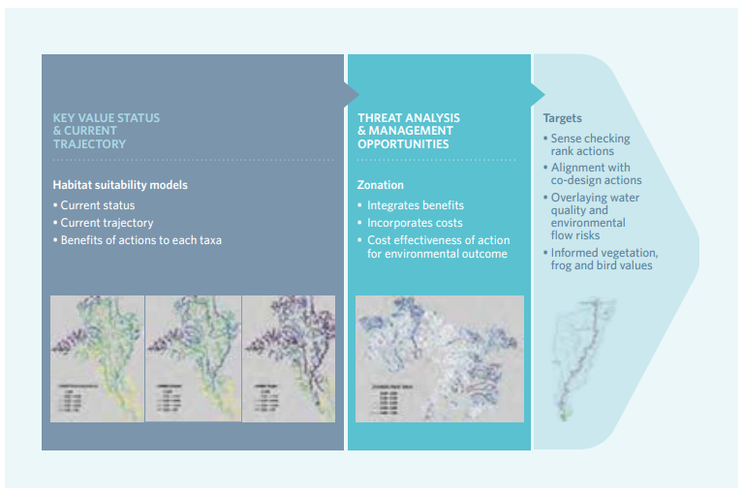
Figure 1: Process for determining the priority areas for interventions (Healthy Waterways Strategy 2008)

Table 1: Options for stormwater management with urban growth
 |  |  |  |  | Discussion
Option | Intervention | Location assessed | Capital or OPEX implication | Description
BAU | Do nothing | All 36 Priority Areas | None | Stormwater generated from new urban development is managed through conventional drainage infrastructure and discharged to waterways at volumes and rates that lead to the irreversible decline of waterway condition. | Failure to manage waterways in accordance with Melbourne Water’s obligations under the Water Act and the Statement of Obligations. Decline in waterway condition across the region. Failure to protect waterways and deliver HWS objectives.
1 | Policy intervention – Improved guidance for best practice stormwater management | All 36 Priority Areas | Policy | Introduction of a flow standard, (runoff flow reduction and infiltration base flow). The standards will apply to the Performance Objectives set out in MW HWS strategy. | EPA Cost Benefit Analysis indicates a positive NPV on the assumption that a state wide offset scheme is available (currently in development). Without an offset scheme, the cost benefit ration falls to approximately 0.8 at an estimated cost of $500M.  EPA and DELWP are progressing the introduction of a flow standard via guidance and the incoming General Environmental Duties. In parallel to this exercise, the best implementation pathway is being considered by DELWP. There are no clear timeframes when a policy instrument such as this will be implemented or how it might be achieved.
2 | Direct investment in harvesting and infiltration infrastructure (preferred option) | Ten investigation areas | Capital | Deliver infrastructure to manage the quantity of stormwater generated from new urban development. HWS objectives can only be supported in selected priority areas, requiring identification and prioritisation of waterways to protect and others to allow to decline in condition | The business cases associated with this expenditure
3 | Market based instruments (e.g. tanks, grants); | All 36 Priority Areas | OPEX | Provide incentives to partners to deliver infrastructure to manage the quantity of stormwater generated from new development. | Market based instruments are generally suitable for delivering lot-scale to medium-scale infrastructure at a low to medium cost effectiveness but are not able to support such a large volume of stormwater harvesting. Most appropriate where large-scale infrastructure is infeasible, e.g. due to site constraints.
4 | Information provision, capacity building, research and development (e.g. Clearwater) | All 36 Priority Areas | OPEX | New technical guidelines, practitioner training, research into new technologies and methods are required to enable delivery of the HWS stormwater objectives.  Research and investigation into the use of real time control technologies to release water from stormwater storages (ponds, lakes and tanks) during periods of drought and low flows to improve habitat for platypus. | This option is a crucial enabling factor in a holistic stormwater program. It is critical to support industry adoption of new beyond BAU approaches that are necessary for delivery and operation of the stormwater harvesting and infiltration infrastructure solutions.  It can result in zero on-ground infrastructure or investment and therefore MW cannot control the impact of this option and it cannot be relied on to protect Emu and Jacksons Creeks
5 | Planning controls and overlays | Ten investigation areas | OPEX | This option would require Melbourne Water to seek to develop planning controls to strengthen the ecological protection and restoration of waterways. The Victoria Planning Provisions (the VPPs) currently include a consideration of stormwater management through Clause 56 and, more recently following the gazettal of Amendment VC154, within Clause 53.18 and Clause 55. These provisions seek to achieve development that is aligned with the Best Practice Environmental Management Guidelines (the BPEM) for stormwater | Despite these provisions, there remains significant gaps in the framework for stormwater management and catchment health within the planning system. Our investigations have identified that there are a range of zones where development is not required to meet the BPEM and that the BPEM is inconsistently applied within existing particular provisions in the VPPs.  Options in this space include developing a conceptual design for a Schedule to the Environmental Significance Overlay (ESO) to address these gaps and deliver a stronger stormwater standard to deliver stronger ecological protection and restoration of waterways. It seeks to apply the ESO to priority areas identified in the Healthy Waterways Strategy and be sufficiently robust to address a range of scenarios  The pitfalls of these options are the timeframes to influence policy makers and pace of development occurring.

The Victorian Waterway Management Strategy (2013) outlines the following tools and approaches for waterway managers: direct government investment; market based instruments (for example, grants, subsidies, trading and auctions); information provision (research and development, or extension); and regulation.

