Business Case

Natural Wetlands Management program

Program Intent | Supporting the environmental values of the region’s priority natural wetlands
Program Lead | Daniel Besley, Team Leader, Catchments, Land and Waterways Services
Program Owner Group/Team/Section | Service Delivery – Asset Management Services  Catchment Asset Management  Catchments, Land and Waterways Services

Business case summary

Melbourne Water, as the waterway manager for the Port Phillip and Westernport region, has a clearly defined role under the Water Act (1989) “…to improve the environmental values and health of water ecosystems, including their biodiversity, ecological functions, quality of water and other uses that depend on environmental condition".

This Act also requires Melbourne Water to develop a strategy (the Healthy Waterways Strategy) for waterway management to meet our obligations. Within the Strategy, natural wetlands are identified, along with rivers and estuaries, as one of three critical natural asset types across the region. A total of 298 Performance Objectives were developed to direct the management of 87 priority natural wetlands over ten years from 2018.

This program delivers on Melbourne Water’s statutory and strategic drivers for 20 of the 87 priority natural wetlands that are not under other forms of management regime (for example, as recognised Sites of Biodiversity Significance, or wetlands proposed to be incorporated within the State Government’s Western Grasslands Reserve). The program shifts Melbourne Water from ad-hoc and reactive investment to a planned approach, which is required as many of these natural wetlands face the common challenges of climate change and urban development.

The program is focused on delivering the least cost solution for meeting Melbourne Water’s wetland Performance Objectives. The program’s planned works include: maintaining native vegetation extent and quality through revegetation, fencing, and controlling pest plants and animals. Program costs were derived from detailed cost data underpinning Melbourne Water’s Vegetation for Environment program which is focused on waterway vegetation management. Due to the similarity in on ground activities, these costs are applicable to wetlands.

Table 1 – program benefits
Program benefits | Program costs
Output (annual): Maintenance of 3Ha of vegetation per wetland per year, sustaining wetland habitat condition  Outcome (5-year): protection of 300Ha of habitat across 20 priority wetlands supporting key values such as birds, frogs and community amenity | Approx. $15,000 per wetland per year  ($300,000 per year)  $1.5M over 5 years

Program Drivers
The program is primarily driven by compliance with Melbourne Water’s legislative obligations for the management of wetlands.

Obligations
The Water Act 1989 (Vic) is the key legislation which guides Melbourne Water’s roles in waterway management including its role “…to improve the environmental values and health of water ecosystems, including their biodiversity, ecological functions, quality of water and other uses that depend on environmental condition". This Act also requires Melbourne Water to develop a strategy for waterway management to meet our obligations. This is the Healthy Waterways Strategy.
The development of the Healthy Waterways Strategy is guided by key government policies, the Victorian Waterway Management Strategy, and Water for Victoria, Water Plan.
Other relevant legislation which guides Melbourne Water’s investment in natural wetlands includes:
- Environmental Protection and Biodiversity Conservation Act 1999 (Cwlth) – Melbourne Water is bound by responsibilities under the act to provide for the protection of the environment, especially matters of national environmental significance. There are three such matters which are relevant to Melbourne Water under this allocation (1) Wetlands of International Importance (Ramsar Wetlands), (2) listed threatened species and communities and (3) listed migratory species.
- Flora and Fauna Guarantee Act 1988 (Vic) – relevant objectives include – “to protect, conserve, restore and enhance biodiversity”, and “to identify and mitigate the impacts of potentially threatening processes to address the important underlying causes of biodiversity decline”.

Strategic Drivers

Healthy Waterways Strategy
The Healthy Waterways Strategy was co-designed with the community and other stakeholders, to ensure its priorities and objectives were those of all stakeholders. The strategy makes clear that by continuing our pre-2018 management approach, Melbourne Water is risking a noticeable and significant decline in waterway condition across the region within the ten year timeframe of the strategy. For example the Healthy Waterways Strategy found that natural wetlands in the Westernport and Mornington Peninsula Catchment under a business as usual approach will see decline in all of the key values these wetlands support (see Figure 2). The strategy also demonstrates targeted investment can ensure the status of key values are maintained or improved.
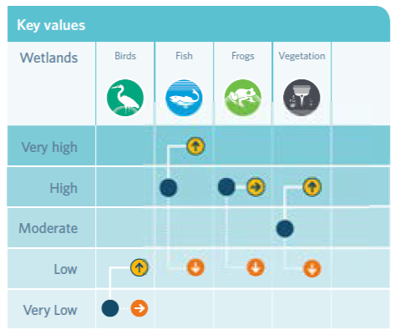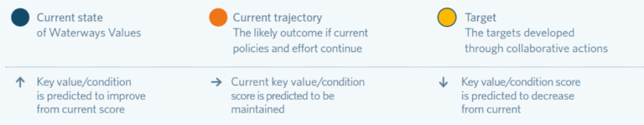
Figure 1 Wetland Value in Westernport and Mornington Peninsula Catchment
Source: Healthy Waterways Strategy
In the Monitoring and Evaluation Plan for wetlands, Melbourne Water has identified 250 of the region’s 14,000 wetlands as having significant biodiversity values present and being priorities for management. The development of the 298 performance objectives for the management of 87 of these wetlands in the Healthy Waterways Strategy used available information on wetland condition and threats, community collaboration and co-design. The strategy’s performance objectives guide actions on natural wetlands associated with:
- Increasing vegetation extent
- Managing pests
- Mitigating threat of soil disturbance
- Protect / maintain or improve vegetation quality
- Protect specific values and habitat
Additionally, the strategy guides regional action, for example seeking to protect important seasonal herbaceous wetland vegetation communities.

Figure 2 – hierarchy of natural wetland priorities

Waterways and Drainage Investment Plan and 2021 Price Submission
Melbourne Water’s Statement of Obligations creates the obligation to develop a Waterway and Drainage Investment Plan (WDIP) that must consider any relevant Victorian waterway management strategy, regional catchment management strategy or catchment sub-strategy. The 2021-2026 WDIP seeks to ensure the effective and efficient delivery of our services, where benefits to the community exceed the costs which involved balancing investment with four key considerations:
- Meeting obligations, responsibilities and directions.
- Aligning with regional co-developed strategies that address the risks of climate change and urbanisation.
- Responding to customer and community engagement, including customers’ preferences and willingness to pay for our services.
- Ensuring our investment is efficient and effective.
The 2021-2026 WDIP informed Melbourne Water’s 2021 Price Submission. Incorporated into this was consideration of customer preferences and advice from Melbourne Water Subject Matter Experts, regarding what the optimal investment in natural wetlands would be to meaningfully deliver towards the Performance Objectives in the Healthy Waterways Strategy.
As a result, 20 wetlands were identified, across 40 Performance Objectives, where investment would be of significant benefit to sustaining wetland condition and values. The program was then costed on the basis of the area (in Hectares, Ha) of wetlands proposed to be managed.

Customer Priority
Beyond the collaboration for the Healthy Waterways Strategy, customers and community were engaged for the WDIP. Our customers generally expect natural wetlands to be protected, and the majority want more done for this service.
A summary of the findings from this process are provided below:
- The Waterways and Drainage Customer Council help define customer value and identified the need to respond to the decline of wetland condition. This information also supported customer preferences articulated in the customer preference and willingness to pay survey. The council’s strategic advice supported a greater than 5% increase in total waterway and drainage spending, and was specifically concerned with meeting the outcomes of the Healthy Waterways Strategy.
- Through the quantitative customers testing, metropolitan, rural and business customers were found to strongly prefer increased natural wetlands service provision. Participants’ responses showed they valued healthy ecosystems and habitats for wildlife. This was consistent with findings in a series of focus groups.
- In a representative survey which included consideration of water and sewerage services, customers showed a preference to keep creeks, rivers and wetlands healthy, closely followed by security of supply (water) – above providing a reliable, uninterrupted supply of water.
- The Waterways and Drainage Community Deliberative Panel supported a vision of: “The climate crisis and the urban expansion rate are threatening our water systems. We recommend aggressive investment and innovation in a needs-driven strategy based on scientific evidence with/& future-proof solutions.” This validated previous engagement in favour of further investment in natural wetlands.

Program Objectives
This program has been developed to enable Melbourne Water to:
- Deliver on our statutory obligations in relation to the management of natural wetlands
- Protect 20 priority natural wetland sites by mitigating threats to wetland condition and values
- Contribute towards meeting 40 of the 298 wetland Performance Objectives in the Healthy Waterways Strategy
- Meet community expectations upon Melbourne Water to manage natural wetlands

Program Background

Wetlands are significant biodiversity assets facing region wide decline in condition and number due to pressures from urbanisation and climate change
If Melbourne Water does not directly invest in managing our priority wetlands over the coming five years, the extent and condition of important habitat will continue to degrade resulting in widespread loss
This expenditure funds the natural wetland management activities to improve the environmental condition of natural wetlands and support the environmental values they provide.
Wetlands are unique features in our landscape and are typically significant biodiversity hot spots. They are home to a variety of native plants and animals, have deep cultural connections and can have high liveability value. There are over 14,000 natural wetlands in the region. These include coastal wetlands dominated by salt tolerant vegetation, ephemeral wetlands on the Victorian volcanic plains and billabong wetlands on the floodplain which are filled intermittently when rivers spill their banks.
As a result of continued urban expansion and a changing climate, our region’s natural wetlands are in decline. The condition of many wetlands is deteriorating as a result of drying, whilst other are being lost entirely as they are built over to make way for new urban areas and some are too wet from stormwater run-off. A wetting and drying regime is critical to the health of the wetlands – each one has its own requirements.
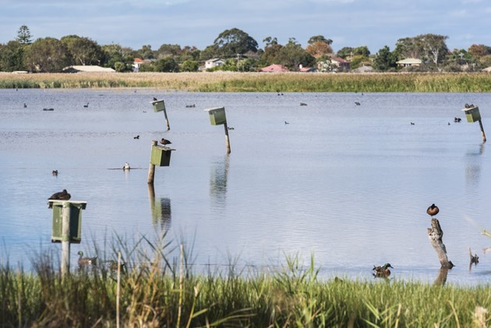 | 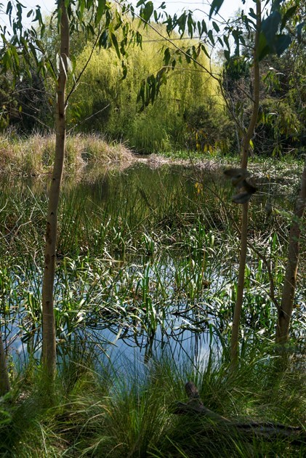

Program scope
Guided by the Healthy Waterways Strategy, Melbourne Water currently plays a role in the protection and management of a number of priority wetlands on public land. Currently, this investment is reactive and opportunistic where funding is available. As part of the 2021 Price Submission, Melbourne Water is proposing an increase in its investment on natural wetlands - through investment in 20 priority wetlands. An investment of $1.5M in operating expenditure will target priority works including:
- Increasing vegetation extent
- Managing wetting and drying regimes
- Managing pests
- Mitigating threats of soil disturbance
- Protecting / maintain or improving vegetation quality
This operating expenditure is one element of Melbourne Water’s program to support Healthy Waterways outcomes.
Over the 2021 Regulatory Period, an increase from base expenditure of $1.50M ($Real2021) is proposed.
Note that this expenditure is complemented by a proposed $2.2M ($Real2021) in capital expenditure for maintaining and natural wetlands forecast over the same price period, and $4.8M ($Real2021) in capital expenditure for the purchase of land for long-term protection and management of high value natural wetlands (i.e. with significant ecological, geomorphological or cultural heritage values) that are at imminent risk of loss through urban development or other threat.

Options identification and assessment
The program funded by this expenditure has been developed with reference to legislation, guidelines, obligations and strategy and supports implementation of the Healthy Waterways Strategy. In developing the program, a number of options were considered and included in customer testing. Table 2 outlines those options, from investment is all high priority natural wetlands through to the continuation of the current ad-hoc and opportunistic investment. The program development was part of the of the Waterways and Drainage Investment Plan which then informed Melbourne Water’s 2021 Price Submission (see Figure 3).
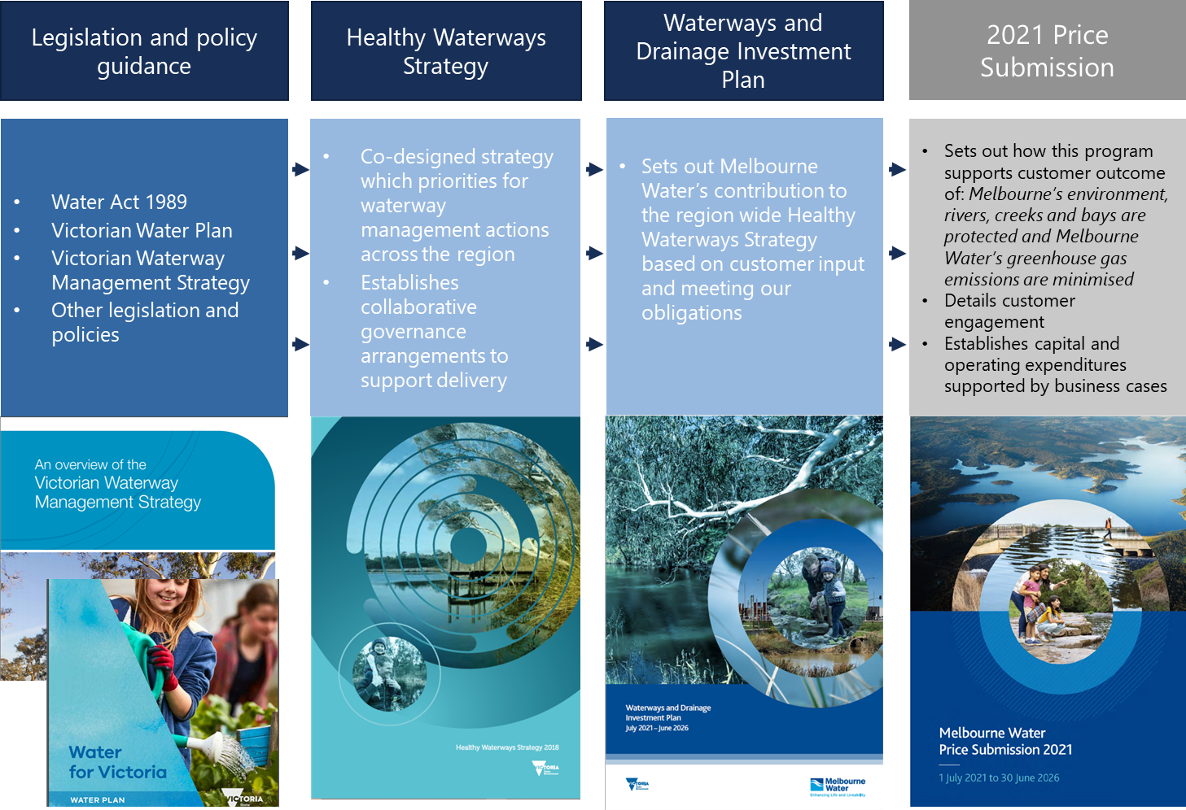
Figure 3 Process to develop the natural wetlands program

Table 2 Options considered for natural wetland management
Option | Cost | Discussion
High investment option. | - $18.7M in operating expenditure | Manage all 250 high priority natural wetlands  Significant improvement (7,500 hectares)
Medium investment option | - $4.7M in operating expenditure | Manage the 63 highest priority natural wetlands  Improved condition and extent of natural wetlands (1,900 hectares)
Low investment option | - $1.5M in operating expenditure | This expenditure will target priority actions in 20 natural wetlands.  This is the preferred option
No additional investment | - | No additional investment. Continued ad-hoc and opportunistic investment only.

Preferred Option
Although there was customer support for a larger program, we are proposing a smaller program and will consider the expansion of the program over time. Regardless, there is a significant uplift in spending for natural wetlands to manage 20 priority wetlands.

Program costs
A flat real $21/22 forecast is being estimated for this program over the 5-years. This is because it is proposed that wetlands being managed under this allocation will be subject to similar management effort each year, and/or that a similar quantum of projects to maintain wetland condition will be initiated each year.
Appendix 1 outlines the priority actions for each of the identified 20 natural wetlands. Investing $1.5M over 5 years will result, as an example, in over 300Ha of wetland being maintained. Each year, 60Ha of wetland will be maintained for $300,000; which is a per wetland benefit of 3Ha for a per wetland cost of $15,000 each year. Individual wetland priorities were determined in the Healthy Waterway Strategy and an initial list of the 20 priority wetlands is provided in Appendix 1.
Melbourne Water considers this to be a very prudent and efficient investment by maintaining important wetland habitat and values into the future for very minimal cost.
Table 3 Options considered for natural wetland management

Description | 2021/2022 | 2022/2023 | 2023/2024 | 2024/2025 | 2025/2026 | PS2021 Total
Total spend | $0.3M | $0.3M | $0.3M | $0.3M | $0.3M | $1.5M

Program benefits
This operating expenditure supports an effective and coordinated management of wetland habitat connectivity and vegetation extent and quality, across priority wetlands and will help sustain key aspects of local wetland environmental condition within the 5-years of the next price period.
This program of works will help deliver:
- Legislative compliance with Melbourne Water’s obligations for managing natural wetlands.
- Significant progress towards meeting up to 40 (out of 298) performance objectives in the Healthy Waterways Strategy for the management of the vegetation condition in and buffers around 20 natural wetlands.
- Improvement to the extent and quality of wetland vegetation (habitat).
- Improved data from monitoring wetland condition.
The risk of not funding this uplift is that works to manage threats and undertake works to improve wetland condition will be unfunded, and it will be almost certain that the extent and quality of wetland vegetation will continue to degrade over 5 years, resulting in a significant loss of important habitat. This degree of risk requires proactive mitigation measures to be in place to eliminate the risk or to reduce the risk to as low as reasonably practicable (ALARP) as per Melbourne Water’s Corporate Risk Management Policy.

Table 4 – benefits, measures and KPIs

Benefit Title | Measure (KPI Description) | Baseline (Current KPI Performance) | KPI Target | Target Benefit Realisation Date
Legislative Compliance | Meeting obligations as defined in the applicable wetland management plans | N/a | Compliant: i.e. having met obligations as demonstrated by evidence of Melbourne Water implementing priority management actions in the plans | FY 25/26
Wetland Performance Objectives | Meeting Healthy Waterways Strategy Performance Objective | None are met currently | 40 Performance Objectives are met or significant progress towards meeting them has been made. | FY 25/26
Wetland management – environmental | Ha (extent) native vegetation maintained (incl. EVCs) in/around wetlands  Quality of native vegetation maintained (incl. EVCs) within these extents | 0 Ha  Various current quality (i.e. rated poor (2) to good (4) from a 5 point condition rating scheme) | 60 Ha vegetation extent maintained to the required quality (each year for the five years of the Price Period)  Incl. pest plant control | FY 25/26
Wetland management – environmental | Pest animal control | None | Allowance of 2 control efforts per year per wetland | FY 25/26

Program implementation
Maintenance activities specific to each site will be informed by data on threats to sustaining wetland condition and values and as such a per wetland works program cost will be derived for each year of the Price Period. The scope (extent and intensity) of maintenance activities will be balanced according to the available budget.
Program delivery will be tracked and reported through Melbourne Water’s systems and wetland condition and values monitoring will be undertaken in accordance with the Wetlands Monitoring and Evaluation Plan.

Implementation example
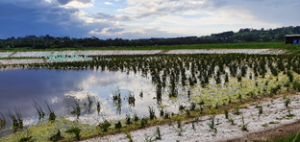

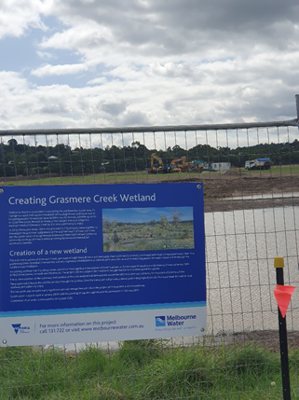

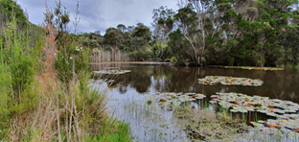
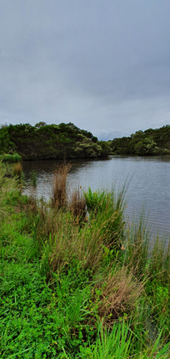

Grasmere Creek natural wetlands, containing a significant population of dwarf galaxias (a listed native fish species). Constructed wetland for biodiversity (left and right top) just above Grasmere Creek realignment project and just above the natural wetland (left and right bottom) needing protection. A park and walking tracks are between and traverse these. This is a multi-pronged approach to protecting the local Creek and wetlands, whilst facilitating public enjoyment of the less ecologically sensitive areas.

Appendix 1
Table 5 - Initial prioritisation identifying the ‘top-twenty’ natural wetlands for management and the focus activity related to HWS Performance Objective theme.

WDIP top 20 | Location | Targeted works
1 | Annulus Billabong Yarra Flats | Manage pests
2 | Banyule Flats Billabong | Manage pests
2 | Banyule Flats Billabong | Increase Vegetation Extent
3 | Barnbam Swamp Lynbrook | Manage pests
3 | Barnbam Swamp Lynbrook | Manage pests
3 | Barnbam Swamp Lynbrook | Increase Vegetation Extent
4 | Bolin Bolin Billabong | Increase Vegetation Extent
5 | Burke Road Billabong | Increase Vegetation Extent
5 | Burke Road Billabong | Protect / maintain or improve vegetation quality
6 | Deanside Marsh Rockbank | Manage pests
6 | Deanside Marsh Rockbank | Increase Vegetation Extent
7 | Domain Chandon Billabongs | Manage pests
7 | Domain Chandon Billabongs | Increase Vegetation Extent
7 | Domain Chandon Billabongs | Increase Vegetation Extent
8 | Hallam Valley Floodplain wetlands | Increase Vegetation Extent
8 | Hallam Valley Floodplain wetlands | Increase Vegetation Extent
8 | Hallam Valley Floodplain wetlands | Re-engage floodplains
8 | Hallam Valley Floodplain wetlands | Protect specific values and habitat
9 | Hearnes Swamp | Increase Vegetation Extent
9 | Hearnes Swamp | Increase Vegetation Extent
10 | Jenz Swamp | Manage pests
10 | Jenz Swamp | Increase Vegetation Extent
11 | Kalkallo Commons Grassland and Kalkallo Creek Wetlands | Increase Vegetation Extent
12 | Laverton RAAF Swamp | Manage pests
12 | Laverton RAAF Swamp | Increase Vegetation Extent
13 | Paynes Rd Swamp | Manage pests
13 | Paynes Rd Swamp | Mitigate threat of soil disturbance
13 | Paynes Rd Swamp | Increase Vegetation Extent
14 | Rockbank No. 1 | Protect specific values and habitat
15 | Spadonis Billabong | Manage pests
15 | Spadonis Billabong | Increase Vegetation Extent
16 | Tootgarook Swamp | Manage pests
16 | Tootgarook Swamp | Manage pests
16 | Tootgarook Swamp | Increase Vegetation Extent
16 | Tootgarook Swamp | Increase Vegetation Extent
17 | Troups Rd Swamp | Manage pests
18 | Willsmere Billabong | Manage pests
18 | Willsmere Billabong | Increase Vegetation Extent
19 | Wyndham Vale Swamp | Manage pests
19 | Wyndham Vale Swamp | Mitigate threat of soil disturbance
19 | Wyndham Vale Swamp | Increase Vegetation Extent
20 | Yallock Creek floodplain wetlands | Re-engage floodplains
20 | Yallock Creek floodplain wetlands | Protect specific values and habitat
20 | Yallock Creek floodplain wetlands | Increase Vegetation Extent

See: https://healthywaterways.com.au/
Performance Objectives are outcome-based measures which guide progress towards the waterway targets and ultimately the goals and vision for waterways across the region.

