Business Case

Flood Mitigation

Program Intent | Minimising flooding and flood damage.
Program Lead | Wendy Smith, Team Leader, Flood Services
Program Owner Group/Team/Section | Service Delivery  - AMS - Catchment Asset Management  - W&CO - Flood Preparedness & Service Performance  Integrated Planning – Innovation and Resilience

Business case summary
Melbourne Water’s flood mitigation programs are a direct outcome of legislative obligations to minimise flooding and flood damage outlined in the Water Act (1989) Section 202. The delivery of programs under this obligation is established through cascading policy but is materially defined in the Flood Strategy – Port Phillip and Westernport. The current Strategy was released in 2015 and a revised strategy (in draft) is due for release in 2021.
This business case relates to new operational expenditure required to meet the intent of the 2021 Flood Strategy and to deliver works in a more prudent and efficient manner. The rise in operational expenditure (OPEX) is offset by a reduction in capital expenditure (CAPEX) of $38M between PS16 and PS21. The overall program reflects an optimisation of total expenditure (TOTEX).
There are two components to the operating expenditure program, both addressing the complexities of flood mitigation in a highly urbanised environment in the face of climate change and urban infill development :
- Program innovation – expands the current program to identify new strategies that may be more effective in some locations
- Delivery innovation – adopts alternative strategies to deliver the current program to ensure the efficient delivery of place based mitigation options.
The expected costs and benefits of this program are outlined in Table 1.

Table 1: Flood mitigation program costs and benefits
Program Component | Cost | Anticipated benefit
Program innovation | $1.7M | A more flexible approach to flood mitigation that addresses the increasing challenge of flooding from climate change and urban development  Flood mitigation options for locations where major infrastructure projects are not feasible.
Delivery innovation | $1.8M | Program delivery focussed on place based solutions, as required by the Flood Strategy.  Reduction in the time to delivery of flood mitigation projects and reduced capex and labour investment

Program Drivers

Obligations
The primary driver for the program is compliance with legislative obligations. The legislative drivers for flood mitigation in the Port Phillip and Westernport catchments are:
- Water Act 1989 - sections 201-212 provide for floodplain management across the State. Melbourne Water is the statutory Floodplain Management Authority for its waterway management district (i.e. the Port Phillip and Westernport region). Section 202(2) of the Water Act 1989 sets out Melbourne Water’s floodplain management functions including a broad and enabling function (s.202(2)(d)): To develop and implement plans and to take any action necessary to minimise flooding and flood damage.
- Statement of Obligation 2015 – section 6.3 sets out responsibilities for planning prudent and efficient investment for flood risk reduction works within the drainage network.

Strategic Drivers
The legislative obligations are reflected and actioned through MW’s strategic directives for flood mitigation in the Port Phillip and Westernport catchments. The Flood Management Strategy 2021 (draft) - outlines how agencies will work together to plan for, avoid and reduce flood risks while supporting emergency preparation and response as required by the Victorian government’s Floodplain Management Strategy. The Strategy identifies climate change and urban development, the effects of which are being experienced in Melbourne now, as key drivers for change. It covers a 10 year period and articulates the need to continue to deliver flood mitigation works, to focus those works on place based solutions and to broaden the suite of tools used to manage flooding. The draft Flood Strategy actions to identify and manage flood risks in relation to potential investment in flood solutions on private property include:
- Action 4.1: Identify high-priority areas for flood effects reduction, then consider a diverse range of potential solutions to identify the right approach for prioritised locations and their communities. Deliver outcomes in collaboration with partners and the community
- Action 4.2: Investigate, develop and deliver place-based capital asset solutions where feasible
- Action 4.4: Identify new opportunities and innovations to reduce flooding and its effects and assess their feasibility
- Action 4.5: Pilot feasible place-based opportunities and innovations to reduce flooding and its effects

Customer Priority
While the primary driver for the expenditure is compliance, MW has sought to ensure that the expenditure program itself is implemented in a manner consistent with the outcomes being sought by its customers. Extensive customer engagement has been undertaken to develop the Draft Flood Management Strategy Port Phillip and Westernport 2021 – 2031 (the draft Strategy) and through the development of the Waterways and Drainage Investment Plan. Outcomes relating to flood mitigation are summarised as follows.
Focus Area 4: Flood Effects Reduction of the Draft Flood Management Strategy Port Phillip and Westernport 2021 – 2031 (the draft strategy) relates specifically to this business case. A workshop with our Local Government customers to inform the vision for this Focus Area, was well represented with 35 registrations. The resulting vision was ‘We continue to explore innovative solutions and expand our suite of tools to manage flood risks’.
In April 2021 Melbourne Water received eight submissions from our Local Government customers who provided commentary relating to ‘focus area 4’, the large majority of which expressed support for the 10 year vision statement and actions to deliver on the vision. A number of submissions responded to the actions relating to innovation with specific examples of innovative practices that should be considered within the actions. One submission stated that ‘identifying new opportunities and innovation is essential’ due to the limited opportunities for structural flood effects reduction and land availability in their local government area. A submission from a Local Government customer relating to the draft strategy more broadly stated that ‘proactive support for innovation in the flood mitigation space’ is required to achieve the draft strategy vision and objectives within the current context.
Outcomes of customer and community engagement on the flood mitigation programs for the development of the Waterways and Drainage Investment Plan include:
- In the Customer Preference and Willingness to Pay Survey, metropolitan and rural customers strongly preferred an increase in all flood services but particularly mitigation which had the 3rd and 4th biggest impact on customer preference shares for rural and metropolitan customers respectively.
- The Waterways and Drainage Customer Council supported the outcomes of the customer survey.
- The Community Deliberative Panel discussed flooding with our subject matter experts. The panel supported putting more effort into mitigating flood through better infrastructure with 26% strongly supporting and 68% mostly supporting our programs. Draft capital and operational expenditure presented on Day 4, including the flood mitigation program, was rated anonymously with the Waterways and drainage investment plan 23% ‘Outstanding’, 77% ‘Good’; none falling into ‘Not sure’, ‘Not so good’ or ‘Dreadful’.
- Local government were briefed on the investments proposed for flood and drainage. Responses included:
  - Managing, collecting and conveying stormwater, along with data such as mapping, modelling and planning information were the priority outcomes for flood management.
  - Providing flood management infrastructure was essential to equipping councils with the tools to manage floods.
  - Areas of collaboration with Melbourne Water identified by participants included maintaining and upgrading flood infrastructure, and gathering and sharing flood, rainfall and mapping data.

Program Objectives
The objective of the flood mitigation program is to reduce flooding in areas where drainage infrastructure is either no longer or never has been sufficient. The additional operational expenditure sought in this business case is targeted at seeking breakthrough solutions to the increasing challenge of developing traditional infrastructure solutions or delivering them in a traditional manner.

Program Background & Details

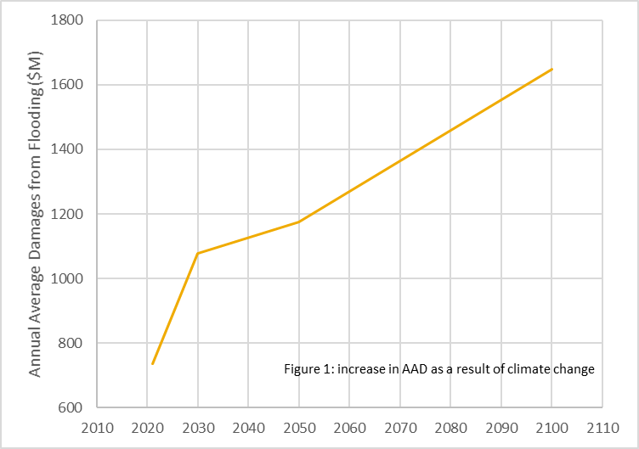
It is estimated there are over 200,000 properties across the Port Phillip and Westernport region with a 1% or greater chance of flooding in a given year. Based on tangible (direct and indirect) and intangible damages, the annual average cost of flooding (refer
red to as annual average damages or ADD) in the region is assessed at $735 million.

Climate change and urban infill development are expected to increase the flooding risk as a result of increased storm intensity and increased runoff due to additional impervious areas (Figure 1). This is expected to result in an increase in Annual Average Damages of 125% by 2100 . These projections do not include sea level rise which will further increase damage costs.
Melbourne Water manages flooding across the Port Phillip and Westernport catchments by working with developers to prevent flooding in new areas and by working with flood management agencies to prevent, respond to and recover from flooding in locations where development has not been effectively controlled and properties experience flooding. The flood mitigation program is part of a suite designed to address the latter issue which includes flood warning and education (‘preparedness’), application of new development controls and the development of comprehensive flood information.

Program Scope

The flood mitigation program augments existing drainage infrastructure. Experience in PD2016 has highlighted the increasingly challenging nature of delivering these works in a highly urbanized setting. Key challenges include the increasing cost of land and capital works, the highly developed and constrained urban landscape and lack of stakeholder acceptance of project impacts.
These lessons have highlighted the need to innovate both within and beyond our programs in order to deliver least cost service solutions. This business case addresses the need for:
- Innovation in the type and nature of infrastructure that is considered
- Reframing of the model for delivering flood mitigation projects to find appropriate location specific (or “place-based”) solutions.
To support the evolution of flood mitigation programs to ensure they continue to deliver effective and efficient works, an increase in operational expenditure is sought for PD2021 and is offset by a decrease in capital expenditure of $38M. The shift in funding mechanism to operational expenditure enables the development of new programs and projects that cannot be capitalized and is an integral part of MW’s commitment to taking a more holistic TOTEX based approach to delivering least cost solutions. Accounting for potential tradeoffs between opex and capex is also consistent with established best practice approaches to infrastructure planning and the ESC’s PREMO regulatory framework.

Proposed Programs

Melbourne Water’s current approach to flood mitigation is through large scale infrastructure, typically pipe duplication and retarding basins. Large infrastructure projects provide substantial community relief from flooding. They reduce economic damages, improve floodplain safety and remove large numbers of properties from flood extents. However, they also face many barriers including stakeholder reluctance, constructability constraints, long lead times (often greater than 10 years) and escalating project development costs. Melbourne Water is addressing these challenges by firstly adding to the suite of solutions that can be applied (Program Innovation) and secondly, by deepening our understanding of the issues at a particular location to ensure the development of robust business cases (Delivery Innovation).

Program Innovation

The program innovation work stream aims to develop a number of alternative technical solutions. Several opportunities have been explored (Table 2).
Table 2: Program innovation options
Flood mitigation solutions | Description | Prioritised
Permeable Road Paving | The reduction of road flooding through road resurfacing | Yes
Flood Gates | Gates that automatically rise when flood water approaches | Yes
Flood Resilient Homes | Flood resilient design is the use of materials and construction systems that can withstand substantial | Yes
Leaky Pipes | Simple concept of installing a box culvert upside down | No
Extended Retarding Basins | Extendable basins would take the idea of the self-rising flood gates and use that around the banks of the basins | No
Three of these options were identified as suitable for consideration in the Program Innovation workstream. These options are outlined as follows.

Permeable Road Paving
The University of Melbourne has developed a new material using recycled tyres and aggregates to produce a highly permeable paving that can be used in heavy load applications such as roads. The new material has 10 times the infiltration rate of traditional porous solutions. The application is currently being tested in a range of applications within the Melbourne University Campus. The product is now registered for commercial applications through a company called ‘Porous Lane’.
For absorption of very large flood events, a 50mm porous top layer is recommended with a 300mm storage layer beneath. Typical costs, depending on the site, are between $230 and $250/m² designed and installed. Where a road surface was planned to be replaced/upgraded, the cost of this upgrade is saved.
We are proposing to undertake a pilot study partnering with Councils and/or VicRoads to identify road segments or large car parks within flood zones that are due for replacement or upgrade. The pilot would investigate the permeability of the surface and its ability to absorb very high rainfall events and overland flow volumes.

Flood Gates
Potential exists for Melbourne Water to use gates in areas where a more traditional earthen levee wall would be specified. The advantage of the gates are that they would sit flush with the ground in normal circumstances, allowing installation without the permanent physical barrier. There is also potential to use gates to upgrade existing levee walls or retarding basins to gain additional capacity above the current design.
Flood gates automatically rise when flood waters approach by hydraulically lifting when water enters a control well. This means that the gates are not electric and do not require human intervention to activate. In recent applications, the gates have been used to protect areas such as driveway entrances to underground carparks.
We are proposing to undertake a pilot study to trial flood gates in an existing flood affected site. In commercial applications, the typical rate is approximately $10,000/m, supplied and installed. This may be less in larger applications.

Flood Resilient Homes
In PD16, in order to understand how alternative solutions might be effectively developed and implemented, Melbourne Water initiated a study based on flood resilient building design. Flood resilient design is the use of materials and construction systems that can withstand substantial and multiple inundations by actively mitigating the effects of flooding. Flood resilient building design enables homeowners to safely store belongings prior to a flood event (with adequate warning) and easily clean, repair and quickly resume normal life after the flood waters recede with minimal longer term disruption to the occupants and without the financial burden of repairs and replacements (Appendix A).
Through this pilot program we will trial flood resilience building strategies on up to 12 properties for a total anticipated cost of $1.2M.
In support of these trials, Melbourne Water is also developing a range of policy positions including:
- Exploring how we work with the insurance sector in Victoria to provide reduced insurance premiums to flood resilient designed houses. This has been demonstrated in South East Queensland, but would need to be proven in the Victorian context.
- Explore evolution of the program to operate as an incentive program, where Melbourne Water will co-fund retrofits with home owners. Consideration will be given to means-testing to identify a level of co-contribution to ensure equitable access across all socio-economic communities.
- If appropriate take learnings to build an ongoing, sustainable programs to add to Melbourne Water’s suite of tools.

Delivery Innovation

Most of the drainage infrastructure projects developed and delivered historically by Melbourne Water were based on a two phase project delivery model (Figure 2). This is a common approach adopted by flood management agencies. As Figure 2 highlights, the emphasis in phase 1 is on defining a hydraulic solution to flooding. Phase 2 addressed a range of other location specific issues such as constructability, stakeholder acceptance and cost benefit.
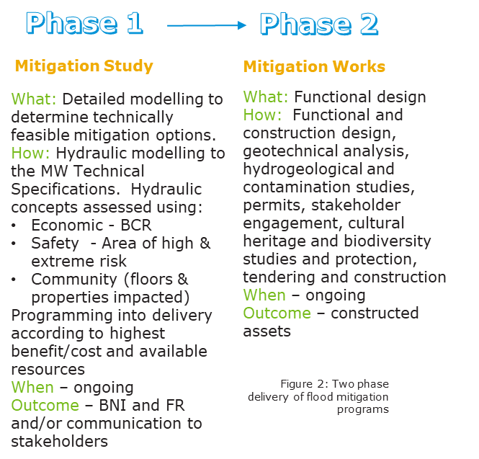
In PD16, experience in delivering flood mitigation projects highlighted the many projects for which a hydraulic solution could be found but for which there were many other local barriers that prevented the project progressing. For instance, of the 25 projects developed over the PD16 period, following phase 1:

- Three projects did not progress due to stakeholder concerns relating to use of open space.
- Most projects, from initial design to functional design, required significant rework to manage new information following detailed landform survey.
- Seven projects were found to be economically unviable.
The combined effect of these issues is an ongoing investment of labour and capital (>$10M) in projects that fail to mature.
To address these complexities, Melbourne Water has introduced additional project phases (Figure 3) which result in earlier and deeper collection of specific local information to inform business cases. The collection of this information requires additional operational expenditure as it necessitates additional studies and options assessments prior to capital business case development.
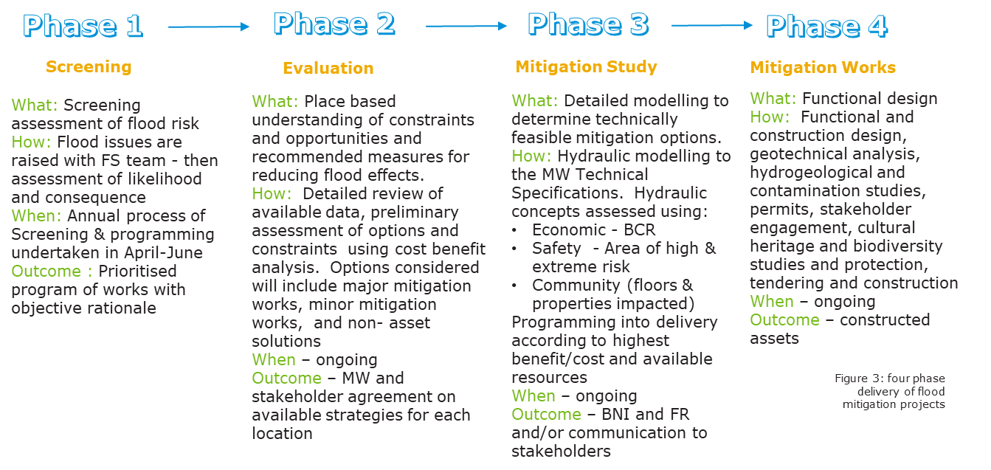
Using the project cycle shown in Figure 3, Melbourne Water aims to develop 2-4 projects (depending on complexity) to the end of Phase 3 in each year of PD21. To support this level of project delivery, more information is required earlier in the project cycle. Additional information necessary includes:
- Deeper and wider stakeholder engagement, supplemented with appropriate tools to assist the stakeholder visualize the constructed project. In PD16, stakeholders frequently resisted mitigation works on the basis of the perceived impact on amenity to other community members, particularly in inner urban areas where open space is limited. Project examples include Hawthorn East Main Drain, Glasses Creek Main Drain and Koornang Road Main Drain. Whilst stakeholders were sympathetic to flood mitigation needs and expressed desire to reduce flooding, they were reluctant to accept perceived loss of local amenity. The additional operational expenditure sought will assist with the development of landscape plans, community engagement and consultation and co-delivery of projects and the use of digital platforms such as virtual reality.
- Measurement of geotechnical information and contaminated land. At present, information on these issues is only gathered late in the project development. In some instances, the presence of substrate that is difficult to excavate (e.g. rock) or contaminated material (for instance asbestos) makes constructing the project substantially more expensive and frequently diminishes the benefit cost ratio such that the project is no longer viable. Examples of these projects include the M1 freeway at Wheelers Hill, Scotchman’s Creek, Regan Street and Acacia Street Main Drain.
- Undertaking detailed survey earlier as part of initial design to reduce the cost of remodeling of catchments. Projects are typically modelled using survey based on LIDAR, an aerial imagery version of landform. The accuracy of this survey is suitable for use in most modelling however detailed survey with greater accuracy is required before the hydraulic design can be finalized. Hydraulic modelling and assessment typically takes 18 months (at a cost of $100K-$150K) which then needs to be repeated during Functional Design. In addition, the new survey data often changes the design of the mitigation option substantially and, infrequently, leaves the project unable to be completed. Collecting the survey data earlier will prevent this rework.
- The location of other infrastructure creates significant barriers to the progress of flood mitigation works. The hydraulic study undertaken in Phase 1 (Figure 2) does not identify the location of other agency infrastructure. Critical infrastructure that might prevent the construction of flood mitigation works is therefore not identified until Phase 2. Projects experiencing this issue include Scotchman’s Creek, Sages Road and M1 Freeway.
- Earlier economic modelling of costs and benefits prior to initiating design to reduce expenditure on projects that are not economically viable. Cost benefit analysis is typically determined following Phase 1 (Figure 2) and follows the investment of substantial capital in Phase 1. Projects are often found to not have a sufficient cost benefit relationship and therefore do not progress. Project examples include Harding Street Main Drain and M1 Freeway at Wheelers Hill.
This additional expenditure is forecast over the 2021-22 financial year as shown in Table 3, noting that the amounts provided are estimates based on Melbourne Water’s experience in delivering similar outcomes:
Table 3: Delivery innovation for FY2122
Project | Deliverables | Total
Hawthorn – Station Street. Development of retaining wall system to store flood waters on a playing field and control flow direction | $60K to develop landscape plans to facilitate stakeholder acceptance of impact  $20K to obtain localized survey to prove up the hydraulic design  $25K to determine the extent of contamination in this highly urbanized location  $20K to understand the complex economics of this specific project including climate change and based on the specific conditions at this location | $125K
Glass Street Richmond. Upper catchment storage solutions to slow the passage of floodwaters into the drain. | $35K to develop landscape architect drawings. The extreme limited space in Richmond will mean any flood storage solutions will impact on amenity. Visualisation of these options will be key to stakeholder acceptance.  $20K to gather localized economic information to inform the cost benefit analysis | $55K
M1 Freeway at Wheelers Hill – upstream storage or pipe augmentation under M2 | $20K to obtain survey information to reduce uncertainty in the hydraulic design  $25K to obtain geotechnical data to reduce uncertainty in the cost estimate for the project  $20K to obtain economic data to reduce uncertainty in the cost/benefit estimate for the project | $65K
Ormond McKinnon development of flood storage options in a highly constrained environment. | $60K to develop landscape architecture plans for this location. Stakeholders have previously strongly resisted flood mitigation projects on the basis of impact on amenity. Acceptance is critical to any project progressing  $30K to obtain geotechnical and contaminated land data. Given the likely storage size at this location, the cost benefit relationship will be difficult to prove. Removing uncertainty in this estimate will be important.  $20K in survey data to reduce uncertainty in the hydraulic options  $20K in economic data to improve the accuracy of the cost benefit calculation. | $130K
Total |  | $375K

Program costs
The proposed flood mitigation operational expenditure (additional to existing) for PD21 is $3.5M. The breakdown of this expenditure is shown in Table 4.
Table 4: Flood mitigation allocation operational expenditure
 |  |  | 21/22 | 22/23 | 23/24 | 24/25 | 25/26 | Total
 | Program Innovation | Flood resilient homes | $182K | $212K | $291K | $340K | $182K | $1,207K
 |  | Permeable Road Paving | $30 | $213K |  |  |  | $243K
 |  | Flood Gates |  |  | $40 | $210K |  | $250K
 |  | Sub-total | $212K | $425K | $331K | $550K | $182K | $1,700K
 | Delivery Innovation | Survey | $60K | $80K | $80K | $80K | $70K | $370K
 |  | Geotech & contamination | $80K | $100K | $100K | $100K | $100K | $480K
 |  | Consultation and visualisation | $155K | $120K | $120K | $120K | $115K | $630K
 |  | Economic analysis | $80K | $60K | $60K | $60K | $60K | $320K
 |  | Sub-Total | $375K | $360K | $360K | $360K | $345K | $1,800
Total |  |  | $587K | $785K | $691K | $910K | $527K | $3500

Program Benefits
The benefits of the Flood Mitigation program include:
- Decreased economic damages both now and into the future. Damage reduction is estimated based on externally developed studies and tools, tailored specifically for Melbourne Water programs.
- Improved community safety, achieved by reducing the depth and velocity of floodwaters in the urban floodplains and quantified using a framework provided by Australian Rainfall and Runoff.
- Reduced social costs including emotional stress, psychological and physical illness, and loss of life.
- Increased community awareness leading to more flood safe actions, more community dialogue around flood resilience and preparedness protecting contents outside the home such as vehicles.
Benefits for Program Innovation include:
- The development of new opportunities for delivering flood mitigation that have effective cost benefit outcomes.
- Programs that address the challenges of flood mitigation where traditional infrastructure solutions are not viable.
- Flood mitigation programs that assist Melbourne to move towards a flood resilient future through the complexities of climate change and urban infill development.
The program benefits for Delivery Innovation include:
- The development of place based solutions that overcome initial stakeholder reluctance and enable earlier identification of barriers.
- Faster delivery of infrastructure projects, moving closer to stakeholder expectations of delivery timeframes. Reduction in investments in projects that, after significant investment, prove inviable. More efficient and prudent flood mitigation programs, delivered at lower capital and labour costs.

Risks

The primary risk associated with this business case is that the investments do not lead to the anticipated outcomes. The future impacts of climate change and urban infill development paired with the existing challenge of implementing flood mitigation works in a highly urbanised environment are difficult to predict.
For both programs, a much greater risk is that the investments are not made. Without these investments, status quo is maintained and flood mitigation solutions are not developed that meet the future needs of a flood resilient city and the programs continue to be delivered in a manner that hampers the speed of delivery and the efficient expenditure of public investment.

Program implementation
The Program and Delivery Innovation elements will both be delivered through competitive tender with service providers with specific technical expertise in each of the individual areas of the program.
The proposed program delivery for the Program Innovation is summarized in Figure 4 and detailed in Table 5.

 | FY21/22 | FY22/23 | FY23/24 | FY24/25 | FY25/26
Permeable Road Paving
Flood Gates
Flood Resilient Homes
Figure 4 – Program Innovation

Table 5: project deliverables for Program Innovation
Financial year | Project | Deliverables | Total
Y21/22 | Flood resilient homes | Dry proofing 18 Larch Street Caulfield South $95k  Dry proofing 21 Larch Street Caulfield South $87k | $182k
 | Permeable paving | Project scoping, catchment investigation and concept design. Engaging with councils and Vic Roads to identify a location where we could jointly deliver a pilot. | $30k
Y22/23 | Flood resilient homes | Two home assessments to identify strategies for flood resilient building design $20k  Dry proofing 36 Station Street and 1301 Main Road Eltham $194k | $214k
 | Permeable paving | Co-deliver with a council and/or Vic Roads a pilot to test the suitability of permeable paving to reduce flood impacts | $213k
Y23/24 | Flood resilient homes | Dry proofing at 1305 Main Road, Eltham $109k  Flood resilient strategies at two properties to be identified through investigation $182 | $291k
 | Flood gates | Project scoping, catchment investigation and concept design $40k | $40k
 | Permeable paving | Post project review | $0
Y24/25 | Flood resilient homes | Five home assessments to identify strategies for flood resilient building design $50k  Flood resilient strategies at three properties to be identified through investigation $290k | $340
 | Flood gates | Co-deliver with a council a pilot to test the suitability of permeable paving to reduce flood impacts | $210k
Y25/26 | Flood resilient homes | Flood resilient strategies at two properties to be identified through investigation $182k | $182k
 | Flood gates | Post project review | $0
Total |  |  | $1.7M
The proposed program delivery for Delivery Innovation responds to the needs of the flood mitigation studies and projects. These are typically not programmed until prioritisation occurs prior to each delivery year. For FY21/22, the proposed program is outlined in Table 3.

Appendix A: Flood Resilient Homes Study

James Davidson Architects were engaged in late 2019 to undertake a pilot study to understand the cost and feasibility of a flood resilient design approach for Melbourne. The project was based on assessing five individual properties in high risk catchments where no large scale infrastructure project has been identified. The study also provided an opportunity to test the appetite of home owners to participate in a pilot program.
The locations selected were Station Street Hawthorn East, Larch Street Caulfield South and Main Road Eltham. Each location contains properties that have experienced repeated flooding of their home above floor level. The criteria for selecting properties was:
- Flood affected dwellings must be impacted above floor level – not just flooding on the property (e.g. gardens, or out-buildings), repeatedly
- There are no feasible cost-effective traditional mitigation options available in these catchments
- Works are only eligible for inclusion where they are designed to reduce flood effects
Properties meeting this criteria and were included in the study are shown in Figures A1-A5.
Following the assessments the best approach for each home was chosen in consultation with the homeowner (the preferred option has been highlighted in bold in the table above). This is based on the typology of the home and the ability to deliver the preferred approach. For example at 36 Station Street dry proofing is the best option. This property could not be raised as it isn’t structurally possible and the home owners preference is to dry proof over wet proofing.
As part of the pilot program, it is anticipated that a further 7 properties will assessed. As the pilot evolves, it is anticipated that further learning from the program will establish new opportunities that may offer wider or deeper benefits.

Cost Benefit Analysis
Flood resilient design can reduce the long-term costs for homeowners by reducing expected costs associated with flood damage. A cost benefit analysis was undertaken as part of the development of the Flood Resilient Building Guidance for Queensland Homes to understand the return on investment for flood resilient homes. This data is directly comparable and relevant to the pilot that will be delivered in Melbourne as it is based on the same design approaches and principles.
The summary of the findings from the Queensland study are that “benefits of resilient homes in high flood risk areas are a viable option for flood events up to and including the 1% (1 in 100) AEP. “ “In these scenarios, flood resilient homes are economically viable under all circumstances modelled up to a 0.5% (1 in 200) AEP”. The average Benefit Cost Ratios are up to 27.3.Flood Resilient Homes – Pilot Program Deliverables

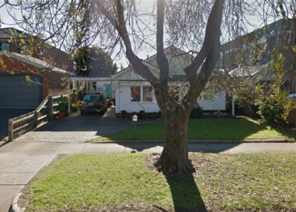
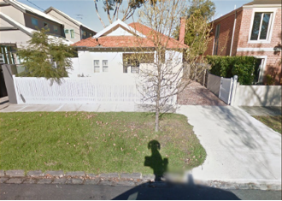

Figure A1 21 and 22 Larch Street Caulfield South
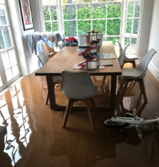
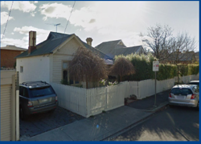

Figure A2 36 Station Street Hawthorn
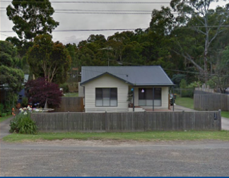
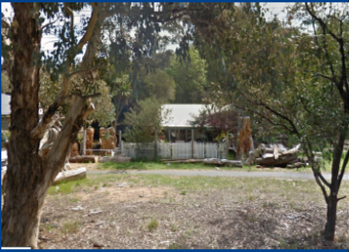

Figure A3: 1303 and 1305 Main Street Eltham
Inspections were carried out at each property and the flood resilience strategies recommended in each report included - house raising, flood wet-proofing and flood dry-proofing:
Wet proofing involves using flood resilient materials and construction methods to allow flood waters to enter the house with a minimised chance of damage and moisture problems afterwards. By accepting a level of risk through wet proofing, and creating space for water to flow, properties can be better prepared for any future flooding that may occur. The wet proofing approach works with flood water rather than against it.
Dry proofing involves sealing the exterior of a dwelling to prevent water from entering. Flood doors are one of the options to achieve this. For low-level floods this is effective, however, greater depths of flood water can result in an increase in force on the building and result in cracking or movement of foundations. It is worth noting that this method can also displace more water onto neighbouring properties.
Raising the level of the house or its services above the projected flood level can be effective. Footings, posts, slabs and other structures all need to withstand an overland flow of water across the site. Services such as air conditioners, hot water units and electrical meter boards can be easily raised above the flood level to minimise the chance of important utilities failing.
A cost estimate for each of the strategies was provided by a builder with experience in flood resilient retrofitting. (Table A1).
Table A1: Estimated cost of retrofitting flood resilient homes
Property | Wet proofing cost | Dry proofing cost | House raising cost
36 Station Street, Hawthorn East | Not acceptable to owner | $99,244 | Not feasible to construct
18 Larch Street Caulfield South | $122,727 | $95,454 | $190,909
21 Larch Street Caulfield South | $127,272 | $86,363 | $209,090
1301 Main Road, Eltham | $131,818 | $95,454 | $172,727
1305 Main Road, Eltham | $154,545 | $109,090 | $200,000
Average cost | $134,090 | $97,121 | $193,181

Draft Flood Management Strategy for the Port Phillip and Westernport 2021-31, Melbourne Water, 2021, Available online at: https://www.melbournewater.com.au/about/strategies-and-reports/flood-management-strategy-port-phillip-and-westernport
Flood Strategy Refresh Workshop Summary Report: Feedback on Key Performance Indicators, Conceptual Framework and 10-Year Vision, Jamie Comley Environmental Consulting, October 2019
Per comms, various organisations, Mar 2021
Per comms, Frankston City Council, Mar 2021
Per comms, Yarra City Council, Mar 2021
Melbourne Water, Waterways and Drainage Investment Plan, Customer Preference and Willingness to Pay Survey (2019)
Melbourne Water Waterways and Drainage Investment Plan Customer Council - Meetings 4 and 5
Per comms, Melbourne Water correspondence with Local Government Customers.
Melbourne Water’s Flood Management Strategy – Port Phillip and Westernport, 2021
Melbourne's Flood Risk Assessment of Average Annual Damage, Jacobs Group, October 2020
Melbourne's Flood Risk Assessment of Average Annual Damage, Jacobs Group, October 2020
The economic cost of the social impact of natural disasters, Deloitte Access Economics, 2016
Jacobs (2019) Flood mitigation damages estimation study and tools
Australian Rainfall and Runoff (2019) Flood hazard classifications

