Minimum Electricity Feed-in Tariffs from 1 July 2024
  - Final Decision
  - 27 February 2024

Acknowledgement
We acknowledge the Traditional Owners of the lands and waterways on which we work and live.
We acknowledge all Aboriginal and Torres Strait Islander communities and pay our respects to Elders past and present.
As the First Peoples of this land, belonging to the world’s oldest living cultures, we recognise and value their knowledge, and ongoing role in shaping and enriching the story of Victoria.

An appropriate citation for this paper is:
Essential Services Commission 2024, Minimum Electricity Feed-in Tariffs from 1 July 2024: Final Decision, 27 February

© Essential Services Commission, 2024
This work, Minimum Electricity Feed-in Tariffs from 1 July 2024, is licensed under a Creative Commons Attribution 4.0 licence [creativecommons.org/licenses/by/4.0]. You are free to re-use the work under that licence, on the condition that you credit the Essential Services Commission as author, indicate if changes were made and comply with the other licence terms.
The licence does not apply to any brand logo, images or photographs within the publication.

Contents
Acknowledgement i
Summary 1
The feed-in tariff is paid to customers for exported energy 1
Solar customers 2
We must set the minimum feed-in tariffs 2
We protect the interests of solar and non-solar customers 3
The value of solar exports 3
Our final decision will lower the feed-in tariffs 3
Solar weighted wholesale prices drive changes in the feed-in tariffs 4
Solar weighted wholesale prices are lower 5
Electricity generators and retailers have different costs 7
We have used the same approach as we have in past reviews 8
We have had regard to stakeholders’ feedback 9
Our minimum feed-in tariff decision 10
The flat minimum feed-in tariff 10
The two time-varying minimum feed-in tariffs are lower than in 2023–24 10
Components of the feed-in tariff 11
Minimum feed-in tariffs over time 12
How we set the minimum feed-in tariffs 13
We must consider certain costs in setting minimum feed-in tariffs 14
The steps for setting the minimum feed-in tariffs 15
The wholesale value of solar energy 17
The solar weighted wholesale costs for the flat minimum feed-in tariff 17
We forecast solar weighted wholesale prices for different parts of the day 18
We use a different futures market approach than the Victorian Default Offer 19
We account for AEMO fees, charges and line losses 20
We consider carbon and human health costs 22
Cost of carbon 22
Human health costs 23
Themes from submissions and our responses 24
Feed-in tariffs are based on facts and the best available information 24
Average wholesale prices are up but daytime prices are down 25
Promoting the interests of all customers 25
Legislation places limits on how we can set the minimum feed-in tariffs 26
Customers can still make significant savings on their electricity bills 27
We will monitor how the value of solar changes across the day 28
Energy markets are complex 29
We have consulted on our draft decision 30
The social cost of carbon is set out in the Order in Council 30
We have considered avoided human health costs 31
We are required to consider the wholesale price of electricity 32
A stepped feed-in tariff is unnecessarily complex 32
Retailers cannot use their customers’ solar energy for carbon credits 32
Appendix A – Technical methodology 34
Forecasting solar weighted wholesale electricity prices 35
Solar weighted wholesale price forecasts for 2024–25 35
Estimate of market fees and ancillary service charges 37
Market fees 37
Ancillary services 39
Estimating avoided transmission and distribution losses 39
Estimate of the avoided social cost of carbon and human health costs 40
Human health costs 41
Damages costs 42
Abatement costs 42
Solar panel installation subsidies 43

Summary
- As Victoria’s electricity industry moves along a path to reduce its carbon emissions, the share of renewable energy generation is increasing. This has lowered the environmental impact of electricity generation and reduced wholesale electricity spot prices, especially during daylight hours.
- For this reason, solar weighted wholesale electricity prices are forecast to be lower in 2024–25 than they were for 2023–24. This means the minimum feed-in tariffs for 2024–25 will be lower than those for 2023–24.
- The minimum flat feed-in tariff will be 3.3 cents per kWh starting 1 July 2024.
- The time-varying feed-in tariffs will range from 2.1 to 8.4 cents per kWh.
- Retailers can offer the flat feed-in tariff and/or time-varying feed-in tariffs. These minimums are floor prices. Retailers can offer more but not less.
- The commission considered all stakeholder submissions in making this final decision. In general, solar customers were strongly against our decision. However, legislation dictates we must base the feed-in tariffs on the value of solar exports. Submissions from solar customers did not include alternative methodologies or facts that showed the value of solar exports to be higher than the proposed draft decision.
- Many Victorians continue to install roof-top solar even though the value of solar exports is decreasing. Significant savings can be made by using the energy generated by the solar panels, rather than importing power from the grid at retail rates. Shifting electricity usage to daylight hours – when solar is producing – is the best way to maximise the financial return on a solar system.

The feed-in tariff is paid to customers for exported energy
Retailers with a minimum of 5000 customers must pay eligible customers at least the minimum feed-in tariff when those customers export energy into the grid.
Eligible customers are those who have a generation facility with total output at the connection point of less than 30 megawatts.

Solar customers
For simplicity, this decision refers to ‘eligible customers’ as ‘solar customers’. Roof-top solar accounts for 99.9 per cent of small-scale renewable energy generation in Victoria.
There are flat and time-varying feed-in tariffs:
- Customers on the flat feed-in tariff are paid the same rate per kWh for their exports regardless of when they export energy
- Customers on time varying feed-in tariffs receive a different per kWh rate depending on the time of day.

We must set the minimum feed-in tariffs
The Electricity Industry Act 2000 requires that the Essential Services Commission sets one or more minimum rates for the electricity that solar customers export to the grid. We refer to these rates as the minimum feed-in tariffs.
The minimum feed-in tariffs reflect the value that solar exports provide to the energy market. This includes the social benefits of reducing pollution associated with fossil fuel electricity generation.
When setting the minimum feed-in tariffs, we must have regard to:
- Prices in the wholesale market
- Avoided transmission and distribution losses
- The avoided social cost of carbon and human health costs attributable to a reduction in air pollution.
The Act requires us to publish minimum feed-in tariffs to apply for the coming financial year by 28 February each year.
While the commission sets the minimum feed-in tariffs, it is electricity retailers who set the feed-in tariffs they pay their customers. Retailers can pay more than the set minimum , but they cannot pay less.

We protect the interests of solar and non-solar customers
Under the Essential Services Commission Act 2001 and the Electricity Industry Act, our objectives include the promotion of:
- The long-term interests of Victorian consumers
- Protections for customers, including in relation to assisting customers who are facing payment difficulties
- Development of full retail competition.
In setting the minimum feed-in tariffs we must consider the long-term interests of both solar and non-solar customers. We do this by setting the minimum feed-in tariffs at a level equal to the value of solar exports.

The value of solar exports
The value of solar exports is:
- The costs retailers avoid when they receive solar exports and
- The value of avoiding pollution.
Minimum feed-in tariffs above the value of solar exports would result in non-solar customers subsidising solar customers through higher electricity rates.
Retailers must pay at least the set minimum feed-in tariffs to their solar customers for purchasing their exported energy. Retailers set their own prices for electricity imports in their market offers. When costs go up, such as the cost of feed-in tariffs for solar exports, retailers pass these on to customers in their market offers. Customers paying more than needed for electricity would not be consistent with our objectives.
In contrast, if the feed-in tariffs were below the value of solar exports, solar customers would be subsidising other energy users.

Our final decision will lower the feed-in tariffs
Our final decision is that the flat minimum feed-in tariff will be 3.3 cents per kWh for 2024–25. This is 32.7 per cent lower than the 2023–24 rate. The time-varying feed-in tariffs will also be lower than during 2023–24.
Table S.1: Minimum feed-in tariffs to apply from 1 July 2024, excluding GST
Flat minimum rate (cents/kWh)
At all times
3.3
Time-varying minimum rates (cents/kWh)
Option One
Overnight | Day | Early Evening
Weekdays: 10 pm – 7 am | Weekdays: 7 am – 3 pm,  9 pm – 10 pm | Weekdays: 3 pm – 9 pm
Weekends: 10 pm – 7 am | Weekends: 7am – 10 pm | Weekends: n/a
7.6 | 2.8 | 7.0
Option Two
Shoulder | Off-peak | Peak
Everyday: 9 pm – 10 am,  2 pm – 4 pm | Everyday: 10 am – 2 pm | Everyday: 4 pm – 9 pm
4.1 | 2.1 | 8.4

Solar weighted wholesale prices drive changes in the feed-in tariffs
To set the minimum feed-in tariff we use a solar weighted wholesale electricity price. This is to reflect the value of rooftop solar generation in the wholesale National Electricity Market.
The solar-weighted wholesale price represents the wholesale prices of electricity at the times when solar customers export power to the grid. Times when the most solar exports occur have the greatest weight. The majority of solar exports take place during the middle of the day.
Export prices around midday therefore receive the greatest weight in determining the minimum feed-in tariffs. Figure S.1 shows the wholesale component as a proportion of the flat feed-in tariff and how this has changed from 2023–24.
Night-time wholesale electricity spot prices are higher than daytime prices. However, the night-time solar weighted wholesale electricity prices are also forecast to decrease in 2024–25. This results in our early evening and overnight feed-in tariff rates also being lower than their 2023–24 equivalents.
Figure S.1: Make up of flat feed-in tariffs for 2023–24 and 2024–25
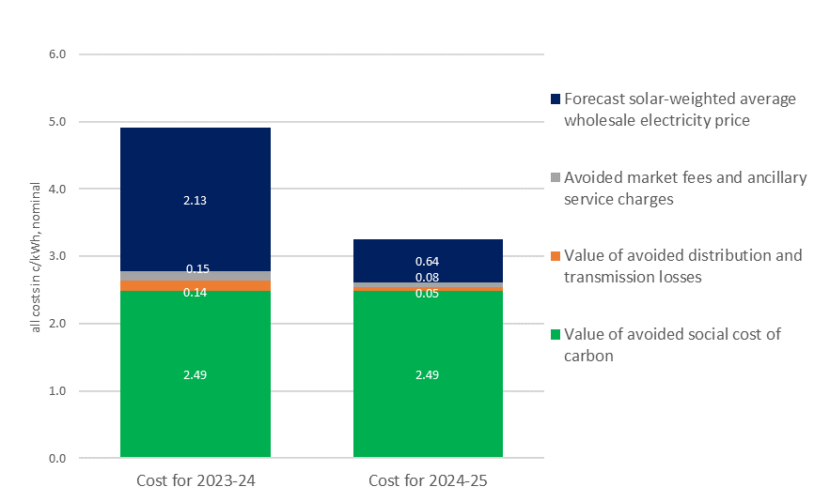

Solar weighted wholesale prices are lower
In Victoria, the installed amount of roof-top solar is increasing rapidly. Between 2014–15 and 2022–23 the share of renewable energy used in Victoria increased from 11.6 per cent to 37.8 per cent. The Victorian community has benefited from this large increase in renewable electricity generation through lower carbon emissions and lower wholesale prices, especially during daylight hours.
Because the number of customers with roof-top solar in Victoria is increasing and daytime electricity demand is falling consumers use their solar panels to cover their daytime consumption. These solar systems also increase supply as solar customers’ surplus electricity is exported to the grid.
The wholesale spot price, which is set by supply and demand in the National Electricity Market, varies according to the time of day. When demand is low and supply is high and increasing, generators get a lower price for the electricity they sell.
This has driven down the wholesale electricity spot price during daylight hours, the very time when most solar exports take place. In fact, this has decreased daytime prices so much that most solar exports happen at times when wholesale spot prices are negative. For example, in 2022–23, 53 per cent of rooftop solar exports happened when wholesale prices were negative (See Figure S.2 below). These low daytime prices have led to significant decreases in solar weighted wholesale prices. As the solar weighted wholesale price is a major component of the feed-in tariff, this drop is reflected in falling feed-in tariffs.
Figure S.2: Share of solar exports occurring when wholesale prices are negative
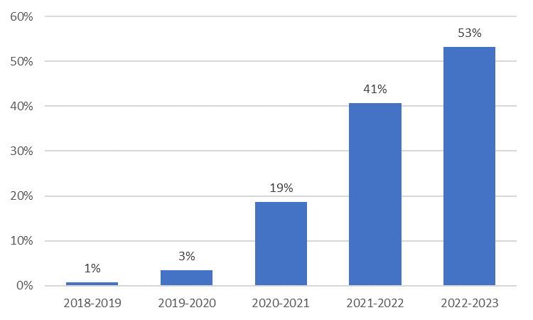
While daytime electricity demand is low, in the evenings (as people are returning home and solar exports go down with the sun) there is an increase in electricity demand and the wholesale spot price increases. This is why the peak, early evening, shoulder and overnight time varying feed-in tariff rates are higher than the rates for daytime tariff periods.
Figure S.3 shows the relationship between solar weighted wholesale electricity prices and total solar exports. Frontier Economics’ report on wholesale electricity prices contains further details.
Figure S.3: Average actual solar weighted prices and solar exports across the day
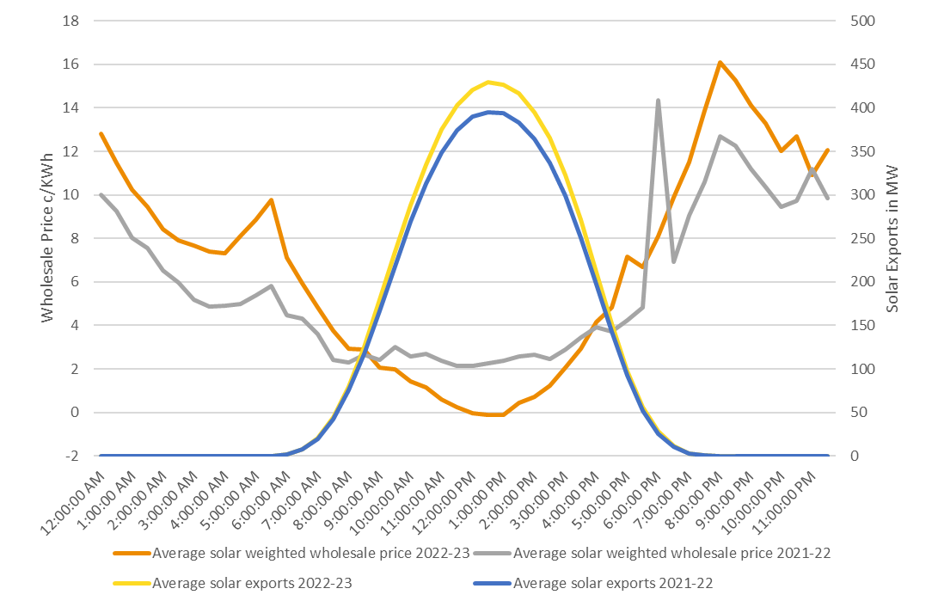
Source: AEMO; Victorian distribution businesses; ESC analysis
Minimum feed-in tariff rates across the board will be lower in 2024–25 than in 2023–24. This is because solar weighted wholesale electricity prices are forecast to be lower for all parts of the day in 2024–25 than corresponding prices in 2023–24. This reflects market expectations that wholesale spot prices will be lower on average for all parts of the day in the next financial year.
We have updated our solar weighted wholesale electricity price forecasts, as foreshadowed in our draft decision. This has led to some of the minimum feed-in tariffs rates for the time varying feed-in tariffs decreasing slightly from what they were in the draft decision.

Electricity generators and retailers have different costs
Solar customers are electricity generators. They are not electricity retailers.
Retailers must buy enough wholesale electricity to cover their customers’ electricity usage across the entire 24 hours of the day. While they buy electricity during the day when demand and wholesale prices are low, they must also buy it at night when demand and prices are high.
Despite changes in the wholesale spot price, retailers generally charge their customers relatively fixed prices across the day, regardless of the wholesale spot price at the time. By doing so, retailers shield their customers from wholesale market price volatility.
Along with buying electricity from the wholesale market, retailers also incur extra operating costs such as:
- hedging wholesale price risks
- transporting electricity
- environmental obligations
- regulatory requirements
- corporate overheads.
Solar customers do not face these additional costs. The extra operational costs retailers bear mean that retail electricity tariffs will always exceed the minimum feed-in tariffs.
To set feed-in tariffs that match retail market offers would mean solar customers are paid for services they do not provide. It would not be appropriate to pay solar customers for value they do not provide when exporting electricity to the grid. Non-solar customers would have to make up this difference through even higher retail prices.
Solar power avoids retail electricity prices
While each customer’s consumption profile is different, generally, solar customers receive greater savings when they use the electricity they generate. When solar customers use the energy their systems produce, they avoid paying retail tariffs.
These savings can be hard to see as bills do not show how much power you have used from your system. Therefore, the savings from your solar panels may not be obvious from your bill.
The payback period on your solar system should account for these avoided retail costs. Most customers will save more by using what they produce than they would from the feed-in tariffs.
To maximise the return on investment for solar panels, in most cases it is best to install a system that roughly matches your daytime electricity requirements and not much more. If you connect a system which far exceeds your daily usage the return per kilowatt installed will be lower, and your payback period longer.
Solar customers can use more of the electricity they produce if they shift some of their electricity usage to when their solar systems are producing (for example by running washing machines or hot water systems during the day instead of at night). This can further reduce the amount of electricity they buy from their retailers and increase the financial return on their solar system.

We have used the same approach as we have in past reviews
In setting the minimum feed-in tariffs to apply from 1 July 2024, we have used the same avoided costs approach as in previous tariff reviews. This approach forecasts the solar weighted wholesale prices for 2024─25 and adds these to other costs retailers and the community avoid when solar customers export their energy to the grid.

We have had regard to stakeholders’ feedback
Following publication of the draft decision we held a consultation period seeking feedback.
Stakeholders made 19 submissions on our draft decision. The submissions were from 15 solar customers, two community solar groups, one distributor and a retailer.
The Electricity Industry Act requires us to look at specific factors and costs when setting the minimum feed-in tariffs. Our decision on the minimum feed-in tariffs reflects the market value of solar exports and their social and environmental benefits. This means that solar customers are paid the value of the energy they produce.
We considered all submissions in reaching our final decision. We summarise and address the key themes from submissions in the ‘Themes from submissions and our responses’ chapter.
In general, submissions from consumers considered the feed-in tariffs in the draft decision to be too low. An energy retailer also proposed a flexible feed-in tariff, and an electricity distributor suggested further public education was needed as consumers generally do not understand the feed-in tariff and how it is set.

Our minimum feed-in tariff decision
Our decision is to set three minimum feed-in tariffs for financial year 2024–25:
- a flat minimum feed-in tariff and
- two time-varying minimum feed-in tariff options.
Solar customers with a flat feed-in tariff are paid the same amount regardless of the time of day or day of the week. Solar customers with time-varying feed-in tariffs are paid different amounts at different times of the day.

The flat minimum feed-in tariff
The flat minimum feed-in tariff for 2024–25 is 3.3 cents per kWh. The flat minimum feed-in tariff for 2023–24 was 4.9 cents per kWh.
Solar weighted electricity prices are forecast to be lower in 2024–25, especially during daylight hours. The growing number of solar installations has caused lower daytime prices by adding to the supply of and reducing the demand for electricity during the day. The flat minimum feed-in tariff reflects these lower solar weighted wholesale electricity prices.
Table 1.1: Flat minimum feed-in tariff 2024–25 (cents per kWh)
Tariff | Flat rate to apply at all times
Minimum feed-in tariff | 3.3

The two time-varying minimum feed-in tariffs are lower than in 2023–24
Tables 1.2 and 1.3 set out the time-varying minimum feed-in tariff rates for 2024–25 and the time blocks for when they apply. Retailers that choose these time blocks must offer at least the minimum rates that apply but can offer higher rates.
Table 1.2: Time-varying minimum feed-in tariffs 2024–25: Option 1 (cents per kWh)
Time block | Overnight | Day | Early Evening
Minimum feed-in tariff | 7.6 | 2.8 | 7.0
Time period weekdays | 10 pm – 7 am | 7 am – 3 pm,  9 pm – 10 pm | 3 pm – 9 pm
Time period weekends | 10 pm – 7 am | 7 am – 10 pm | n/a

Table 1.3: Time-varying minimum feed-in tariffs 2024–25: Option 2 (cents per kWh)
Time block | Shoulder | Off peak | Peak
Minimum feed-in tariff | 4.1 | 2.1 | 8.4
Applicable period every day | 2 pm – 4 pm, 9 pm – 10 am | 10 am – 2 pm | 4 pm – 9 pm

Components of the feed-in tariff
When setting the minimum feed-in tariffs we must have regard to certain costs that retailers avoid when they purchase a solar customer’s exports. These include:
- solar weighted wholesale electricity prices during daytime hours
- National Energy Market fees and ancillary service charges
- network or line losses.
We must also have regard to the avoided social cost of carbon and human health costs.
Solar weighted wholesale electricity prices drive the changes in the feed-in tariffs. During the peak and evening periods solar weighted wholesale prices contribute up to 65 per cent of the feed-in tariffs. However, during the daytime and off-peak feed-in tariff periods, solar weighted wholesale prices contribute close to zero per cent of the feed-in tariff or even reduce it.
Table 1.4 sets out the costs that make up the feed-in tariffs, including the wholesale charges.
Table 1.4: Components of the 2024–25 minimum feed-in tariffs (cents per kWh)
 | Flat | Option 1: Time-varying tariffs |  |  |  | Option 2: Time-varying tariffs
Component |  |  | Overnight | Day | Early evening | Shoulder | Off-peak | Peak
Solar weighted wholesale electricity prices | 0.64 |  | 4.74 | 0.20 | 4.19 | 1.41 | -0.41 | 5.48
Avoided market fees and ancillary service charges | 0.08 |  | 0.08 | 0.08 | 0.08 | 0.08 | 0.08 | 0.08
Value of avoided transmission  and distribution losses | 0.05 |  | 0.31 | 0.02 | 0.27 | 0.09 | -0.02 | 0.35
Value of avoided social cost of carbon and human health costs | 2.5 |  | 2.5 | 2.5 | 2.5 | 2.5 | 2.5 | 2.5
Total | 3.3 |  | 7.6 | 2.8 | 7.0 | 4.1 | 2.1 | 8.4

Minimum feed-in tariffs over time
Table 1.5 shows how the flat minimum feed-in tariff and time-varying feed-in tariff options have changed over time.
Table 1.5: Comparison of minimum feed-in tariffs, 2018–19 to 2024–25
Period | 2018–19 | 2019–20 | 2020–21 | 2021–22 | 2022–23 | 2023–24 | 2024–25
Flat rate | 9.9 | 12.0 | 10.2 | 6.7 | 5.2 | 4.9 | 3.3
Time-varying rate Option 1
Overnight | 7.1 | 9.9 | 9.1 | 6.7 | 7.1 | 11.3 | 7.6
Day | 10.3 | 11.6 | 9.8 | 6.1 | 5.0 | 4.4 | 2.8
Early evening | 29.0 | 14.6 | 12.5 | 10.9 | 6.9 | 9.3 | 7.0
Time-varying rate Option 2
Shoulder | N/A | N/A | N/A | N/A | N/A | 5.5 | 4.1
Off-peak | N/A | N/A | N/A | N/A | N/A | 3.9 | 2.1
Peak | N/A | N/A | N/A | N/A | N/A | 10.6 | 8.4

How we set the minimum feed-in tariffs
When solar customers export electricity, their retailers receive electricity that they would otherwise have to buy from the National Electricity Market. The minimum feed-in tariffs reflect what retailers would pay if they bought that same electricity from the market plus a payment for the social benefits of renewable energy.
If the minimum feed-in tariffs were higher than this, retailers (and therefore their customers) would be better off buying electricity from the National Electricity Market.
Supply and demand in the National Electricity Market determine wholesale prices. We estimate the wholesale price for the minimum feed-in tariffs by placing greater weight on prices when more solar exports occur (the solar weighted wholesale price). We then add avoided market fees, network costs, and the additional environmental and health benefits of green energy.
We have used this approach to determine the minimum feed-in tariffs applicable from 1 July 2024. This is the same approach we have used in previous feed-in tariff reviews.
Various sources, such as coal, hydro, gas and renewables generate the energy supplied to Victorians. Large generators provide most of the energy in the National Electricity Market. Rooftop solar panels provide a smaller but growing share. Figure 2.1 shows the links between solar customers and the different participants in the electricity market.
See Appendix A – Technical Methodology for further details on the calculations.
Solar customers play a dual role in the electricity market. They are generators when they export electricity to the grid and customers when they purchase electricity from their retailer. Buying electricity from the National Electricity Market and selling it to customers imposes certain costs on retailers. For example:
- wholesale electricity costs
- hedging wholesale cost risks
- other energy market fees
- transporting costs (the poles and wires connecting customers to electricity generators)
- energy lost during transport (network losses)
- environmental programs
- corporate overhead costs.
Retailers avoid some of these costs when they buy electricity from solar customers. These include:
- network losses
- market fees
- the price of wholesale electricity.
The costs retailers avoid reflect the market value of solar energy. We use these to set the minimum feed-in tariff (along with the environmental and social value of solar).
Figure 2.1: Solar customers’ role in the Victorian electricity market
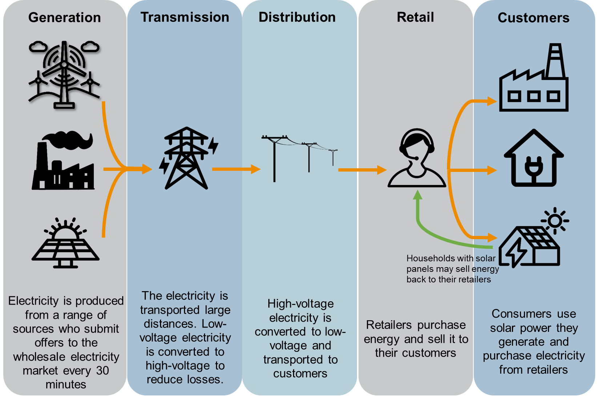

We must consider certain costs in setting minimum feed-in tariffs
The minimum feed-in tariff is an estimate of what a retailer would pay if they bought electricity from the National Electricity Market (plus payment for the benefits of renewable energy) instead of receiving solar exports.
The Electricity Industry Act provides the factors we must have regard to when setting the minimum feed-in tariffs. These are:
- prices in the wholesale market
- avoided transmission and distribution losses
- the avoided social cost of carbon and human health costs attributable to a reduction in air pollution.
How we determine these costs is explained in more detail in the following chapters.
We must also be guided by our objectives under the Essential Services Commission Act 2001, which is to promote the long-term interests of consumers.

The steps for setting the minimum feed-in tariffs
As with previous years, we used the following process to determine the minimum feed-in tariffs and account for the factors outlined in Figure 2.2:
- Develop a forecast of solar weighted wholesale electricity prices to reflect market expectations for 2024─25:
  - for the flat minimum feed-in tariff, we forecast solar weighted wholesale electricity price for the whole of 2024─25.
  - for the time-varying minimum feed-in tariffs we forecast solar weighted wholesale electricity prices for each time block by weighting forecast spot prices in that block by its share of total solar exports.
- Add in the benefit of market fees, ancillary service charges and other market operator charges retailers avoid when they get electricity from solar customers instead of the wholesale market.
- Increase the resulting values to account for energy saved by not transporting the energy long distances from large scale generators (transmission and distribution losses).
- Add the avoided social cost of carbon and human health costs from air pollution.
Figure 2.2: Costs we must have regard to in setting the feed in tariffs
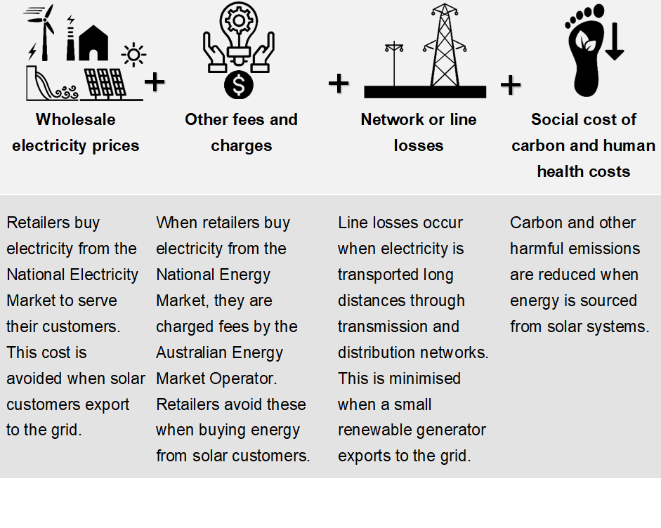

The wholesale value of solar energy
When retailers get energy from solar customers, they avoid buying electricity in the wholesale market. Therefore, calculating the minimum feed-in tariff for the upcoming financial year requires us to estimate the solar weighted wholesale price of electricity.
We have used a futures market approach to forecast wholesale spot prices. Victorian baseload swap futures traded on the Australian Securities Exchange represent the market’s expectation of what average spot prices will be in 2024–25.
The prices in the futures market reflect retailers’ and generators’ expectations for wholesale electricity prices.
A futures market approach to forecasting wholesale spot prices is the same approach we have used in past decisions.

The solar weighted wholesale costs for the flat minimum feed-in tariff
Solar panels account for 99.9 per cent of small-scale renewable generation in Victoria. Unmodified futures prices reflect the average wholesale price for across all 24 hours of the day. Therefore, they are not appropriate for setting the feed-in tariffs as most solar exports happen during daylight hours.
To calculate the minimum feed-in tariffs, we need to estimate the average wholesale spot price during those times when electricity from solar panels is being exported: the solar weighted wholesale price.
We estimate the solar weighted wholesale price by ‘weighting’ prices at each relevant National Electricity Market trading interval by the share of solar exports that happen at that interval.
For example, for the flat feed-in tariff, we multiply the wholesale spot price for each applicable half hour trading interval by the solar exports that took place at that interval. We then divide the amount for each interval by the total amount of solar exports for the year. We then add all the results together to find the solar weighted average price for the year. We refer to this process as 'solar weighting’.
Solar weighting means that prices for electricity when solar panels are not exporting – such as in the evening – have almost no impact on the calculation of the feed-in tariff. This means small-scale solar generators do not get paid the wholesale spot price when they are not exporting. This helps the minimum feed-in tariffs reflect the value consumers get from solar energy exports.

We forecast solar weighted wholesale prices for different parts of the day
Solar weighted wholesale prices vary throughout the day. But distinct patterns are evident. They are generally lower during daylight hours, when there are more solar exports, and higher in the early morning and night times.
Figure 3.1: Average actual solar weighted prices and solar exports across the day 2022-23
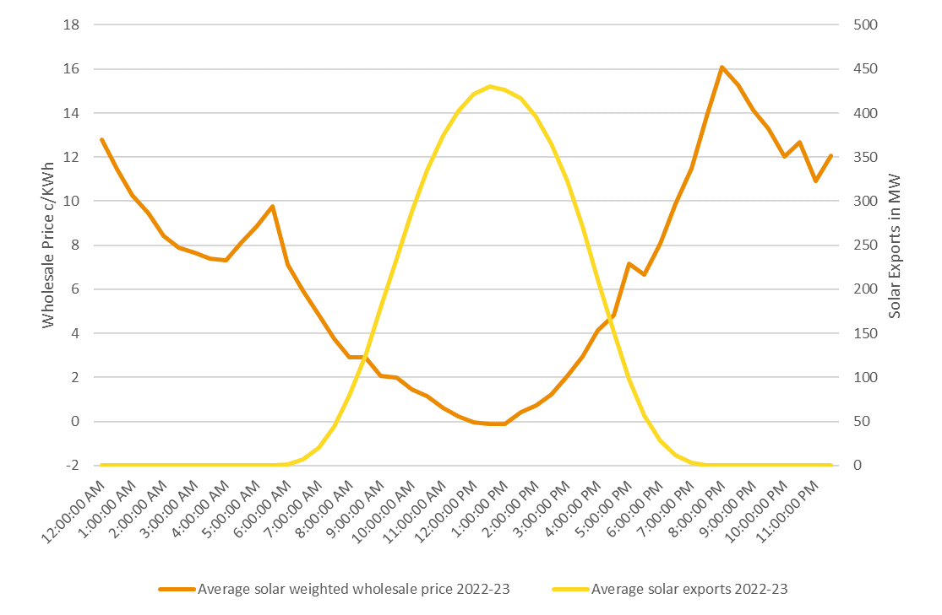Source: AEMO; Victorian distribution businesses; ESC analysis
To reflect these changes in the solar weighted wholesale price, we have time-varying minimum feed-in tariffs in addition to the flat minimum feed-in tariff. We allow retailers to choose whether to offer customers time-varying feed-in tariffs, a flat tariff or a combination.
We use the same forecast solar weighted wholesale prices to calculate the flat feed-in tariff and time-varying feed-in tariffs.
The flat tariff uses the overall solar weighted average for all times. While the rates for the time varying feed-in tariffs only use the solar weighted average wholesale electricity prices for the relevant time periods.

We use a different futures market approach than the Victorian Default Offer
We also use ASX Energy futures to forecast spot prices in our Victorian Default Offer decisions. However, there are some differences between our wholesale benchmarks for the Victorian Default Offer and the minimum feed-in tariffs.
The wholesale benchmark in the Victorian Default Offer includes hedging costs. Solar customers do not incur hedging costs and solar exports do not prevent retailers from incurring hedging costs. For this reason, we do not include hedging costs in the minimum feed-in tariffs.
In addition to this, we do not solar weight wholesale prices for the Victorian Default Offer. This is because electricity retailers must buy electricity at all times of the day and night, even when the sun is not shining.

We account for AEMO fees, charges and line losses

Market fees and ancillary service charges
When retailers buy energy from the wholesale spot market, they must pay market fees and ancillary service charges to the Australian Energy Market Operator (market operator).
Retailers avoid these fees when they buy electricity from solar customers. These cost savings increase the value of energy produced by solar customers. Including these savings in the value of the feed-in tariff is consistent with the approach we have used in past reviews.
The market operator sets its fees for each year through its annual budgeting process. As with previous decisions, we have used fees published in the most recent Budget and Fees paper (in this case for 2023–24) to derive our best estimate for costs avoided.
The market operator also recovers the cost of it providing ancillary services from market participants (retailers) and publishes the recovery rate of ancillary service charges on a weekly basis. As in past years we forecast the cost of ancillary services using the average charges over the last year. For this decision we used 52 weeks of data from 1 January 2023 to 31 December 2023.

Network or line losses
Large-scale generators are located far away from most energy consumers. The energy from the generators must travel long distances through the grid (transmission and distribution networks). Some energy is lost when it moves through the grid, and we refer to this as ‘network losses’ or ‘line losses’. The magnitude of network losses depends on the location of the generator and factors like the quality of the line.
In contrast, energy generated by solar systems is typically close to the point of consumption, so less energy is lost travelling along the grid.
We account for the network losses that retailers avoid when they buy energy from solar customers by using a loss factor which we apply to the (avoided) cost of wholesale energy. This increases the value of wholesale electricity included in the minimum feed-in tariffs.
We have used the market operator’s estimates of distribution loss factors and marginal loss factors for 2023–24 – the latest available— to develop loss factors for Victoria.
See Appendix A – Technical methodology for further details on the calculation of market fees, ancillary services and network losses.

We consider carbon and human health costs
Emissions released during gas or coal-fired generation impose an economic cost on society by contributing to the greenhouse effect. This cost is often referred to as the cost of carbon. Along with carbon, fossil fuel generation is associated with air pollution (such as particulate matter) which can have a negative impact on human health. It follows that when solar energy is made available to the grid, some of this air pollution is avoided.
We are required to consider the cost of carbon and human health costs when determining the minimum feed-in tariff.
We have kept the same assumptions for the social cost of carbon and human health costs that we have used in previous decisions.
This area is the subject of ongoing review by the Department of Energy, Environment and Climate Action and we will continue to monitor developments in this space.

Cost of carbon
The National Electricity Market uses energy generated from a variety of fuel sources and technologies of varying carbon intensiveness.
The Victorian Government published an Order in Council in February 2017 specifying a methodology and the factors that we must have regard to when setting the social cost of carbon. We have adopted this methodology for our decision.
The Order in Council methodology gives the avoided social cost of carbon a value of 2.5 cents per kWh. This is the same value as for previous years.
We have added this to the flat feed-in tariff and time-varying feed-in tariffs.

Human health costs
The human health costs are the estimated health costs of air pollution (such as particulate matter) associated with fossil fuel powered electricity generation.
There is no Order in Council that specifies a factor or method for determining the avoided human health costs attributable to a reduction in air pollution; there are different methods to estimate these costs.
In past years we have not given a separate valuation of the avoided human health costs. This reflects the fact that there is potential overlap between the social cost of carbon and human health costs. There is also potential overlap between the avoided human health costs and other subsidies for solar customers.
Based on the information currently before us, our decision is to use the same approach as in previous years.
See Appendix A – Technical methodology for more details

Themes from submissions and our responses
This chapter addresses the key themes raised by stakeholders in response to our draft decision. We received 19 submissions. These include written submissions made through Engage Victoria and our feed-in tariff mailbox.
We received submissions from 15 solar customers, two community solar groups, an energy retailer and an electricity distributor.
In general, solar customers opposed the draft decision to reduce the minimum feed-in tariffs.
Most customers said the minimum feed-in tariffs should be higher. In general, solar customers felt the minimum feed-in tariffs do not fairly compensate them and that the difference between the feed-in and retail tariffs is unfairly large.
These submissions did not provide any new evidence or alternative methodologies to support these views (or they proposed approaches that would not meet our legislative requirements). Others expressed concern about existing owners recouping their investment.
The energy retailer’s submission agreed with our methodology and proposed we add a flexible feed-in tariff option where retailers could set their own time blocks and rates, provided these were on average equal to or higher than the minimum feed-in tariff.
An electricity distributor highlighted how difficult it was for consumers to understand how to make the most of their solar systems and proposed that further public education initiatives are needed.

Feed-in tariffs are based on facts and the best available information
Most solar customers felt that our proposed feed-in tariffs were too low. One solar customer’s view typified those of many:
The feed in tariff should not be decreased at this stage at all. It should be increased.
The feed-in tariff methodology is based on the best available model and data. As outlined in Appendix A, we use export data, historic wholesale prices, and the prices in the futures market.
In general consumer submissions did not provide any detailed alternative models or evidence to suggest our analysis was incorrect. The alternative models that were suggested, such as making the minimum feed-in tariff a set percentage of the retail price, did not reflect the factors we must consider. We could not adopt this methodology because as explained in the summary chapter, we must have regard to the wholesale electricity price.
Some submissions provided quantitative evidence, but this evidence was not directly related to the value of solar exports. For instance, some submissions suggested that we should base the feed-in tariffs on retail prices, the capital costs or rooftop solar or other grid-scale solar.

Average wholesale prices are up but daytime prices are down
Other customers expressed their frustration that the minimum feed-in tariff is declining while retail rates are increasing:
Maintain the current or significantly increase the proposed feed-in tariff to cover significant increases in residential power prices, as the excess used helps to cover the massive price increases residential customers continue to suffer through year on year.
We acknowledge that retail electricity prices have increased recently. However, the increased availability of solar energy has decreased demand for and increased the supply of electricity during daylight hours which has led to lower wholesale prices when solar panels are exporting.
In contrast, wholesale prices are much higher in the early morning, and from early evening into the night. But solar exports are very low at those times. Because of this, overall average wholesale prices have increased while daytime prices have declined.
Retailers must buy electricity across all hours of the day. Not just during daylight hours when solar panels are generating and wholesale electricity prices are falling. Because retailers must also buy wholesale electricity during the evening (which is the time at which wholesale electricity prices are at their highest) retail prices have increased.
While solar customers do not receive retail rates for their exports, they can avoid retail costs by consuming the energy they produce. The more of their own energy they use, the greater the return on their solar system will be.

Promoting the interests of all customers
Some solar customers felt that our proposed feed-in tariffs were unfair and favoured industry. For example, one solar customer wrote:
How can it be end-users pay more to buy power than they can sell it for? There is a huge disparity, and it reduces the benefits. Seems like utility companies can pocket the profit from end-users’ investment.
The minimum feed-in tariffs for 2024–25 give solar customers a payment that reflects the value of their exports without non-solar customers paying too much for electricity. As discussed on page 9 in the Summary, solar customers are electricity generators when they export energy.
Solar customers may not see themselves as part of the wholesale market, especially as they purchase the electricity at retail prices. However, when solar customers are exporting energy, they are providing a wholesale service like other generators. This is just a part of retailers’ total costs.
As explained in the Summary, retailers have additional costs they must cover. These costs and the fact that most solar exports occur at a time when the wholesale price is lowest means that the minimum feed-in tariffs are much lower than the retail prices.
The feed-in tariffs reflect how much solar customers’ energy is worth in the energy market at the time they export it. Under the Electricity Industry Act we must have regard to a number of the costs retailers avoid when they buy electricity from solar customers (instead of buying it from the National Electricity Market) plus the environmental and health benefits.
While solar customers receive an income stream from feed-in tariffs, they should not rely on exports to repay their investment. The main financial benefit of installing a solar system is being able to buy less electricity from the grid.
Solar customers can avoid paying retail prices through consuming their own energy, which non-solar customers cannot. Many electricity customers cannot install solar panels. Maybe they live in an apartment or an embedded network. Maybe they cannot afford them. Or maybe they are renting, and the property owner is unwilling or unable to install them. We must also consider these consumers in making our decisions.

Legislation places limits on how we can set the minimum feed-in tariffs
Some submissions argued the minimum feed-in tariffs should be closer to the retail electricity price:
Implement a new methodology with the guiding principle that the feed-in tariff should be same as the retail rate or as close to it as possible.
Other customers proposed we should adopt a methodology based on retail tariffs:
Feed-in tariff should be a percentage of the kilowatt charge. That way if your prediction that charges will drop is wrong and charges rise so will the feed -in tariff. Feed-in tariff maintains parity. A percentage rate of 25% would be appropriate.
Legislation sets out the factors we must consider in setting the minimum feed-in tariffs. The Electricity Industry Act requires that we have regard to a specific list of factors that includes wholesale prices: not retail prices.
Also, as explained above, the economic value of solar exports and the retail cost of electricity are driven by different things. Therefore, setting the minimum feed-in tariff as a set percentage of the retail tariff would be less reflective of the value of solar exports than the approach we are required to use under legislation.

Customers can still make significant savings on their electricity bills
Various submissions argue that our decision removes the value of household solar. One customer stated:
We purchased them for many thousands of dollars it was worthwhile. Now uneconomic. Sad that we have all been led down the wrong garden path.
The minimum feed-in tariffs reflect the value of solar exports. We acknowledge solar customers incur costs for the installation and maintenance of their systems. However, the minimum feed-in tariff is a payment to reflect the economic value of the energy that solar customers export. It reflects the efficient price for solar exports. It does not, and should not, aim to cover solar customers’ installation and maintenance costs.
However, unlike traditional large-scale generators, solar customers can also benefit by using the energy they generate. Any assessment of the economic viability of investing in a solar system must account for bill savings from self-consumption as well as revenue from feed-in tariffs.
As we stated in the Summary, self-consumption offers solar customers the biggest savings they can get from their roof top solar systems. Installing rooftop solar panels saves the average Victorian household $1,073 on their annual energy bills.
Customers may not always see these savings in their bill as their meter will not record the energy that is consumed before the surplus is exported to the grid. However, given the size of savings from self-consumption, it is critical to include their value when calculating payback periods.

We will monitor how the value of solar changes across the day
In its submission, GloBird energy said:
GloBird commends the ESC for introducing the new minimum feed-in time-varying tariff option 2. We consider this tariff structure is a step in the right direction. Nevertheless, we note that the current three minimum tariff structures are fixed in nature and therefore do not provide flexibility or promote innovation to address consumers’ varied load profiles or needs. We propose the ESC to introduce the following minimum FIT solution:
            - The ESC determines the minimum FIT flat rate – no changes to existing process or methodology.
            - The ESC determines the average daily export profile (in kWh) for each 30-minute interval (48 intervals in total). These figures can be sourced from Frontier Economics’ model.
            - Retailers are allowed to introduce their own FIT structures and rates, provided the resulting weighted average price, when applying the rates to the annual export profile, is greater than or equal to the minimum FIT flat rate set by the ESC.
As we stated in our previous decision, we have considered GloBird Energy’s proposal for a flexible minimum feed-in tariff. We have decided not to implement a flexible minimum feed-in tariff for our 2024–25 minimum feed-in tariff final decision. However, we may consider doing so in future decisions.
We have not implemented a flexible feed-in tariff for this decision because we introduced the new time varying feed-in tariff (Option 2) in our 2023–24 decision. While we seek to provide retailers and customers with more options and flexibility, time-varying feed-in tariffs are still relatively new and so far not many retailers are offering these tariffs. We would like to have more evidence on how retailers and customers use these tariffs before introducing more complexity into the market.
Similarly, we have not mandated that retailers offer the time-varying feed-in tariffs.

Energy markets are complex
AusNet’s submission stated that consumers do not fully understand the issues around the minimum feed-in tariffs:
Our research shows there is a lack of understanding among customers around the feed-in tariff including who decides the value and how, and whether the feed-in tariff provides more value compared to self-consumption.
Similarly, Geelong Sustainability stated there was a need for the commission to engage with consumers, particularly, to explain the recent decline in the value of the minimum feed-in tariff:
The 2024 minimum feed-in tariff valuation has reduced by 36 per cent relative to 2023, and Geelong Sustainability asserts that the essential services commission must now take a significant role in facilitating the support and education of energy consumers.
We acknowledge there is value in providing simple and effective communication to the community about the minimum feed-in tariffs. To meet this need, educational materials on our website have been updated and an explainer video produced.
We have consulted on our draft decision
Some stakeholders considered that we have not consulted widely or provided enough time for them to make a submission:
Once again, this consultation process has proven the lack of thought that Victorians would put aside some significant time to provide substance to this annual process on the basis of an advertisement in the major Victorian newspapers in the second week of December with an expected reply in 17 days.
The advertisements in the major newspapers were one part of our consultation process. The consultation process commenced on 22 November, when we published our draft decision on both our website and the Engage Victoria website. Consultation closed 22 December. In addition to public input, we also sought out local solar groups for direct consultation.

The social cost of carbon is set out in the Order in Council
Geelong Sustainability submitted that the social cost of carbon was too low, stating:
Geelong Sustainability asserts it is important to recognise local energy mix as a relevant factor for the determination of a mFIT and suggests that existing methodologies in fact under-value the social cost of carbon…
Another submission also noted:
…we are annually updating pricing and feed-in tariff etc, but ‘the social cost of carbon’ remains the same as 2017.
Victoria is the only jurisdiction that includes a social cost of carbon in its feed-in tariff. The methodology is set by the Victorian Government via an Order in Council. The Order in Council, which we must have regard to, provides the methodology and factors that we must consider when calculating the social cost of carbon.
The methodology and factors in that Order set out the Victorian government’s policy on the social cost of carbon.

We have considered avoided human health costs
Geelong Sustainability was of the view that we can no longer assign a value of zero to the avoided human health costs.
For the reasons outlined in the chapter, ‘We consider carbon and human health costs’, and in previous decisions, we have not included a separate amount for avoided human health costs. As we stated in these chapters, we consider, that while these costs are not zero there is a lack of Victorian specific information to determine a damages cost and these costs may be accounted for by the social cost of carbon and other subsidies.
In its submission, Geelong Sustainability made several new points that had not been raised in feedback on previous feed-in tariff reviews:
Geelong Sustainability disagrees with the position of the Essential Services Commission – that overlap exists between the subsidisation of solar panels and human health costs – and this does not align to the methodology for the determination of the minimum feed-in tariff. This position should be reconsidered as the subsidies of solar panel installation have reduced significantly (small scale technology certificates); while the human health costs of non-renewable energy only appear to be growing.
While subsidies for solar are declining, it is also true that solar exports are displacing less fossil fuel generation. As renewable energy displaces existing generation the amount of air pollution attributable to electricity generation has declined, especially when household solar is exporting to the grid.
Therefore, we remain of the view that human health costs are non-zero, but there is a reasonable amount of evidence that the health benefits for solar generation are already accounted for elsewhere: through solar subsidies or the social cost of carbon (as defined by Order in Council).

We are required to consider the wholesale price of electricity
Another submission stated that we had valued solar weighted wholesale costs at a rate lower than the cost of building large-scale solar farms:
The flat feed-in tariff values the solar weighted average wholesale electricity price at 0.7 c/kWh. This is much lower than the levelized cost of energy for a utility scale solar farm, which are actively supported by the Victorian Government, for example via the VRET1 and VRET2 programs. Government policy is to increase the supply of renewable energy into the electricity market to support the energy transition.
Our task is to set a price for feed-in tariffs that reflects the value of solar exports. We are required by the Electricity Industry Act to have regard to the wholesale electricity price, and not the cost of individual investments.

A stepped feed-in tariff is unnecessarily complex
Geelong Sustainability submitted:
…an enhanced commercial value of solar export exists for the first few kWh fed into the grid and is demonstrated by several retailer offers. The Essential Services Commission should consider that feed-in tariffs be determined by the volume of solar exported rather than a time of use or flat minimum.
When we decide the minimum feed-in tariffs we determine an average value for solar exports, which captures the variance in value throughout the day. A stepped tariff would be unlikely to materially increase feed-in tariff credits for most solar customers and it would create unnecessary complexity.

Retailers cannot use their customers’ solar energy for carbon credits
Geelong Sustainability said that retailers onsell their customers’ solar energy as ‘green power’ to other customers for additional revenue:
What has failed to be considered is that electricity retailers generally aim to onsell solar energy within their customer portfolio (often as green power) at an additional 4-8 cents per kWh, enabling additional revenues. It is our belief that any minimum feed-in tariff determination that only considers wholesale energy prices is perceived by energy consumers as transferring the price risks to them without passing through potential upsides.
Customers can choose to buy GreenPower for an additional cost.
Under the GreenPower rules, retailers participating in the scheme, must buy enough large-scale generation certificates to offset the carbon emissions of their customers buying GreenPower.
These certificates are only produced by large scale generators. In contrast, small scale generators such as roof top solar create small scale technology certificates. Solar customers generally give these certificates to their solar installers (to offset installation costs). Solar installers then sell certificates to electricity retailers who use those certificates to meet their obligations under the Small-scale Renewable Energy Scheme.

Appendix A – Technical methodology
Our approach to determining the minimum feed-in tariffs for 2024–25 is consistent with the approach used to set the minimum feed-in tariffs for 2023–24. The methodology is made up of the following steps:
- Forecast solar weighted wholesale costs: the value of electricity sourced from small-scale renewable generators, based on the avoided cost of purchasing an equal amount of electricity from the wholesale market, accounting for price changes throughout the day and seasonally, including:
- both flat rate and time-varying rate solar weighted wholesale electricity price forecasts
- avoided market fees and ancillary service charges.
- Account for electricity lost in transport: increase the costs from components above to account for avoided transmission and distribution losses.
- Account for social benefits: add the avoided social cost of carbon and avoided human health costs.
Table A.1 shows how the minimum feed-in tariff is calculated from these components.
Table A.1: Calculating the minimum feed-in tariff
 |  | Flat rate | Time-varying rate Option 1 |  |  | Time-varying rate Option 2
Component | Calculation |  | Overnight | Day | Early evening | Shoulder | Off peak | Peak
A: Solar weighted wholesale electricity prices | Solar export-weighted average price forecast (cents per kWh) | 0.64 | 4.74 | 0.20 | 4.19 | 1.41 | -0.41 | 5.48
B: Avoided AEMO market fees and ancillary service charges | Budget National Electricity Market fees for 2023–24 for 2024–25 + Average of the ancillary service charges between 1Jan 2023 to 31 Dec 2023 (cents per kWh) | 0.08 | 0.08 | 0.08 | 0.08 | 0.08 | 0.08 | 0.08
C: Transmission and distribution loss adjustment | Customer weighted average losses across all distribution zones | 6.36% | 6.36% | 6.36% | 6.36% | 6.36% | 6.36% | 6.36%
D: Value of avoided transmission and distribution losses | Multiply (A + B) by C | 0.05 | 0.31 | 0.02 | 0.27 | 0.09 | -0.02 | 0.35
E: Value of avoided social cost of carbon | Based on the amount specified in the Order in Council specifying the avoided social cost of carbon. | 2.49 | 2.49 | 2.49 | 2.49 | 2.49 | 2.49 | 2.49
F: Value of avoided human health costs | Not accounted for separately for a number of reasons including overlap with social cost of carbon and installation subsidies. | 0.00 | 0.00 | 0.00 | 0.00 | 0.00 | 0.00 | 0.00
Total (rounded to one decimal place) | A + B + D + E + F | 3.3 | 7.6 | 2.8 | 7.0 | 4.1 | 2.1 | 8.4

Forecasting solar weighted wholesale electricity prices
Consistent with previous feed-in tariff decisions, we have used a futures market approach to forecast solar weighted wholesale electricity prices in 2024–25. The benefits of using a futures market approach include:
- Ensuring our decision matches the view of ‘the market’ as represented by contract prices
- Providing more transparency to stakeholders than other modelling approaches.
It is in the long-term interests of Victorian consumers to have the benefit of a price that reflects efficient market outcomes. It also promotes competition in the energy industry by creating the right investment incentives.
Transparency of the inputs for analysis is consistent with our objectives to promote protections for customers and to promote the long-term interests of Victorian consumers. Increased transparency gives stakeholders greater opportunities to understand and provide meaningful feedback on our decisions.

Solar weighted wholesale price forecasts for 2024–25
We engaged Frontier Economics to forecast solar weighted wholesale electricity prices for 2024–25 using a futures market approach. The following section outlines the approach.
Forecasting the solar weighted wholesale electricity price for the flat minimum feed-in tariff involves five steps. The purpose of this is to estimate what retailers would pay for customers’ solar exports if this electricity were sold in the wholesale spot market in 2024–25 in the same way as other generators’ output. The steps we take to calculate the flat feed-in tariff are as follows:
- Calculating the price level for 2024–25. We use the average price of 2024–25 quarterly baseload future swaps from the Australian Stock Exchange (after adjusting for an assumed contract premium of five per cent) weighted by traded volume across the most recent 12 months up to a particular date (for this decision this was 16 January 2024).
Frontier Economics updates these estimates between our draft and final decisions to reflect the most up to date market expectations available. These updates resulted in a very small difference between the solar weighted wholesale prices contained in our draft and final decisions.
- Selecting the appropriate historical prices and export profile. The commission collected half-hourly actual export data for customers from each Victorian electricity distribution network for the period from 1 July 2022 to 30 June 2023. This is the most recent financial year for which data is available. Corresponding spot price data for the same period is available from the Australian Energy Market Operator.
- Calculating the scaling factor 2024–25. After averaging prices for each quarter for the relevant historical year, they are compared to the quarterly futures prices in step 1 to determine a scaling factor for each quarter.
- Apply the scaling factor to the historical prices. Each half-hourly price in the base year is scaled by the relevant factor calculated in step 3 to forecast the half-hourly prices expected in 2024–25.
- Calculate the solar weighted wholesale price. The solar weighted wholesale electricity component of the flat feed-in tariff is calculated by averaging the half-hourly prices from step 4, weighted by the volume of solar exports from step 2. The formula for this is:
Flat feed-in tariff solar weighted wholesale electricity price |  | $$\frac{\sum_{t=1}^{17,472}{(expected price 2024{25}_{t} ×solar exports_{t})}}{Total solar exports}$$
 | =
Note that:
expected price 2024-25_{t} = expected spot prices for trading interval t in 2024-25.
solar exports = the expected half-hourly solar exports for trading interval t in 2024-25.
Total solar = the sum of all solar exports for 2024-25.

Solar weighted wholesale price forecast for the time-varying minimum feed-in tariffs
Steps 1 to 4 of forecasting the time-varying feed-in tariffs are the same for forecasting the flat feed-in tariff. Like the flat feed-in tariff approach, the commission has set the time-varying feed-in tariffs using weighting based on solar export profiles. For step 5, the only difference is that the above weighting is done three times, once for each time-block, using only the expected prices and solar exports from the relevant time-block.

Estimate of market fees and ancillary service charges
When retailers purchase energy from the wholesale market, they must pay market fees and ancillary service charges to the Australian Energy Market Operator (market operator). The market operator charges these fees based on the amount of electricity that retailers purchase from the wholesale market. Retailers can avoid them if they get electricity from solar customers.
We have included these fees and charges (shown in Table A.2) in our calculation of avoided costs. The total value of market fees and ancillary services are 0.08 cents per kWh.
Table A.2: Avoided market fees and ancillary service charges
Item | Fee  $ per MWh | cents per kWh
National Electricity Market fees | 0.41 | 0.04
Ancillary service charges | 0.37 | 0.04
Total | 0.78 | 0.08
Source: AEMO 2023–24 Budget and Fees report for market fees; AEMO ancillary services recovery summaries for 2023.

Market fees
The National Electricity Market (NEM) fees levied by the market operator – core and functions – are set in advance each year through its annual budgeting process. We have used the market fees published in the 2023–24 AEMO Budget and Fees paper as the best estimate for fees in 2024–2025. This leads to an estimate of the total market fees avoided in the 2024–25 minimum feed-in tariffs to be 0.041 cents per kWh.
In its 2022–23 Budget and Fees paper, the market operator approved an increase of 4.5 per cent year on year in 2023–24 and 2024–25 for fees on NEM core functions. Therefore, we have increased the 2023–24 budget for NEM core fees by 4.5 per cent as the estimated cost for 2024–25.
Other market fees – such as IT upgrades, five-minute settlements and global settlement compliance, and the Distributed Energy Resources integration program – do not have a clearly planned trajectory. Changes between the 2023–24 budget and the 2022–23 budget were also close to zero. Therefore, we have used the 2023–24 budget for these fees as the estimated costs for 2024–25.
In the 2021 Electricity Fee Structure Final Report and Determination, the market operator also announced it would change the structures of all the fees mentioned above from financial year 2023–24. The new structure involves charging 50 per cent of the fees based on a variable rate per MWh (megawatt-hour) and the remaining 50 per cent based on a fixed rate per connection point per week. Because our approach estimates the costs avoided when retailers purchase exports from solar customers, we only include the variable fees in our calculation. Fixed costs are not avoided when retailers purchase solar exports.
At the time of this decision, the market operator had not published its budget for 2024–25. So, we have used the same market fee amount as we used in our draft decision.
The rebalancing of fixed and variable fees has reduced the market fees included in the 2024–25 minimum feed-in tariffs. The NEM fees we propose in our decision for 2024–25 are 0.04 cents per kWh. The National Electricity Market fees in our 2023–24 decision were 0.11 cents per kWh.

Ancillary services
The market operator recovers the cost of providing ancillary services to the National Electricity Market from market participants (retailers). It publishes the ancillary service charges on a weekly basis on its website.
We have used this data to estimate the avoided costs for ancillary services to be 0.037 cents per kWh. We based this estimate on the 52-weeks from 1 Jan 2023 to 31 Dec 2023. This is the same approach we used last year.

Estimating avoided transmission and distribution losses
Electricity supplied to the wholesale market is often produced by large generators located some distance away from the point of consumption. Electricity is transported to households and businesses via a transmission and distribution network (also known as the ‘grid’). During this process, a small portion of electricity originally exported to the grid is lost as heat and sound. This is referred to as network or line losses.
Small-scale renewable generation reduces network losses because the generated electricity is transported a short distance, so line losses are minimal. The extent of the associated cost savings varies depending on the location of the generation facility (among other factors such as the quality of the line and the amount of electricity flowing through it). These cost savings are incorporated into the feed-in tariffs by applying a ‘loss factor’ to the avoided cost of purchasing electricity in the wholesale market, including market fees and ancillary service charges.
Using the market operator’s estimates of distribution and marginal loss factors for 2023–24, we have estimated a flat customer share-weighted loss factor of 1.0636 for Victoria. We have then applied this loss factor to derive the value of avoided network losses used in the minimum feed-in tariff calculations. Table A.3 sets out the inputs to the loss factor calculation which are publicly available on the market operator’s website.
In this review, we have used the same approach to network losses as we use for the Victorian Default Offer. This is the same approach we took in the last feed-in tariff review. To calculate the distribution loss factors (DLF) for urban distribution areas we have used the short sub-transmission factor. For the Powercor and AusNet distribution zones, however, we took the load weighted average of the short and long sub-transmission distribution loss factors using data provided by Powercor and AusNet.
We then calculated the marginal transmission loss factors (MLF) using the simple average of the marginal loss factors across each distribution area (removing some nodes that have no small business or residential load). We multiply the DLFs and MLFs to derive the total loss factors. These factors are then weighted by the number of low voltage customers in each distribution zone to develop a Victoria-wide loss factor. See Table A.3 for details.
Table A.3: Inputs for calculating loss factors
Distribution business | Distribution loss factor | Average marginal loss factor | Total loss factor | Number of customers
AusNet Services | 1.0810 | 1.0041 | 1.0854 | 804,402
CitiPower | 1.0450 | 1.0000 | 1.0450 | 344,206
Jemena | 1.0447 | 1.0006 | 1.0454 | 375,395
Powercor | 1.0738 | 0.9980 | 1.0717 | 911,648
United Energy | 1.0483 | 0.9987 | 1.0469 | 707,561
Customer share-weighted average |  |  | 1.0636
Data sources:
Distribution loss factor & Marginal transmission loss factor: AEMO, published factors for 2023–24 financial year;
Load volume as averaging weights over short sub-transmission lines and long sub-transmission lines: data request AusNet Services and Powercor, over financial year 2022–23;
Number of customers - AER, RIN response, electricity networks proposals, 31 October 2023.

Estimate of the avoided social cost of carbon and human health costs
In February 2017, the Victorian Government issued an Order in Council (‘Order’) specifying a methodology for determining the social cost of carbon and the factors we must consider when applying this methodology.
It defines the avoided social cost of carbon as the avoided ‘cost per kilowatt-hour (kWh) of small renewable energy generation electricity purchased by a relevant licensee’ (e.g., retailer), determined in accordance with the following methodology and factors:
$$Avoided social cost of carbon=Volume factor×Price factor$$
The volume factor, in the Order is an emissions intensity coefficient factor of 1.27 kilograms (kg) of carbon dioxide equivalent (CO2e) per kWh of electricity exported by a small renewable energy generator. This means that 1.27 kg (or 0.00127 tonne) of CO2e is assumed to be avoided for each kWh of electricity exported by a small renewable energy generator.
For the price factor, we have used the method specified in the Order to determine the value of a tonne of CO2e. It results in a value of $19.63 per tonne of CO2e. The resulting avoided social cost of carbon is 2.5 cents per kWh.

Human health costs
The Victorian Government has not made a separate Order in Council that specifies a factor or method for determining avoided human health costs attributable to a reduction in air pollution.
We reviewed the associated health benefits as part of our inquiry into the value of distributed generation in 2016. We have re-examined this matter a number of times since. However, due to a lack of sufficient evidence and data, we have not been able to reliably place a separate monetary value on the avoided human health costs.
We note that there is evidence that the avoided human health costs are already accounted for through the avoided social cost of carbon and/or subsidies provided for solar installations. We have adopted this view. As a result, our decision is to set the stand-alone avoided human health costs at 0 cents per kWh.
There is a variety of methodologies to price the avoided human health costs attributable to the reduction in air pollution, with no approach widely accepted. These methodologies fall into two broad categories:
- Damages costs: damages caused by the pollution.
- Abatement costs: costs of avoiding the pollution.

Damages costs
Under the damages cost approach, the avoided human health costs are calculated using estimated health costs of pollution from electricity generation. The costs of the damages vary significantly according to where the generation, and therefore pollution, occurs. The dispersion of pollutants depends heavily on local conditions.
If generators are in a densely populated area, the pollution will affect more people and the human health costs will be higher. In contrast, if the generation occurs in a low population area, there will be lower health costs.
There is no detailed research on the dispersion of pollutants in Victoria. The state’s coal-fired generation is in the Latrobe Valley. This is a relatively long distance from Victoria’s larger population centres. In many other parts of the world, the distance between generation and consumption is not as large. While there is some gas generation within Melbourne, it accounts for only a small share of total generation.
To calculate the damages costs and total avoided human health costs, it would be necessary to establish the unit health costs of fossil fuel generation and then assess how solar exports displaces this generation.

Abatement costs
An alternative is to use the cost of avoiding pollution. Under this method, we measure the cost of preventing pollution to get the value of avoided human health costs. This approach can be especially helpful when abatement costs are known but damages costs are not.
Some other jurisdictions have adopted abatement costs as a possible way of measuring environmental externalities (such as the cost of carbon) when damages costs are unknown or uncertain. The Order in Council uses an abatement cost approach for determining the avoided cost of carbon.
When using an abatement cost approach there may be an overlap between the avoided health costs and the social cost of carbon.
Abatement of fossil fuel generation is paid for through the social cost of carbon. Both carbon emissions and other harmful pollutants are avoided when this abatement takes place. If we pay to avoid carbon pollution, it follows that we also avoid other types of pollution.
The potential overlap between the avoided human health costs attributable to a reduction in air pollution and the avoided social cost of carbon was noted at the time these avoided costs were introduced into the minimum feed-in tariff.

Solar panel installation subsidies
To encourage solar installations, and acknowledging the associated social benefits, customers receive government subsidies when they install solar systems. These include both state (Victorian solar panel rebate scheme) and federal programs (small scale renewable energy scheme).
As the main social benefits of solar installation are reductions in carbon emissions and noxious pollutants, there may be some overlap between these subsidies and the avoided cost of carbon and avoided health costs.

Clean Energy Regulator, Postcode data for small-scale installations, accessed 04 January 2024.
Electricity Industry Act 2000, s. 40FBB(3)(a)(b), and (c).
Electricity Industry Act 2000, s. 40FBB(2)(a)
Essential Services Commission Act 2001, s. 8.
Electricity Industry Act 2000, s. 10.
The Option 1 tariff periods reflect arrangements in older time varying network tariffs. The periods were set in an Order in Council: Victoria Government Gazette, No S 216, 19 June 2013, Advanced Metering Infrastructure (AMI Tariffs) Order, Schedule, p 9. Accessed 20 December 2023. The time periods for Option 2 were developed after consultation with stakeholders, GloBird submission, pg. 2, 23 January 2023.
Feed-in tariffs for solar customers registered for GST are subject to GST. Most residential solar owners are not registered for GST. Australian Tax Office, Electricity and Gas Industry Partnerships, accessed 5 January 2024,
Department of Energy, Environment, and Climate Action, VRET Progress Report 2022-23, p.6, accessed 19 February 2024.
Frontier Economics, Wholesale price forecasts for calculating minimum feed-in tariff: Final report for the Essential Services Commission, January 2024, chapter 4.
Frontier Economics, Wholesale price forecasts for calculating minimum feed-in tariff: Final report for the Essential Services Commission, January 2024, chapter 4.
Electricity Industry Act 2000, s. 40FBB(3).
Electricity Industry Act 2000, s. 40FBB(3)(a), (b) and (c).
The value of network losses varies as the value of the energy transported varies. For example, as the wholesale price of electricity increases, the value of the associated loses on the transmission and distribution networks will increase.
Australian Energy Market Operator, Data dashboard: Fuel Mix, accessed 31 January 2024.
OpenNEM Project, An Open Platform for National Electricity Market Data, accessed 31 January 2024.
Electricity Industry Act 2000, s. 40FBB(3)(a)(b), and (c).
Essential Services Commission Act 2001, s. 8.
Frontier Economics, Wholesale price forecasts for calculating minimum feed-in tariff: Final report for the Essential Services Commission, January 2024, p. 14–15.
Clean Energy Council, Postcode data for small-scale installations, accessed 4 January 2023,
A very small amount of exports from small-scale renewable generators happen at night (for example from small wind turbines or small batteries). For this reason, some weight is placed on overnight prices, but not very much.
Essential Services Commission, Victorian Default Offer to apply from 1 July 2023: Final Decision 25 May 2023.
The Australian Energy Market Operator manages electricity and gas systems and markets across Australia. This includes the National Energy Market (NEM), which connects the power systems of Queensland, New South Wales, the Australian Capital Territory, Victoria, South Australia and Tasmania.
Electricity Industry Act 2000, s. 40FBB(3)
Order specifying a Methodology and Factors for the Determination of the Avoided Social Cost of Carbon 2017 (Vic) made under section 40FBB(3B) of the Electricity Industry Act 2000.
Victorian Government 2016, Energy Legislation Amendment (Feed-in Tariffs and Improving Safety and Markets) Bill 2016, Explanatory Memorandum, p. 4.
Paul Berg submission, (ID 1146795), 22 November 2023
Anonymous submission, (ID 1151060), 9 December 2023
Mark submission (ID 1146816), 22 November 2023
Indar Ghikpal submission, (ID 1150330), 5 December 2023
Anonymous submission, (ID 1150271), 5 December 2023
Electricity Industry Act 2000, s. 40FBB(2)(a), Electricity Industry Act 2000, s. 40FBB(3)(a)(b), and (c).
Peter Rice submission (ID 1150341), 5 December 2023
Solar Victoria, Solar saves more than money and the environment, accessed 6 February 2024.
GloBird Energy submission, (ID 1151749), 15 December 2023
Essential Services Commission 2023, Minimum Electricity Feed-in Tariffs to Apply From 1 July 2023: Final Decision, 27 February
AusNet submission, 21 December 2023
Geelong sustainability (ID 1152459), 20 December 2023
The materials can be found the Essential Services Commission website as well as the explainer video.
Golland submission, 22 December 2023
Geelong sustainability (ID 1152459), 20 December 2023
Golland submission, 22 December 2023
Victorian Government 2017, Victoria Government Gazette No. S 36, Tuesday 21 February 2017, Order specifying a methodology and factors for the determination of the avoided social cost of carbon (Order in Council).
Geelong Sustainability (ID 1152459), 20 December 2023
Essential Services Commission 2023, Minimum Electricity Feed-in Tariffs to Apply From 1 July 2023: Final Decision, 27 February, p. 26
Geelong Sustainability (ID 1152459), 20 December 2023
Kristyn Hart submission (ID 1151649), 14 December 2023
Electricity Industry Act 2000
Geelong Sustainability (ID 1152459), 20 December 2023
Geelong sustainability (ID 1152459), 20 December 2023
Greenpower, About GreenPower accessed 17 January 2024
Clean Energy Regulator, Small-scale Renewable Energy Scheme, accessed 15 February 2024
Electricity Industry Act 2000, s. 10(c).
Essential Services Commission Act 2001, s. 8.
Frontier Economics, Wholesale price forecasts for calculating minimum feed-in tariff: Final report for the Essential Services Commission, January 2024, p. 15.
Australian Energy Market Operator, 2023─24 AEMO Budget and Fees, published in June 2023, accessed 04 September 2023
Australian Energy Market Operator, 2022─23 AEMO Budget and Fees, page 6-7. Published in June 2022, accessed 18 October 2023
See ‘NEM benchmark fee’ in Table 9 on page 25 of the 2023-24 AEMO Budget and Fees paper, referenced above.
Australian Energy Market Operator, Electricity Fee Structure Final Report and Determination, published in March 2021, last access 28 September 2023
Australian Energy Market Operator, AS Recovery Summary File 2023 (spreadsheet downloadable), ‘RECOVERY_RATE_CUSTOMER’. accessed on 17 January 2024
We have used the 52-week average up to December for final decisions. Even though there are a few months’ gap to 1 July when the new minimum feed-in tariff applies, we have decided a forecast adjustment is unnecessary. We consider that because the ancillary charges are published week by week, our approach allows for the actual ancillary charges avoided to always be reflected in the minimum feed-in tariff.
Australian Energy Market Operator, Distribution loss factors for the 2023-24 Financial Year, accessed 31 August 2023.
Australian Energy Market Operator, Marginal loss factors for the 2023-24 Financial Year, accessed 31 August 2023.
Victorian Government 2017, Victoria Government Gazette No. S 36, Tuesday 21 February 2017, Order specifying a methodology and factors for the determination of the avoided social cost of carbon (Order in Council)
Essential Services Commission 2016, The energy value of distributed generation, August 2016, pp. 62-63,
Victorian Government 2016, Energy Legislation Amendment (Feed-in Tariffs and Improving Safety and Markets) Bill 2016, Explanatory Memorandum, p. 4.

